Boys and Girls I am so excited to be your Primary 1 Teacher and I can’t wait to meet you all!
I was hoping that you could do something for me. Do you think you could draw a picture of you? Somewhere on the picture ask your grown up to write down 5 things you would like me to know about you.
To get you started here are 5 things about me;
- I have 3 grown up children
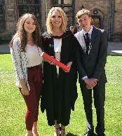

- My favourite story book is The Day The Crayons Quit
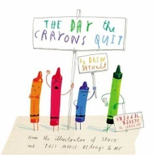

- My favourite colour is red
- I like to bake cakes
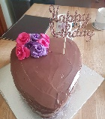
- I have a dog called Bella
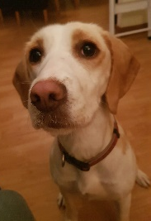

You can bring your picture when you come to visit or on your first day of school in August.
Love Mrs Bell

