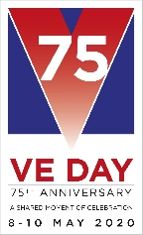
Health and Wellbeing Tasks
Week – 4th May 2020

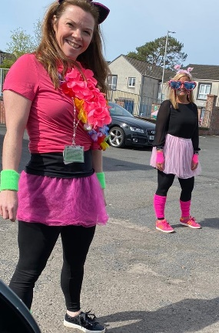
Hello Everyone – I hope you and your families are all well! This is a short week as we have a holiday Monday and VE day celebration is on Friday.

Teachers on Tour
If we didn’t come and see you could you please send us a message on teams, email the school or even give the school a call as Miss Flint and I will be out again WEDNEDSDAY 6TH MAY so we will add you to our list!

Task 1 – Activity Cards – Football Skills
During this time it is so important to keep active. I have included some great ideas from active schools ideas to help your football skills.

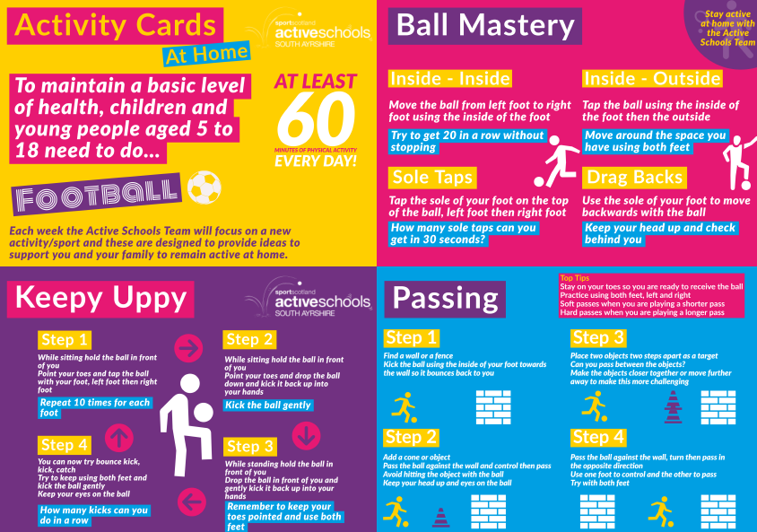
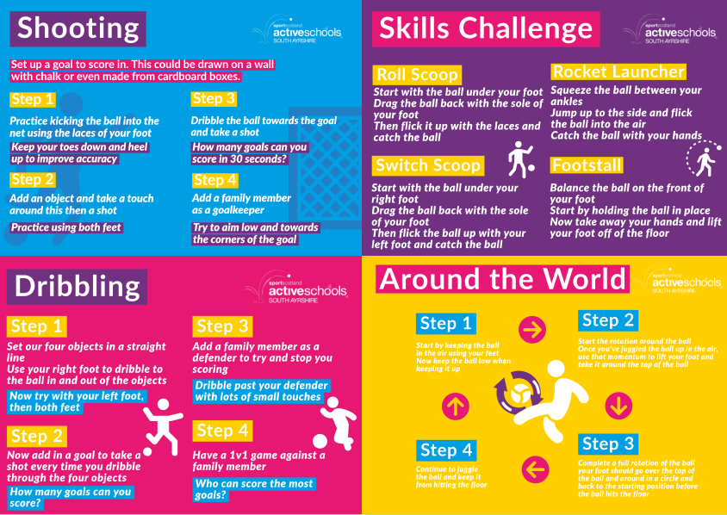
Task 2 – Time Capsule
We are looking a lot this week at history but in fact we are part of a major piece of history at the moment. Take time to look at this time capsule idea. You could use it to create your own time capsule about life during lockdown or you could use some ideas and come up with your own creative way to remember this period of time.
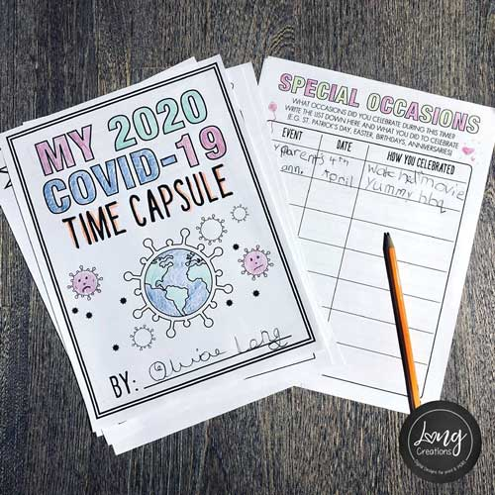
https://letsembark.ca/time-capsule

Take care and stay safe,
Mrs Kay

