Easter Holiday Family Fun
Please ask permission first
Dance Off  Family competition, winner chooses the next dance. | Design an Easter Egg  Display the design in your window. | PE with Me  Design your own fitness show for your family similar to Joe Wicks | Family Picnic  in the garden / living room,  help make the snacks for this.
Den Building  Use cushions, blankets etc to build a den/fort | I Spy  Look for Easter Eggs in windows around the neighbourhood. | Cosmic Kids  Try one of the yoga adventurse  https://www.youtube.com/user/CosmicKidsYoga | Junk Challenge  Using old boxes etc. to create a tall tower, robot or rocket.
Kids Charades  Guess the movie or even just an action e.g. cycling a bike etc. | Fashion Show  Wear different combinations of clothes. Try to be unusual | Bubble Fun  Make your own bubble mix with washing up liquid and water. | Secret Agent  Leave messages / clues around the house for your family to find.
Upcycle  Wash out and decorate a tin or glass jar. Use it to store things. | Movie Magic  Design an invite for your family to watch a movie together. | Bird Feeder  Wash out a milk carton to make a bird feeder for the garden  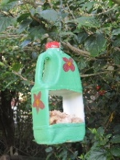 | Shadow Drawing  When the sun creates a shadow, layout some objects to draw round
Easter Treats
Please ask permission first

Easy Easter Nests |  | Easter Biscuits | 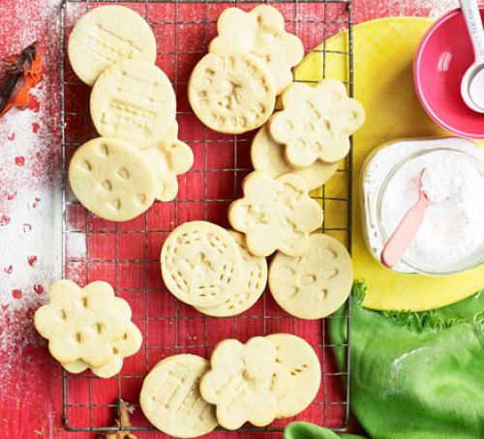
Ingredients  200g milk chocolate, broken into pieces  85g shredded wheat crushed (or rice krispies or cornflakes)  2 x 100g bags mini eggs  cupcake cases  Method  1. Melt the chocolate in a small bowl placed over a pan of barely simmering water. Pour the chocolate over the shredded wheat or cereal and stir well to combine.  2. Spoon the chocolate wheat into 12 cupcake cases and press the back of a teaspoon in the center to create a nest shape. Place 3 mini chocolate eggs on top of each nest. |  | Ingredients  200g unsalted butter, softened  200g golden caster sugar  1 large egg  ½ tsp vanilla extract  400g plain flour, plus extra for dusting  Method  1. Heat oven to 200C/180C fan/gas 6 and line a baking sheet with baking parchment. Put the butter in a bowl and beat it with electric beaters until soft and creamy. Beat in the sugar, then the egg and vanilla, and finally the flour to make a dough. If the dough feels a bit sticky, add a little bit more flour and knead it in.  2. Pull pieces off the dough and roll them out to about the thickness of two £1 coins on a floured surface. The easiest way to do this with small children is to roll the mixture out on a baking mat. Cut out shapes using a 9cm biscuit cutter, or a use the rim of a small glass and peel away the leftover dough around the edges. Press some clean toys gently into the biscuits, making sure you make enough of a mark without going all the way through. Re-roll off-cuts and repeat.  3. Transfer the whole mat or the individual biscuits to the baking sheet and bake for 8-10 mins or until the edges are just brown. Leave to cool for 5 mins, then serve. Will keep for three days in a biscuit tin.
Crispy Chocolate  Fridge Cake |  | Easter Fun Snacks
Ingredients  - 300g dark chocolate, broken into chunks  - 100g butter  - 140g golden syrup  - 1 tsp vanilla extract  - 200g biscuit, roughly chopped  - 100g sultana  - 85g Rice Krispies  - 100-140g mini eggs  optional  50g white chocolate  Method  - 1. Line a 20 x 30cm tin with baking parchment. Melt the chocolate, butter and golden syrup in a bowl set over a pan of simmering water, stirring occasionally, until smooth and glossy. Add the vanilla, biscuits, sultanas and Rice Krispies, and mix well until everything is coated.  - 2. Tip the mixture into the tin, then flatten it down with the back of a spoon. Press in some mini eggs, if using, and put in the fridge until set. When hard, drizzle all over with the melted white chocolate and set again before cutting into chunks. |  | Use whatever you have in the cupboard to make an Easter themed snack/lunch. Images below are for some inspiration  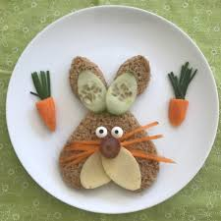  These are just a few suggestions. The main thing is to play, have fun and relax as a family over Easter. We will be back in touch really soon to hear all your news.

