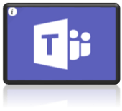
Family Support Information

Home learning requires your child to log into GLOW – here is the link if your child is unsure:

https://sts.platform.rmunify.com/Account/SignIn/glow

When your child has successfully logged into GLOW look for these ICONS at the left of the screen
If you click on this icon (My Launch Pad) - it shows you the tiles your child uses most for learning.

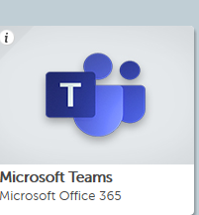
When you click on My Launch Pad as above, you will see some tiles appear – click on the one that says TEAMS – It should look like this:

Click on this tile and you should see your child’s class tile with their teacher’s name…like this…
This is your child’s class tile – it may have a colourful image in the centre.

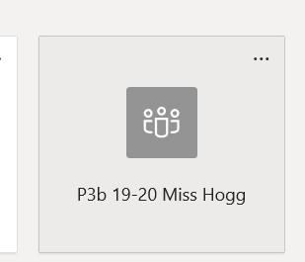

Click on this tile and you will see this at the top of the page…

If you want to access the list of Home learning task that have been set by your child’s teacher then click on ‘Files’

Here you will find a range of tasks across the curriculum, for your child to be working on.

If your child wants to ask a question or share learning ideas with others in their class/teacher – they use the are called ‘Posts’

Please note these are not social media sites/chat rooms and they should not be clogging up with general chat – the focus should be around the learning tasks set. The CT will delete any inappropriate comments.

Pupils should follow the same rules we teach them about safety on-line – although this is a secure area – we still expect to have regard for their own and others personal safety.

Please note this is not an area to ask the teacher information about the school/public health information – all communications about these wider issues will be sent by the school Management team through the school text/email system

How to share my work with the teacher or another pupil (this could be a document/photograph/video)

Please encourage your child to post any of their own work/learning within their own FOLDER.

To find your child’s FOLDER – click on the ‘Files’ tab below:

You will then see a Yellow folder that says ‘P2 Home Learning’ ( or whatever class your child is in)

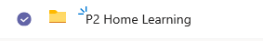

Click on this and you should find a sub -folder with your child’s name on it..

Here is where your child can save any of their work to share with the teacher or peers.

Have fun!

