'What do we want for our children and how will we work together to achieve this?’

Learning and Teaching

* Engaging and active lessons which are well planned
* Setting challenging goals and targets for pupils
* Shared expectations and standards.
* Learning intentions and co-constructed success criteria and contexts for learning are linked to the real world and are shared with pupils.
* Timely, accurate feedback is provided to ensure appropriate next steps in learning.
* Collaborative working allows learners’ thinking skills to develop.
* Self-evaluation allows pupils and staff to reflect on different learning styles.
* ICT is used effectively to enhance and support teaching and learning.

**Cairn Primary School**

* Our vision and aims drive us forward
* Our values underpin all that we do.

**Our Vision**

Believe to Achieve

At Cairn Primary we strive to create an inclusive, nurturing and stimulating environment where all of our children feel valued and inspired to achieve their full potential. We appreciate the contribution of all pupils, parents and staff to the Cairn Community. We promote a strong sense of belonging which creates a positive ethos within the school. Together as a team we are empowered to achieve our goals and aspirations.

**Our Values**

We actively promote respect, honesty, kindness, trust and inclusion within our school community.

[](https://www.google.co.uk/imgres?imgurl=https%3A%2F%2Fwww.gillibrand.lancs.sch.uk%2Fimages%2F800x800s%2Fnews%2Fvalues-1024x426.jpg&imgrefurl=https%3A%2F%2Fwww.gillibrand.lancs.sch.uk%2Fnews%2F2018-09-24-school-values&docid=UvErsLNdDGjHdM&tbnid=2hKcf-GlLuyIJM%3A&vet=10ahUKEwi_-92GhZbkAhUFxIUKHaeJA3EQMwipASgzMDM..i&w=800&h=333&bih=782&biw=1600&q=school%20values%20&ved=0ahUKEwi_-92GhZbkAhUFxIUKHaeJA3EQMwipASgzMDM&iact=mrc&uact=8)

**Our Aims**

Our aim at Cairn Primary is to achieve excellence and equity through raising attainment for all, and to recognise the range of skills, talents, hopes and enthusiasm of all our pupils thereby encouraging them to realise their full potential. We provide a wide range of planned experiences to enthuse and motivate our pupils for learning, while continuing to develop a set of positive values and attributes that will prepare our pupils for the future. We work in partnership with pupils, parents and the wider community to create a positive environment where all opinions, skills and talents are valued and recognised.

Our children are **responsible citizens**, who respect others and have knowledge and understanding of the world and Scotland’s place in it. They can make informed choices and decisions.

Our children are confident individuals, who have self-respect, secure values and beliefs, and ambition. They pursue an active and healthy lifestyle, make informed decisions and achieve success in different areas.

**The Curriculum**

The totality of all that is planned for children throughout their education

* Ethos and Life of the School- community involvement, nurturing approach, open door policy
* Curriculum subjects – 8 curricular areas
* Interdisciplinary Learning – core to learning
* Opportunities for Personal Achievement

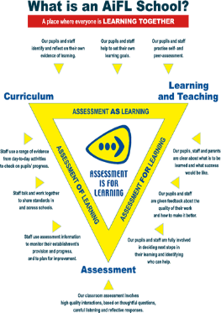

Our children are:

Responsible citizens

Successful learners,

Confident individuals

Effective contributors

**Principles for Curriculum Design**

**Principles for curriculum design:**

**• Challenge and enjoyment**

**• Breadth**

**• Progression**

**• Depth**

**• Personalisation and choice**

**• Coherence**

**• Relevance**

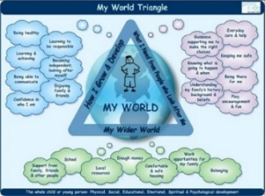[](http://www.google.co.uk/url?sa=i&rct=j&q=&esrc=s&source=images&cd=&ved=2ahUKEwi445rc86LkAhUpxIUKHSgGDAIQjRx6BAgBEAQ&url=http%3A%2F%2Falvaacademy.com%2Fgirfec%2F&psig=AOvVaw2d4Nz0JkVidOgSCRJrEQAj&ust=1566990246626789)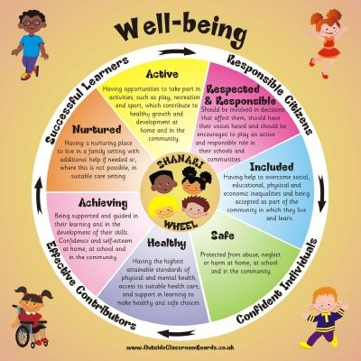[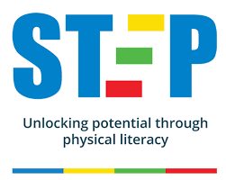](https://www.google.co.uk/imgres?imgurl=https%3A%2F%2Fengage-education.com%2Fwp-content%2Fuploads%2F2018%2F10%2FSTEP_Logo_and_Strapline-Medium.png&imgrefurl=https%3A%2F%2Fengage-education.com%2Fstep-physical-literacy%2F&docid=eOMz02FEOhMRZM&tbnid=bUhX6B8DuBucuM%3A&vet=10ahUKEwiJ-_7s8qLkAhWByIUKHYeCA5AQMwhqKBkwGQ..i&w=500&h=399&bih=782&biw=1600&q=Raising%20attainment%20for%20all&ved=0ahUKEwiJ-_7s8qLkAhWByIUKHYeCA5AQMwhqKBkwGQ&iact=mrc&uact=8)

Assessment

* Wider and personal achievements are tracked and reviewed to ensure that all learners have the chance to experience new opportunities.
* Staff ensure that pupils experience opportunities for challenge and application in unfamiliar contexts.
* Seemis tracking and monitoring is used to track CFE levels for all children based on a range of assessments and moderated teacher judgement. Developmental milestones are regularly tracked and assessed within the EYC.
* Formative and Summative assessments including GL and SNSA assessment data is analysed regularly to identify where additional support or challenge is required.
* We have tight systems in place to assess the impact of targeted interventions.
* A range of AifL strategies are used to enhance independence, personalisation and choice in learning.
* Holistic assessments are being created to ensure we assess in context.
* Moderation of planning, delivery and assessment is ongoing to ensure a consistent approach.

Entitlements

All children and young people are entitled to experience:

* A coherent curriculum from 3 to 18
* A broad general education, including well planned experiences and outcomes across all the curriculum areas. This should include understanding of the world and Scotland’s place in it and understanding of the environment.
* A senior phase which provides opportunities for the study of qualifications and other planned opportunities for developing the four capacities.
* Opportunities for developing skills for learning, skills for life **and skills** for work.
* Opportunities to achieve to the highest levels they can through appropriate personal support and challenge.
* Opportunities to move into positive and sustained destinations beyond school.

Personal Support

* Pupil voice, target setting and MTV strategies are effectively utilised to allow pupils to experience personalisation and choice.
* SMART targets ensure learning tasks are set appropriately to the individual needs of each child.
* Sharing targets and home learning tasks with parents allows for personal support at home.
* Staged Intervention paperwork is updated regularly in consultation with pupils, parents, staff and wider agencies.
* Regular TAC meetings are held each session for children who require additional support and allows all partners to effectively support learning.
* Interventions for literacy, numeracy and health and wellbeing are closely monitored to ensure impact on engagement, learning and attainment.
* Challenging learning experiences are planned for more able children to ensure their individual needs are met.
* Assemblies continue to celebrate personal achievements within and across the four capacities and look closely at wider achievements and community involvement.
* Nurturing approaches are well embedded throughout the whole school to support children who face a range of challenges.
* There is strong pastoral care across the school and pupils are provided with targeted programmes such as Give us a Break, Anger Anxiety Gremlin, Circle of Friends as well as access to our ’Hub.’
* We provide family engagement programmes and encourage parents to access courses provided by CLD within the school and community.