 Dyslexia Awareness Week 2018

Dyslexia Awareness Week is 5th-10th November 2018. The Dyslexia Friendly Schools (DFS) Committee will give a presentation at assembly and give each child a blue ribbon to show their support for dyslexia.

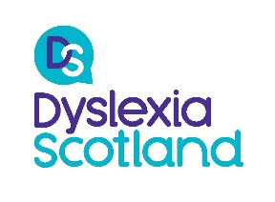Further Information can be found:

<https://www.dyslexiascotland.org.uk/dyslexia-awareness-week>

<https://blogs.glowscotland.org.uk/sa/cairnprimaryschool/pupils/dfs/>

<https://twitter.com/CairnPS>

[](https://www.dyslexiascotland.org.uk/)From the DfS Committee

 Dyslexia Awareness Week 2018

Dyslexia Awareness Week is 5th-10th November 2018. The Dyslexia Friendly Schools (DFS) Committee will give a presentation at assembly and give each child a blue ribbon to show their support for dyslexia.

Further Information can be found:

<https://www.dyslexiascotland.org.uk/dyslexia-awareness-week>

<https://blogs.glowscotland.org.uk/sa/cairnprimaryschool/pupils/dfs/>

<https://twitter.com/CairnPS>

[](https://www.dyslexiascotland.org.uk/)From the DfS Committee