


Braehead Primary School and Early Years Centre

SCHOOL IMPROVEMENT PLAN: 2025-2026


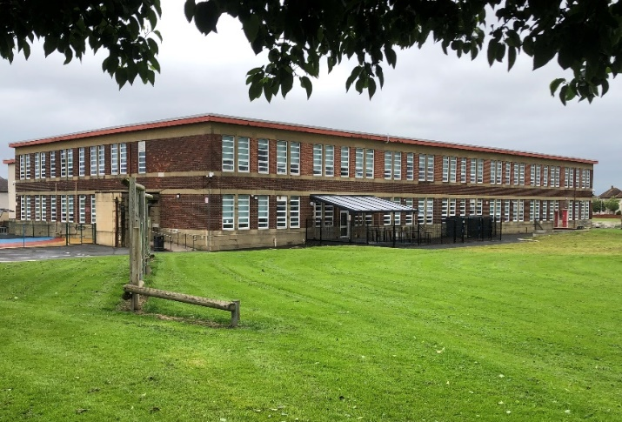

At Braehead Primary School and Early Years Centre we believe that our main strengths are our;

Inspirational Children
Whole School and Early Years Centre Staff Team
Parents/Carers and Children Committed to Change
Community Involvement and Partnerships

Vision

Our vision is to embed Braehead Primary and Early Years Centre as a key learning hub within the local community. Through working within the community and with all of our community partners we will develop positive, productive and creative relationships. These will provide opportunities for our children to embrace experiences which promote effective learning within an ever-evolving educational curriculum and help us find the right motivations to allow our children to confidently engage in their own learning, achieve meaningful success and shape the world around them.

Values
Our values are:

Commitment, Ambition, Resilience, Equity

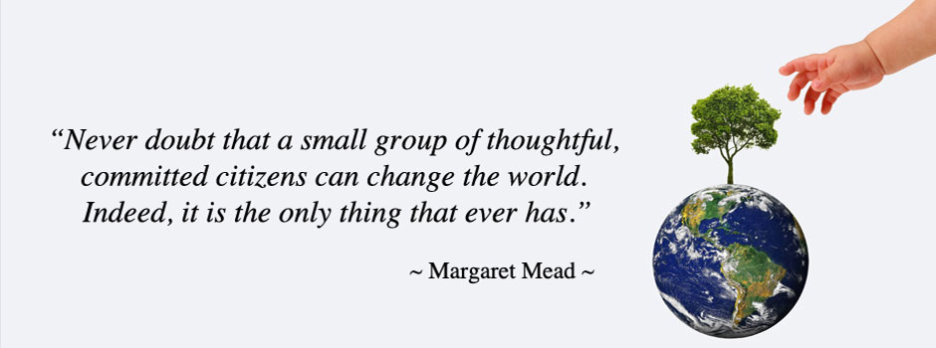

Aims
At Braehead Primary School and Early Years Centre we aim to be a positive, inclusive and continuously improving learning organisation. We aspire to achieve this in many ways, including utilising the local and national plans, and frameworks below;

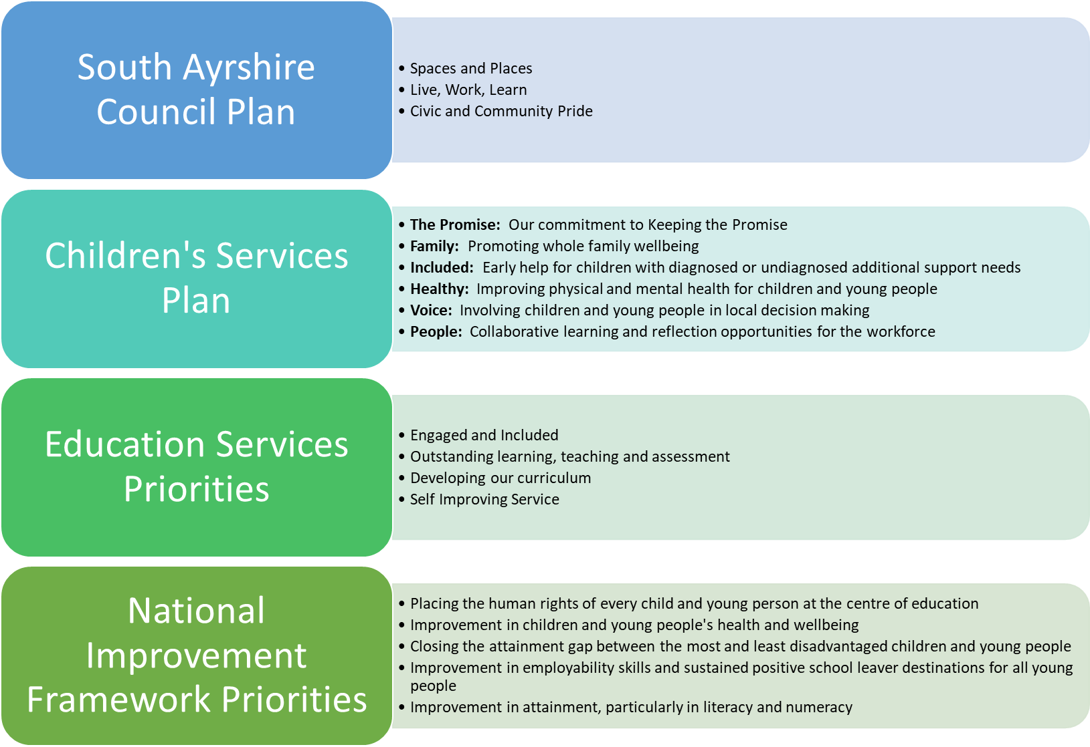

Summary Statement and Priorities

Using self-evaluation within team meetings the school continuously reviewed the 2024-2025 School Improvement Plan (SIP) throughout the year. We have included our evaluation of this performance data review within our Standards and Quality June 2025 Report which accompanies this document. In consultation we have identified the priorities for the forthcoming year as highlighted below within this SIP. The priorities and targets in this plan enable us to clearly set out the next steps on our journey, promoting a Curriculum for Excellence throughout and have been developed through the school audit process which has included:

• Consultations with staff and staff audits
• Parental Questionnaires
• Pupil Questionnaires and pupil impact/feedback activities
• Self-evaluation using HGIOS 4 and Care Inspectorate HGIOELC
• Tracking, monitoring and evaluation of learning and teaching

The priorities within the 2025-2026 School Improvement Plan were devised with staff throughout 2024-2025; will be discussed with the Pupil and Parent Councils in September 2025, before being shared with parents, also in September 2025. As we move beyond some of the impact of 2024-2025 on attendance and attainment hopefully with a focussed educational year ahead of us there will be a continued commitment to educational aspiration and improvement with the aim to reset, refresh and enrich wider social and educational opportunities through strong partnerships with our families and community. At all times the priority will be to continue to strive to provide equity and equality for all learners.

The SIP is a working document and is regularly reviewed and adapted to ensure it is meeting the needs of the pupils of Braehead Primary School and Early Years Centre.


Whole School and Early Years Centre Priorities and Educational Rationale

No | Priority name | Outcome
1 | Raising Attainment in Literacy | - Raise attainment in reading, writing and Early Years Literacy Development Milestones by 5% across all school stages through provision of consistent literacy programmes and approaches.  - Raise attainment in reading and writing by 5% across Primary 1, 2 and 3 through provision of consistent phonics programmes and approaches.  - Develop confident and skilled readers in Braehead Primary and Early Years Centre with a lifelong love of reading and the confidence to access all aspects of education, culture and society.  - Support all education staff in Braehead Primary and Early Years Centre to implement best practice through a culture of shared knowledge, collaboration and enquiry.  - Promote the implementation of an excellent reading and writing curriculum which prioritises best practice, challenge and adapted teaching for children with additional support needs.  - Gather, use and analyse data effectively to drive change and improvement in children’s literacy skills, literacy confidence and reading attainment.  - Targeted individuals and groups of children will achieve appropriate levels of attainment in literacy through relevant and focussed early intervention strategies.
2 | Wellbeing, Equality and Inclusion For All | - To improve breadth, progression, choice and personalisation of learning within Health and Well Being at Early, First and Second Level.  - Improve mental health and resilience in all of our children and young people, providing effective supports where necessary and relevant.  - To improve children’s confidence and increase the culture of positive thinking across the whole curriculum and school community.  - To develop digital technology as an effective learning and teaching approach for engaging children and parents in learning.  - To improve our approaches to differentiation/adaptive teaching in our classrooms ensuring we meet the needs of all learners.  - To enhance all teaching staff’s confidence of how to adapt planning, teaching and assessment to meet the needs of their learners.
3 | Early Years Centre Development | - Ensure the Early Years Centre is providing high quality learning interactions, experiences and environment for children to play and learn in.  - Children with additional support needs will experience developmentally appropriate learning and teaching to support their development.  - Children will make sustained improvement in their literacy learning.  - Children will experience at all times a consistent, nurturing approach from all staff.  - Staffing structure and remits developed further to support Early Years provision including new Depute Manager role, and further development of Principal Teacher role, Senior Early Years Practitioner role, Equity and Excellence role and Key Worker role.  - Outdoor learning area, resources and practice developed further to improve and enhance learners’ experiences in Literacy, Numeracy and Health and Well Being for all children.  - Processes and procedures for targeted and universal interventions implemented further to ensure these are tailored to meet the needs of the provision and reflect the individualised plans for all children, including commitment to data driven decision making to enhance children and family support.

PRIORITY 1: RAISING ATTAINMENT IN LITERACY
HGIOS 4/HGIOELC QI: 1.1 Self-Evaluation for self-improvement, 2.2 Curriculum, 2.3 Learning, teaching and assessment, 2.4 Personalised support, 3.1 Ensuring wellbeing, equality and inclusion, 3.2 Raising attainment and achievement
Education Services Priorities: 1. Engaged and Included, 2. Outstanding Learning, Teaching and Assessment, 3. Developing Our Curriculum
NIF Priorities: 3. Closing the attainment gap between the most and least disadvantaged children, 4. Improvement in employability skills and sustained positive school leaver destinations for all young people, 5. Improvement in attainment, particularly in literacy and numeracy
What Outcomes Do We Want To Achieve? | How Will We Achieve This?  (Intervention Strategies) | Lead Person | Start and Finish Dates | How Will We Measure Impact On Children and Young People?  (Include Where Possible Current Measure and Target)
Whole School and EYC Priorities:  To raise attainment in Reading and Writing in P1 – P7 by 5% by end of session 2025/26.  To support and develop staff confidence and capacity to implement best practice through a culture of shared knowledge, collaboration and enquiry.  To promote the implementation of an excellent reading curriculum which prioritises best practice, challenge and adapted teaching for children with additional support needs.  To gather, use and analyse data effectively to drive change and improvement in children’s reading skills, reading confidence and reading attainment.  To develop confident and skilled readers in South Ayrshire with a lifelong love of reading and the confidence to access all aspects of education, culture and society.  To raise attainment in writing by 5% across the school through provision of consistent writing criteria across all genre and stages.  To raise attainment by 5% in Primary 1, 2 and 3 ACEL literacy data through provision of an embedded play-based curriculum and further focussed development of the Read, Write, Inc phonics programme.  Targeted individuals and groups of children will achieve appropriate levels of attainment in literacy through relevant and  focussed early intervention strategies. | - School will review the role and purpose of the reading leader and in collaboration with the South Ayrshire Reads (SAR) team plan how this role will be used to support reading development over the coming year.  - Reading Leader will attend series of SAR led sessions to support further development of staff confidence and practice in reading through team teaching and mentoring.  - All practitioners will have the opportunity to take part in three bespoke South Ayrshire Reads (SAR) professional learning inputs throughout the year focussed on The Planning and Teaching of Whole Class Text.  - To build collective efficacy and promote an outward-looking approach to improvement, all staff will have the opportunity to develop their practice in collaboration with partner schools and the SAR team through collaborative activities. This will include external visits, modelled lessons, professional discussions and coaching sessions.  - Identify new or returning staff in need of catch-up sessions to work with the SAR Team to develop a clear plan, ensuring all staff are equipped with the knowledge and skills to support reading development effectively.  - All staff will have had the opportunity to engage in additional high-quality CLPL in an area of interest to support specific needs, and in collaboration with the SAR Team.  - All teaching staff will have the opportunity to engage with assessment implementation and data analysis to drive learning and teaching through professional dialogue discussions. Focus will be on interpretation, analysis and evaluation of their pupils’ literacy attainment.  - School community will have the opportunity to engage with and access support to implement and embed additional related SAR priorities. This will include parents and carers having opportunities to engage with workshops and learning sessions based on supporting their child’s reading development.  - Learning Intentions and Success Criteria to be fully embedded and evident within every lesson in every class. Increased pupil input and involvement in co-creating next steps and targets.  - All class teachers following an embedded general writing criteria template to assess writing.  - Writing criteria template to be completed by class teachers at key points across the school calendar, in order to moderate writing across all levels.  - Writing criteria template to be used to record and predict ACEL attainment across all stages.  - Relevant literacy interventions identified and provided for individual and small groups of children. Focus on Boost Groups and Pupil Support Teacher focussed class input.  - Phonics Leader will promote and support further development of staff confidence and practice in phonics development through team teaching and mentoring.  - To build collective efficacy and promote an outward-looking approach to improvement, staff team will have the opportunity to develop their practice in collaboration with partner schools through collaborative activities. This will include external visits, modelled lessons, professional discussions and coaching sessions.  - All teaching staff will have the opportunity to engage with assessment implementation and data analysis to drive learning and teaching through professional dialogue discussions. Focus will be on interpretation, analysis and evaluation of their pupils’ phonics and/or fluency attainment.  - Early Years Team and Primary 1 working collaboratively within literacy to share transitions, approaches, practices, resources and interventions. Link directly to South Ayrshire developments.  - Examine further implementation of South Ayrshire Reads approaches within Early Years.  - Quality Assurance calendar provided to set clear opportunities and dedicated time for senior management, peers and pupils to engage in learning and teaching rounds, sampling and observations.  - Staff teams within school will continue to develop a deeper awareness and understanding of The Promise and all that is included within the national guidance and local authority initiatives.  - Whole school team will support learners with experience of care to provide improved wellbeing and in turn work towards improved educational outcomes. | B McPherson  (Head Teacher)  K Cook  (Depute Head Teacher)  SAR Team  S Lynch  (South Ayrshire Reads Lead)  B McPherson (HT)  SAR Team  S Lynch (SAR Lead)  B McPherson(HT)  Whole Team  S Lynch (SAR Lead)  B McPherson (HT)  Literacy Work Group  B McPherson (HT)  SAR Team  S Lynch (SAR Lead)  B McPherson (HT)  SAR Team  B McPherson (HT)  K Cook (DHT)  O Kettlewell  (Principal Teacher)  S Lynch (SAR Lead)  S Lynch (SAR Lead)  B McPherson(HT)  SAR Team  Senior Management Team (SMT)  All Class Teachers  S Lynch (SAR Lead)  SMT  S Lynch (SAR Lead)  SMT  All Class Teachers  SMT  All Class Teachers  K Cook (DHT)  M Hamilton  (Pupil Support Teacher)  A Clayton  (Read, Write, Inc Lead)  B McPherson (HT)  A Clayton (RWI Lead)  B McPherson (HT)  Literacy Work Group  B McPherson (HT)  K Cook (DHT)  O Kettlewell (PT)  A Clayton (RWI Lead)  F Keating  (Depute Manager Early Years Centre)  S Brown  (Senior Early Years Practitioner)  J Kirkwood  (P1 Class Teacher)  S Lynch (SAR Lead)  A Clayton (RWI Lead)  F Keating (DM EYC)  S Brown (SEYP)  E Nisbett  (Equity and Excellence Lead)  N Ferguson (EYC PT)  B McPherson (HT)  F Keating (DM EYC)  B McPherson (HT)  Whole School Team  Whole School Team | June 2025  September 2025 to  May 2026  September 2025 to  March 2026  September 2025 to  June 2026  September 2025  June 2026  September 2025 to  May 2026  September 2025 to  May 2026  December 2025  Ongoing until June 2026  Ongoing until June 2026  September 2025 to  May 2026  September 2025 to  May 2026  September 2025 to  June 2026  September 2025 to  May 2026  Ongoing 25/26  September 2025 to  May 2026  August 2025  Ongoing 25/26  Ongoing 25/26 | Impact will be measured through a termly and year beginning - year end comparative class, school and national assessment processes including;  Phonics Screener (P2 and P3)  Oral Reading Fluency (P4 – P7)  Read, Write, Inc (P1 and P2)  NSA at P1, P4, P7  GL at P3, P5, P6 (to be confirmed)  STAR Assessment  Schonell Spelling/Reading  Early Years Developmental Milestones  Curriculum for Excellence predictions and attainment.  Literacy Comprehension tasks, pupil jotter work, school self-evaluation tasks through school, cluster and authority wide assessment and moderation meetings, pupil focus groups.  From 2024-2025 (NSA Data)  68% of children at P1 currently reaching age appropriate levels in National Standardised Literacy Assessment (27% at Band 4, 23% at Band 5 and 18% at Band 6 and above). 32% are below (18% at Band 3, 14% at Band 2 and 0% at Band 1 or below).  63% of children at P4 currently reaching age appropriate levels in Scottish National Standardised Reading Assessments 21% at Band 7, 21% at Band 8 and 21% at Band 9 and above).  37% are below 29% at Band 6, 0% at Band 5 and 8% at Band 4 or below).  46% of children at P4 currently reaching age appropriate levels in National Standardised Writing Assessments (12% at Band 7, 17% at Band 8 and 17% at Band 9 or above). 54% are below (25% at Band 6, 17% at Band 5 and 12% at Band 4 or below).  38% of children at P7 currently reaching age appropriate levels in National Standardised Reading Assessments (13% at Band 9, 19% at Band 10 and 6% at Band 11 and above). 62% are below (31% at Band 8, 13% at Band 7 and 18% at Band 6 or below).  44% of children at P7 currently reaching age appropriate levels in National Standardised Writing Assessments (19% at Band 9, 19% at Band 10 and 6% at Band 11 or above). 56% are below (31% at Band 8, 19% at Band 5 and 6% at Band 4 or below).  From 2024-2025 (CfE secure level attainment in Literacy and English)  33% of children in Early Years reaching all of their Literacy Developmental Milestones in session 2024-2025 with 78% reaching 8 or more by June 2025.  P1 Reading 57%  Listening and Talking 62%  Writing 57%  P2 Reading 72%  Listening and Talking 78%  Writing 67%  P3 Reading 53%  Listening and Talking 64%  Writing 54%  P4 Reading 79%  Listening and Talking 75%  Writing 62%  P5 Reading 52%  Listening and Talking 61%  Writing 39%  P6 Reading 59%  Listening and Talking 87%  Writing 45%  P7 Reading 50%  Listening and Talking 75%  Writing 50%  From 2024-2025 (GL English Assessment)  32% of Primary 3 pupils on target  55% of Primary 6 pupils on target  Targets for June 2026  Early Years Literacy 60-70%  P1 Reading 70%  Listening and Talking 70%  Writing 70%  P2 Reading 65%  Listening and Talking 70%  Writing 65%  P3 Reading 75%  Listening and Talking 80%  Writing 70%  P4 Reading 60%  Listening and Talking 70%  Writing 60%  P5 Reading 85%  Listening and Talking 80%  Writing 70%  P6 Reading 60%  Listening and Talking 70%  Writing 50%  P7 Reading 60%  Listening and Talking 80%  Writing 55%

PRIORITY 2: WELLBEING, EQUALITY AND INCLUSION FOR ALL
HGIOS 4/HGIOELC QI: 2.1 Safeguarding and child protection, 2.4 Personalised support, 2.5 Family learning, 3.1 Ensuring wellbeing, equality and inclusion Wellbeing, 3.2 Raising attainment and achievement.
Education Services Priorities: 1. Engaged and Included.
NIF Priorities: 1. Placing the human rights of every child and young person at the centre of educationt, 2. Improvement in children and young people's health and wellbeing, 3. Closing the attainment gap between the most and least disadvantaged children and young people, 5. Improvement in attainment, particularly in literacy and numeracy.
What Outcomes Do We Want To Achieve? | How Will We Achieve This?  (Intervention Strategies) | Lead Person | Start and Finish Dates | How Will We Measure Impact On Children and Young People?  (Include Where Possible Current Measure and Target)
Whole School and EYC Priorities:  To improve breadth, progression, choice and personalisation of learning within Health and Well Being at Early, First and Second Level.  Improve mental health and resilience in all of our children and young people, providing supports where necessary.  To improve children’s confidence and increase the culture of thinking across the whole curriculum.  To develop digital technology as an effective learning and teaching approach for engaging children and parents in learning. | - Through review, adaptation and provision of a wide range of health and wellbeing opportunities within and outside school in order to increase opportunities for learners to engage in all aspects of Health and Wellbeing consistently and independently.  - Through making use of current personal/wider achievement class overview to identify pupils who have limited opportunities available to them. These pupils will be targeted for activities and clubs in school and within the community.  - Through working in partnership with cluster schools, Active Schools and other bodies to increase provision and access to opportunities for all and specifically to target individuals and year groups for age appropriate health and wellbeing development.  - Through actively seeking out and sharing good practice within and beyond the school such as re-establishing Bikeability and promoting Primary 5 swimming.  - Through further development of quality feedback and pupil voice processes which allow children to have an accurate understanding of their progress and what they need to do to improve. Provide processes which enable children to articulate their views for personal and social improvement such as assemblies, pupil council, JRSOs, learning walks.  - Implement identified support strategies for individual children and families in liaison with partner agencies both inside and outside of school.  - Continued focus on relevant training such as Child Protection, The Promise, Zones of Regulation, Nurture and Visual/Hearing Impairment for whole staff team.  - Use of individual and group programmes to support school context such as Nurture Fidelity, Bounce Back, Zones of Regulation Rapid Literacy and Numeracy resources. Continued review and adaptation of health and wellbeing approaches across all classes to provide the most effective learning and teaching approaches across the school.  - Full implementation and tracking of school behaviour management policy and Anti-Bullying policy in line with SAC management guidelines.  - Implementation of more robust tracking of daily attendance across the school and development of attendance support role.  - Through provision of team training opportunities and support on emerging policy, strategies and pedagogy (Staged Intervention, ACEs/Trauma, Boxall, Ecological Assessments) to ensure equitable approaches and early interventions are being provided to meet wellbeing, inclusion and equality for all.  - Through monitoring and addressing the level of progress being made by targeted groups (children living in SMID 1-2, in receipt of Free School Meals (FME), care experienced, children with additional support needs.  - Through embedding digital technology resources into the whole school and early years stages, using I-Pad, Coding and Seesaw developments to increase engagement of pupils and parents in recording and developing their own learning experiences.  - Lead role identified in school to take forward the implementation of Communication Friendly School strategies and approaches across the whole school.  - Through using Education Scotland’s ICT and Technology benchmarks to support teacher and pupil assessment judgements and decisions about next steps in learning.  - Through CLPL training opportunities in-house and outside school for all staff in emerging developments such as the creation and development of the school Blog, TEAMs and Seesaw. | O Kettlewell (PT)  N Cannon  (Nurture Teacher)  O Kettlewell (PT)  O Kettlewell (PT)  B McPherson (HT)  K Cook (DHT)  O Kettlewell (PT)  B McPherson (HT)  O Kettlewell (PT)  B McPherson (HT)  K Cook (DHT)  K Cook (DHT)  B McPherson (HT)  B McPherson (HT)  K Cook (DHT)  N Cannon (NT)  M Hamilton (PST)  J Osborne  (Staged Intervention Principal Teacher)  B McPherson (HT)  O Kettlewell (PT)  B McPherson(HT)  C Lennon  (PEF Attendance)  K Cook (DHT)  J Osborne  (STINT PT)  B McPherson (HT)  SMT  Whole School Team  O Kettlewell (PT)  J Osborne  (Seesaw Lead)  All teachers  K Cook (DHT)  M Hamilton (PST)  All teachers  O Kettlewell (PT)  J Osborne  (Seesaw Lead) | August 2025  to  June 2026  August 2025  to  June 2026  August 2025  to  June 2026  August 2025  to  June 2026  August 2025  to  June 2026  August 2025  to  June 2026  September 2025  (ongoing)  August 2025  (ongoing)  August 2025  to  June 2026  August 2025  to  June 2026  August 2025  to  June 2026  August 2025  to  June 2026  August 2025  to  June 2026  August 2025  to  June 2026  August 2025  to  June 2026  August 2025  to  June 2026 | Impact will be measured through year beginning-year end comparative class, school and national assessment processes (Glasgow Motivational Wellbeing Profiles (GMWP), SHANARRI Wheel, Annual Pupil/Parent Survey and impact on CfE Levels in Literacy and Numeracy). Examination of ongoing class and school assessment, both focussed and holistic will also be used. SAC PE Framework, benchmarks, Early Years Developmental Milestones, school self-evaluation tasks, pupil/parent impact dialogue and professional dialogue meetings will also be used.  100% of pupils to have access to or be engaged in at least one wider achievement activity either within school or within the community.  70% of children in Early Years reaching all of their developmental milestones.  100% of pupils to have access to or be engaged in at least one wider achievement activity either within school or within the community.  - SAC Ecological Assessment  - Emotional Literacy checklist  - SD questionnaire  - Boxall profiling  - Pupil evaluations  - Staff evaluations  - 100% of children will improve in each of their GMWP, SHANARRI indicators from year beginning to year end.  Target is to achieve 5% aggregate increase in pupil perception of overall wellbeing via GMWP survey and annual Parent Survey.  Logged bullying Incidents and weekly behaviour tracking spreadsheet.  Baseline attendance figure from 2024-2025 of 89%. Target to achieve 90% by year end 2025-2026.  Monthly SAC attendance reports.  100% of pupils within whole school and early years centre to have weekly access to I-Pad and digital technology to build personal profile of learning experiences.

PRIORITY 3: EARLY YEARS CENTRE DEVELOPMENT
HGIOS 4/HGIOELC QI: 2.2 Curriculum, 2.3 Learning teaching and assessment, 2.4 Personalised support, 3.1 Ensuring wellbeing, equality and inclusion, 3.2 Raising attainment and achievement
Education Services Priorities: 1. Engaged and Included, 2.Outstanding Learning, Teaching and Assessment, 3. Developing Our Curriculum, 4. Self Improving Service
NIF Priorities: 1. Placing the human rights of every child and young person at the centre of education, 2. Improvement in children and young people's health and wellbeing, 3. Closing the attainment gap between the most and least disadvantaged children, 5. Improvement in attainment, particularly in literacy and numeracy
What Outcomes Do We Want To Achieve? | How Will We Achieve This?  (Intervention Strategies) | Lead Person | Start and Finish Dates | How Will We Measure Impact On Children and Young People?  (Include Where Possible Current Measure and Target)
Early Years Centre Priority A  High quality learning interactions, experiences and environment for children to play and learn in.  Children with additional support needs will experience developmentally appropriate learning and teaching to support their development.  Early Years Centre Priority B  Children will make sustained improvement in their literacy learning.  Early Years Centre Priority C  Children will experience at all times a consistent, nurturing approach from all staff. | Improvement in the Quality of Learning and Teaching.  - Continue to embed effective planning processes with all staff members involvement. Further develop learning, teaching, assessment and tracking policies and procedures.  - Long term planning to be fully implemented to ensure breadth of curricular experiences for children.  - Introduction of responsive planning across the centre to ensure children’s choice and voice are used to inform provision.  - Monitoring of children’s learning experiences and commitment to professional learning walks.  - Termly progress meetings with key workers to monitor children’s achievements.  - Nurture environment audit, literacy environment audit and maths and numeracy environment audit to be carried out to ensure high quality learning environments. Numeracy focus on development of embedding meaningful subitising for children.  - Staff CLPL focused on upskilling in delivering key skills. Identify one staff member to attend ‘Nuturing Mathematical Thinkers training course’.  - Develop use of community spaces to support learning in the wider world.  - Continued implementation of early heuristic play.  - ASN tracking to be fully implemented.  - ASN planning approaches to adapt teaching approaches. Continue to develop planning approaches to focus on differentiation and use ASN milestones template to track and support progress.  - Monitoring of children’s experiences and needs. STINT plans to be fully developed and implemented when required.  Improvement in Attainment – Literacy  - Principal Teacher to lead on embedding phonological awareness across the centre including small group times.  - CLPL to staff regularly linked to planning cycle to build staff confidence in early literacy skills.  - Literacy audit focusing on interactions.  - Focused stay and play sessions around target milestones to support parents to develop skills at home.  - Home learning materials for children around literacy developmental milestones.  - Increase use of songs / stories and rhymes in daily practice with children.  - Continue to plan and implement focused phonological awareness experiences at group times.  - Early Years Team to work towards successful implementation of the Communication Friendly Environment Award. Focus and attention on groups with speech and language therapy.  Improvement in Attainment – Health and Wellbeing  - Improvement focus on Nurture as a Whole School approach (Principle 5 – all behaviour is communication). Focussed CLPL for whole staff team to support.  - Use of Boxall assessments to understand children’s needs and plan effective supports. Review of STINT processes and how these are used to effectively provide support for children.  - Positive relationship policy to be further developed and implemented to ensure consistency. Continued implementation of positive behaviour strategies (Warm and Fuzzies).  - Self-evaluation and reflection on practice to identify next steps and actions. | F Keating (DM EYC)  N Ferguson  (EYC PT)  T Marshall  (Literacy Lead)  M Bryce  (Numeracy Lead)  E Nisbett (EEL)  H McBain  (Additional Support Needs Lead)  F Keating (EYC DM)  S Brown (SEYP)  N Ferguson  (EYC PT)  E Nisbett  (EEL)  N Ferguson  (EYC PT)  F Keating (EYC DM)  T Marshall  (Literacy Lead)  V Aivaliotou,  (Communication Friendly Lead)  Whole Team | August 2025 to  June 2026  August 2025  to  June 2026  August 2025 to  June 2026  Commenced May 2025  to  June 2026 | Literacy / Maths & Numeracy audits will record areas of improvement, actions taken and progress made.  Staff survey of confidence in providing learning experiences for children across the curriculum.  Evidence of use of community spaces to support planning cycles.  Long term planner will evidence coverage across the curriculum.  80% of pre-school children will have high levels of involvement in play and learning (current measure 43%).  60% of all pre-school children will achieve all of their developmental milestones (current measure 28%).  80% of pre-school children will achieve developmental milestone “I can recognise ‘how many’ without having to count” (current measure 55%).  Children with ASN will make progress in their learning and development (individual learning trackers, ASN milestones, GL assessments).  All children with ASN will show improvement in their involvement in learning (Leuven scale assessment – baseline for 4 children)  Impact will also be measured through termly recording and analysis of Early Years Developmental Milestones, early years self-evaluation tasks, pupil/parent impact dialogue and professional dialogue meetings.  Impact on children’s experiences of learning will be highly visible through photographic evidence, profiling, mark making and pupil engagement within the school and Early Years Centre.  80% of pre-school children will achieve developmental milestone “I can identify words that start with the same sound” (current measure 39%).  95% of pre-school children will achieve developmental milestone “I can identify rhyming words” (current measure 83%).  85% of pre-school children will achieve developmental milestone “I can recognise letter symbols” (current measure 72%).  90% of pre-school children will achieve 8 – 10 literacy developmental milestones (current measure 78%).  Increased parental confidence in supporting children’s learning.  Achievement of level 1 CFA by December 2025 and level 2 by April 2026.  Increased staff confidence in providing high quality literacy experiences.  Targeted input for target children as identified by Leuven Scale assessment.  80% of pre-school children will have positive wellbeing (Leven scale assessment, base line May 2025 – 50%).  Complete Leuven scale assessment for Ante-Pre children in Sept 2025 then termly review.  Data from Boxall assessments will evidence children’s progress in their wellbeing (no base line).  80% of pre-school children will achieve developmental milestone “I can talk about my learning” (current measure 56%).  Staff feedback in confidence from nurture training (base line April 2025).

Maintenance Agenda 2025-2026

In addition to the identified priorities, Braehead Primary School and Early Years Centre will continue to commit to the following maintenance agenda throughout our whole provision within school and within the early years;

LEARNING AND TEACHING
- Continue to develop SAC curricular frameworks and national benchmarks to enhance planning, assessment, learning and teaching.
- Continue to provide digital technology systems as communication platforms including GLOW, Teams, Blog and the re-introduction of Seesaw.
- Continue to provide support and challenge for pupils using ASN, Nurture and Pupil Support strategies and resources.
- Continued implementation of Children and Young People's Act, GIRFEC, SHANARRI, Rights of the Child, UNCRC and Team with the Family commitments.
CFE/RAISING ATTAINMENT
- Continue to develop ‘The Write Stuff’ programme to maintain progress within appropriate Early Years – Primary 7 stages.
- Continue to develop Read, Write Inc phonics programme further and maintain progress within Early Years – Primary 3 stages.
- Continue to use class, school and national assessments to inform pupil progress and decisions about next steps in learning.
- Continue to use Education Scotland’s Literacy and English benchmarks to support teacher and pupil assessment judgements and to analyse individual pupil progress, attainment and achievement. Developmental Milestones to be used within Early Years Centre.
- Continue to use SEEMIS progress and achievement model to report pupil progress to parents and carers.
- Continue to develop effective Numeracy and Maths programmes supported by the Numeracy Lead teacher role and a minimum of 6 hours maths weekly.
- Continue to implement and monitor Reading Wise, Rapid Maths and Catch Up Literacy/Numeracy as effective pupil support programmes.
- Continue to provide 2 hours quality PE weekly.
- Continued development of Rights Respecting Schools Award accreditation towards Silver Level.
- Continued development of Dyslexia Friendly School accreditation.
ASSESSMENT AND ACHIEVEMENT
- Monitoring, evaluation and tracking of pupil levels through ACEL, NSA, GL, GMWP and continuous, comparative classroom assessment.
- Weekly pupil and termly parent/carer assemblies to highlight wider achievement and school values.
- Continue to develop and implement meaningful Pupil Profile and learning journey reporting through emerging communications platform.
SELF-EVALUATION
- Continue to offer programme of support via PRD and PDR processes for all staff team.
- Continue to provide regular staff team meetings and class observations to monitor, track and evaluate school improvement progress.
- Continue to engage in professional, pupil impact and parental dialogue.
- Provision of protected professional dialogue and development time planned into team meeting diary to allow all teaching and early years team to take an active part in planning, implementing and evaluating change and improvement processes across the curriculum.
CLUSTER
- Continue to assess and moderate collegiately across the curriculum to ensure consistency across school/cluster/authority.
- Continue to plan and develop initiatives collegiately which support educational and personal development for all pupils.
- Continue to commit to programmes of transition, nurture and collective participation to support pupil well-being and personal growth.
PASTORAL
- Continue to develop an awareness and deeper understanding of The Promise and all that is included within the national guidance and local authority initiatives, enhanced by completing The Promise Education Award in June 2025.
- Continue to support recruitment of strong and effective Parent and Pupil Councils to promote positive parental and pupil voice and engagement.
- Continue to develop strong, collaborative community relationships through family and community engagement initiatives and partnerships.

Evaluation of School Priorities  (For 2025-2026) | How well are you doing?  What’s working well for your learners? | How do you know?  What evidence do you have of positive impact on learners? | What are you going to do now?  What are your improvement priorities in this area? | How would you evaluate this using HGIOS?4 six-point scale?
Priority 1
Raising Attainment in
Literacy

Evaluation of School Priorities  (For 2025-2026) | How well are you doing?  What’s working well for your learners? | How do you know?  What evidence do you have of positive impact on learners? | What are you going to do now?  What are your improvement priorities in this area? | How would you evaluate this using HGIOS?4 six-point scale?
Priority 2
Wellbeing, Equality
and Inclusion For All

Evaluation of School Priorities  (For 2025-2026) | How well are you doing?  What’s working well for your learners? | How do you know?  What evidence do you have of positive impact on learners? | What are you going to do now?  What are your improvement priorities in this area? | How would you evaluate this using HGIOS?4 six-point scale?
Priority 3
Early Years Centre
Development A, B and C

Pupil Equity Fund budget for 2025-2026

Priority | Staffing costs | Resources/ other | Total
Priority 1 | Class Teacher  (Literacy Development)  (1.0 FTE – 35 hours) |  | £69 248
Priorities 1 and 2 | School Assistants  (2.1 FTE – 59 hours) |  | £46 692
Priorities 1 and 2 | Attendance Support  (7.5 hours) |  | £5 979
Priority 2 |  | Dolphin House Funding, Nurture and ASN Resources | £3 031
 |  |  | £124 950

***Pupil Equity Funding remained static at £124 950 with staffing costs increasing***

