|  |
| --- |
| **EYC and Class Blogs** |
| **Early Years Centre**    We have been exploring Autumn by observing the changes in our local environment and even went on an Autumn scavenger hunt around the village. We have been focussing a lot on the beautiful colours we see at this time of year, throughout the EYC. We also had lots of fun celebrating Halloween.    Mrs Chesterman, Miss Millarvie  **P1-3**  **Halloween**  Halloween was a really important time for us in the class, so Miss Burton made sure to give us lots of Halloween themed activities. We had great fun with our Halloween maths games, writing spooky stories, making Halloween decorations, creating magic wands and artwork, and then having a ball at our Halloween party. Don’t we just look fantastic in our costumes?  C:\Users\sa11burtone\AppData\Local\Microsoft\Windows\INetCache\Content.Word\IMG_3506.JPGC:\Users\sa11burtone\AppData\Local\Microsoft\Windows\INetCache\Content.Word\IMG_4023.JPG  C:\Users\sa11burtone\AppData\Local\Microsoft\Windows\INetCache\Content.Word\IMG_3991.JPG    C:\Users\sa11burtone\AppData\Local\Microsoft\Windows\INetCache\Content.Word\IMG_4024.JPG  C:\Users\sa11burtone\AppData\Local\Microsoft\Windows\INetCache\Content.Word\IMG_3995.JPG  C:\Users\sa11burtone\AppData\Local\Microsoft\Windows\INetCache\Content.Word\IMG_4026.JPG  **IDL – Biodiversity**  During our biodiversity topic we did lots of exploring in our garden area. We identified different bugs that live on the school grounds and the different signs of Autumn. We have decided to put ourselves forward for the ECO Committee at school and as part of that we carried out an Environmental Review of the school. We found lots of good practice and then identified areas for us to develop. We are now going to work on creating an action plan and putting it into place. We told Miss Burton that we wanted to move our topic onto learning about different animals and gave her lots of questions that we wanted to find out about. We are going to find out the answer to questions like: Can wolves eat berries? What do reindeers eat? What is the difference between a turtle and a tortoise?  **Numeracy and Mathematics**  We have been focusing on addition in maths. Each group has a different focus within addition, whether it is to 10, 20, 100 or above and we have been taking part in activities based on this learning. We love Hit the Button and are all getting much faster at solving problems. We have also been learning different strategies we can use to help us solve addition, this could be through putting the big number in our head and adding on, using our Rekenrek or making friendly numbers. We are about to move onto larger numbers and subtraction  **Literacy and English**  In writing last term we learned more about sentences and how to write short paragraphs using the Slow Writing process. Here we would write sentences based on different criteria and using a picture as inspiration. It linked well with our sentence mentor task and is making us better at writing sentences. This term we have moved onto looking at non-fiction. We are exploring the difference between fiction and non-fiction books and how we can use non-fiction books to help us find out more information about topics.  **Play Based**  C:\Users\sa11burtone\AppData\Local\Microsoft\Windows\INetCache\Content.Word\IMG_3500.JPGThis term we have been lucky as our new resources have begun arriving for our play-based area. We love the new home area equipment, like our Doctor’s kit, babies, highchair and cleaning centre. We are learning to take turns with these resources as we all want to have a go! There has been lots of building taking place this term and one of our favourite things to build with is the magnetic shapes. We love working together to make huge rockets or making our own robots with secret compartments. Our farm arrived with our families, animals, and transport. We have great fun making up stories of what is happening on the farm. We are still deciding on the best name for the farm but now we are going with Barr Primary Farm. Our people who help us figures gave us a challenge to make somewhere for them to work. We worked together as a team to build them somewhere to work which even had a garage to park all their vehicles. Still one of our favourite things to do during play-based time is to draw. At Halloween we made decorations for the classroom and Miss Burton has collected an Art Gallery’s worth of pictures we have made for her; it always makes her smile.  C:\Users\sa11burtone\AppData\Local\Microsoft\Windows\INetCache\Content.Word\IMG_3510.JPGC:\Users\sa11burtone\AppData\Local\Microsoft\Windows\INetCache\Content.Word\IMG_3515.JPG  C:\Users\sa11burtone\AppData\Local\Microsoft\Windows\INetCache\Content.Word\IMG_4081.JPG  C:\Users\sa11burtone\AppData\Local\Microsoft\Windows\INetCache\Content.Word\IMG_4080.JPG  C:\Users\sa11burtone\AppData\Local\Microsoft\Windows\INetCache\Content.Word\IMG_3505.JPG  C:\Users\sa11burtone\AppData\Local\Microsoft\Windows\INetCache\Content.Word\IMG_4140.JPG  C:\Users\sa11burtone\AppData\Local\Microsoft\Windows\INetCache\Content.Word\IMG_4144.JPG  C:\Users\sa11burtone\AppData\Local\Microsoft\Windows\INetCache\Content.Word\IMG_4141.JPG  C:\Users\sa11burtone\AppData\Local\Microsoft\Windows\INetCache\Content.Word\IMG_4143.JPG  C:\Users\sa11burtone\AppData\Local\Microsoft\Windows\INetCache\Content.Word\IMG_4138.JPG  C:\Users\sa11burtone\AppData\Local\Microsoft\Windows\INetCache\Content.Word\IMG_4142.JPG  C:\Users\sa11burtone\AppData\Local\Microsoft\Windows\INetCache\Content.Word\IMG_4139.JPG  **Daily Fitness**  With us now being able to have fitness indoors we have been really enjoying our Go Noodle time again. We love to have our daily fitness and have missed our Go Noodle routines. It didn’t take us long to get back into the swing of things.  Miss Burton  P4-7  **Outdoor Learning**  At pupil request, we have timetabled that on a Thursday afternoon each week we will embrace the outdoor classroom and get outside for our learning. On November 5th we ventured up the Barr trails a stroll and participated in a scavenger hunt – all of our instructions were in French, in order for us to revise our colours and positional language. The pupils thoroughly enjoyed their stomp with Reilly informing me he had clocked up 15000 steps!  Image  Image  See the source image**Energy & the Environment**  We participated in a poster design competition in term 1 for the Energy Agency lockdown calendar. I am delighted to inform you that we had two successful class winners - Reilly Blanchard P5 and Rosie Denham P7. These pupils will have their poster featured in the 2021 calendar and are both invited to attend an online awards ceremony in December with the Provost for South Ayrshire.  Our Inter-Disciplinary Learning for Term 2 is ‘Energy & the Environment’. We have begun with a focus on ‘climate change’ and are linking this to the UNICEF campaign ‘Outright’. We have started a new class novel called ‘Wilderness Wars’ by Scottish author and teacher Barbara Henderson. We are exploring renewable & non-renewable energy sources and electricity in Science.  **Halloween – What a SCREAM!**  ImageA real highlight of term 2 so far has to be our Halloween party! We did not let COVID-19 dampen our spooky spirits. Mrs McBirnie set a daily ‘Halloween’ maths or literacy challenge every day with a prize up for grabs. We learnt Halloween vocabulary in French and even created spooky mansions in art. On Friday, we had a class ‘pumpkin drive’ which got a particularly enthusiastic response and finished the day with our other party activities.  Image | |

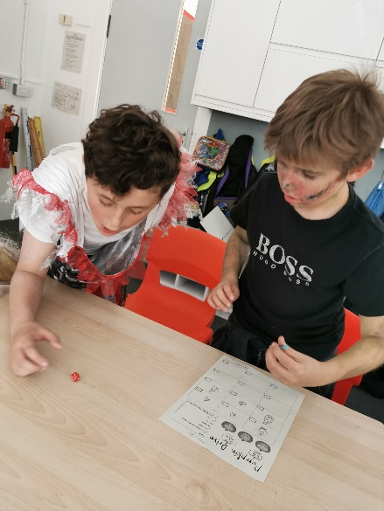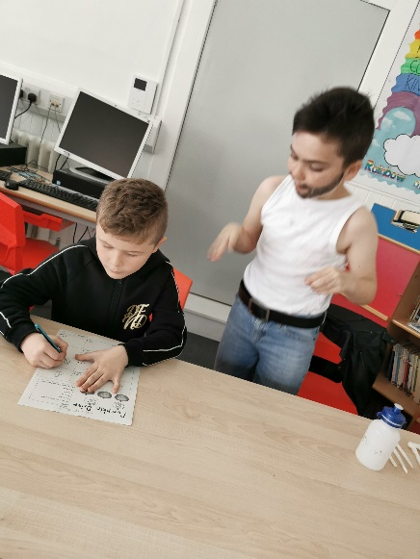

**School highlights so far - P4-7**

* I loved our class novel ‘Charlie changes into a chicken’ especially the writing task when we could choose our own animal that Charlie changed into.
* Dixie is my highlight – he is my friend, he helps us and he is really funny.
* I like maths because it helps me when I’m working on the farm. Decimals and division are my favourite.
* I like sharing my playtime with the little ones. It’s nice to see them and it is fun!
* I really enjoy ‘Beat That’ in maths because there are lots of different sums and you need to work fast.
* I love lunchtime because the whole class eats and plays together now.
* I love outdoor learning because it’s great getting out in the fresh air and being around nature even if we are doing work at the same time.
* I like writing because you get to be really imaginative. I have lots of story ideas and find it really relaxing.
* I like art because you can be creative and just let your imagination free. My favourite pieces so far have been my poppies poster, ‘The Scream’ and the exploding heads.
* I enjoy P.E as I like being active in body and mind.
* I like reading as when you have a good book you just can’t put it down.
* I enjoy learning my times tables and I’m getting really good at them.
* Most of all, I like Mrs McBirnie because she is so funny and kind *(no pupil was paid for this comment!).*
* I really like ALL of my classmates and I love our school as well.

Mrs McBirnie