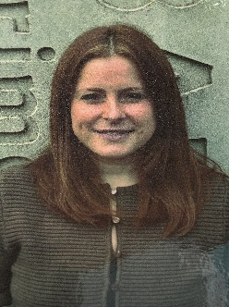

Eilidh McBean
Head Teacher
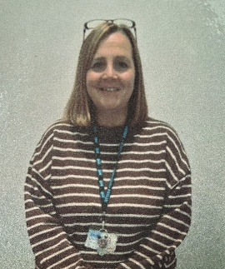


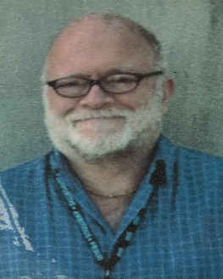

Paul Marsh Chelsea McIlwraith Lynne Ferguson Gillian Young
Clerical Assistant Principal Teacher/ P1-7 Class Teacher Pupil Support
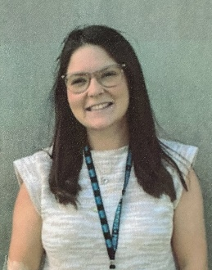
P1-7 Class Teacher Assistant



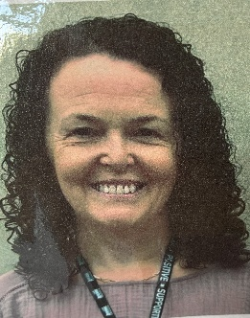

Amy Clark Elizabeth McKie Kevin Reid Maureen McClymont
Early Years Early Years Janitor Catering Assistant
Practitioner Practitioner

