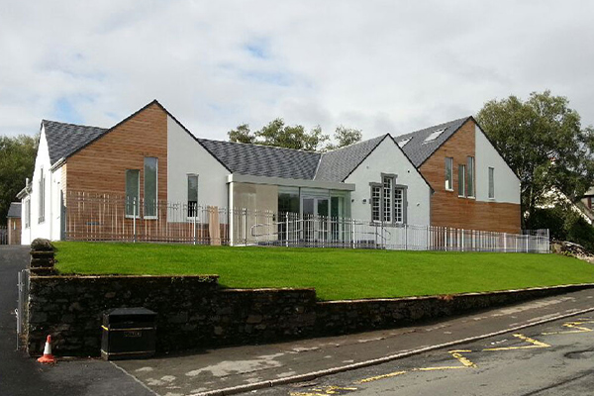

|  |
| --- |
| **Barrhill Primary School and Early Years Centre**  **Standards and Quality Report**  **June 2025** |

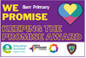

**Contents**

VISION 3

VALUES 3

AIMS 3

CONTEXT OF THE SCHOOL/EARLY YEARS CENTRE 4

WHAT KEY OUTCOMES HAS THE SCHOOL ACHIEVED? 5

SUMMARY OF PROGRESS 7

EVALUATIVE SUMMARY 16

WHAT ARE THE KEY PRIORITIES FOR IMPROVEMENT IN 2025-2026? 19

WHAT IS THE CAPACITY FOR IMPROVEMENT? 20

|  |
| --- |
|  |

**Barrhill Primary School and Early Years Centre**

**Standards and Quality Report**

**2024-2025**

The purpose of this report is to provide an answer to the question – ‘How good was our school in 2024-2025?’ The following pages will tell you about the quality of education in the school and Early Years Centre (EYC) and how the children benefit from coming here.

# VISION

Our School Community is a place where everyone is encouraged to grow and learn in an inclusive and nurturing environment. Pupils are motivated and challenged to be the very best they can be.

**Grow, Learn, Thrive…Together!**

# VALUES

Respect

Inclusion

Kindness

Teamwork

# AIMS

* To create a welcoming atmosphere with a positive ethos where there is a safe, relaxed, and secure teaching/learning environment.
* To involve and encourage parents, carers, partner agencies and the wider community to play an active role in supporting learning and celebrating success both at school and at home.
* To ensure that school staff work within a professional environment where they can take advantage of opportunities for further training and development to enhance learning and teaching, ensuring that we offer the highest quality learning experiences for our pupils.
* To promote the well-being of all children through opportunities to develop socially, emotionally, physically, and intellectually, developing a positive attitude and high self-esteem.
* To provide the highest quality of learning and teaching by providing experiences that enable children to enjoy their education, through a variety of teaching approaches and learning styles.

# CONTEXT OF THE SCHOOL/EARLY YEARS CENTRE

Barrhill Primary School and Early Years Centre is a rural, non-denominational school serving the village of Barrhill and surrounding district. School capacity is 45 and this session the roll is 24 pupils with 3 EY pupils: all pupils live in SIMD decile 4, 34% of pupils are entitled to a free school meal (local Authority average is 21%), 46% of pupils are on staged intervention level 2 or above, and current average attendance is 93.1% (local Authority average is 93.7%) - with no exclusions.

.

**Attendance (%)**

|  |  |  |  |  |  |
| --- | --- | --- | --- | --- | --- |
| **2019/2020** | **2020/2021** | **2021/2022** | **2022/2023** | **2023/2024** | **2024/2025** |
| **96.25** | **97.7%** | **90.7%** | **94.6%** | **92.2%** | **93.1%** |

There are 2 classes: P1-4, P5-7 plus an Early Years Centre, with staff working closely together to support and challenge pupils. Pupils also benefit from weekly additional music tuition and being supported by the Active Schools Co-ordinator. Children in the EYC access 1140 hours. We do not receive any additional cluster pupil support.

Our staff team consists of Head Teacher, shared with Barr PS and EYC; Principal Teacher (0.5FTE classroom teacher/0.5FTE Principal teacher); 1 Class Teacher (1FTE); 1 fulltime Early Years Practitioner; 1 fulltime 0.6 Early Years Practitioner; 1temporary 0.4 Early Years Practitioner; 1 school assistant; 1 clerical assistant; 1 janitor and 1 catering assistant. The Head Teacher has been in post since the 16th of August 2024 and is currently undergoing The Standard for Headship. The Principal Teacher is mostly class committed. All staff have a leadership role and develop areas such as mental wellbeing, digital technologies, early communication, literacy and numeracy.

The school offers educational facilities for boys and girls between the ages of 3 and 12 years and is non-denominational.

The school enjoys links with our partner school, Barr; cluster primaries and feeder Secondary, Girvan Academy and organise projects throughout the year e.g. transition projects, Health Week, Developing the Young Workforce event, fundraisers. The school is well supported by the Parent Council who work hard to secure funding for school activities and the annual residential for P6-7.

The improvement plan focussed on the health and wellbeing of our learners and staff team, with a clear emphasis on literacy, numeracy, and creativity. Attainment data was gathered by the school using the 4 stages of progress, National Standardised Assessments and GL Assessments. As this is a small school, general statements about progress have been used.

**ATTAINMENT IN HEALTH AND WELLBEING**

Most children are making good progress towards achieving expected CfE levels in Health and Wellbeing. Most children who require additional support for their learning in Health and Wellbeing are making good progress towards their individual targets.

**ATTAINMENT IN LITERACY AND ENGLISH**

Across the whole school, most of children are currently making good progress towards achieving expected CfE levels in Literacy and English, with a minority working beyond expected levels. Most children who require additional support for their learning in literacy are making good progress towards their own targets.

**% Secure or Better at the Appropriate Stage (P1, 4 and 7): Literacy**

|  |  |  |  |  |  |  |  |  |  |  |  |  |  |  |
| --- | --- | --- | --- | --- | --- | --- | --- | --- | --- | --- | --- | --- | --- | --- |
| **2020/2021** | | | **2021/2022** | | | **2022/2023** | | | **2023/2024** | | | **2024/2025** | | |
| **Reading** | **Writing** | **Listening and talking** | **Reading** | **Writing** | **Listening and talking** | **Reading** | **Writing** | **Listening and talking** | **Reading** | **Writing** | **Listening and talking** | **Reading** | **Writing** | **Listening and talking** |
| **45** | **36** | **45** | **50** | **50** | **50** | **50** | **33** | **50** | **67** | **67** | **67** | **50** | **61** | **89** |

**ATTAINMENT IN NUMERACY AND MATHEMATICS**

Most children are making good progress towards achieving expected CfE levels in Numeracy and Mathematics, with a minority working beyond expected levels. Almost all children who require additional support for their learning in Numeracy are making good progress towards their individual targets.

**% Secure or Better at the Appropriate Stage (P1, 4 and 7): Overall Maths**

|  |  |  |  |  |
| --- | --- | --- | --- | --- |
| **2020/2021** | **2021/2022** | **2022/2023** | **2023/2024** | **2024/2025** |
| **45** | **50** | **50** | **67** | **67** |

**ATTAINMENT IN THE EYC**

Specific achievement levels for the EYC are not recorded due to the low number of pupils, as individuals could be easily identified.

Progress over time is closely monitored and tracked using in school systems. Support is allocated flexibly to support pupil need. In all cases pupils who have not achieved expected levels are supported by an action plan and are in our system of staged intervention.

# WHAT KEY OUTCOMES HAS THE SCHOOL ACHIEVED?

Progress towards our improvement priorities continued at pace. Self-evaluation processes allowed us to gather reduced evidence through:

* Whole School Tracker
* Class/EYC observations
* Staff feedback information
* Staged intervention paperwork
* Planning and assessment information
* Staff training records
* Summative and formative assessment results
* Focus group feedback
* Attendance monitoring
* Work scrutiny
* Data analysis
* Professional Dialogue Meetings

The School Improvement Plan has impacted positively on the school and EYC with achievements and attainment in all curricular areas. At close of school/EYC in June:

* Across the school, some pupils increased their reading and spelling ages and almost all their numeracy age.
* Each pupil has been involved in leading aspects of the school improvement plan through leadership roles and Pupil Committees.
* Collaborated with the whole school community and external partners to update and refine the school's vision, values, and aims, ensuring they reflect our current context. These now serve as the foundation for all school policies.
* High quality staff development continued, impacting on each child and across the staff team.

Pupil Equity Funding provided indoor and outdoor equipment, suitable outdoor clothing to support outdoor learning and ACE days, and the supply of a light breakfast to pupils during a morning HWB soft start.

# SUMMARY OF PROGRESS

|  |  |
| --- | --- |
| **School Priority 1: Improvement in attainment for all, particularly in literacy and numeracy.** | |
| **NIF Priority:**  Improvement in attainment, particularly in literacy and numeracy.  Closing the attainment gap between the most and least disadvantaged children. | **Links to HGIOS 4/HGIOELC:**  1.2, 2.2, 2.5, 3.2, 3.3 |
| **Progress and impact**   * All teaching staff participated in the Improving Pedagogy and Equity (IPE) training, facilitated by the South Ayrshire Learns team, where they demonstrated a clear commitment to enhancing both the quality and inclusivity of their teaching practices. Through active engagement in the professional learning sessions, staff deepened their understanding of equitable pedagogical approaches and have begun to apply this knowledge in their classroom environments. Early indications show a positive shift in instructional strategies, with a greater focus on differentiation, learner engagement, and inclusive practice. * The school and EYC have embarked on the journey towards achieving accreditation in the South Ayrshire Communication Friendly Environment Award. As part of this commitment, we have taken significant steps to create a more inclusive and accessible learning environment. Visual supports have been embedded consistently across the school to enhance communication for all learners, particularly those with additional support needs. All key areas of the school are now clearly labelled, and resources are easily identifiable, ensuring pupils can navigate and access their learning environment with greater independence and confidence. This initiative is fostering a more supportive and inclusive ethos and demonstrates the school’s ongoing dedication to equity and communication-friendly practice. * We are proud to celebrate our achievement of Core accreditation in the Scottish Book Trust’s Reading Schools programme. Through a range of inclusive and engaging initiatives, we have promoted reading for pleasure, strengthened learner voice in reading choices, and actively involved families and staff in our reading journey. Achieving Core status highlights the meaningful progress we’ve made in embedding reading at the heart of school life — supporting literacy, wellbeing, and a lifelong love of books for all our learners. We are planning to apply for Silver accreditation August/September 2025. * **As part of our Reading Schools journey, we have introduced a Reading Buddies initiative to foster a love of reading and peer support across our school.** This initiative allows pupils to share books, build confidence, and enjoy reading together in a supportive and inclusive way. Older pupils have also recorded stories for younger learners, making them accessible both in school and at home — helping to extend the joy of reading beyond the classroom. In addition, we have embraced our outdoor spaces as calm, welcoming environments for reading sessions, further promoting wellbeing and making reading a positive, shared experience for all. * Literacy Focus Days/ Weeks continue to be popular amongst all stakeholders. Dyslexia Awareness Week, World Poetry Day, Scottish Book Week and World Book Day activities all helped to promote a love of literacy and were enjoyed by all learners. * **We have recently reviewed and updated our curriculum rationale to ensure it is more relevant, meaningful, and reflective of our unique school context.** As part of this process, we have embedded our newly refreshed Vision, Values, and Aims, ensuring they are at the heart of our curriculum and the learning experiences we provide. To support understanding and accessibility for our whole school community, we have also developed a communication-friendly version of our curriculum rationale using ThingLink — making it more engaging and easier to navigate for pupils, parents, and staff alike. * A streamlined medium-term tracker was implemented to ensure consistent approaches across planning stages and enhance collaboration among teachers sharing the same class. This promoted cohesive teaching strategies and allowed for effective tracking of Experiences and Outcomes (Es & Os). Assessment tracking was strengthened to include writing assessments, GL assessments (P3&P6), national standardised assessments (P1, P4 & P7), NARA, Schonell spelling, baseline numeracy, and the Single Word Reading Test. Diagnostic tools such as Sumdog and ReadingWise were also utilised to support targeted interventions. * A comprehensive writing assessment tracker was introduced to align with our existing Talk for Writing programme. This tracker focuses on assessing specific writing skills across four pieces of work. Combined with teacher observations, it has proven invaluable in providing robust evidence for determining achievement of a level in writing. * Very effective deployment of School Assistants and our Pupil Support Teacher ensured that their time implementing Literacy and Numeracy interventions, supporting boost groups and individuals was maximised. Assisted technologies are now more confidently being used in our P5-7 class to support dyslexic learners and reluctant writers e.g. the use of Immersive Reader and electronic dictionaries. * The Talk Boost intervention programme continues to support the development of expressive language skills across our junior class. The use of this intervention with targeted individuals has improved expressive language skills. * This session, pupils from P2–P7 benefited from focused online Gaelic lessons provided by the Fèisean Gaelic Association. These sessions have enriched our 1+2 languages curriculum and complemented our existing French programme effectively. * During Finance Fortnight, pupils engaged in a highly motivating and entrepreneurial learning experience that combined creativity, teamwork, and financial literacy. Working within their house groups, learners developed and pitched business ideas during a ‘Dragons’ Den’ style assembly, showcasing confidence, innovation, and persuasive communication. Successful ideas were then brought to life, with pupils taking forward the design, creation, and sale of their products at the school Christmas Fayre. This project was aligned with Money Matters inputs from Stepping Stones for Families, ensuring a strong link to financial education and real-world money management skills. * Each year, our learners celebrate Scottish culture and heritage through a rich, month-long interdisciplinary topic that explores poetry, Scots dialect, history, culture, clans, and landscapes. This learning experience fosters a deep sense of national identity and pride, while also developing key literacy and social studies skills. The month concluded with a well-attended family Scottish celebration event, where this session we were delighted to welcome two members of the Carrick Burns Club to judge our annual poetry competition Additionally, for the first time, our P5–7 class participated in a cluster-wide Burns Supper event, hosted by our partners in the South Ayrshire Reads team. This experience provided valuable opportunities for learners to engage with peers from other schools, share their learning, and perform in a traditional setting. * Our Early Years Centre (EYC) team has worked collaboratively to strengthen curricular planning systems, ensuring breadth, challenge, and appropriate support within our mixed-age 2–5 room. Both members of the team have taken on leadership roles in Numeracy and Literacy, working in partnership with Barr Primary School to share good practice and further develop their expertise in these key areas. * We have developed and implemented a more robust Staged Intervention process within our Early Years Centre (EYC) to better meet the individual needs of every child. This approach ensures early identification of additional support needs and enables timely, targeted interventions. Through close monitoring, collaboration with families, and multi-agency input where appropriate, we are able to create personalised support plans that promote positive outcomes for all learners.   **Scottish month & cluster burns**  **Next steps – Whole school & EYC**   * Achieve Silver & Gold in the Scottish Book Trust Reading Schools programme. * Achieve 4 areas towards accreditation in South Ayrshire Communication Friendly award – Environment, Supportive Learning Approaches, Adult Interaction Styles Manner & Nurturing Communication * Begin our phase 3 journey with South Ayrshire Reads * Continue to increase staff’s knowledge of contemporary children’s literature through the Scottish Book Trust and Reading Schools initiatives. * Continue to use Reading Buddies in both classes and the EYC to improve fluency and build confidence. | |

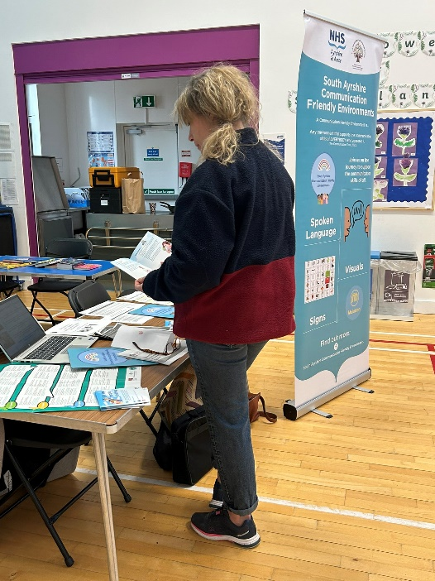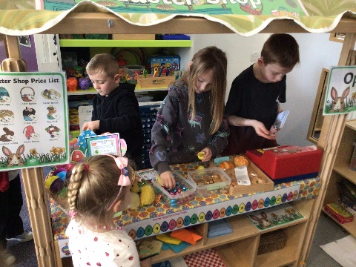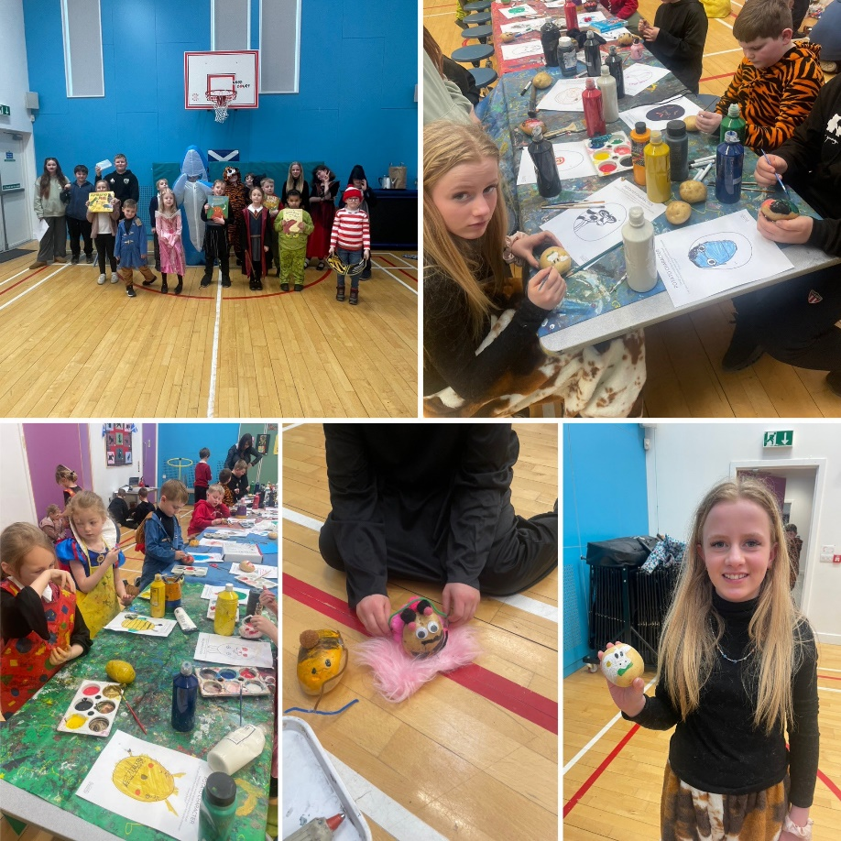

|  |  |
| --- | --- |
| **School Priority 2: Improvement in children’s and young people’s health and wellbeing.** | |
| **NIF Priority:**  Improvement in children and young people’s health and wellbeing. | **Links to HGIOS 4/HGIOELC:**  1.2, 2.1, 2.7, 3.1 |
| **Progress and impact**   * **Our Principal Teacher and Seasons for Growth trainer has successfully delivered the first 10 sessions of this supportive programme with a selected group of pupils.** The sessions have provided a safe and nurturing space for children to explore and understand change and loss in their lives. Through group discussion and structured activities, pupils have engaged with a range of themes designed to build resilience, emotional literacy, and coping strategies. This has been an incredibly positive experience, with pupils showing strong engagement, empathy, and mutual support throughout the programme. * **Across the whole school and EY, we introduced the online learning platform** Treehouse **into our Term 3 assemblies to support pupils in developing confidence, a positive mindset, and resilience.** The sessions have been engaging and accessible, with all pupils participating enthusiastically. The platform’s relatable content and interactive approach have helped reinforce key messages around emotional wellbeing, self-belief, and perseverance. Feedback from pupils has been very positive, and the use of Treehouse is already making a meaningful contribution to our whole-school approach to wellbeing and personal development. * **Our senior class teacher has worked in close partnership with our Educational Psychologist to deliver a targeted programme of eight sessions rooted in Positive Psychology.** These sessions have supported our senior pupils in developing key skills around resilience, managing stress and anxiety, understanding their emotions (psychoeducation), and applying both cognitive and behavioural strategies. Pupils have also engaged in structured problem-solving activities, helping to build confidence and independence. This focused work plays a vital role in preparing our young people for a positive transition to secondary school, equipping them with practical tools to support their wellbeing and personal growth. * Transition programmes across Early Years and from Primary 7-S1 have been very successful and helped to reduce anxieties in both pupils and parents around moving on. Girvan Academy’s Enhanced Transition Programme deserves to be highlighted. This was tailored to support the needs of our most vulnerable learners, they attended a number of visits to the academy, met with key personnel from Pupil Support and Guidance and established relationships. They also spent time problem-solving and completing challenges with Thriving Communities staff based in Girvan Academy, this enabled children from cluster schools to get to know one another, supported team building and from these activities, new friendships have been formed. Our young people looked forward to these sessions and they are now very much looking forward to attending Girvan Academy. * **This session, we developed a comprehensive** Family Engagement Calendar **to outline a wide range of opportunities for families to connect and collaborate with the school.** Events and activities included outdoor learning experiences, Early Years PEEP sessions, curricular workshops, whole-school performances, learning showcases, parent and community electives, Youth Music performances, seasonal celebrations, Reading Schools events, and celebrations of success. These opportunities supported meaningful partnerships between home and school, helping to strengthen our school community. Most sessions were very well attended, with consistently positive feedback from families highlighting the value and impact of their involvement. * **Teaching staff have provided a variety of out-of-school and lunchtime clubs to enrich pupils’ learning and extend curricular knowledge beyond the classroom.** These opportunities have supported the development of skills, interests, and confidence in a relaxed and engaging environment. In addition, we partnered with Barr Primary School to launch our first joint virtual book club — a fantastic opportunity for pupils to connect with peers from another school, share their love of reading, and develop discussion and critical thinking skills. This collaborative initiative has been a great success and reflects our commitment to creative, learner-focused experiences. * **Due to our small school numbers, attendance at sporting events this year has been limited, but we have still offered valuable opportunities for our pupils to engage in individual competitions.** One standout event was Hyrox, which was incredibly well received, and our pupils had a fantastic experience participating. While team competitions have been more challenging to enter because of our smaller numbers, we are excited to announce that for the next session, we will be collaborating with Active Schools and Thriving Communities to create multi-school teams across our cluster. This will ensure that all children, regardless of class size, will have the chance to participate in a wider range of team sports and events. * **Our Eco Committee has built invaluable partnerships with members of our wider community to enhance and develop our outdoor learning spaces.** In collaboration with the wider school, the committee has planted a range of fruits and vegetables to encourage sustainability and promote hands-on learning. The ECO Committee, in partnership with our Parent Council, have successfully funded a new garden poly-tunnel for growing fruits, vegetables and plant, and an outdoor learning cabin. These additions have created more welcoming and functional outdoor spaces for learning, socialising, and connecting with nature. This ongoing work highlights our school's strong commitment to sustainability, community engagement, and pupil-led improvement. * Our school is proud to have achieved The Promise Award, demonstrating our commitment to ensuring that the voices, rights, and wellbeing of all children and young people are at the heart of everything we do. Through this process, we have reflected deeply on our practice and taken meaningful steps to align our values and actions with the core principles of The Promise. We have strengthened relationships across our school community, improved how we listen to and act on pupil voice, and created nurturing, inclusive environments where every child feels safe, respected, and valued. Our work has included enhanced partnership working, staff training, and a continued focus on wellbeing and equity. * **This session, we have strengthened our support for Young Carers by taking a whole-school, inclusive approach to recognising and responding to their needs.** A dedicated Young Carer Champion has been identified within the school, providing a key point of contact for pupils and families. In addition, we have developed a Young Carers Policy and Support Pack to ensure that families and partners are informed and empowered to access the right support at the right time. * Primary 6 and 7 visited Dolphin House during February. The pupils participated in outdoor learning experiences with Dolphin House instructors, and this helped to improve team building skills, social skills and wellbeing. This was a joint residential with our partner school, Barr. * Pupil Voice continues to play an important role in every classroom and in the life of the school. Classroom Charters are created and displayed in all classes at the beginning of the year and these help to raise awareness of children’s rights and their responsibility to uphold these rights. * The SLT within the EYC communicated with all parents effectively to improve attendance. During periods of absence check in phone calls were made alongside Team with the Family meetings and consequently attendance has improved.   **Next steps**   * Deliver whole school assemblies centred around health, wellbeing, and diversity, using carefully selected reading books to support and inspire discussion. * The Ways to Wellbeing Groupwork – collaboration with colleagues from Educational Psychology * RRS Silver award to be renewed * Organise events which will update and involve parents more in our HWB curriculum/ RRS agenda, build on past successes and organise new opportunities for them to embrace and buy in to. * Multi-schools team approach to support attendance at sporting competitions * Implementation of achievements tracker and continuous celebration of success * Continue to ensure transitions are successful for everyone across all stages by working in partnership with all stakeholders and creating/ running with programmes that make a positive difference to change at key stages in education. * Further develop self-evaluation across the school using HGIOS4 and linking Care Standards to HGIOELC. | |

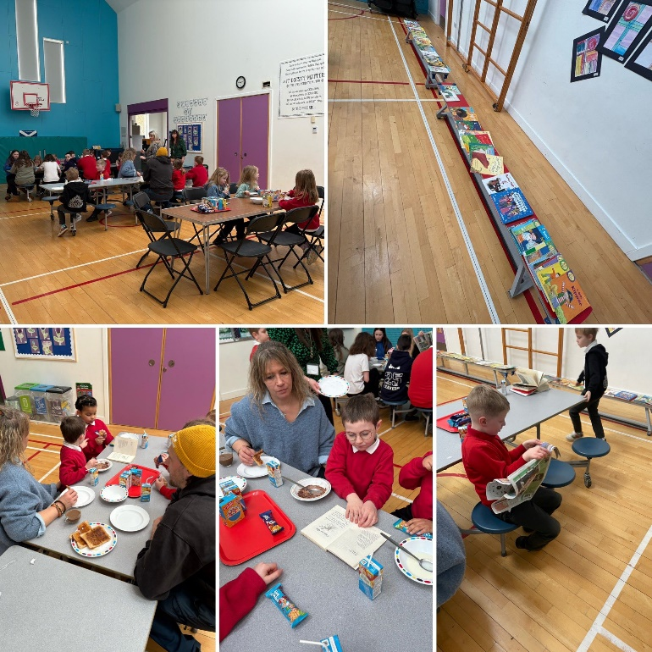

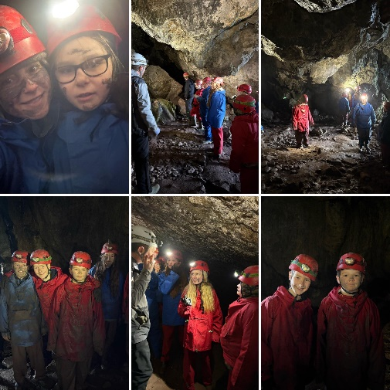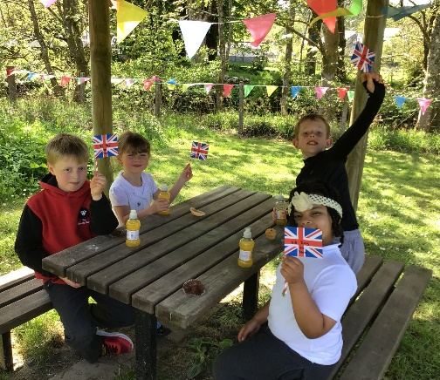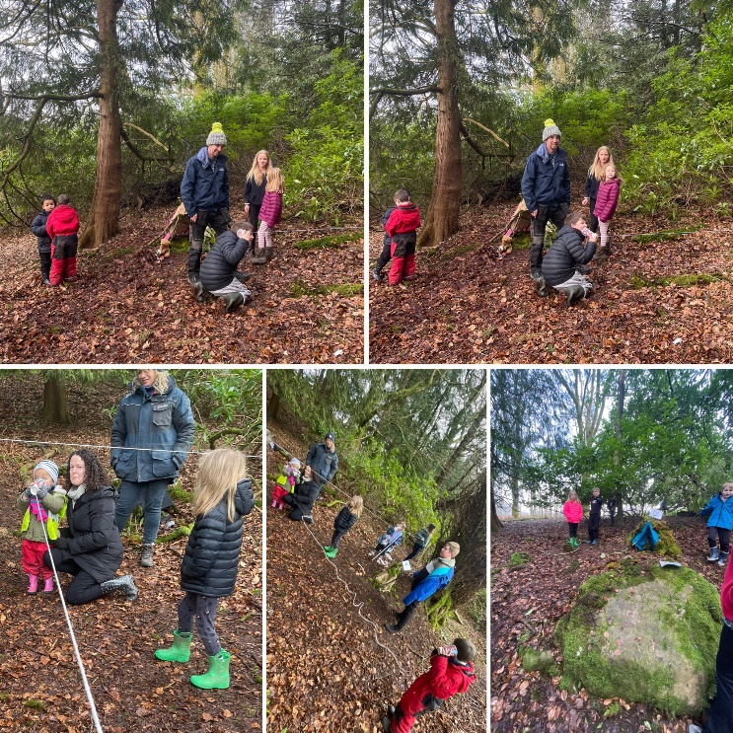

|  |  |
| --- | --- |
| **School Priority 3: Sustainability and Creativity** | |
| **NIF Priority:**  Improvement in employability skills and sustained positive school leaver destinations for all young people. | **Links to HGIOS 4/HGIOELC:**    1.2, 1.3, 2.2, 2.3, 3.3 |
| **Progress and Impact**   * Learners are provided with a rich variety of opportunities to explore and express their creativity across a wide range of community and school-based projects. Participation in initiatives such as the CRAG lantern-making workshops encourages collaboration, innovation, and pride in local heritage. Engagement with SAC competitions, seasonal art projects (including Remembrance poppies) as well as interhouse challenges and sewing activities, allows pupils to develop practical artistic skills while expressing individual and collective identity. Notably, the creation of a VE 80 memorial video offered pupils a meaningful opportunity to engage with history through digital media, fostering a deeper connection to the past while honing technical skills. * This session, we have fostered strong community links that have significantly enriched our creative and educational initiatives. Partnerships with Active Schools and Thriving Communities have enabled the delivery of engaging activities such as Pickle Ball, while collaboration with Ayr United Football Club and Balfour Beatty has provided pupils with valuable opportunities to engage in physical, practical and team-building activities. Our involvement with Carrick Rural Arts Group (CRAG) has further supported creativity through workshops like lantern making and other community arts projects. * This session, our Senior Leadership Team (SLT) has provided staff with comprehensive professional development focused on the integration of AI and the use of digital tools such as ThingLink. As a result, all staff have begun to embed elements of AI into their daily planning, enhancing both efficiency and the quality of learning experiences. The use of ThingLink has been particularly impactful in improving communication with families, with staff now using the platform to share interactive and accessible curriculum overviews. This digital approach has strengthened home–school partnerships and ensured that key information is presented in an engaging, user-friendly format for both pupils and parents. These developments reflect a forward-thinking and inclusive approach to digital learning and communication. * The Digital Committee has played a key role in advancing digital literacy and practice across the school. By sharing their knowledge and skills through a dedicated family and parent workshop, they have helped to strengthen digital confidence and engagement within our wider school community. The use of digital devices is now embedded across all classrooms, supporting learning, teaching, and assessment in meaningful and consistent ways. As a result of this whole-school approach, we are well on our way to achieving the Cyber Schools Award, reflecting our commitment to equipping learners with essential digital skills for the future. * This session, we have undertaken a collaborative and inclusive process to refresh our school’s vision, values, and aims, ensuring they reflect our current context and strong position within the community. Working closely with all our school community partners, including parents, staff, and partner agencies, we gathered a wide range of views. Our Pupil Voice Committee played a central role in this process, collating feedback and leading the creation of a new set of school values that truly represent our shared aspirations. This collective input has also enhanced our Curriculum Rationale, ensuring it include the views of all our partners. * Our Eco Committee has worked in close partnership with wider community groups to significantly enhance our outdoor learning and environmental spaces. Through collaboration, commitment, and pupil leadership, the committee has driven forward a range of sustainable initiatives that have made a visible impact on our school grounds. * Development of Meta-Skills framework * ‘Developing the Young Workforce’ embedded in curriculum throughout the school year with an end of year celebration focussing on ‘World of Work’. * Community Interhouse Challenges * P6 & P7 John Muir Award * Creating Partnerships with local community to enhance the electives programme. * Continue to schedule focus weeks throughout the school year – linked to SIP priorities. * Continue to promote Pupil Committees throughout the school. | |

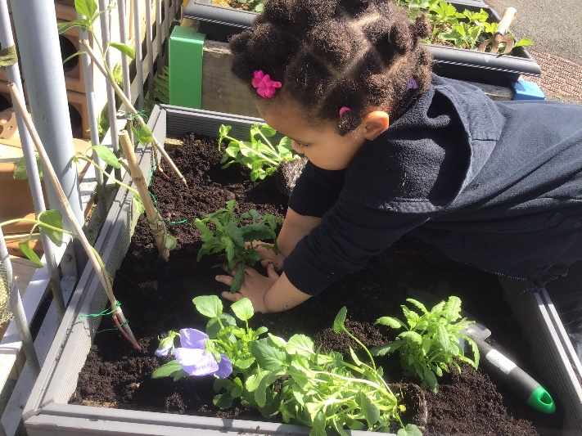

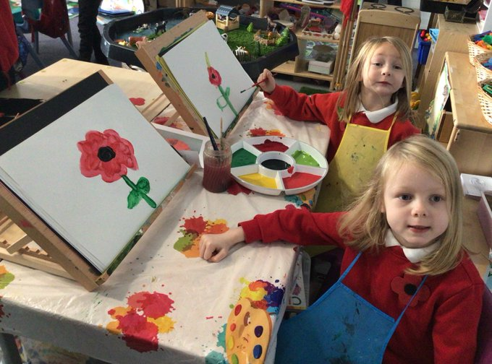

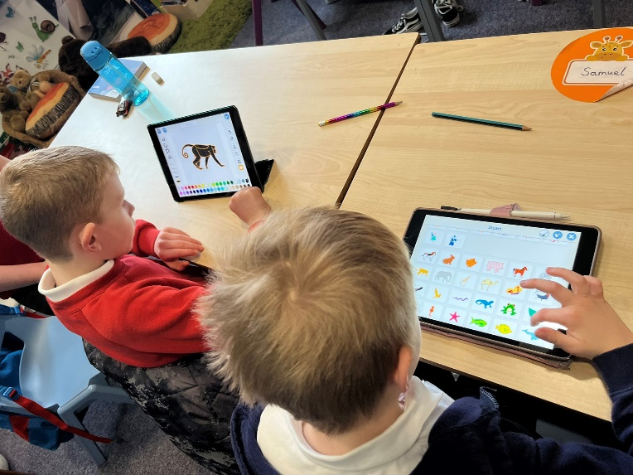

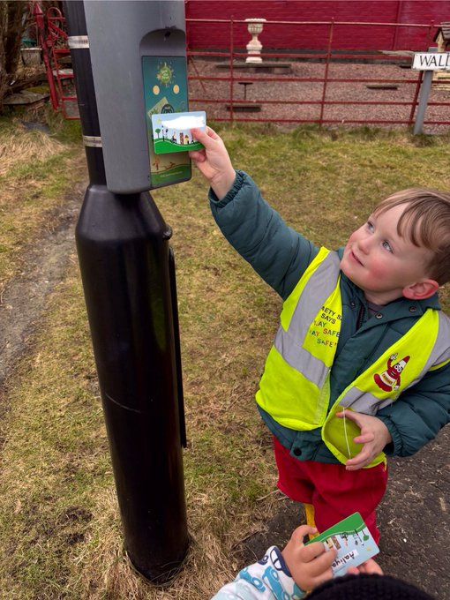

|  |  |
| --- | --- |
| **Cluster Priority: Art and Design Framework** | |
| **NIF Priority:**  Improvement in attainment, particularly in literacy and numeracy.  Closing the attainment gap between the most and least disadvantaged children. | **Links to HGIOS 4 / HGIOELC:**  1.1, 1.2, 1.3, 2.2, 2.3, 2.4, 3.2 |
| **Progress and impact**   * Teaching staff and EYPs have worked in trios with other members of the cluster to observe the delivery of art and design. * Training was delivered by one of our own teachers, and others from within the Steering Group, during the in-service day in May. This was very well received by cluster staff, with positive feedback given. * Staff are developing confidence in teaching art and design through observations of colleagues from different schools. Children responded positively to visitors to their class, and this has increased engagement.   **Next Steps**   * Continued increase in teacher confidence through more PL experiences and evaluation of impact. | |

# EVALUATIVE SUMMARY

|  |
| --- |
| **1.3 Leadership of change** |
| The aspirational vision, values and aims are clear within the school and EYC and there is a strong commitment from the whole team to secure positive outcomes for children. Our values are reinforced and celebrated through our ethos, Assemblies, class charters and Values awards. The children understand them extremely well and use them in conjunction with the United Nations Rights of the Child.  Through the well-planned calendar of self-evaluation, staff meetings and stakeholder consultation, we have a clear vision of where we want to be and what we need to do to get there. The school is consultative and data rich, and this helps inform our next steps. Staff are encouraged and empowered to lead innovative change within the school and EYC and collegiate working across the two schools is the norm.  Staff within the school are fully committed to improvement and have high expectations of all learners. Clear remits and expectations across the two schools have led to leadership opportunities at all levels and all staff have engaged in further training and development – locally and for some nationally, which is a key driver for change. Self-evaluation is at the heart of our development priorities. Professional staff use their Leadership of Learning time to develop pedagogy, support each other and improve the quality of learning and teaching.  Pupil leadership is a key strength of the school. All children regularly participate in a committee, making valuable contributions to the life and work of the school.  Overall, we show very good leadership of change across the school and EYC. |
| **2.3 Learning and teaching** |
| The ethos we champion is extremely positive, and staff focus on getting it right for every child. Almost all children demonstrate confidence and engagement during learning activities. Staff know the children very well and are attuned to their needs. Through observations and regular professional dialogue, it is clear to see that the experiences offered are enjoyable and well matched to pupils’ needs. Staff empower children to make decisions about their own learning and our children are involved in the wider life of the school e.g. committees, in the community.  Teachers adopt a wide range of strategies to meet the varied needs of their pupils-providing high quality, individualised learning. Staff are keen to improve and work collegiately with partners in a positive way. The school environment, inside and outside, is used effectively by all the staff and pupils. We use a variety of approaches to allow our learners to demonstrate their knowledge, understanding and skills.  Children experience a broad and balanced curriculum. Our curriculum and planning processes are designed to ensure all our children receive a high-quality experience across all curricular areas through breadth, depth and application of learning. Staff provide appropriate encouragement and scaffolding to enable children to learn successfully through their play.  Most pupils use peer/self-assessment to effectively plan next steps in their learning and can talk about what they have been learning. They are involved in evaluating and setting their learning targets termly. Teachers have a very good understanding of the moderation cycle and use this well, helping to give them an improved understanding of national standards. Online Learning Journals are used to track learning journeys, with some pupils and parents contributing to the process.  Staff meet termly for Professional Dialogue meetings with the HT to predict, track and improve learner outcomes. Learners are involved in aspects of planning learning; digital learning is progressive and taught within relevant contexts.  Overall, the quality of learning, teaching and assessment across the school and EYC is very good. |
| **3.1 Ensuring wellbeing, equity and inclusion** |
| Staff have a shared understanding of wellbeing and work together to promote our values and high expectations, ensuring all children feel secure and valued. Relationships across the school community are extremely positive and each child is treated as an individual.  All pupils receive 2 hours of quality PE each week, with specialist knowledge and skills shared across the school. We have increased staff and pupils’ knowledge of children’s rights through RRS work in class, through the committee and at Assemblies. Children have a very good understanding of the wellbeing indicators and how they link to our values. Staff have received input on current legislation and particular policies relating to wellbeing.  At Barrhill, all staff are committed to improving the health and wellbeing of our pupils. Our positive relationships with pupils and their families lead to excellent support and positive outcomes. Staff have received guidance and training on staged intervention and wellbeing processes and pupils and parents are involved in evaluating and setting targets. The teachers and our school assistant provide high quality support to pupils experiencing difficulties in literacy, numeracy and self-regulation. Pupils who require additional support for their learning or with emotional and behavioural needs are closely monitored through the staged intervention process, with appropriate strategies and supports in place.  Staged intervention procedures lead to improved outcomes, with individual action plans in place, where appropriate. Where children experience barriers to their learning, interventions are put in place. Pupil Equity Funding is effectively deployed to target the needs of identified learners. 1:1 literacy and numeracy interventions are improving outcomes for identified learners.  Staff identify pupil needs in a timely manner and early intervention strategies are used to target support needs. Appropriate links are made with other professional partners including: educational psychologist, school nurse, speech and language therapist.  Overall, the school and EYC is very good at ensuring wellbeing, equality and inclusion needs are met. |
| **3.2 Raising attainment and achievement** |
| Attainment, evidenced through formal measures, has been positive and every child has made good progress from the start of the school session. This is evidenced through ongoing assessments, baseline/value added assessments, observations, feedback and confident teacher judgements. Support is in place for pupils who are not making expected progress. More able learners are being challenged in specific areas.  Due to our small numbers, we track individual pupil results over time rather than cohorts of pupils to get a more accurate assessment. Through rigorous tracking procedures in place, it is clear that most pupils are making progress from prior levels of attainment. Attainment data is being used to identify progress and next steps.  Staff record the progress in learning of every child in literacy, numeracy and health and wellbeing. Children’s attainment has increased in recent years due to planned interventions to meet their individual needs. Effective systems are in place to track all pupils with a particular focus on those identified as being most vulnerable. At tracking meetings this information helps inform decisions and allocation of resources.  Staff and children share and celebrate achievements in and out of school in Assemblies and in Learning Journals. All children have opportunities to attend out-of-school clubs and staff provide further opportunities through leading lunchtime clubs.  All staff are aware of the socio-economic and emotional circumstances for individual children and families. PEF is used to provide training for staff and support for children relating to health and wellbeing. Staff carefully monitor the impact of the approaches using clear measures at key points in the year. As a result, children’s attainment and emotional wellbeing is improving which is accelerating the progress and equity for all children.  All staff are committed to addressing the cost of the school day to ensure children are not disadvantaged in any way. Additional funding is sourced to ensure trips are fully funded.  Overall, the school and EYC is good at raising attainment and achievement. |

# WHAT ARE THE KEY PRIORITIES FOR IMPROVEMENT IN 2025-2026?

From the National Improvement Framework, the key priorities for Barrhill PS and EYC for session 2025-2026 are:

|  |
| --- |
| ***School Priority 1:* Improvement in attainment for all, particularly in Literacy** |
| **Reading –**   * To raise attainment in reading across the school through the accreditation of our Gold Reading School award * To ensure all pupils receive high quality differentiated learning opportunities in reading through the development of consistent approaches to pedagogy and assessment. * To embed the South Ayrshire Reads programme from EY to P7   **Writing –**   * To work in collaboration with partner agencies to raise attainment in writing across the school. * To ensure all pupils receive high quality differentiated learning opportunities in writing through the development of consistent approaches to pedagogy and assessment.   **Listening & Talking –**   * To further develop good listening and talking skills across the school by adopting a consistent approach to pedagogy. |

|  |
| --- |
| ***School Priority 2:* Improvement in children’s and young people’s health and wellbeing** |
| * Support the inclusion of all learners within the school. * Provide environments that are supportive and inclusive. * Work collaboratively to achieve the next level of accreditation in our Rights Respecting School’s journey. * Work collaboratively with Active Schools and Thriving communities to support and increase attendance at cluster sporting events. * Continue to promote high attendance and ensure pupils have the supports needed to foster good attendance habits. * Work collaboratively with partners within Educational Psychology to promote positive wellbeing |

|  |
| --- |
| ***School Priority 3* – Improvement in employability skills and sustained positive school leavers destinations for all young people.** |
| * **Integrate meta-skills across the entire school curriculum**, ensuring they are embedded in everyday learning experiences. * **Implement a detailed tracking system** to monitor personal achievements and participation in extracurricular clubs, both in and out of school, with a clear link to skill development. * **Embed Developing the Young Workforce (DYW) skills and initiatives throughout the academic year**, hosting a celebration event and a meaningful work experience opportunity on Term 4. * **Strengthen partnerships with local businesses and the wider community** to enhance learning and career pathways. |

# WHAT IS THE CAPACITY FOR IMPROVEMENT?

The school/EYC is in a very good position with definite capacity to make further improvements. The over-riding focus will continue to be on closing the gap and ensuring our young people are safe, happy and supported in their wellbeing.

Our capacity for improvement has been measured through the careful analysis of triangulated quality assurance evidence alongside ‘How Good is our School 4’ and ‘How Good is our Early Learning and Childcare.’ Additional evaluation of our Pupil Equity Fund projects and targeted interventions has also allowed us to analyse the strategic gains made towards ensuring both excellence and equity for all and identify future opportunities for strategic growth.

Leadership of change is well managed and at an appropriate but challenging pace. The staff are enthusiastic and motivated and through self-evaluation, collegiate working, moderation opportunities and ensuring high expectations, our pupils will continue to receive an excellent education and ‘be the very best they can be!’

***The school community knows its strengths and areas for development and together it will move forward and achieve continued success!***

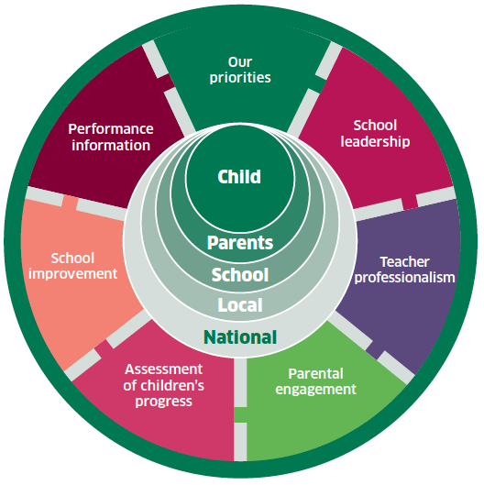

**National Improvement Framework for Scottish Education**

* *Getting it Right for Every Child!*