Barr and Barrhill Primary Schools and Early Years Centres

IMPROVEMENT PLAN: 2023-2024

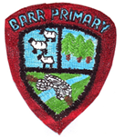

VISION

Our School Community is a place where everyone is encouraged to grow and learn in an inclusive and nurturing environment. Pupils are motivated and challenged to be the very best they can be.

VALUES

Kindness Respect Confidence Honesty Achievement

AIMS

• To create a welcoming atmosphere with a positive ethos where there is a safe, relaxed and secure teaching/learning environment.

• To involve and encourage parents, carers, partner agencies and the wider community to play an active role in supporting learning and celebrating success both at school and at home.

• To ensure that school staff work within a professional environment where they can take advantage of opportunities for further training and development in order to enhance learning and teaching, ensuring that we offer the highest quality learning experiences for our pupils.

• To promote the well-being of all children through opportunities to develop socially, emotionally, physically and intellectually, developing a positive attitude and high self-esteem.

• To provide the highest quality of learning and teaching by providing experiences that enable children to enjoy their education, through a variety of teaching approaches and learning styles.

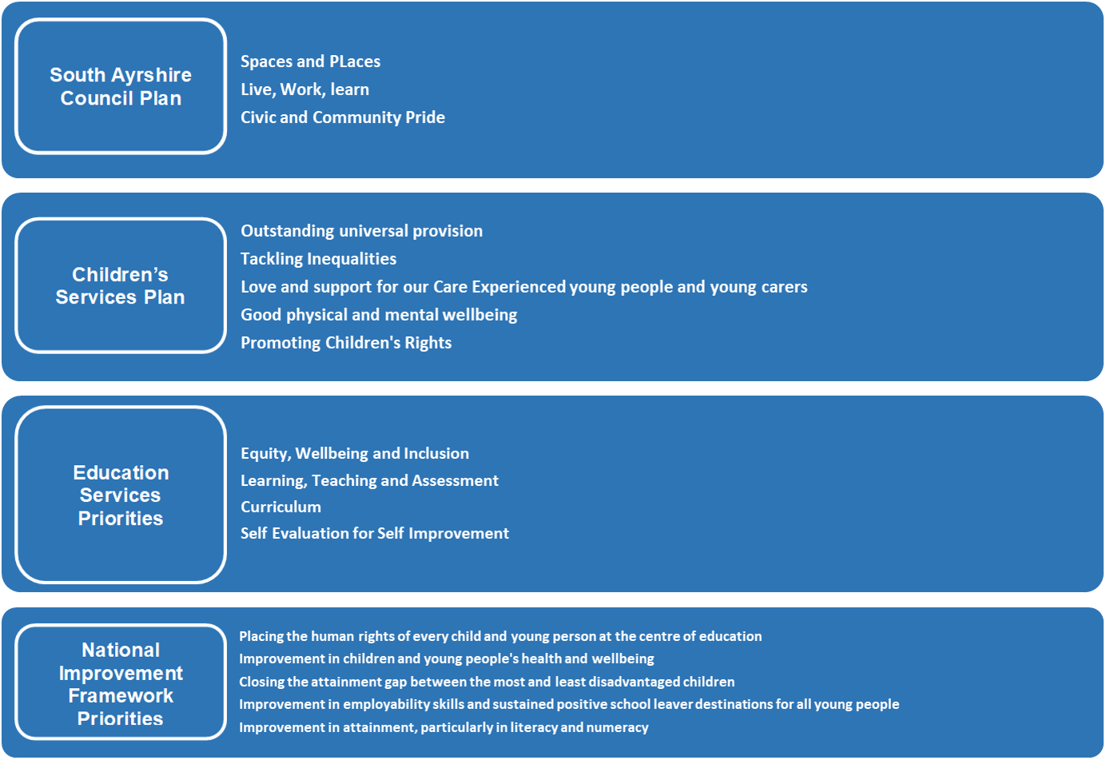

Priority 1: Improvement in attainment for all, particularly in literacy and numeracy
What Outcomes Do We Want To Achieve? | How Will We Achieve This?  (Intervention Strategies) | Lead Person | Start and Finish Dates | How Will We Measure Impact On Children and Young People?  (Include Where Possible Current Measure and Target)
Pupils are motivated and engaged in their learning through high quality learning and teaching opportunities.  Q.I 3.2  Q.I 1.2  Increased attainment in literacy and numeracy for all children and therefore close the attainment gap.  Q.I 3.2  Q.I 3.3  Increased family engagement opportunities to support literacy and numeracy development within local and national guidelines.  Q.I 2.5  To improve children’s literacy and numeracy skills in the Early Years Centre.  Q.I 3.2  To embed Learning the South Ayrshire Way, ensuring high quality learning and teaching to improve pupil outcomes.  Q.I. 1.2  Q.I. 2.3  To develop confident and skilled readers in South Ayrshire with a lifelong love of reading and the confidence to access all aspects of education, culture and society.  Q.I. 1.2  Q.I. 2.3  To support and develop all education staff in South Ayrshire to implement best practice through a culture of shared knowledge, collaboration and enquiry.  Q.I. 1.2  Q.I. 2.3 | Embed opportunities for learning through play and exploration in the senior classes, ensuring children understand the skills they are developing. | L Ferguson  A McBirnie | August 2023-June 2024 | Undertake baseline assessments September 2023. Re-assess at end of May 2024.  80% of TOTAL number of children in P1, P4,  P7 to attain age appropriate CfE levels and age  equivalent standardised testing results.  20% children who are not achieving receive  targeted support.  P1, P4, P7 standardised assessments provided  by local authority and interrogation of data informs allocation of targeted support within the school.  Reading, writing and maths assessments moderated across the two schools.  Reading, writing and maths is tracked and discussed through learning conversations and tracking meetings.  Planning templates evaluated and reviewed accordingly.  Classroom observations – including pupil views.  Staged intervention paperwork – action plans are clear and evaluated.  PL/PRD/PDR records.  Pupil questionnaires.  Focus group feedback.  Attendance monitoring.  Work scrutiny – pupil profiles, pupil work, Learning Journals.  100% of all children in our Early Years Centre achieve 8 or more of their developmental milestones.  Targeted support in the Early Years Centre  from PT has a positive impact.  90% attendance rate in our Early Years Centre.  Parents are more confident and informed of what their child is learning.  All pupils will have an e-profile and be able to share them with their parent(s).  Tests of change analysis.
 | Embed Big Maths across the school and share supports with parents/carers. | Numeracy Working Party | August 2023-June 2024
 | Achieve ‘Core’ in the Scottish Book Trust Reading Schools programme. | P Murphy  All staff | August 2023-June 2024
 | Extend opportunities for EY staff to work across the EYC and Primary 1 to support and extend learning in literacy and numeracy. | Principal Teachers  All EYPs | August 2023-June 2024
 | Build on approaches in the EYC and infant class to improve vocabulary and communication, linking with Speech and Language colleagues. | Principal Teachers  All EYPs | August 2023-June 2024
 | Weekly engagement in outdoor learning through the use of the South Ayrshire Overview of Outdoor Experiences or similar. | C McIlwraith  All EYPs  All teachers | August 2023-June 2024
 | Engage in professional learning to develop the use of questioning to extend children’s learning and provide increased challenge. | All staff | August 2023-June 2024
 | Identify good practice for teachers to observe within the SWEIC rural family relating to multi-composite play. | Principal Teachers | Term 1
 | Extend the use of symbols to support and enhance younger children’s communication skills. | All EYPs | August 2023-June 2024
 | Provide opportunities for all children to explore digital technologies through play and learning. | E Burton  A Taylor  All EYPs  All teachers | August 2023-June 2024
 | Continue to improve children’s handwriting through daily fine motor skills activities. | All teachers | August 2023-June 2024
 | Develop a more robust evaluative system for analysing targeted individual and small group interventions e.g. 5-minute boxes, Toe-by-Toe. | P Murphy  M Sinclair  G Young | Terms 1 and 4
 | Continue to audit and evaluate our practice and pedagogy in relation to Talk for Writing. | Literacy Working Party | Terms 1 and 4
 | Use of Meemo to improve working memory skills. | A McBirnie  L Ferguson | August 2023-June 2024
 | Share effective practice through timetabled peer visits and stage meetings. | P Murphy  All teachers | August 2023-June 2024
 | Deliver parental workshops on reading approaches. | All teachers | Term 2
 | All classes to engage with virtual author sessions to enhance reading culture. | All teachers | August 2023-June 2024
 | Timetabled weekly reading buddy sessions across EYC/school. | All EYPs  All teachers | August 2023-June 2024
 | Further develop home link activities to support literacy development in the EYC and P1. | All EYPs  Principal Teachers | August 2023-June 2024
 | Develop an approach to using Giglets: linking the resource to Talk for Writing and to enhance aspects of literacy transition e.g. supporting children’s understanding and development of rhyme. | P Murphy  All EYPs  All teachers | August 2023-June 2024
 | Introduce Gaelic language learning throughout the EYC and school. | A Taylor | Term 4
 | Education staff, parents, children and young people will be introduced to the strategic vision of (SAR) the South Ayrshire Reads initiative.  Education staff will have had the opportunity to attend an online South Ayrshire Reads Engagement session.  Primary education staff will have engaged in initial science of reading training (Sept Twilight) and follow-up training (TBC).  School assistants will have had the opportunity to attend in-person Supporting Children with Reading training. | All staff  All staff  All teachers  M Sinclair  G Young | August 2023  April 2024  September 2023  February 2024
 | Work with staff to ensure the outcomes and impact of all initiatives are measurable and can be evidenced through the attainment tracker. | P Murphy  All teachers | Terms 2-4
 | Make tracking processes more cohesive for improved access and easier analysis. | P Murphy  All teachers | Term 1
 | Build on current moderation opportunities and extend to other curricular areas, building staff confidence in use of 4 stages of progress. | P Murphy  All teachers | August 2023-June 2024
 | Provide opportunities for EYPs to moderate with teachers, to further develop understanding of early level skills development. | Principal Teachers  All EYPs | August 2023-June 2024
 | Ensure long-term planning is manageable and clearly identifies what has to be learned and assessed. | SLT | November 2023
 | Involve children in the planning process, self-evaluation, peer and self-assessment through an agreed and consistent approach. | P Murphy  All teachers | August 2023-June 2024
 | Develop shared expectations in relation to the presentation of written work. | P Murphy  All teachers | August 2023
 | Audit and share good practice of methods used to provide quality written or visual feedback. | Principal Teachers | October 2023
 | Increase opportunities to review progress in Learning Journals, ensuring targets are relevant and meaningful to support children to make improvements in their learning. | All EYPs  All teachers | August 2023-June 2024
 | Further develop an approach to assessing learning through play. | Principal Teachers | August 2023-June 2024
Review aspects of the school and EYC curriculum, to best meet the needs of all our learners.  Q.I. 2.2 | Curriculum working parties with a focus on high quality teaching and learning, support and challenge. | As per staff remits | August 2023-June 2024 | Skills pathways accounted for within planning folders.  More updated policies available.  Professional dialogue around planning.  Through classroom observations.  Focus groups with pupils.  PL/PRD/PDR records.  Scrutiny of transition records and progression.
 | Further develop the use of pupil curricular ambassadors to drive forward curricular improvements. | P Murphy | August 2023-June 2024
 | Deepen learning and pedagogical understanding through Leadership of Learning Days; participation in accredited achievement awards; professional learning opportunities; research and professional enquiry. | All staff | August 2023-June 2024

Priority 2: Improvement in children’s and young people’s health and wellbeing
What Outcomes Do We Want To Achieve? | How Will We Achieve This?  (Intervention Strategies) | Lead Person | Start and Finish Dates | How Will We Measure Impact On Children and Young People?  (Include Where Possible Current Measure and Target)
Children are safe, happy and settled at school.  Q.I 3.1  Q.I 2.1  Identified children who are experiencing low mood and/or anxiety are fully supported.  Q.I 3.1  Q.I 2.1  Increased resilience in our children and young people.  Q.I 3.1  Through increased staff confidence and capacity, children’s mental wellbeing is supported.  Q.I 1.2  Q.I 2.7 | Use Glasgow Motivation and Wellbeing Profile (GMWP) to track pupil wellbeing. | A McBirnie | Terms 1/3 | Wellbeing Webs.  GL PASS data.  South Ayrshire’s Mental Health and Wellbeing Assessments.  Parental views.  Pupil views.  Staff meetings: check-ins.  HT observations.  Attendance doesn’t fall below 90%.  Late-coming reduced.  Through staff discussions at planned meetings or PRD/PDR sessions.
 | Increase availability of our Mental Health First Aider to deliver targeted support and interventions e.g. Seasons for Growth. | A McBirnie | August 2023-June 2024
 | Extend family learning opportunities and parental events within the school and EYC. | All staff | Dates noted on calendar
 | Increase the range of after school/lunchtime clubs to encourage and increase the involvement of more children e.g. homework club, science. | All teachers | August 2023-June 2024
 | Increase children’s understanding of diversity and inclusion, therefore promoting tolerance and acceptance of others. | All staff | August 2023-June 2024
Increased opportunities and participation in physical activity and sport for all pupils within local and national guidelines.  Q.I 3.1 | Enter and attend a range of competitive sporting events. | P Murphy | August 2023-June 2024 | Fitness testing carried out twice over the session.  A marked increase in after school clubs participation.  Playground observations.  Parent and pupil feedback.  Achievement of awards.  Children growing and eating own fruit and vegetables.
 | Provide opportunities for pupils to improve their growth mindset and resilience. | All EYPs  All teachers | August 2023-June 2024
 | Children to plant, grow and utilise home-grown products to increase understanding of where food comes from and what is needed for a healthy lifestyle. | All EYPs  All teachers | August 2023-June 2024
 | Further develop the outdoor areas in partnership with the local community and parents. | All staff | August 2023-June 2024

Priority 3: Improvement in employability skills and sustained positive school leaver destinations for all young people – Sustainability and Creativity
What Outcomes Do We Want To Achieve? | How Will We Achieve This?  (Intervention Strategies) | Lead Person | Start and Finish Dates | How Will We Measure Impact On Children and Young People?  (Include Where Possible Current Measure and Target)
Develop a whole school and community approach to Learning for Sustainability: global citizenship, sustainable development education, outdoor learning.  Q.I 2.2  Q.I 1.3 | Increase use of outdoor spaces to promote creativity, curiosity and enquiry. | All staff | August 2023-June 2024 | LFS audit and evaluation.  Calendar of events planned.  PL/PRD/PDR records.  Monitor implementation of LFS policy.  Pupil feedback.  Parental feedback.  Through pupil profiles.
 | Connecting Classrooms Project implemented at a whole school level. | A McBirnie  L Ferguson | August 2023-June 2024
 | P6 and P7 pupils to achieve the John Muir Award. | A McBirnie  L Ferguson | Term 4
 | Further develop business and community links within the local area. | All staff | August 2023-June 2024
 | Programme of financial numeracy sessions to develop real-life money skills. | P Murphy  All teachers | Term 1
 | Staff training in outdoor learning to further enhance teaching and learning in the outdoors. | All staff | August 2023-June 2024
 | Refresh engagement of children in meaningful discussion about their skills development through the use of the Career Education Standard (3-18). | E Burton  All EYPs  All teachers | Term 1
 | Eco-Schools Green Flag awarded. | A Taylor  C McIlwraith | By June 2024
Children’s rights are recognised and their views and opinions are listened to and acted upon.  Q.I 1.2 | Further develop children’s understanding of their rights, keeping a high and visible priority throughout the school and EYC. | A McBirnie  L Ferguson | August 2023-June 2024 | Wee HGIOS feedback.  Minutes of committee meetings  Regular appearance in local press, social media, community newsletters.  Pupils happy to take on leadership roles.
 | Embed the use of talking and thinking floorbooks in the junior classes. | Principal Teachers | Term 1
 | Ensure children are aware of their role and purpose in taking forward improvements and help them to recognise the important skills they are developing through these activities. | P Murphy  All teachers | August 2023-June 2024
Develop the skills and confidence of staff in the appropriate and effective use of digital technology to support learning and teaching.  Q.I 2.3 | Continue to provide high quality staff professional learning opportunities to increase confidence and skills to support effective digital teaching across all levels. | E Burton  A Taylor | August 2023-June 2024 | E-profiles in use throughout the schools and EYCs.  The use of digital supports is greatly increased within the classrooms.  Staff confidence increased.  Monitor impact of staff development.  Twitter and the website updated and more detailed.  Achievement of awards.
 | Timetabled and regular use of Learning Journals across the school and EYC to evidence and celebrate pupils’ achievements and attainments. | All EYPs  All teachers | August 2023-June 2024
 | Build on work already undertaken and achieve the Digital Schools’ Award (Barr) and Cyber Schools’ Award (Barrhill). | E Burton  A Taylor | August 2023-June 2024
 | More opportunities for children to develop their own digital skills e.g. Robots. | All EYPs  All teachers | August 2023-June 2024
Implement the creative process to support children to develop inquisitiveness, open-mindedness, imagination and problem-solving skills.  Q.I 3.3 | All pupils will have the opportunity to perform for an audience. | All staff | Dates noted on calendar | CLPL records.  Children make real life links with their learning.  Observations by HT.  All pupils involved in performing either in an assembly or show.  Pupil feedback.  Parental feedback.
 | Develop the Creativity Framework to include meta-skills. | P Murphy | August 2023-June 2024
 | Extend use of inter-house challenges and projects, linking with the local community. | All staff | August 2023-June 2024
 | Have a focus on World of Work/Masterclass type activities in order to Develop the Young Workforce. | All EYPs  All teachers | Term 4

Priority: Expressive Arts Framework
To focus on improving confidence and competence of staff to effectively teach Expressive Arts and provide learners with the skills, approaches, knowledge and understanding that they require throughout their lives: year 1 art and design; year 2 dance and drama; year 3 music.
HGIOS 4 / HGIOELC Q.Is1.1, 1.2, 1.3, 2.2, 2.3, 2.4, 3.2 / SACP 1,2/ CSP 1,2 / ESP 2, 3, 4 / NIF 1, 2
What Outcomes Do We Want To Achieve? | How Will We Achieve This?  (Intervention Strategies) | Start and Finish Dates | How Will We Measure Impact On Children and Young People? (Include Where Possible Current Measure and Target) | January 2024 Review
- Children and young people’s skills development, approaches to and knowledge and understanding in Expressive Arts is enhanced due to further staff development of pedagogy and assessment.  - Children and young people have a coherent and progressive learning experience in Expressive Arts across and throughout Girvan cluster schools/EYCs. There is a collegiate development of an art and design programme linked to Girvan Academy.  - Children, young people and staff will engage more readily with Expressive Arts and aspire to pursue a career in Expressive Arts.  - Staff will share experiences and good practice at all levels, moderate expectations in Expressive Arts and develop greater collegiality between cluster schools/EYCs.  - Children and young people will experience quality learning and teaching in Expressive Arts due to increased levels of confidence and expertise in staff.  - Quality learning and teaching will be informed through reliable and relevant assessment information. | - Individual schools will have negotiated collegiate time with staff to make these tasks happen.  - All teaching/EYC staff will join a group of 3.  - Each member of staff may be from another CFE level.  - August In Service: HTs will present the plan to all staff; staff will be notified of their Trio and focus area and asked to contact each other.  - Steering Group: carry out school/EYC audits; staff consultation; provide CLPL over the session; collate a directory of professional and community links to aid with planning and delivering art and design lessons; identify and cascade up-to-date information relating to planning and assessing art and design.  - September: Trios will arrange an online meeting to plan lessons and arrange dates for lessons to be taught and observed over the next 6 months (3 lessons, 3 visits).  - September – November: Trios will observe one colleague teaching an art and design lesson (time swapped from RCCT/collegiate time).  - December – January: Trios will observe second colleague teaching an art and design lesson (time swapped from RCCT/collegiate time).  - January – March: Trios will observe third colleague teaching an art and design lesson (time swapped from RCCT/collegiate time).  - May in service (half day session): Showcase session at Girvan Primary School to celebrate staff and pupil learning.  - CLPL will be organised throughout the year and be on an opt-in basis. | August 2023 - June 2024 | Individual school/EYC self-evaluation of Expressive Arts.  Showcase Presentation in May.  Classroom observations (SMT, mentors, colleagues from across schools/EYCs).  Staff evaluations following CLPL activities. | Cluster questionnaire for staff and children.

Appendix 1

Budget

Priority | Staffing costs (F/y) | Staffing costs (P/Y) | Resources/ other | Total
Barr PEF  Mental Health First Aider improves readiness to learn; self-confidence; resilience; growth mindset and attendance of identified learners.  Increased staff knowledge and understanding of barriers relating to the poverty related attainment gap. | £6412  0.1 class teacher |  |  | £6480
Barrhill PEF  Mental Health First Aider improves readiness to learn; self-confidence; resilience; growth mindset and attendance of identified learners.  Increased staff knowledge and understanding of barriers relating to the poverty related attainment gap. |  |  | Over and above her management time and Leadership of Learning days, the Mental Health First Aider will be covered 2 days per term for professional learning and development of whole school wellbeing. | £2160

