

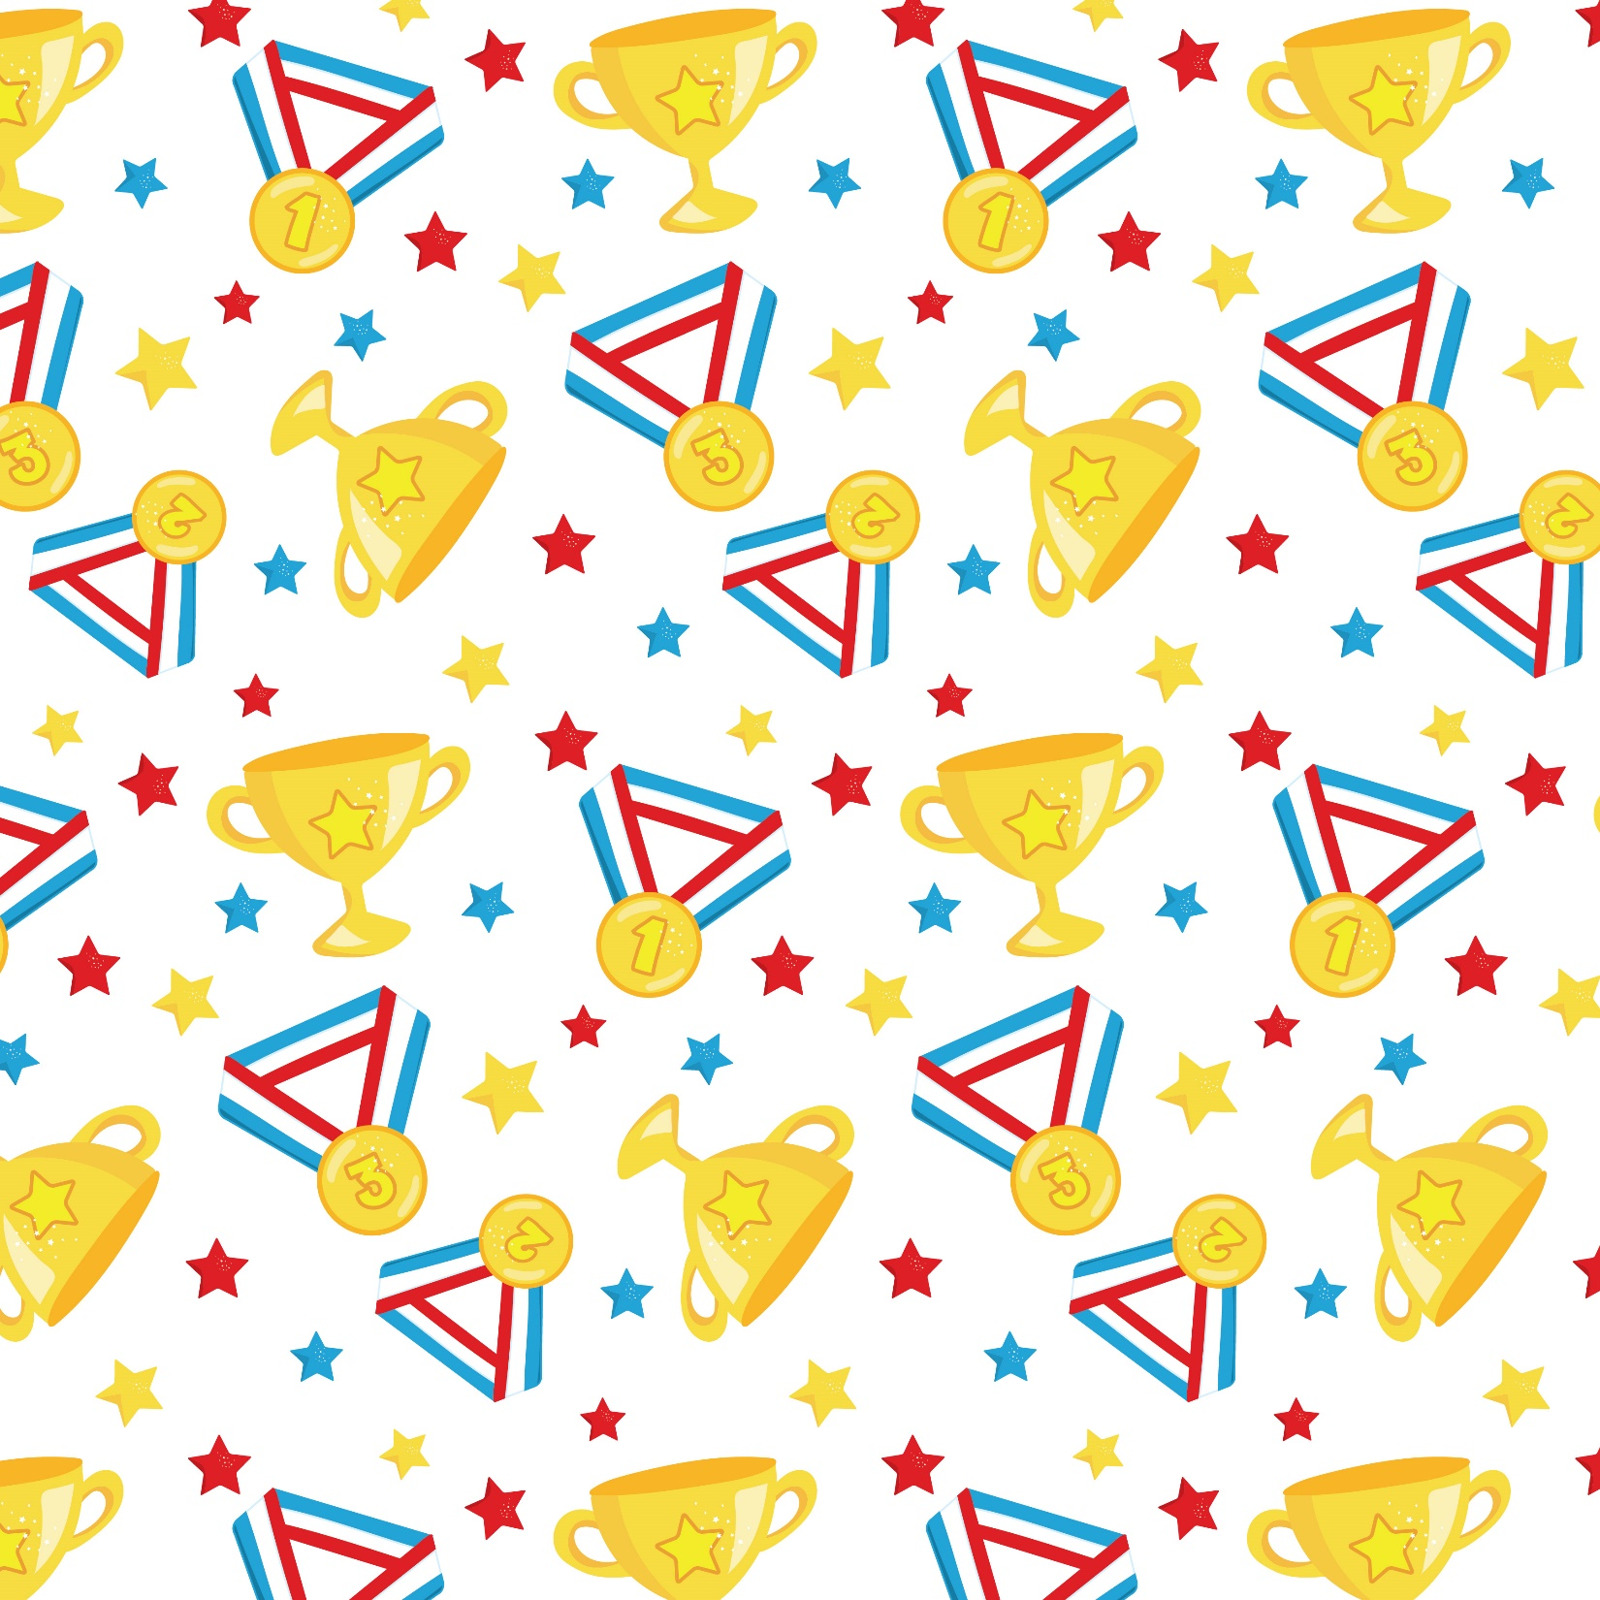

**How to play:**

* Once you complete a physical activity tick it off.
* Can you complete the activities in the red squares for **10 extra bonus points**?
* If you are finding some of the activities hard, change them or have a rest and then continue.
* When performing the activities make sure that you are honest.
* Photos and videos of you taking part would be much appreciated.
* Use the record sheet to record your activities and scores.
* Have fun and get active!
* **Submit results by Monday 15th June 2020**

**Achieve Gold**

Complete all the activities

on the card – **100 points**

**Achieve Silver**

Complete 15 of the activities

on the card – **50 points**

**Achieve Bronze**

Complete 5 of the activities

on the card – **25 points**

**Bonus Family Challenge**

Can you complete the bonus challenge as a family? Extra 100 points for completing the challenge below as a family.

**Family Challenge**: Have a relay race as a family. How quickly can you complete the relay?



Ballantrae Primary and EYC Virtual Sports Bingo  
Monday 8th June to Friday 12th June 2020

**Tea Bag Challenge**

Set up a tea cup and stand between 1-3 meters away from it. Throw a tea bag at the cup. How many times can you get a tea bag in a minute.

**Daily Mile**

Measure out a mile in your garden or time yourself for 15 minutes. Walk or run your mile.

**Jump for Joy**

See how many times can you jump (both feet leaving the ground) for 30 seconds.

**Egg/Potato and Spoon Challenge**

Make a circuit around your garden and time how quickly you can race around without dropping your egg/potato.

**Wellie Toss**

See how far you can toss a wellie. Measure the distance using your feet.

**Keppy Uppy Challenge**

How many Keepy Uppys can you do with a toilet roll?

**Target Practice**

Set up three empty bottles about 3-5 metres from you. Using a ball (or a toilet roll/rolled up pair of socks) try to bowl the bottles over. How quickly can you get all three?

**Cushion Race**

Make a circuit around the garden and time how quickly you can run around it with a cushion balanced on your head.

**Fitness Circuit**

Set up 4 stations, a start line and a finish line. On **GO** run to first station:

**Step 1** – Do 20 Star Jumps and run to next station

**Step 2** – Do 15 Burpees and run to the next station

**Step 3** – Do 10 Sit ups and run to the next station

**Step 4** – Do 5 Press ups and run to the finish

**Create Your Own Workout**

Can you create your own workout to your favourite song? Come up with your workout routine (repetition of at least 5 moves) and try it out.

**The Cup Challenge**

Make a circuit around the garden and with a full cup of water, run around the course. How quickly can you do with without spilling any water?

**Timed Scavenger Hunt**

Ask someone at home to make a list of 10 items you could find in the house/garden. Time yourself to se how long it takes you to find each item.

**Bat and Ball Challenge**

Use a bat and ball/ a plastic bottle and a paper ball or a frying pan and a pair of socks. How many times can you keep the ball item up in the air without it dropping?

**Toilet Roll Race**

Make a circuit around the garden and time how quickly you can run around it with a toilet roll between your legs.

**Floor is Lava**

Use 4 clothing items to get from one side of the garden to the other without touching the group. How fast can you get from one side to the other safely?

**Sock Challenge**

Put a pile of socks at one end of your garden/room and another pile of socks at the other end. Start at one side and run to the other where you put on a pair of socks. Running between the piles, how many pairs of socks can you put on in a minute?

**Head, Shoulders, Knees and Toes**

How many times can you do the head, shoulder, knees and toes actions in one minute?

**Around Your Waist**

Move ball/balloon all the way around your waist for 1 minute. How many times can you get it around in a minute? Your time ends if ball/balloon is dropped before the minute is up.

**Speed Jumps**

Lay a scarf/broom/rake on the group. Stand on one side of the object (side on). How many times can you jump over the object from one side to the other in a minute?

**Throw and Clap Challenge**

Using a pair of socks/ball, through the socks/ball in the air and from the time they leave your hands until you catch them again you have to see how many times you can clap your hands. What is the best score you can get?

**Under and Over Challenge**

Balance a broom/stick between two objects at a height you can safely climb over and go under. In 30 seconds how many times can you go under and climb over the object. A full turn means you have gone under and climbed back over.

**Long Jump**

Make a Start Line, stand with your feet about shoulder-width apart, facing forwards with your

toes just behind the line. When you’re ready, dip slightly at the knees and jump as far as you

can raising your arms up above your head to propel yourself forward as far as possible. Use your feet to measure how far you have travelled.

**Create Your Own Obstacle Course**

Can you make an obstacle course in your house or garden? You must have 5 obstacles in your course. How quickly can you complete your course?

**Water Bottle**

Hold a full bottle of water straight out in front of you with either your right or left hand. Can you hold it for a minute? Switch arms and see which one is stronger.

**Marathon Challenge**

Place your 2 cones, jumpers or Garden Objects 3-5 metres apart on a flat, non-slip surface. When you say go run back and forward between the points for 3 minutes. How many runs can you do in that time?

Name:

**Monday**

**Tuesday**

**Wednesday**

**Thursday**

**Friday**