


S
A
D
I
N
O
C
L
E
R
E
P
A
G
C
K
4
Pegasys Publishing - Serving Scottish Education since 1994
E
N
G
L
I
S
H
L
E
V
E
L
D
English Language

“Close Reading”

Pack 4 5-14 Level D

The Secret of City Cemetery

That’s why he was beside himself with glee when he saw city workmen digging graves at the edge of the public cemetery. They were paupers’ graves, intended for persons whose families couldn’t afford the fancy plots near the centre of the cemetery. Several graves were dug before winter frost would make digging difficult. Willard knew they would be filled in as needed.

He was clever enough to see that the part of the cemetery where the graves had been dug was located next to the playground of Mark Twain Middle School. The sidewalk leading into the school playground and up to the front entrance ran beside the freshly dug graves. There was no way a kid could go in or out of the playground or school building without passing by the graves.

When weather permitted, smaller neighbourhood children always played in the schoolyard till dark. Willard didn’t believe in ghosts. But he knew most of the kids did. He counted on that.
(From The Secret of City Cemetery by Patrick Bone)

**************************
1. What does the word ‘glee’ mean?
2. Who were digging graves?
3. Who were the paupers?
4. What made digging difficult?
5. Which word is used to describe Willard?
6. Where were the new graves located?
7. What would the children have to pass before entering school?
8. What do you understand by the phrase, ‘When weather permitted’?
9. What did Willard not believe in?
10. What did Willard count on?

(Close Reading Pack 4 - Passage 1)

Elephants

The elephant is the largest land animal in the world. Of all the animals, only some kinds of whales are bigger. There are two main types of elephant. The larger kind is the African elephant, which lives in Africa, south of the Sahara desert. The Asiatic, or Indian elephant, lives in India, Sri Lanka and parts of South-East Asia.

Elephants have enormous strength and are very intelligent. They can be tamed and trained to perform useful tasks, such as carrying logs. Unfortunately, people hunt and kill elephants for their tusks, which are used for making carved ivory ornaments. If this illegal poaching is not stopped, the entire population of African elephants could be wiped out in less than 20 years.

In the wild, elephants roam the country in search of food and water. They do not have permanent homes. They are social animals and move around in groups or herds. A herd consists of one or more families. A family is made up of several adults and their young. The family unit is closely knit, and all the members protect each other and go to the aid of any elephant in distress.
(From Elephants by Barrett)

**************************

1. What type of animal is the elephant?
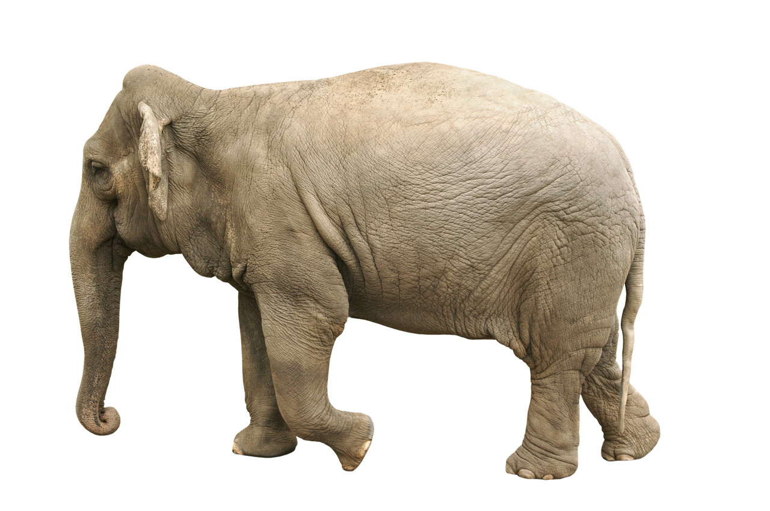
2. What may be bigger than the elephant?
3. Where do African elephants live?
4. What are Asiatic elephants also known as?
5. Name two qualities elephants have.
6. What can elephants be trained to do?
7. Who are a threat to the African elephants?
8. Quote the sentence which shows elephants live in different places.
9. What does a herd consist of?
10. What do you think ‘elephant in distress’ means?

(Close Reading Pack 4 - Passage 2)

Smart Ice-Cream

Now I knew his secret. That rat Dadian had been eating Smart Ice-Cream; that’s how he got one hundred for maths. I knew there couldn’t be anyone as clever as me. I decided to fix Peppi up once and for all. I took out the bolt cutters and cut the locks off the four bins; then I put sand into every bin in the van. Except for the Smart Ice-Cream. I didn’t put any sand in that.

I laughed to myself. Peppi wouldn’t sell much ice-cream now. Not unless he started a new flavour – Sand Ice-Cream. I looked at the Smart Ice-Cream. I decided to eat some; it couldn’t do any harm. Not that I needed it – I was already about as smart as you could get. Anyway, I gave it a try. I ate the lot. Once I started I couldn’t stop. It tasted good. It was delicious.

I left the van and went home to bed, but I couldn’t sleep. To tell the truth, I didn’t feel too good. So I decided to write this. Then if any funny business has been going on you people will know what happened. I think I have made a mistake. I don’t think Dadian did get any Smart Ice-Cream.
(From Smart Ice-Cream by Paul Jennings)

**************************


1. What secret does he now know?
2. Dadian recently performed well in which subject?
3. Who is going to be ‘fixed up’?
4. What were the bolt cutters used for?
5. What was put into the bins?
6. Why was he laughing to himself?
7. What would the new flavour of ice-cream have to be called?
8. How much Smart Ice-Cream did he eat?
9. Where did he go when he left the van?
10. What is the mistake he thinks he’s made?
(Close Reading Pack 4 - Passage 3)

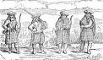
The Highland Clearances

For a time towards the end of the late 18th century, it looked as though crofting might provide a decent living for ordinary Highlanders. They began to cultivate a new crop, the potato, which grew so well that even a small croft could produce enough food to feed a family. Highlanders also made money by fishing for herring, making whisky and gathering kelp – a kind of seaweed, which when burnt, produces soda used to manufacture soap and glass.

Unfortunately, by 1815 the weaknesses of the crofting system were also becoming all too obvious. As families grew, crofts were split up between children. The plots of farmland became smaller than ever, and crofters became poorer. A cheap chemical substitute for kelp was invented, and herring fishing proved to be very unreliable. Crofters found it increasingly difficult to pay their rents.

At the same time, sheep farming became more profitable, as Scotland’s growing towns and cities demanded mutton to eat and textile mills needed wool to make into cloth. Gradually crofters began to be turned off their land to make way for more sheep.
(From Scotland by Mike Hirst)

**************************

- What does the word ‘cultivate’ mean?
- Why did it seem like the potato was a good crop to grow on crofts?
- In what other ways could crofters make a living?
- How do we know that the passage is going to go on to talk about negative things in paragraph 2?
- In your own words, explain why crofters became poorer.
- Why did their other methods of making money start to fail?
- Explain in your own words why the demand for sheep grew?
- What happened to the crofters as a result?

Riding the Silver Wave

He ran into the water and plunged into a wave. I just stood there and watched, not knowing what to do. Then I lost him and I wondered if I should follow or go for help. Ratso had vanished too. I panicked. I thought they had both drowned, then suddenly the waves parted and I saw them: Craig thrashing through the water; Ratso too far out and in trouble.

I didn’t think twice after that. Craig was going to need all the help he could get and I knew it. I flung myself onto my board and paddled as fast as I could, but I was only halfway out when I saw Ratso go under. A wave rolled over me and I came up just in time to see Craig pull him up again. Then another wave hit me and I lost sight of them.

I suppose I should have known. I suppose I should have realized something was very wrong when I saw the boy sitting cross-legged on his board. The waves didn’t seem to touch him. He was drifting through them like they weren’t even there, but he had his back to me so I couldn’t see him properly. It was only when I was closer that I noticed how thin and skinny he was. Only then did I notice his hair was like plaited seaweed and that his surfboard was glowing electric blue in the water.
(From Riding the Silver Wave by Ben Bo)

**************************

1. Which verb describes how he entered the water?
2. Name the dilemma facing the narrator.
3. What does the narrator think has happened to the two boys?
4. What does the narrator fling himself on to?
5. Where is the narrator when Ratso goes under?
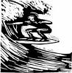
6. What happens when the second wave hits the narrator?
7. When does the narrator realize something is wrong?
8. Why could the narrator not see ‘him’ properly?
9. Name one adjective to describe this strange boy.
10. Which simile describes the boy’s hair?
(Close Reading Pack 4 - Passage 5)

Foxes

Some farmers say that foxes will attack sheep. This is probably not true. Foxes only hunt small animals, unless they are very hungry. But they will eat any dead animals they find. Dead animals are called ‘carrion’.

When there is plenty of food, a fox will often bury some to eat later. It digs a hole in the ground and uses its nose to cover up the food with earth and leaves. The store is called a ‘cache’. Sometimes, the fox marks the spot with its smell so it can find the cache more easily.

In winter, food is often hard to find. Many of the insects have died. There are no berries and the ground is too hard for digging. Small animals like voles and mice make tunnels under the snow. The fox waits until it hears an animal scuttling along one of these ‘runs’. Then it starts to dig into the run. After a while, the fox stops, listens and starts to dig again. It may have to dig into lots of different runs before it finds enough to eat.
(From Foxes by Keith Taylor)

**************************
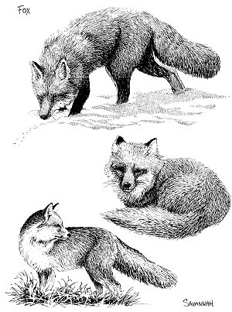
1. What ‘untrue’ claim do farmers make about foxes?
2. Which types of animals do foxes hunt?
3. What is ‘carrion’?
4. When there is plenty of food, what will a fox do?
5. Which body part does a fox use to hide the food?
6. What name is given to this hidden food?
7. What helps the fox find the hidden supply more easily?
8. Name two things which make winter difficult for foxes.
9. Which animals make tunnels under snow?
10. How does a fox detect these animals?

(Close Reading Pack 4 - Passage 6)

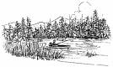

Gone Fishing

William liked days out. They were better than being at school, and sometimes they went to quite interesting places. Things happened too, like when Malcolm, who was very greedy, threw up in the coach, and one of the girls fainted. And there was the time at the zoo when Sandra fell into the penguin pool, and he’d gone off by himself, not known the time and kept everyone waiting. Becca, who always knew everything, claimed he’d been eaten by a lion.

William hadn’t wasted much time on the lion, which looked so mangy and bad-tempered it probably would have eaten someone, given half a chance. He’d made for the small mammal house, where he peered into dimly lit windows at animals who only came out when it was dark. It was a pity there wouldn’t be a small mammal house at Bardon Hall.

But there was water. As the coach crossed a grey stone bridge, William saw on either side an expanse of water so wide that there were small islands on it. He wished at once that he’d brought his rod, though Mrs Butler would probably have made him leave it behind.
(From Gone Fishing by Jean Richardson)

**************************

1. Why did William like days out?
2. What type of person was Malcolm?
3. What happened to Sandra?
4. Why was everyone kept waiting?
5. What was Becca’s outrageous claim?
6. Which two adjectives describe the lion?
7. Where did William head for at the zoo?
8. When did the animals come out?
9. What was William happy to see at Bardon Hall?
10. What did William wish he had brought with him?

(Close Reading Pack 4 - Passage 7)

Dairy

Eating more than our bodies need means we put on weight. So to keep a healthy weight it is important to follow a balanced diet and keep physically active. The fat content of dairy products varies a lot, and much of this fat is saturated fat, which can raise cholesterol and is linked to heart disease. So although eating dairy products won’t make you fat, some are high in saturated fat and you should only eat small amounts or eat them less often. Or, you could choose reduced fat versions instead.

Dairy products such as milk, cheese and yoghurt are a really important part of a healthy balanced diet because they are great sources of protein and vitamins A, B12 and D. They’re also an important source of calcium, which helps to keep our bones strong. This is important for everyone but if you’re into sport you’ll already know how crucial this is.

The calcium in dairy foods is easy for the body to absorb. Cutting out dairy products can be bad for your health because you could be missing out on these nutrients. Semi-skimmed, skimmed milk and low fat yoghurts contain at least the same amount of protein, B vitamins, calcium, magnesium, phosphorous, potassium and zinc as full fat versions. They just contain less saturated fat.
(From www.eatwell.gov.uk)

**************************

1. What makes us put on weight?
2. Which two things are important to maintain a healthy weight?
3. What are the dangers of saturated fat?
4. Which products contain vitamin B12?
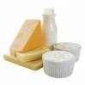
5. What is necessary for strong bones?
6. Choose another word which means the same as ‘crucial’.
7. What does ‘easy for the body to absorb’ mean?
8. Why is cutting out dairy bad for your health?
9. Name two things contained in low fat dairy products.
10. What is the only difference between full and low fat dairy products?
(Close Reading Pack 4 - Passage 8)

Dan, Dan the Half-Time Man

The team looked about as lively as a row of last year’s turnips. They didn’t believe they could win any more. Dan was worried they were going to break up and where would that leave him? He wasn’t even good enough for a free transfer. An orange squirted in his eye. He couldn’t see the point in having oranges. All the players did was have a quick slurp and toss them to the ground. What a way to treat his little segments.

Then an idea kicked off in his brain and ran up the wing. Play began, but he was so busy thinking that he didn’t see Gita’s clumsy tackle that gave the other side a penalty. He was so busy thinking, he didn’t notice Jim the Goalie tread on his own boot-laces as he tried to save the penalty. He was so busy thinking, he barely heard Sid’s vicious comments as he lumbered on to the pitch with his plate at half-time. He’d got it! The idea bounced twice round his skull and hit the back of the net. He couldn’t wait to get home.

Everyone was out so he had the kitchen to himself. He was going to concoct something. Something to wake them up. Something to make them win.
(From Dan,Dan the Half-time Man by Burchett and Vogler)

**************************

- What simile is used to describe how the team looked?
- What does this suggest about them?
- What word could describe how he team feel at this point?
- What is Dan’s job in the team?
- What phrases are repeated in paragraph 2 and why?
- Which verb suggests he went clumsily onto the pitch at half time?
- Why do you think the writer uses such a short sentence in ‘He’d got it!’
- What technique is used to show the idea went round in his head?
- Why do you think the writer uses this?
- What does the last paragraph lead to you to think Dan will do?

Australia

The first inhabitants of Australia were the Aborigines, who migrated there at least 40,000 years ago from Southeast Asia. There may have been between a half million to a full million Aborigines at the time of European settlement.

Dutch, Portugese and Spanish ships sighted Australia in the 17th century; the Dutch landed at the Gulf of Carpentaria in 1606. In 1616 the territory became known as New Holland. The British arrived in 1688, but it was not until Captain James Cook’s voyage in 1770 that Great Britain claimed possession of the vast island, calling it New South Wales. A British penal colony was set up at Port Jackson (what is now Sydney) in 1788, and about 161,000 transported English convicts were settled there until the system was suspended in 1839.

Free settlers and former prisoners established six colonies. Various gold rushes attracted settlers, as did the mining of other minerals. Sheep farming and grain soon grew into important economic enterprises. The six colonies became states and in 1901 federated into the Commonwealth of Australia with a constitution that incorporated British parliamentary and U.S. federal traditions. Australia became known for its liberal legislation, free compulsory education, the secret ballot, women’s suffrage and sickness and old-age pensions.
(From www.infoplease.com)

**************************

1. Who were Australia’s first inhabitants?
2. How long ago did these people migrate there?
3. How many people were there at the time of European settlement?
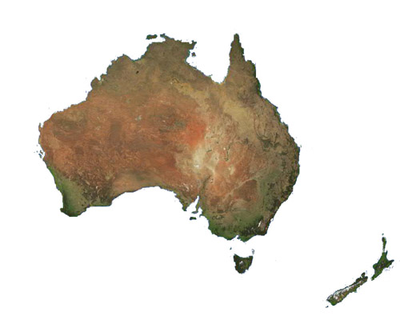
4. When and where did the Dutch land in Australia?
5. Who allowed Britain to claim the island?
6. What do you think the word ‘possession’ means?
7. What was Sydney formerly called?
8. What attracted settlers to the six colonies?
9. Name two things which became important to the economy.
10. What does the word ‘incorporated’ mean?
(Close Reading Pack 4 - Passage 10)

The Ghost Behind the Wall

It had started with him just forgetting where he put things - teaspoons and cups, his keys, his wallet. It was so frustrating; he always used to have a memory like a jewel. Next, he’d started not recognising things. It wasn’t just faces or people. It was everyday things. The first time it happened in a big way, it had been with a teapot. He saw it on the cooker and he just hadn’t got a clue what it was. "Whatever is that thing? What on earth is it for?" he muttered to himself. He thought it looked hilarious, with its fat body and its funny, bendy, spouty thing sticking out. He had to keep going into the kitchen to have another look at it and laugh. "What a stupid-looking thing!" he giggled. Hilarious! Then he forgot that he didn’t know what it was for and made himself a cup of tea, and it wasn’t until the next day that he suddenly remembered that he’d forgotten what it was for three whole hours.

In one way it was quite funny. He’d enjoyed not knowing what a teapot was, it had been good fun. You saw things so freshly. But it was very worrying nonetheless.

The next thing was he’d started finding himself with no memory at all of what he’d been doing for the past hours or minutes. The other day he had found himself with a pair of scissors in his hands busy cutting his trousers in half.
(From The Ghost Behind the Wall by Melvin Burgess)

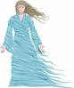
**************************

1. Name the four items he started forgetting.
2. Which word describes how he felt by this?
3. Which simile describes how his mind used to be?
4. What was the next stage in his memory lapses?
5. What object really baffled him one day?
6. Which word describes how this object appeared to him?
7. Why did he keep going into the kitchen?
8. How long had he forgotten what the object was for?
9. Why did he find this so funny?
10. What was he doing with the scissors?
(Close Reading Pack 4 - Passage 11)

Italy

The migration of Indo-European peoples into Italy probably began about 2000B.C. and continued down to 1000B.C. From about the 9th century B.C. until it was overthrown by the Romans in the 3rd century B.C., the Etruscan civilization dominated the area. By 264 B.C. all Italy south of Cisalpine Gaul was under the leadership of Rome. For the next seven centuries, until the barbarian invasions destroyed by the western Roman Empire in the 4th and 5th centuries A.D. , the history of Italy is largely the history of Rome. From 800 on, the Holy Roman Emperors, Roman Catholic popes, Normans and Saracens all vied for control over various segments of the Italian peninsula. Numerous city-states, such as Venice and Genoa, whose political and commercial rivalries were intense, and many small principalities flourished in the late Middle Ages. Although Italy remained politically fragmented for centuries, it became the cultural centre of the Western world from the 13th to the 16th century.

In 1713, after the War of the Spanish Succession, Milan, Naples and Sardinia were handed over to the Hapsburgs of Austria, which lost some of its Italian territories in 1735. After 1800, Italy was unified by Napoleon, who crowned himself king of Italy in 1805; but with the Congress of Vienna in 1815, Austria once again became the dominant power in a disunited Italy.
(From www.infoplease.com)

**************************

1. What began around 2000B.C.?
2. When did the Romans overthrow the area?
3. Where did Rome control by 264B.C.?
4. When did the barbarian invasions take place?
5. Name two groups who vied for control of the peninsula.
6. What does the word ‘intense’ mean?
7. What did Italy become from the 13th to 16th century?
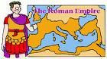
8. Name two areas handed over to the Hapsburgs.
9. Who later unified Italy?
10. What does the word ‘dominant’ mean?

(Close Reading Pack 4 - Passage 12)

The Turbulent Term of Tyke Tyler

Our school is one of the oldest in the country, state schools, that is. So old that it has beams in the roof, which leak when it rains, and windows so high that you can’t see out of them. And the bogs, well, you’d think they’d been built in Roman times except that Sir tells us that these Roman guys were fantastic plumbers, so it seems most likely that they date from the Dark Ages instead. Rusty corrugated iron roof, worm-eaten seats, flaking white-washed walls, wreathed in snaky pipes lagged in old sackcloth, and above all this a loft, high up and hard to get at, stuffed with books, chairs, scenery, costumes, papers, pictures. Old Buggsy, the caretaker, goes up about once a year on a ladder.

I’ve been up there, as well. I think I’m the only kid in the school that has. You see, I like climbing. It feels good.
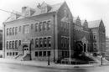
So, bearing in mind that at any moment somebody might find out about the missing money, I clambered on to a cistern, over the pipes, up to a gap, swung across quite a wide space, climbed a bit more, and was suddenly there among all the junk. I didn’t hang about. I pushed the tenner behind a picture of that sailor pointing out the Atlantic, or some other sea, to Sir Walter Raleigh.
(From Tyke Tyler by Gene Kemp)

**************************

1. How old is the school?
2. What normally happens when it rains?
3. What do you think the ‘bogs’ are?
4. What did the Romans have a talent for?
5. Which adjective is used to describe the roof?
6. Name all six items the loft is stuffed with.
7. How often does the caretaker go into the loft?
8. Why is Tyke the only person to have been in the loft?
9. How much money is Tyke trying to hide?
10. Who is the sailor pointing out the sea to?
(Close Reading Pack 4 - Passage 13)

The Olympic Torch

The ancient Greeks believed that fire was given to humankind by Prometheus, and considered fire to have sacred qualities. Mirrors were used to focus the sun’s rays to ignite flames that would burn perpetually in front of Greek temples. Greek rituals also included torch relays, although this was not actually part of the Olympic games.

Today, the Olympic flame is lit in front of the ruins of the temple of Hera in Olympia, Greece. The flame emphasises the connection between the ancient games and the modern ones. In the past, a high priestess of the Temple of Hera would light the flame using a skaphia, the ancestor of parabolic mirrors.

The modern use of the Olympic flame began in 1936. It coincided with the advent of a long relay of runners carrying torches to bring the flame from Olympia to the site of the games. Once there, the torch is used to light a cauldron that remains lit until it is extinguished in the closing ceremony of the games. The first such relay took place for the 1936 Berlin Games. Some 3300 runners brought the flame through Greece, Bulgaria, Yugoslavia, Hungary, Austria, Czechoslovakia and Germany. Similar relays have taken place for every Summer Olympics since.
(From www.infoplease.com)

**************************

1. Where did the ancient Greeks believe fire came from?
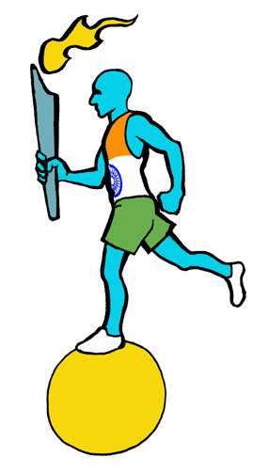
2. What was used to focus the sun’s rays?
3. What does the word ‘perpetually’ mean?
4. Name something included in Greek rituals.
5. Where is the flame lit today?
6. What does the flame emphasise?
7. Explain what ‘ancestor’ means.
8. When did the modern use of the flame begin?
9. What does ‘extinguished’ mean?
10. How many runners carried the torch in 1936?
(Close Reading Pack 4 - Passage 14)

The King’s College

When William had first received my letter telling him of my plans to make this trip to Aberdeen, and asking if I might lodge with him, he had taken it as a sign that I had emerged from that black tunnel of despair that I had hidden myself in since my disgrace. He had written back to me almost instantly, suggesting that we should seek out some old friends of our student days who were to be in the Old Town at the time of my visit. My first impulse had been to say no, I could not face it, but Jaffray dissuaded me from being so hasty. Now the meeting no longer filled me with dread. Indeed the thought of seeing those friends again gave me some pleasure. "I will be glad to see them," I said. "But as for the morning, I mean to use it to examine your uncle’s notebooks. Jaffray is sure that if the flower used to poison Patrick Davidson is to be found, it will be found there."

"Then you must use my study. The light there is the best in the house, and it is the room furthest from the kitchen, so you will have peace. What these women find to gossip and cackle about all day long, I do not know. I am sure old Duncan only pretends at deafness to save himself having to listen to them. Is that not right, Duncan?"
(From Alexander Seaton by Shona Maclean)

**************************

1. Who does the narrator write to?
2. Which metaphor describes the narrator after his disgrace?
3. Explain what ‘almost instantly’ means.
4. Where were the old friends going to be?
5. Explain what ‘dissuaded’ means.
6. What was used to poison Patrick?
7. Name two benefits the study has.
8. Choose another word for ‘peace’.
9. What do the women do all day?
10. Who is pretending to be deaf?

(Close Reading Pack 4 - Passage 15)

Paula Abdul

Paula Abdul is a singer and choreographer who serves as a judge on the American talent show ‘American Idol’. She grew up in Southern California and became a cheerleader for the Los Angeles Lakers in the early 1980s. She earned a reputation as a choreographer which led to a job as an assistant dance director for The Jacksons, which in turn led to a job choreographing videos for Janet Jackson’s album ‘Control”. In the late 1980s and early ‘90s, Abdul worked in choreography for television and film and had a string of pop hits of her own. Her debut album, 1988’s ‘Forever Your Girl’, produced four top hits, including ‘Straight Up’. Her second album ‘Spellbound’ also did well, but her third ‘Head Over Heels’ (1995) was less successful and Abdul’s personal life was topsy-turvy too. She divorced her husband, the actor Emilio Estevez, recovered from an eating disorder and successfully fought off a lawsuit by a backup singer who claimed to be the main singer of several tracks on ‘Forever Your Girl’.

By the late 1990s, Abdul was back focusing on her choreography, having abandoned her recording career. Since 2002 she has been a judge on ‘American Idol’, where she is very well known for her sometimes heated arguments with fellow judge, and British born celebrity, Simon Cowell.
(From www.factmonster.com)

**************************


1. What are Paula Abdul’s two main talents?
2. Where did she grow up?
3. What was she in the early 1980s?
4. What was her involvement with Janet Jackson?
5. Explain what a ‘debut album’ is.
6. Name one of her four top hits.
7. When did she release her third album?
8. Who was she married to?
9. What was her backup singer claiming?
10. Explain what ‘abandoned her recording career’ means.

(Close Reading Pack 4 - Passage 16)

Don’t Open Your Eyes

Diesel’s parents had talked about getting a proper house with a proper garden for years and years. She had shared the dream for as long as she could remember. She had pictures in her memory box that she had drawn when she was five years old – with trees that looked like green lollipops, and human beings that were triangles or rectangles, with round heads and crooked legs sticking out at odd angles – titled Our New House. The house in those pictures – a triangle on top of a square, with a curly pig’s tail of smoke sticking out of a chimneypot – had never happened. There had always been something in the way, either not enough money or no houses of the right kind to be found. Now the dream was real.

She looked down from the window of her new bedroom into their new back garden. It had a long rectangle of tufty lawn, untidy flower borders; and a greenhouse at the bottom. The garden of the empty house next door was more interesting. She could see into it over the wall. There were full-grown trees growing there, far too big for a back garden. Through their branches she could see things lurking, like shipwrecks on the green seabed of grass and weeds. Old furniture, and wasn’t that a supermarket trolley? And maybe parts of a motorbike? She decided she would investigate. It didn’t look as if it would be hard to climb over.
(From Don’t Open Your Eyes by Ann Halam)

**************************


1. What had Diesel’s parents talked about getting for years?
2. Where did Diesel keep her pictures?
3. What did the trees in her pictures look like?
4. Which two shapes made up the house in her pictures?
5. Where is Diesel looking out from?
6. Which adjective describes the flower borders?
7. What sits at the bottom of Diesel’s new garden?
8. Which two words describe Diesel’s feelings about her neighbour’s garden?
9. Name two items Diesel sees in her neighbour’s garden.
10. What does Diesel decide to do now?

(Close Reading Pack 4 - Passage 17)

Tony Blair

Tony Blair became the youngest British Prime Minister of the 20th century when he took office in 1997. Blair was born in Scotland but spent much of his childhood in Durham, England. He studied Law at Oxford and then practised law until 1983, when he was elected as a member of Parliament for Sedgefield. Blair was a member of the Labour Party, which at the time was dominated politically by the Conservative Party of Margaret Thatcher. Blair was soon a rising star of what became known as the ‘new Labour’ movement, with positions more centrist on fiscal affairs and social issues like crime. He became leader of the Labour Party in 1994, and three years later was named Prime Minister, replacing John Major, when Labour won a Parliamentary majority.

Blair was just 44 years old when he was elected making him the youngest British Prime Minister since Lord Liverpool in 1812. Blair was often compared with the sitting U.S. President Bill Clinton when he took office in 1993, at the age of 46. Blair was re-elected in Parliamentary elections in 2001 and again in 2005. He stepped down as the Prime Minister on 27th June 2007 and was succeeded by the Chancellor of the Exchequer, Gordon Brown.
(From www.factmonster.com)

**************************

1. When did Tony Blair take office?
2. Where did he spend much of his childhood?
3. What did he study at University?
4. Where was he member of Parliament for?
5. Who was leader of the Conservatives at this time?
6. Explain what the word ‘dominated’ means.
7. Name two issues which became centrist under new Labour.
8. Who did he replace in the 1997 election?
9. Explain what ‘stepped down’ means.
10. Name the three election years Blair won.

(Close Reading Pack 4 - Passage 18)

Charlie and the Chocolate Factory

There is something about very cold weather that gives one an enormous appetite. Most of us find ourselves beginning to crave rich steaming stews and hot apple pies and all kinds of delicious warming dishes; and because we are all a great deal luckier than we realize, we usually get what we want- or near enough. But Charlie Bucket never got what he wanted because the family couldn’t afford it, and as the cold weather went on and on, he became ravenously and desperately hungry. Both bars of chocolate, the birthday one and the one Grandpa Joe had bought, had long since been nibbled away, and all he got now were those thin, cabbagy meals three times a day.

Then all at once, the meals became even thinner.

The reason for this was that the toothpaste factory, the place where Mr Bucket worked, suddenly went bust and had to close down. Quickly, Mr Bucket tried to get another job. But he had no luck. In the end, the only way in which he managed to earn a few pennies was by shovelling snow in the streets. But it wasn’t enough to buy even a quarter of the food that seven people needed. The situation became desperate. Breakfast was a single slice of bread for each person now, and lunch was maybe half a boiled potato.
(From Charlie and the Chocolate Factory by Roald Dahl)

**************************

1. What does very cold weather do to people?
2. Name two dishes people crave in this weather.
3. Why was Charlie not as lucky as most people?
4. Write down two words to describe how hungry Charlie was.
5. Where did the two bars of chocolate come from?

6. How often does Charlie get ‘cabbagy meals’?
7. Where did Mr Bucket used to work?
8. Why does Mr Bucket need to look for another job?
9. How many people does Mr Bucket need to feed?
10. What does each person have for breakfast?
(Close Reading Pack 4 - Passage 19)

Susan Anthony

Susan Brownell Anthony was born in 1820 and died in 1906. She was an American reformer and leader of the woman-suffrage movement, working to gain women the right to vote. From the age of 17, when she was a teacher in rural New York state, she campaigned for equal pay for women teachers, for coeducation, and for college training for girls. When the Sons of Temperance refused to admit women to their movement, she organised the first women’s temperance association called the Daughters of Temperance. Susan Anthony lectured on women’s rights and on abolition and, along with Cady Staton, secured the first laws in the New York state legislature guaranteeing women rights over their children and control of property and wages.

In 1872 she led a group of women to the polls in Rochester, New York, to test the right of women to vote under the terms of the Fourteenth Amendment. Her arrest, trial, and sentence to a fine (which she refused to pay) were a cause celebre; other women followed her example until the case was decided against them by the U.S.Supreme Court. From 1869 she travelled and lectured throughout the United States and Europe. The secret of her power, aside from her superior intellect and strong personality, was her unswerving singleness of purpose.
(From www.factmonster.com)

**************************

1. How old was Susan Anthony when she died?
2. What was the suffrage movement fighting for?
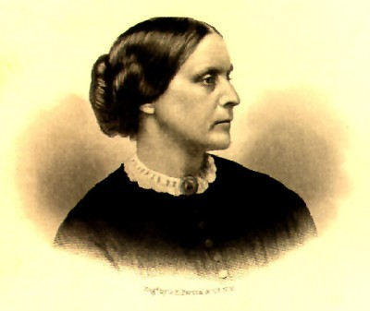
3. What did she work as at age 17?
4. Who refused to admit women?
5. Name the subjects Anthony lectured on.
6. What did the New York state laws guarantee?
7. What did Anthony do in 1872?
8. What punishment was given to her?
9. Where did she lecture from 1869?
10. Explain what ‘superior intellect’ means.
(Close Reading Pack 4 - Passage 20)

ANSWERS

4-1(The Secret of City Cemetery)
1. joy/delight
2. workmen
3. very poor people
4. winter frost
5. clever
6. next to playground
7. graves
8. when it was good or dry or nice enough/allow them to continue
9. ghosts
10. other kids did

4-2 (Elephants)
1. largest land animal
2. whales
3. Africa, south of Sahara
4. Indian
5. strength &intelligence
6. carrying logs
7. poachers
8. do not have permanent homes
9. one or more families
10. in danger or difficulty

4-3 (Smart Ice – Cream)
1. Dadian ate smart ice cream
2. maths
3. Peppi
4. cut locks off bins
5. sand
6. Peppi couldn’t sell ice cream
7. sand ice cream
8. the lot/all
9. bed
10. doesn’t think Dadian ate any

4-4 (The Highland Clearances)
1. late 18th century
2. potato
3. fishing/whisky/kelp
4. soap & glass
5. by 1815
6. families grew
7. cheap chemical
8. pay rent
9. sheep farming
10. turned out to make room for sheep

4-5 (Riding the Silver Wave)
1. ran or plunged
2. follow or get help
3. both drowned
4. his board
5. halfway out
6. loses sight of them
7. sees boy sitting cross legged on board
8. he had his back to him
9. thin/skinny
10. like plaited seaweed

4-6 (Foxes)
1. attack sheep
2. small animals
3. dead animals
4. bury to eat later
5. nose
6. cache
7. marks spot with smell
8. insects die/no berries/ground frozen
9. voles & mice
10. stops to listen

4-7 (Gone Fishing)
1. better than being at school
2. greedy
3. fell into penguin pool
4. gone off alone
5. been eaten by a lion
6. mangy & bad tempered
7. small mammal house
8. dark
9. water
10. rod

4-8 (Dairy)
1. eat more than need
2. balanced diet & activity/exercise
3. raise cholesterol/link to heart disease
4. milk, cheese, yoghurt
5. calcium
6. essential/necessary
7. body can digest or use easily
8. miss nutrients
9. magnesium, phosphorous, potassium, zinc
10. less saturated fat

4-9 (Dan, Dan the Half – Time Man
1. row of last year’s turnips
2. that they could win
3. break up
4. orange squirts in it
5. players slurp then toss to ground
6. idea
7. Gita’s clumsy tackle
8. tread on bootlaces
9. lumbered
10. kitchen

4-10 (Australia)
1. Aborigines
2. at least 40,000 years ago
3. half million to million
4. Gulf of Carpentaria 1606
5. Capt. James Cook
6. own/control
7. Port Jackson
8. gold rushes/mining
9. sheep farming & grain
10. included

4-11 (The Ghost Behind the Wall)
1. teaspoons/cups/keys/wallet
2. frustrating
3. memory like a jewel
4. not recognising things
5. teapot
6. hilarious
7. to look and laugh
8. 3 hours
9. good fun/enjoyed not knowing
10. cut trousers in half

4-12 (Italy)
1. migration of Indo Europeans to Italy
2. 3rd century BC
3. Italy south of Cisalpine Gaul
4. 4th & 5th century AD
5. Emperors, Popes, Normans, Saracens
6. powerful/serious
7. cultural centre of western Europe
8. Milan, Naples, Sardinia
9. Napoleon
10. in control/powerful/important

4-13 (Tyke Tyler)
1. one of oldest in country
2. roof leaks
3. toilets
4. plumbing
5. rusty/iron
6. books/chairs/scenery/costumes/
paper/pictures
7. once a year
8. likes climbing
9. ten pounds
10. Sir Walter Raleigh

4-14 (The Olympic Torch)
1. Prometheus
2. mirrors
3. constantly/continually
4. torch relays
5. temple of Hera
6. connection between ancient & modern games
7. relative
8. 1936
9. put out
10. 3300

4-15 (King's College)
1. William
2. black tunnel of despair
3. straight away/very quickly
4. Old Town
5. persuaded not to or against
6. flower
7. light best/furthest from kitchen
8. quiet
9. gossip and cackle
10. Duncan

4-16 (Paula Abdul)
1. singer & choreographer
2. Southern California
3. cheerleader
4. choreographed videos for ‘Control’
5. first one
6. Straight Up
7. 1995
8. Emilio Estevez
9. that she had sang tracks
10. put aside/gave up on it

4-17 (Don't Open Your Eyes)
1. house with garden
2. memory box
3. green lollipops
4. triangle & square
5. window of bedroom
6. untidy
7. greenhouse
8. more interesting
9. furniture/trolley/motorbike
10. to investigate

4-18 (Tony Blair)
1. 1997
2. Durham
3. Law
4. Sedgefield
5. Margaret Thatcher
6. controlled/directed/influenced by 7. fiscal affairs & social issues
8. John Major
9. passed over control/resigned from
10. 1997,2001,2005

4-19 (Charlie and the Chocolate Factory)
1. gives enormous appetite
2. stews, hot apple pies
3. couldn’t afford it
4. ravenously/desperately
5. birthday & grandpa Joe
6. 3 times
7. toothpaste factory
8. factory went bust & closed down 9. 7
10. one slice of bread

4-20 (Susan Anthony)
1. 86
2. women the right to vote
3. teacher
4. Sons of Temperance
5. women’s rights and abolition
6. women rights over children and control of property and wages
7. led women to polls
8. a fine
9. USA & Europe
10. highly intelligent/ gifted intellectually/ academically brilliant

