S2 Close Reading:
Homework Booklet
Fiction and Non-Fiction
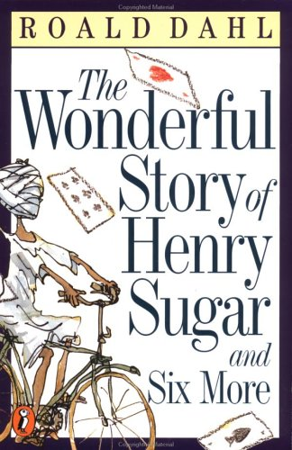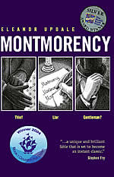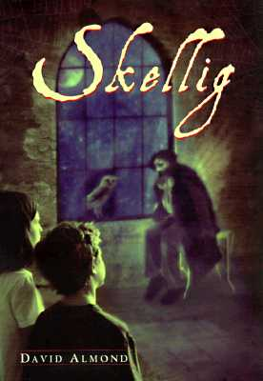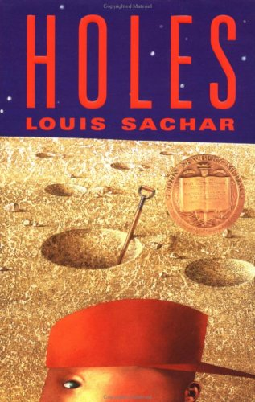

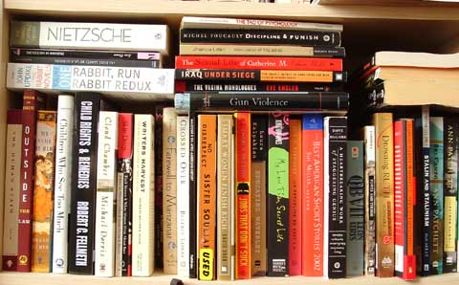
Section A - Fiction
Contents:

Exercise One: Skellig
Exercise Two: Roll of Thunder Hear My Cry
Exercise Three: Montmorency
Exercise Four: The House on the Hill
Exercise Five: Going Solo
Exercise Six: The Wonderful World of Henry Sugar
Exercise Seven: The Call of the Wild
Exercise Eight: Mrs Frisby and the Rats of Nimh
Exercise Nine: The Flour Babies
Exercise Ten: Whispers in the Graveyard
Exercise Eleven: Holes



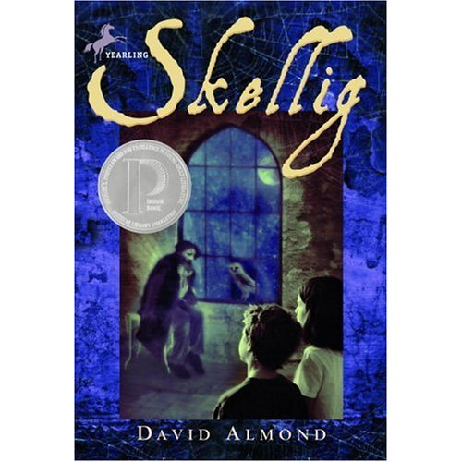
Exercise One
Below is an extract from the novel ‘Skellig’. It describes how a boy named Michael and his family move into a new house. Michael goes out to the garage to explore and finds a strange man who seems to have been there for a long time.

I nearly got into the garage that Sunday morning. I took my own torch and shone it in. The outside doors to the back lane must have fallen off years ago and there were dozens of massive planks nailed across the entrance. The timbers holding the roof were rotten and the roof was sagging in. The bits if the floor you could see between the rubbish were full of cracks and holes. The people that took the rubbish out of the house were supposed to take it out of the garage as well, but they took one look at the place and said they wouldn’t go in it even for danger money. There were old chests of drawers and broken wash-basins and bags of cement, ancient doors leaning against the walls, deck chairs with the cloth seats rotted away. Great rolls of rope and cable hung from nails. Heaps of water pipes and great boxes of rusty nails were scattered on the floor. Everything was covered in dust and spiders’ webs. There was mortar that had fallen from the walls. There was a little window in one of the walls but it was filthy and there were rolls of cracked lino standing in front of it. The place stank of rot and dust. Even the bricks were crumbling like they couldn’t bear the weight any more. It was like the whole thing was sick of itself and would collapse in a heap and have to get bulldozed away.

Questions:
- Where does Michael go on Sunday morning?
- In your own words describe what the entrance to the garage and the roof looks like.
- Explain why the garage had not been cleared out.
- Look at the sentence that begins “There were old chests…” what do you notice about the length of the sentence? Why do you think it has been written like this?
- Pick out a phrase that describes what the garage smelled like.
(6a) Write down the phrase the writer uses which makes the
garage sound as if it has feelings.
(6b) Identify the technique the writer uses.
(7) In your own words describe what Michael thinks will happen to
the garage.
- Find out the meanings of the following words and write their
definitions: timbers, sagging and bulldozed.
- Use each word in an interesting sentence.


Exercise Two
Below is an extract from the novel ‘Roll of Thunder Hear my Cry’. It describes what life is like for Cassie who is a young black girl living in Mississippi in the 1930s which could be a very dangerous place for Black people because of some racist attitudes.
I started to climb back up into the porch but froze as a caravan of headlights appeared suddenly in the east, coming fast along the rain-soaked road like cats eyes in the night. Jason whined loudly, growing skittish as the lights approached, and when they slowed and braked before the house he slunk beneath the porch. I wanted to follow, but I couldn’t. My legs would not move.
The lead car swung into the muddy driveway and a shadowy figure outlined by the headlight of the car behind him stepped out. The man walked slowly up the drive.
I stopped breathing.
The driver of the next car got out, waiting. The first man stopped and stared at the house for several long moments as if uncertain whether it was the correct destination. The he shook his head, and without a word returned to his car. With a wave of his hand he sent the other driver back inside, and in less that a minute the lead car had backed into the road, its headlights facing the other cars. Each of the cars used the driveway to turn around, then the caravan sped away as swiftly as it had come, its seven pairs of rear lights glowing like distant red embers until they were swallowed from view by the Granger forest.

Questions:
- In the opening sentence the speaker describes seeing ‘…a caravan of headlights…’.In your own words explain what she means by this.
- A) Identify and quote the technique the writer uses in sentence one.
2) B) Why is it effective?
- In your own words explain how Jason feels when he sees the lights approaching.
- What does Jason do when the cars stop?
- Look at the last two sentences in Paragraph One. What do you notice about the length of the sentences? Why do you think they have been written like this?
- The writer describes the man who gets out of the car as being “… a shadowy figure…” Give two reasons why she might describe him like this.
- Explain why you think the writer has made Paragraph Three so short “I stopped breathing.”
- A) When the cars leave the house the writer describes their lights as “glowing like distant red embers…”. Identify the technique used.
8) B) Why is it effective?
9) Find out the meanings of the following words and write their definitions: skittish, slunk and
embers.
Use each word in an interesting sentence.

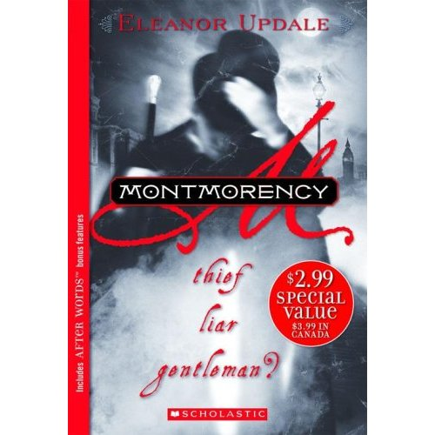
Exercise Three
Below is an extract from the novel ‘Monmorency’. It is set in Victorian London and tells the story of a man who leads a double life; he is a gentleman by day and a thief by night.
From his room, on days when the smoke from London’s chimneys had not curdled the fog into smog, he had a clear view of the enormous green space that was one of the town’s lungs. If he went on to the balcony, he could look down on the chaotic traffic: an undisciplined sprawl of horses, carriages and pedestrians, and then across the road to the calm of the park. In the early morning, shop workers, and even some of the Marimion’s own staff could be seen hurrying along the paths, anxious to get to work, and hardly noticing their surroundings at all. Later, children would play with balls or hoops, and wealthier adults walked at a more leisurely pace. He observed how the men conducted themselves: how they wore their clothes, held their gloves and used their canes. He saw them stop, bow forward slightly and mechanically lift their hats when they met an acquaintance coming the other way.
Questions:
- Why do you notice about the length of the opening sentence?
(1b) Why do you think the sentence has been written like this?
(2a) Identify and quote the technique the writer uses in the opening
sentence.
(2b) Why is it effective?
(3) In your own words describe what he can see if he looks from his
Balcony.
- Explain the contrast (differences) in what he sees.
- Pick out one word that describes how the staff of the Marimion walked to work and one word that describes how the wealthier adults walked.
- Pick out three things that he notices about how the men behave.
- Pick out one word which shows that these men are used to behaving a particular way.
- Find out the meanings of the following words and write their definitions: curdled, smog, sprawl, conducted, mechanically and acquaintance
- Use each word in an interesting sentence

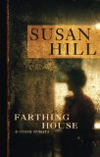
Exercise Four
Below is an extract from ‘The House on the Hill’. It tells the story of two cousins who go to stay with their aunt in her old spooky mansion. They discover a secret room which hides a secret.

Now it was November. Fireworks had their season, wet yellow leaves lay like skin on the pavements of Knightshill, and glistening black trees were everywhere adrip. Each afternoon, fawnish fog slipped up the river, blanketing the low-lying parts of the city, and coiling lazily upwards into Wisteria Avenue. The old Gothic mansions took on the appearance of castles in a ghost story, with their pointed roofs and ornamental turrets wrapped in gauzy scarves of mist. In the garden of The Mount, every tree wept sadly, and Jane took to filling hot-water bottles for the children before she went off to bed.
For Philip and Susan it was a waiting time. Although the light under the door continued to shine, they had no inclination to investigate further. The information in Ewan MacNeil’s letter to Hamish Gilmore, interesting though it was, did not immediately seem to lead to any further discovery. So, as Susan said, there was nothing for it but to wait and see what happened next. But what did happen next was so unexpected, and so upsetting, that it drove all thoughts of eerie rooms and past events from their minds, for a considerable time to come.
Questions:
(1a) Identify and quote the techniquethe writer uses in the second
sentence.
(1b) Why is it effective?
(2a) In your own words describe how the fog moves once the
afternoon arrives.
(2b) Pick out any two words that describe the movement of the
fog.
(3) Explain what each word tells you about how the fog moved.
Describe the overall tone of the first paragraph
(4a) Identify and quote the technique used in the sentence that begins “In
the garden of The Mount...”
(4b) Explain why it is effective.
(5a)What do you notice about the length of the sentence at the
beginning of the second paragraph?
(5b)Why is it effective?
(6a) How would you describe the tone that is created by the final
sentence?
(6b) Pick out two words that help to create the tone.
Find out the meanings of the following words and write their
definitions: adrip, fawnish, ornamental, gauzy and inclination.
Use each word in an interesting sentence.
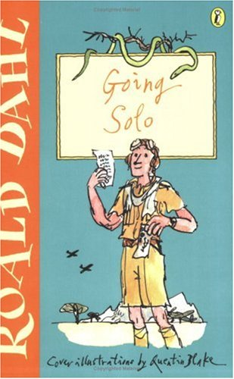
Exercise Five
Below is an extract from ‘Going Solo’. It is the second part of Roald Dahl’s life story. It tells of his adventures in Africa when he was a young man.
Only once did I see any elephant. I saw a big tusker and his cow and their one baby moving slowly forward in line astern about fifty yards from the road on the edge of the forest. I stopped the car to watch them but I did not get out. The elephants never saw me and I was able to stay gazing at them for quite a while. A great sense of peace and serenity seemed to surround these massive, slow-moving, gentle beasts. Their skin hung loose over their bodies like suits they had inherited from larger ancestors, with the trousers ridiculously baggy. Like the giraffes they were vegetarians and did not have to hunt or kill in order to survive in the jungle, and no other wild beast would ever dare to threaten them. Only the foul humans in the shape of an occasional big-game hunter or an ivory poacher were to be feared, but this small elephant family did not look as though they had yet met any of these horrors. They seemed to be leading a life of absolute contentment.

Questions:
- What do you notice about the length of the opening sentence?
- Why do you think it has been written like this?
- Why do you think the writer does not get out of the car to watch the elephants?
- In your own words describe the feeling that the writer says these animals give off.
- Identify and quote the technique the writer uses to describe their
skin.
- Explain why it is effective.
- What do elephants have in common with giraffes?
- Who is the elephants’ only enemy?
- What is the writer’s attitude towards the elephants’ enemy?
- Pick out one word that conveys his attitude.
- Find out the meanings of the following words and write their
definitions: tusker, astern, serenity and ancestors.
- Use each word in an interesting sentence.

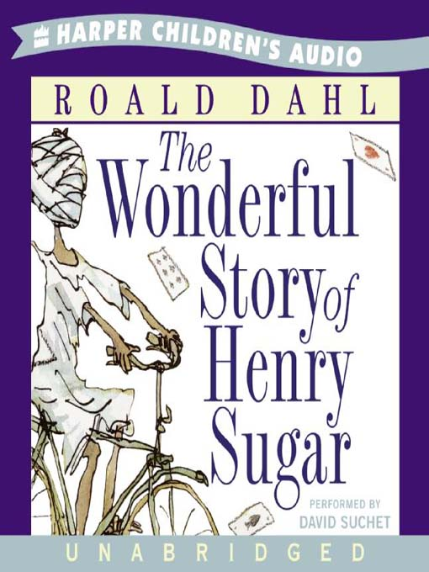
Exercise Six
Below is an extract from ‘The Wonderful World of Henry Sugar’. It tells the story of a successful businessman who is very self-centred and vain.
Henry Sugar was forty-one years old and unmarried. He was also wealthy. He was wealthy because he had had a rich father who was now dead. He was unmarried because he was too selfish to share any of his money with a wife.
He was six feet two inches tall, but he wasn’t really as good-looking as he thought he was.
He paid a great deal of attention to his clothes. He went to an expensive tailor for his suits, to a shirtmaker for his shirts, and to a bootmaker for his shoes.
He used a costly aftershave lotion on his face, and he kept his hands soft with a cream that contained turtle oil.
His hairdresser trimmed his hair once every ten days, and he always took a manicure at the same time.
His upper front teeth had been capped at incredible expense because the originals had had a rather nasty yellowish tinge. A small mole had been removed from his left cheek by a plastic surgeon.
He drove a Ferrari car which must have cost him about the same as a country cottage.

Questions:
(1)In your own words explain why Henry Sugar has so much money and
why he has never married.
(2) What does he look like? Give 4 different points.
(3) What special ingredient does his hand cream contain?
(4) Pick out a phrase which emphasises how much money he spends
on his teeth.
(5)In your own words explain why he spends so much money on his teeth.
(6) What is the overall impression you get of Henry Sugar?
(7) Find out the meanings of the following words and write the definitions: manicure, capped and tinge.
(8) Use each word in an interesting sentence.

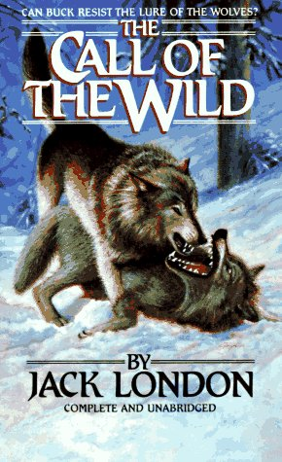
Exercise Seven
Below is an extract from ‘Call of the Wild’ which tells the story of a dog called Buck who lives in California and is stolen from his owners by gold diggers to help them find gold and become rich.
And through it all Buck staggered along at the head of the team as in a nightmare. He pulled when he could; when he could no longer pull, he fell down and remained down till blows from whip or club drove him to his feet again. All the stiffness and gloss had gone out of his beautiful furry coat. The hair hung down, limp and draggled, or matted with dried blood where Hal’s club had bruised him. His muscles had wasted away to knotty strings, and the flesh pads had disappeared, so that each rib and every bone in his frame were outlined cleanly through the loose hide that was wrinkled in folds of emptiness. It was heartbreaking, only Buck’s heart was unbreakable. The man in the red sweater had proved that.
As it was with Buck. So it was with his mates. They were perambulating skeletons. There were seven all together, including him. In their very great misery they had become insensible to the bite of the lash or the bruise of the club. The pain of the beating was dull and distant, just as the things their eyes saw and their ears heard seemed dull and distant. They were not half living, or quarter living. They were simply so many bags of bones in which sparks of life fluttered down in the traces like dead dogs, and the spark dimmed and paled and seemed to go out.
Questions:
(1) Why do you think the writer says that Buck ‘staggered’ along the Road?
(2) Pick out an expression that reveals how exhausted he was.
(3) In your own words explain what it was that made him get back up
again
(4) In what ways had Buck’s appearance changed? Answer in your own
words.
(5) Look at the sentence that begins “His muscles had wasted away…” What do you
notice about the length of the sentence? Why do you think is has been written like
this?
(6) Look at the sentence “As it was with Buck”. How does this sentence link the first and
second paragraphs together?
(7) Pick out a phrase which emphasizes how thin all the dogs
were.
(8a) Look at the sentence that begins “The pain of the beating…” What technique
does the writer use?
(8b) Why is it effective?
(9) What is the overall tone of the passage?
(10) Find out the meanings of the following words: draggled, knotty perambulating and
insensible.
(11) Use each word in an interesting sentence.
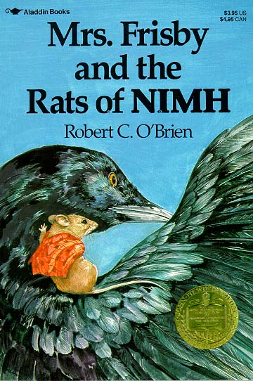
Exercise Eight
Below is an extract from ‘Mrs Frisby and the Rats of Nimh’ which tells the story of Mrs Frisby and her family. Their nest is about to be ploughed over by the farmer so she seeks advice from an owl who tells her to ask the rats of Nimh for help.
She might, she thought, go back to Mr Ages and see if he had any ideas that would help. Was there some medicine that would make Timothy get strong sooner? She doubted it; surely if he had such medicine he would have given it to her the first time. She was thinking about this when she climbed out through the knot hole and slithered to the ground below – not ten feet from the cat.
Dragon lay stretched out in the sunlight, but he was not asleep. His head was up and his yellow eyes were open, staring in her direction. She gasped in terror and whirled around the fence post to put it between her and him. Then, without pausing, she set out on a dash across the garden as fast as she could run, expecting at any instant to hear the cat’s scream and feel his great claws on her back. She reached the shrew’s hole and considered for a fraction of a second diving into it, but it was too small.
Then she glanced back over her shoulder and saw an amazing sight. The cat had not moved at all! He was lying exactly as before, except that now one of his eyes was closed. The other, however, was still looking straight at her, so she did not pause, but raced on.
Finally when she was a safe distance away – two-thirds across the garden and nearly home – she stopped and looked again more carefully. The cat still lay there and seemed to have gone to sleep. That was so odd – so unheard of – she could hardly believe it. Feeling quite safe, but puzzled, she looked for a vantage point from which she could see better. By rights, she should be dead, and though she had escaped by what seemed almost a miracle, she scolded herself for having been so careless. If the cat had killed her, who would take care of her children?

Questions:
(1) What is the main thing on Mrs Frisby’s mind when she leaves her home?
(2) The writer says that she ‘slithered’ to the ground. Why is this a good word to use to
describe her movements?
(3) Pick out a phrase which shows Mrs Frisby’s surprise at seeing Dragon the cat.
(4) Pick out one word that writer uses to describe the speed of Mrs Frisby.
(5) Why does Mrs Frisby not jump into the shrew’s hole?
(6) Look at the third paragraph that beings “Finally when she was a safe distance away…”.
Name the punctuation used and explain why you think it is effective.
(7) It says that Mrs Frisby looked for a ‘vantage point’. In your own words explain what this
means. How did the paragraph help you to arrive at the meaning?
(8) Find out the meanings of the following words and write their definitions: slithered,
whirled and vantage point.
(9) Use each word in an interesting sentence.

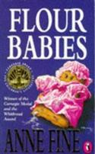
Exercise Nine
Below is an extract from a novel called ‘The Flour Babies’. It tells the story of a boy called Simon Martin who becomes involved in a project looking after imaginary babies made from bags of flour.
The place he chose was a bush a few yards behind the one goal still flooded in sunlight. He thrust the flour baby into the rather meagre greenery, desperately hoping she would appear to be no more than a bundle of towel to the circle of his team mates already booting the ball to one another in the warm-up. Mr Fuller was watching him dangerously, arms folded, from the side of the pitch. But still Simon took his time, wedging the flour baby firmly into the bush. Mr Fuller was the least of his problems. At least now the snoopers couldn’t pick on him. She was there, in sight, and she was clean and safe. Mr Fuller could punish him for being late by giving him fifty press-ups. But if Simon got thrown off the flour baby project, he might miss The Glorious Explosion.
And it was going to be brilliant. That much he knew. Once or twice since Mr Cartwright dealt out the flour babies, Simon had suffered moments of doubt. It struck him that he might somehow have misheard the conversation in the staffroom, or missed the point. And even if he hadn’t, one question still remained to be answered. Was the whole business worth it? After all, it wasn’t generally Simon’s way to stick at a project for the length of a lesson, let alone for a whole three weeks. Would any – Could any explosion Mr Cartwright had to offer be worth the grind of dragging this flour baby around, keeping her clean, for twenty-one days of his life?

Questions:
- Why does Simon stand next to the bush at the beginning of the
passage?
- The writer says that “He thrust the flour baby into ...greenery.”
Why do you think the writer chooses to use the word “thrust”?
- In your own words explain why Simon is not too concerned about
the fact that his football coach is watching him do this?
- Why does Simon not want to be thrown off the project?
- Look at the opening sentence of Paragraph Two. Why does the
writer put the word brilliant in italics?
- How does this sentence act as a link in the passage?
(7a) In your own words describe what the Flour Baby Project is.
(7b) What do you think the purpose of this experiment is?
(8) Find out the meanings of the following words and write their
definitions: meagre, snoopers and misheard.
(9) Write each word in an interesting sentence of your own.
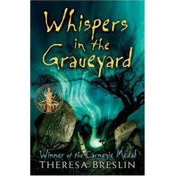
Exercise Ten
Below is an extract from a novel called ‘Whispers in the Graveyard’. It tells the story of a boy called Solomon who discovers a sinister secret in his local graveyard.
It’s almost midnight when I get home. He’s flaked out on the couch, mouth open. The telly’s talking loudly to itself. I pause before drawing the curtains over.
The world news. Images of starving children and warring adults are reflected on my window panes. The lights in the street beyond and the houses opposite are ghostly shadows. Are the pictures which I see captured on the glass a distortion or for real? I shut the blinds and they disappear.
When I was younger I thought that the people on the telly were actually there. Then at night when the set was turned off, they got smaller and smaller, and slid down the cables all the way to London or wherever. In Primary Five the teacher explained to the class how television worked. I remember thinking that my idea was more sensible.
I try not to look at him lying there like a felled tree, jaw slack, face worn and stubbly. I throw a travelling rug over him and go through to the kitchen.
I just leave the mess. I don’t have the energy to clear up this war zone. I find some bread and make myself a sandwich and go upstairs.
As I take my jeans off I find the notice which I took from the graveyard earlier. I spread out the crumpled paper on the floor and peer at it closely. It’s too difficult for me to work out what it says. I’ve a problem with print for as long as I can remember. From the very first reading book I ever had.
Questions:
(1a) Look closely at the Paragraph One. What do you notice about the length of the sentences?
(1b) Why do you think they have been written like this?
(2)In your own words describe what Solomon’s father is doing when he returns home.
(3) Pick out a phrase which shows that Solomon finds his street quite frightening.
(4) How did Solomon think television worked when he was younger?
(5) Pick out an example of informal language in Paragraph Three.
(6a) Look at Paragraph Three “I try not to look at him...” Identify the technique Solomon uses to describe his father’s appearance.
(6b) Why is it a good description of his father?
(7)When Solomon goes upstairs he tries to read a notice but says he has difficulty doing so. What do you think his problem might be?
(8)Find out the meanings of the following words and write their definitions: captured, distortion, sensible and slack.
(9) Use each word in an interesting sentence.


Exercise Eleven
Below is an extract from ‘Holes’. It tells the story of Stanley Velnats whose punishment is to dig hole after hole in the burning desert at a juvenile detention centre.As his story unfolds, so does that of his ancestors. Will Stanley be able to dig up the truth before he falls victim to the family curse?
The sun was almost directly overhead. He figured he could walk for no more than another hour, maybe two, before he had to turn back.
It seemed pointless. He could see there was nothing ahead of him. Nothing but emptiness. He was hot, tired, hungry, and, most of all, thirsty. Maybe he should just turn around now. Maybe he’d already gone halfway and didn’t know it.
Then, looking around, he saw a pool of water less than a hundred yards away from where he was standing. He closed his eyes and opened them to make sure he wasn’t imagining it. The pool was still there.
He hurried toward it. The pool hurried away from him, moving as he moved, stopping when he stopped.
There wasn’t any water. It was a mirage caused by the shimmering waves of heat rising off the dry ground.
He kept walking. He still carried the empty sack of sunflower seeds. He didn’t know if he might find something to put in it.
After a while he thought he could make out the shape of the mountains through the haze. At first he wasn’t sure if this was another kind of mirage, but the farther he walked, the clearer they came into a view. Almost straight ahead of him, he could see what looked like a fist, with its thumb sticking up.
Questions:
(1a) Look at the second paragraph “It seemed pointless…” What do you notice about the length
of the sentences?
(1b) Why do you think they have been written like this?
(2a) Look at the last two sentences of Paragraph Two. Pick out one word that the writer
repeats.
(2b) Why do you think it is repeated?
(3) Why does Stanley close his eyes in Paragraph Three?
(4) “It was all a mirage…” In your own words explain what a ‘mirage’ is.
(5a) Identify and quote the technique used to describe the heat.
(5b) Why is it effective?
(6) Look at Paragraph Six “He kept walking…” Why do you think the
chooses to start every sentence with the word “He”?
(7a) Look at the sentence in the last paragraph that begins “At first he wasn’t sure if this
was another mirage…”. What do you notice about the length of the sentence?
(7b) Why do you think it has been written like this?
(8) Find out the meanings of the following words and write their definitions: mirage,
shimmering and haze.
(9) Use each word in an interesting sentence.
Non Fiction Close Reading Exercises
Section B – Non – Fiction
Contents Page:

Exercise One: ‘Diamond Dogs’
Exercise Two: ‘Teen Reading – A Contradiction in Terms?’
Exercise Three: ‘Why plastic is the scourge of sea life.’
Exercise Four: ‘Spectacles? Cool? Can’t see it, myself.’
Exercise Five: ‘Afghan girl defies death threats over Olympics’
Exercise Six: ‘Only Snobs sneer at McDiploma Graduates.’
Exercise Seven: ‘Let adult fatties eat themselves to death. The kids we can save.’
Exercise Eight: ‘Save our Sundays- shut all the shops.’
Exercise Nine: ‘Is our children reading?’
Exercise Ten: ‘Scientists develop non-stick gum’


Exercise One

Diamond Dogs

From canine cocktail gowns to poochy perfumes- pampering your pet is now at a whole new level, says Danny Buckland
The elegant coat is designer indulgence, the diamonds are sparkling and, with the scent of a fine perfume lingering, there is more than a hint of diva in the air. Hair care is with organic products, naturally, and nail polish and a boutique handbag add a little extra glitz.
But this little vignette of super style has a surprising twist. For once, it is the celebrities who are under-dressed as dogs take centre stage in a fashion trend that is confounding market forces – and, some might say, common sense.
Barely a decade ago, the canine accessory list was functional rather than fashionable with leather leads, a rubber bone, flea powder with a tartan waistcoat fastened with Velcro forming the basic wardrobe. Now the inventory stretches across frontline design houses such as Hermes, Chanel, Aquascutum and Ralph Lauren.
It is easy to view pet pampering as the preserve of slightly mad celebrities adopting miniature dogs as fashion statements and, as some psychologists would contend, comfort blankets against a hostile world. But, whatever the motives of pooch-toting stars such as Paris Hilton, Nicole Richie, Sandra Bullock and Charlotte Church, it seems that it is not only the famous who are going crazy for canine couture.

Excerpt from The Sunday Express

Questions:

- What technique does the writer use in the title?
- Find another example of this from the passage.
- Find three words from paragraph one which suggest that only the very best is suitable for the dogs.
- What is the ‘surprising twist’ mentioned in paragraph two?
- Why is a dash used at the end of paragraph two?
- Explain in your own words what the difference is between ‘functional’ and ‘fashionable’.
- How does the writer show the extent of this trend at the end of paragraph three through sentence structure?
- Choose a phrase from paragraph four which suggests that the dogs provide security for celebrities.
- Dictionary work: What does ‘vignette’ mean?
Use this word in a sentence.
Exercise Two
Teen Reading – A Contradiction in Terms? 

“Today’s young people are exposed to a wider variety of reading material than any previous generation,” according to Honor Wilson-Fletcher, director of the National Year of Reading, because of the explosion of digital media.
A report: ‘Read up, Fed up: Exploring Teen Reading Habits in the UK today’ does seem to establish that young people are reading different things from previous generations, and responding in a different way. In the list of things they love to read, magazines and blogs feature higher than books and the loathed list is dominated by material teenagers are forced to read.
Song lyrics and computer game cheats may not rank alongside ‘War and Peace’ in terms of sustained reading but they do add to a picture of a varied reading diet which includes some old favourites and some surprises. A typical teenage perversity is evident in the lists. Although ‘Bliss’ and ‘Heat’ rank at the top of the “loved” material, the fourth most loathed item is “reading about skinny celebrities in magazines”. The Harry Potter series features in both the most loved list (at 5) and in the most loathed (at 8). Old favourites like ‘The Lion, the Witch and the Wardrobe” are in the loved list while Facebook is loathed.

READ UP: THINGS TEENS LOVE TO READ
- Heat magazine
- =Bliss magazine
2. =Song lyrics online
- Computer game cheats online
- My own online blog or fan fiction
- The Harry Potter series
- Anne Frank’s diary
- Film scripts
- Books by Antony Horowitz
- The Lion, the Witch and the Wardrobe
- = BBC online
- = Books by Louise Rennison

FED UP: THINGS TEENS LOATHE TO READ
- Homework
- Shakespeare
- Books over 100 pages
- Reading about skinny celebrities in magazines
- The books I am made to read by school/my teachers
- Encyclopaedias and dictionaries
- The Beano
- = The Harry Potter series
- = Music (scores)
- = Maps/direction
- Facebook
- = Financial Times
10. = Anything in another language

Questions:

- Paragraph One
Explain in your own words why today’s young people are exposed to a wider variety of reading material than any previous generation.
- Paragraph Two
Why is a colon used after the word ‘report’?
- Explain in your own words what the report establishes.
- Quote one word from paragraph two which suggests the material teenagers are forced to read features heavily in the loathed list.
- What is ironic about the content of the ‘loved’ and ‘loathed’ lists?
- What is number six on the ‘things teens love to read’ list?
- What is joint tenth on the ‘things teens loathe to read’ list?


Exercise Three

Why plastic is the scourge of sea life.

One cigarette lighter, a toothbrush and a toy robot. The list of plastic items recovered from the stomach of a Laysan albatross chick that died on a remote Pacific island reads like a random assortment of everyday household objects.
It is now clear this chick is among many thousands of seabirds that have died from ingesting plastic debris, and nowhere in the world seems to be too isolated for this deadly form of marine pollution.
Dutch scientists have found that more than nine out of ten European fulmars – seabirds that eat at sea – die with plastic rubbish in their stomachs. A study of 560 fulmars from eight countries revealed they had ingested an average of 44 plastic items. The stomach of one fulmar that died in Belgium contained 1,603 separate scraps of plastic.
Birds are not the only ones to suffer. Turtles, whales, seals and sea lions have all eaten plastic. It is estimated that much of the plastic rubbish that fell into the sea 50 years ago is till there today, either floating in the huge circulating “gyres” of the Pacific or sitting on the seabed waiting to be gobbled up by a passing sea creature.
It is estimated that the amount of plastic we are consuming will continue to grow substantially, by as much as a third in the space of a single decade in the case of each American consumer.
The only way to deal with the growing threat plastic poses to wildlife and the environment is to curb our consumption and to no longer treat plastic as an innocuous disposable commodity. Indeed, there is now a case for it to be treated as a potentially toxic waste product with the stiffest sanctions for its desultory disposal.

Extract from The Independent 5th Feb 2008

Questions:

- What three items were found in the chick’s stomach?
- Explain in your own words why ‘many thousands of seabirds…have died’. (Paragraph two)
- Explain why the writer has uses parenthesis in paragraph three.
- How many scraps of plastic were found in the stomach of one fulmar that died in Belgium?
- How does the sentence structure emphasise the damage plastic causes in paragraph four?
- What phrase in the final paragraph means to lessen our use of?
- Dictionary work: What does ‘innocuous’ mean?
- What word used later in the passage means the opposite of ‘innocuous’?

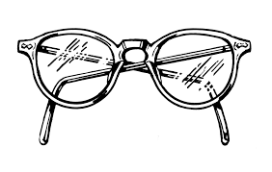
Exercise Four
Spectacles? Cool? Can’t see it, myself.
One of the pivotal events of my school career occurred when I was seven.
My teacher, Mrs Soames, had noticed that I was struggling to read what she was writing on the blackboard. In fact, to get a decent view of what she was writing, I needed to get so near the blackboard I practically ended up with chalk on my nose. Soon she tired of my constant trips to the front of the class and my mother was informed that I needed a sight test.
The optician prescribed me glasses- to be precise, one pair of standard issue National Health specs of the type specifically designed to maximise the humiliation for any child. They worked a treat. From being a kid with poor eyesight and moderately high esteem I became a kid with good eyesight and low self esteem.
I was at the time the only myopic pupil in the class, though soon I was joined by some of the other smaller, weedier pupils. In an instant my football career was almost dead. If I wanted to head the ball, it meant leaping athletically while removing my glasses in the same instant, then putting them back on to see where the ball had gone – this stuff never happened to Johann Cruyff.
Then there was the shape of the glasses. They were round – so was my name. This lead to some hilarious jokes. The jokes got even better a couple of years later when I switched to square frames (you could probably make up your own here).
Then there was the attitude of my classmates who now saw me as a swot. My teachers, unimpressed with my progress, had me down for a dunce. Glasses were ruining my life.
Thankfully, it seems that the current generation of children are not going through this experience. According to a new survey, kids with glasses are now seen as cool. Indeed, 43% of speccy four-eyed (I’m sorry – I mean bespectacled) children now claim that having the right pair of glasses make them more popular than their deprived un-myopic mates. They cite the influence of Johnny Depp and Harry Potter for making specs acceptable, which is ironic because Harry wears precisely the same kind of glasses which ruined my own image in the 70s.
Questions:
1) Which word from paragraph one tells us that this was an important event?
2) What is the effect of the dash used in paragraph two?
3) Comment on the sentence structure used in line ten.
4) Explain in your own words the change the glasses brought about. (paragraph three)
5) Which word from paragraph four means to be short sighted?
6) Explain why the dash is used at the end of paragraph four.
7) Paragraph six - What contrasting views did the classmates and the teachers have of
Simon Round?
8) Which two celebrities have made glasses popular?
9) What is ‘ironic’ about this?
10 a) How would you describe the overall tone of the passage?
b) Quote one piece of evidence for this.
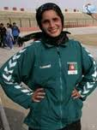
Exercise Five

Afghan girl defies death threats over Olympics
By Tom Coghlan in Kabul

A teenage athlete has overcome a campaign of intimidation including death threats to become the only female member of the team to represent Afghanistan at the Beijing Olympics.
Mehboba Ahdyar, a shy 19-year-old from Kabul, will face the worlds best 1,500 metre runners in August wearing a veil and a baggy tracksuit.
While she is unlikely to mount the winner’s podium, few of her opponents will have endured such a perilous training regime to get them to the games. Training for Mehboba begins after nightfall. It is the only time when, as a woman, she can supplement her official training sessions without threats or harassment.
She recently had to destroy the Sim card on her mobile phone because the number had become known to fundamentalists who bombarded her with death threats.
“They say that they will not leave me alive,” she said, with a shrug.
In spite of the taunts and death threats, she insists she will run for national pride.
“I will compete against heroes,” she said, although she could not name any of the world’s leading middle-distance runners. “We have trained for three years. I hope for a medal or at least to break Afghan’s record.”

Daily Telegraph 29 March 2008

Questions:

- Paragraph One
Explain in your own words what Mehboba Andyar has overcome.
- a) What will she be wearing at the Olympics?
b) Why do you think this is?
(3) Quote the word which shows that the training schedule was
dangerous.
- Paragraph three
What does the word ‘bombarded’ suggest about the number of death threats she received?
- “They say that they will not leave me alive,” she said, with a
shrug.
What does this suggest about her attitude towards her opposers?
- a) What is interesting about Mehboba’s knowledge about the
other competing athletes?
b) Can you think of an explanation for this?

Exercise Six

Only Snobs Sneer at McDiploma Graduates

‘Do you want fries with that A Level?’ First we had McJobs and now we have McDiplomas, with news that the burger giant has been accredited to give out qualifications.
Cue a welter of jokes about BScs in burger flipping, and accusations that the Qualifications and Curriculum Authority is dumbing down our education system. But all this hilarity has exposed a rich vein of snobbery in British society, not just about fast food and American business values but also about the lower reaches of the service industry.
What McDonald’s will offer is a basic shift manager’s course – a qualification which shows that the young person has learned what needs to be known about the day to day running of a restaurant. Is this any different from the old idea of the butcher’s or baker’s apprentice learning the shop trade?
Now, some may say McDonald’s may not be the most wholesome of eateries, and there may be nutritional and ethical qualms about their products. But no one can argue that McDonalds is not a phenomenally successful business which has got that way by giving people something they want in the most efficient and cost-effective manner.

Extract from an article in the ‘Manchester Evening News’ 30th January 2008

Questions:

- Quote the phrase in paragraph one which shows that McDonalds are a huge company.
- Paragraph two
Explain in your own words what the reactions to the news of the qualifications have shown.
- Paragraph three
Why do you think the writer uses a question here?
- Paragraph four
Quote the word which shows there are concerns about McDonalds as a business.
- Explain in your own words the positive aspects of McDonalds.
- a) Dictionary work
Find out the meaning of the word ‘ethical’.
b) Use this word in a sentence.

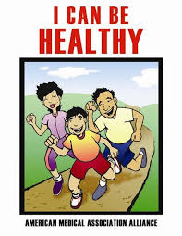
Exercise Seven

Let adult fatties eat themselves to death. The kids we can save.
Janet Street-Porter

If the government really wants to tackle obesity, it should channel all its resources into getting the young fit and healthy.
According to our Prime Minister, obesity is ‘one of the biggest threats’ we face. For some time now politicians have employed the same terminology to talk about health issues as they do about waging wars – which generally entails maiming and killing people. Being fat isn’t acceptable – it’s talked about as an ‘epidemic’ or a ‘battle’ that must be fought, just like operations in Afghanistan and Iraq.
It does seem a bit rich to use such emotive language to describe nothing more than a plethora of love handles or beer guts. And I’m not sure that spending millions of pounds on public service advertising telling us what we all know already – if you eat too much you pile on the pounds – isn’t a complete waste of time.
The latest bit of armoury to be deployed against fatties is the extraordinary notion of offering cash or vouchers for leisure centres for successful dieting. The British Heart Foundation is running a competition called The Biggest Loser, which hands out £130 gift vouchers for the entrant who loses the most weight.

Extract from an article in ‘The Independent’ 27 January 2008

Questions:

- Paragraph One
What does the writer think the government should do to tackle obesity?
- a) What technique is used when referring to being fat as a ‘battle’?
b) What does this suggest about the government’s attitude
towards obesity?
- Why is parenthesis used in paragraph three?
- Quote the word used in paragraph four which continues the idea of war.
- a) Dictionary work: Find out the meaning of ‘plethora’.
b) Use this word in a sentence. (1)


Exercise Eight

Save our Sundays – shut all the shops
Mariella Frostrup

In Bilbao recently for a weekend, it took me a little while to figure out why the atmosphere was so different to back home. Then I realised it was a Sunday and that all the shops were closed.
In this country, whether its Chinese New Year or Christmas, Easter or Halloween, we’re out there answering the call of the high street. And if M&S profits go down, it’s a crisis in the economy. We’ve created a system in which our future depends on our ability to shop until we drop.
It makes our talk about global warming just hot air. I’m still not over the cost of Halloween and the Guy Fawkes Day. With pumpkins, fancy dress, fireworks and sweets, the nation’s bill must be in the high millions.
When I was a kid in Ireland, Halloween meant snipping up an old sheet and wafting around the streets in search of pennies from the neighbours. Nowadays, even toddlers wouldn’t be seen dead in a home-made ghoul costume. The streets were littered with children dolled up in the finest fancy dress that money can buy.
The streets and parks of Bilbao were full of families, parents and pushchairs, teenagers and grandparents all strolling about enjoying the sunny winter’s day. If sharing quality time with those we love reduces the stress of modern life, a real day off makes perfect sense.
In the UK by midday on a Sunday, we’re armed with plastic and ready for our next assault on the high street. Maybe it’s time we asked why.

The Observer 11 November 2007
Questions:

1) Paragraph One - Why was the atmosphere different in Bilbao?
2) How does the sentence structure at the beginning of paragraph two emphasise the extent
of our shop opening hours?
3) ‘…we’re out there answering the call of the high street.’
a) What figure of speech is used here?
b) What does this image suggest?
4) Quote the word from paragraph two which suggests less profits means a disaster.
5) ‘It makes our talk about global warming just hot air.’
a) What technique is used here?
b) What does this image suggest?
6) Paragraph four - What does the word ‘littered’ suggest about the number of children
dressed up?
(7) Paragraph five - Explain in your own words the effect of sharing quality time
with those we love.
8) What is the effect of the final sentence?

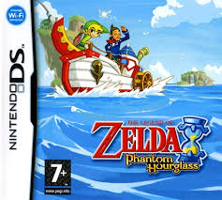
Exercise Nine

Is Our children reading?
Steven Poole
As George Bush nearly asked: “Is our children reading?” The answer appears to be no, according to the 2006 report of the International Literacy Study. As the Guardian summarises its findings: “England has plummeted from third to 19th in an international league table of children’s literacy as pupils replace books with computer games.”
Imagine the headlines 100 years ago: “Children spending too much time playing outdoors with hoops and sticks, says minister; should be forcibly enclosed to study improving literature.” There’s always some apparently pointless youth activity to scapegoat.
As has always been the case, though, the adult paranoia expressed here about the supposedly harmful influence of videogames depends on a sublime ignorance of the form. In fact, you’re not going to get far in most modern videogames if you can’t read. And some of the make you read an awful lot.
So if children are not so much interested in picking up a paperback, maybe that says more about the quality of books currently being foisted upon them than it does about the evils of digital entertainment. Children are, after all, quite discriminating. If someone writes a new Harry Potter, they’ll curl up with it for days. If not, there’s always the games console.

Extract from an article in The Guardian 1 December 2007
Questions:

- What should George Bush have asked?
- Why is a colon used after ‘findings’ in paragraph one?
- What are children meant to be replacing books with?
- Paragraph two
Quote the word which suggests children’s activities are used as an excuse for them not reading.
- Paragraph three
Quote the word which suggests that the writer is not convinced by the argument against videogames.
- Paragraph four
Explain in your own words the reasons given by the writer for children reading less.
- Quote the word which suggests that children make informed
decisions about their reading.
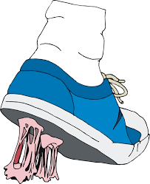
Exercise Ten

Scientists develop non-stick gum
Steve Connor
Non-stick chewing gum which cannot glue itself to pavements, seats or shoes – and with the added bonus of being completely bio-degradable – has been invented by a British scientist in what is thought to be a world first.
The gum contains a new kind of rubber-like polymer that lacks the stickiness of conventional chewing gums, which have become a costly environmental problem for local councils because of the millions of discarded cuds which remain glued to pavements and buildings for years.
Professor Terence Cosgrove of Bristol University said that tests have demonstrated that the non-stick gum can be easily removed from public places by natural processes and that it degrades easily in the presence of water.
Trials in public places have confirmed that the gum is either easy to remove or does not stick at all to pavements and seats. Tasting tests have also shown that it performs just as well as conventional gum.
It is estimated that local councils in Britain spend about £150m a year on removing chewing gum cuds from public places. Meanwhile, chewing gum products are one of the fastest growing areas of the confectionary business, growing by 7% over the past three years.

Extract from The Independent 14 September 2007

Questions:

- How does the sentence structure of the first line emphasise the damage chewing gum causes?
- Paragraph one
Why is parenthesis used here?
- Paragraph two
Explain in your own words what is different about the new chewing gum?
- Paragraph three
Quote the word which shows the chewing gum breaks down into nothing.
- Paragraph four
Summarise the three main advantages of the new chewing gum.
- a) Dictionary work.
Find out what the word ‘estimated’ means.
b) Use this word in a sentence.

