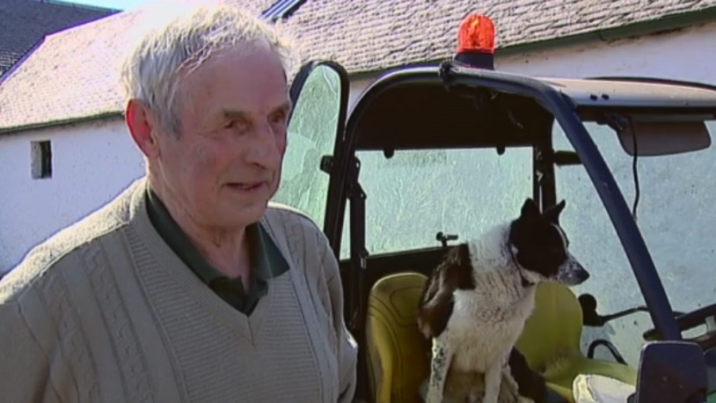
My dog stole my tractor
Farmer Tom Hamilton, with his dog Don and the Gator utility vehicle that Don ‘stole’>

1: I’ve been farming sheep and cattle on this hillside in South Lanarkshire, Scotland for 54 years. I use a John Deere Gator to get about – a utility vehicle bigger than a quad bike but smaller than a tractor. It’s just a little truck with a roll cage, really – it does about 40mph. My black and while border collie, Don, always sits beside me in the passenger seat. I’ve had him about 5 years now, since he was a pup. He’s not the best dog I’ve had, but he’s good enough.
2: It was a little after 8am when I spotted the lost lamb. I was in the top field, near where the motorway cuts through my land. The lamb had become separated from its mother. You have to keep them paired up, so I hopped out of the Gator to tend to it while Don stayed in his seat and watched me through the back window. That’s the way we always work – I leave the door open and if I need any help from Don, I shout and out he comes.
3: Lamb and mother reunited, I turned back to the Gator only to see it lurch suddenly away from me. This was so unexpected it took me a moment to process what was happening. I’d put the handbrake on when I jumped out, as I always do, and I knew Don wasn’t able to release it – had it not engaged properly? I still don’t know how, but it was clear that Don had somehow set the vehicle in motion. He was watching me, without any obvious concern, as the Gator careered away.
4: My stomach lurched as I saw where it was heading. I didn’t even have time to call out, and anyway, what could I have said? My heart seemed to freeze in my chest as I gave chase, praying I’d be able to throw myself through the open door before disaster struck.
5: There was no more than 150 yards to the motorway, and the gap was closing fast. I’m pretty fit for a 77-year-old, but even before I tripped I knew I stood no chance of catching up. I fell heavily, winding myself, and was still picking myself up as the Gator crashed through a wooden fence and plunged out of view. The last thing I saw before it disappeared was Don’s face, gazing benignly back at me.
6: Beyond the fence was a steep, 30ft bank, and at the bottom of that the northbound carriageway of the M74, teeming with rush-hour commuters. I could hear the roar of the traffic. I listened for a sound of an impact or of screeching brakes as I dashed towards the fence, but none came.
7: Heart in mouth, I reached the fence and peered over. Below me, a man in a high-visibility jacket was standing in the road, holding his arms wide to stop oncoming vehicles. He had broken off from a group of road maintenance workers on the hard shoulder. The Gator was resting against the crash barrier in the central reservation, having miraculously crossed three busy lanes. I couldn’t see Don, but as I approached the Gator he leapt out on to the road, apparently unhurt, and dashed back up the bank and out of sight.
Don was unhurt in this ‘incident’ and the farmer was able to repair his vehicle.
Task – Answer the following questions
Before you start, decide the skills you will need for this task. It might be sensible to skim, scan, highlight and underline.

1. Read paragraph 1 again.
a) Identify the word in the second sentence tells us the Gator is basic and useful?
b) Look at the third sentence. Quote two separate words that show the Gator is not a very special vehicle.

2. Read paragraph 2 again.
b) Identify the word that informs us his farm is divided by the road.
c) Explain what the word ‘hopped’ suggests about the way he got out of the Gator.
d) Quote the word that tells us the writer knew that the lamb required care.

3. Now read paragraph 3 again.
a) Explain what the word ‘lurch’ suggests about the way the Gator moved away.
b) ‘…it was clear that Don had somehow set the vehicle in motion.’
Identify the single word here that supports the idea that the writer does not know how Don achieved this.
c) The writer says the Gator ‘careered’ away. Explain what this word suggests about the way the vehicle moved.

4. Read paragraph 4 again.
a) Quote two separate phrases in this paragraph that makes clear the writer felt shocked.
b) Explain what the word ‘throw’ tells us about how he would have to move to get back into the vehicle.

5. Read paragraph 5 again.
a) Explain what the word ‘plunged’ informs the reader about the way the Gator went out of sight.

6. Read paragraph 6 again.
a) Comment on what the word ‘teeming’ suggests about the motorway.
b) Explain what the word ‘dashed’ suggests about how the writer moved.

7. Read paragraph 7 again.
a) Explain what the word ‘miraculously’ suggests about the way the Gator crossed the motorway.

