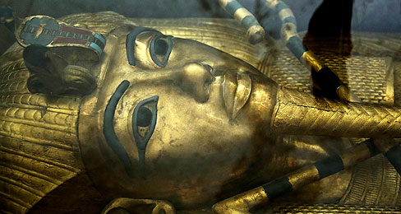
King Tut May Have Company
Does a hidden chamber in the famous pharaoh’s tomb hold the remains of Queen Nerfertiti?
1: King Tutankhamen, an ancient Egyptian pharaoh, died 3,300 years ago. King Tut became pharaoh when he was about 9 years old and ruled for 10 years, until his death. In 1922, the British explorer Howard Carter discovered King Tut's tomb, which was filled with treasures. His remains and burial items, including a gold sarcophagus, are among the most iconic objects associated with ancient Egypt.
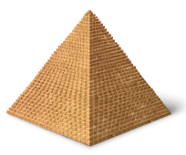
2: Now, archaeologists have a hunch that King Tut may not have been alone in his tomb for all of those centuries. Nicholas Reeves, a British Egyptologist, recently asserted that certain parts of the structure of King Tut’s tomb point to the existence of a hidden chamber behind it. He also said the tomb appears to originally have been designed for a queen, rather than a king.
3: Who might share Tut’s final resting place? According to Reeves it could be Nefertiti, an Egyptian queen and possibly King Tut’s stepmother, who was thought to have died about 10 years before King Tut.
A Tomb for Two
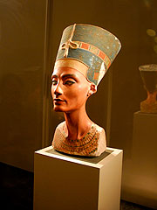
4: According to the new theory, the tomb was originally built for Queen Nefertiti. The chambers where King Tut was buried were added later. King Tut died abruptly, at just 19 years old. Some researchers believe Tut’s burial may have been rushed, leading those in charge of burying him to add to Nefertiti’s existing tomb, rather than build a new one.
5: Archaeologists have been searching for the notorious Nefertiti’s tomb for many years. A statue showing the queen’s head, discovered in 1912, made her renowned in modern times. She is believed to have been extremely beautiful. Her tomb, archaeologists theorise, could hold items even more spectacular than those found with King Tut. Ancient Egyptians buried their dead with many ceremonial items, including statues, masks, illustrated scrolls, and jewellery.
6: Finding Nefertiti’s tomb would be an enormous accomplishment. According to Egypt’s antiquities minister, Mamduh al-Damati, it would be the “most important discovery of the 21st century.”
Ancient History Meets New Technology
7: The next step is for Egyptian officials to get approval for a plan to test Reeves’s theory. Archaeologists will need high-tech radar equipment so they can peek behind the walls of King Tut’s tomb without doing any physical damage. Such technology helps researchers study archaeological sites without the risk of destroying any structures or artefacts.
8: If the proposal to bring in radar equipment is approved, work could start within the next three months. November marks the 93rd anniversary of the discovery of King Tut’s tomb. Finally finding the burial site of his famous stepmother would be a fitting way to mark the occasion.

