Ayr Academy Geography

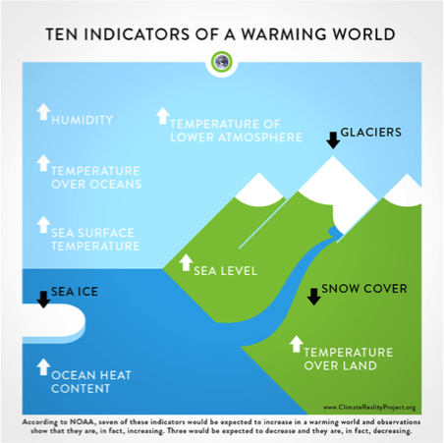



Global Issues

Climate Change

BGE (S3)

**An introduction to Climate Change**

By the end of the lesson I will be able to: 

1. Describe what climate change is.
2. Give at least 3 pieces of evidence that climate change exists.

**Task 1**

**Copy and Complete**

**Climate change** is the process of our planet _________up.

Scientists estimate that since the **Industrial Revolution**, human activity has caused the _________ to warm by approximately **1°C**. While that might not sound like much, it means big things for people and wildlife around the globe.

**Task 2**

Copy the diagram below and add the labels from the table to show how the greenhouse effect works.

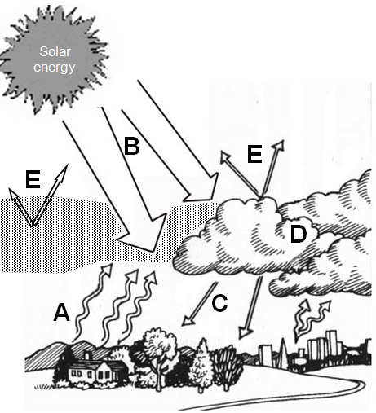

|  |
| --- |
| Solar **energy** from the sun enters the atmosphere |
| Solar energy is **absorbed** by the surface of the earth which then radiates back out as heat **energy** |
| Gasses in the atmosphere such as water vapour and carbon dioxide **absorb** energy **radiated** from the surface, acting like a “trap”. |
| **Energy** is **re-radiated** from these gases* which increases the temperature of the atmosphere. |
| Some heat **energy** either i) is **reflected** by clouds (known as the *Albedo effect*) or ii) escapes the atmosphere disappears out into space |

*\* - These gases include water vapour, carbon dioxide, methane and others*

**Task 3a)**

|  |  |  |  |  |  |  |  |  |  |  |  |
| --- | --- | --- | --- | --- | --- | --- | --- | --- | --- | --- | --- |
|  | 2009 | 2010 | 2011 | 2012 | 2013 | 2014 | 2015 | 2016 | 2017 | 2018 | 2019 |
| Air (°C) | 10 | 12 | 14 | 11 | 11 | 9 | 12 | 15 | 13 | 14 | 15 |

Source: https://climate.gov/news-features/understanding-climate/climate-change-global-temperature

Graph showing global average air and sea temperatures 2009 - 2019



Average temperature °C

**3b)** Using the graph from task 3a describe the changes that have taken place for global air temperature since 2009.

Use the writing frame to help you complete this question.

Overall the global air temperatures have _______________. The greatest increase was between _______ and _______ when the temperature rose by_______°C. The largest fall in temperatures occurred between _________ and ________ where the global temperature decreased by _________°C. Between ________ and _______ the average temperature remained constant at _________°C.

**Evidence – Extra information**

**1. Fossils**  

We can look at the fossils of plants and animals to tell us about the past. Dinosaurs were large lizards. For such large creatures to exist, the climate must have been a lot hotter than it is just now. Scientists believe that they were neither warm nor cold blooded but somewhere in between. In the hot, humid climate of the Jurassic period (200 to 145 million years ago), dinosaurs thrived but around 97million years ago, the climate cooled rapidly and dinosaurs died out in a mass extinction very suddenly.

**2. Tree Rings** 

Trees can live for hundreds, sometimes over one thousand years. They are very sensitive to local climate conditions, experiencing wet years, dry years, cold years, hot years and forest fires.

The rings of a tree tell us how old the tree is but also what the climate was like when the tree was growing. Light coloured rings represent wood growing in spring/early summer and dark rings represent late summer/autumn. The wider the rings are, the warmer and wetter the climate as this is when the tree will have grown rapidly. Narrow rings represent drier/colder conditions where the tree barely grew.

**4. Ice core analysis from Greenland/Antarctica**

Ice cores taken in Antarctica by scientists, like tree rings, the layers of snow that falls, build up over time to form ice. The thicker the layer, the colder/wetter the climate. When snow turns to ice it traps the air in bubbles which can be analysed and tell us what the temperatures were like when the ice formed. The amount of carbon dioxide in each layer found will tell us how cold or warm the climate was. This is because many believe the levels of carbon dioxide in the atmosphere are linked to the average temperature.

**3. Ice loss from Arctic/Antarctic and mountain glaciers**

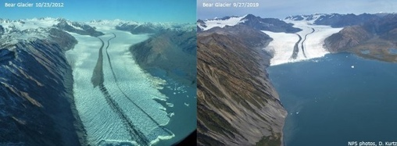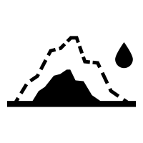

Recent photographic evidence has shown how ice is being lost due to increased global temperatures. Since the late 1970s (40+ years ago) the Arctic ice cap has lost 600,000km2 of ice.

Glaciers, during ice ages, carve out wide deep “U-Shaped” valleys e.g. Rothes Glen/ Drummochter Pass / Glen Roy. Scotland is made up of many U-Shaped valleys, indicating that in the past it was a lot colder and glaciers filled the mountain areas.

**5. Coral Reef growth rings**

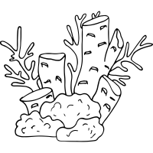Corals have calcium carbonate skeletons. The oceans absorb CO2 from the atmosphere and Corals use the carbon to build their skeletons. Some corals produce growth rings in the same way tree produce growth rings. Coral grows slower when seawater temperature cools producing a narrow ring, and faster when seawater is warm producing a thicker ring.

However, if seawater gets too warm, coral growth suffers, and the coral may die. Looking at the thickness or thinness of growth rings can show how warm or cold the oceans were and this can be used to show how warm or cold the atmosphere was at the time when the coral was alive.

**Physical and Human Causes of Climate Change**

By the end of the lesson I will be able to: 

1. Describe at least 4 physical causes of climate change.
2. Describe at least 4 human causes of climate change.

**Task 4**

Using ICT you should research in detail the causes of climate change. These can be split into two categories: Physical and Human. See the table below for an overview. Many people often think of just the human causes of climate change not realising that physical processes have also had an impact on the global climate.

|  |  |
| --- | --- |
| **Physical Causes** | **Human Causes** |
| Volcanic eruptions | Increased Co2:  *1. Burning fossil fuels*  *2. More vehicles*  *3. Deforestation* |
| Ocean circulation | Increased Methane:  *1. Padi Fields*  *2. Belching cows*  *3. Landfill sites* |
| Tectonic Plates | Increased nitrous oxide:  1. Fertilisers  2. Vehicles |
| Earth’s orbit | Increases CFC’s:  1. Refrigeration  2. Air conditioning |

Sources:

* BBC bitesize – National 5 Geography Climate change
* <https://www.natgeokids.com/uk/discover/geography/general-geography/what-is-climate-change/>
* <https://climatekids.nasa.gov/climate-change-meaning/>
* <https://www.explainthatstuff.com/globalwarmingforkids.htm>
* <https://www.unicef.org/zimbabwe/media/1111/file/Child%20friendly%20climate%20change%20handbook.pdf>

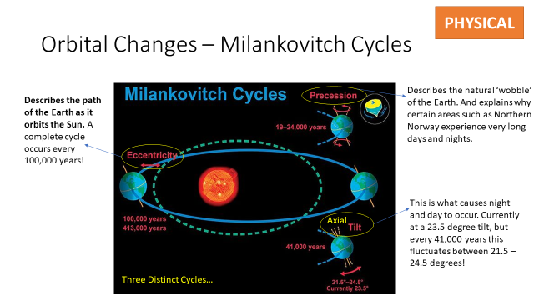

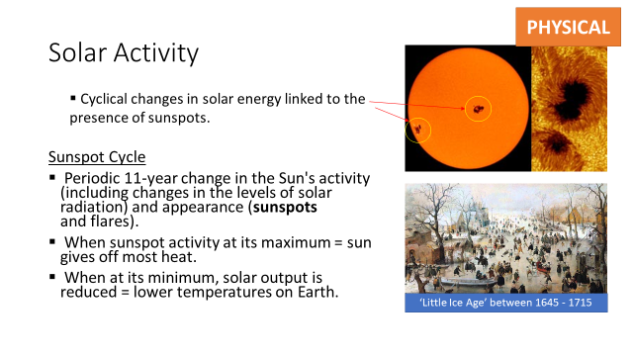

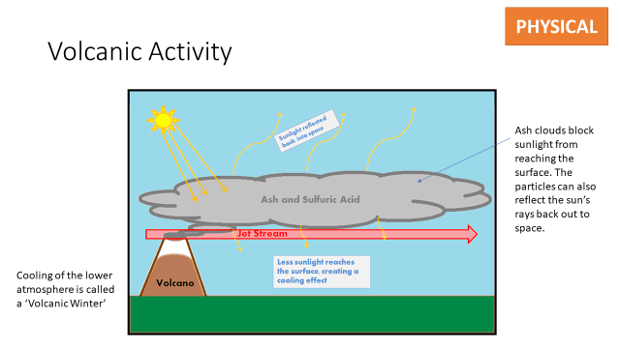

**Physical and Human Causes of Climate Change (2)**

**Applying your learning**

By the end of the lesson I will be able to: 

1. Answer an exam style question on the causes of climate change.

**Task 5**

Card sort – match the cause of climate change to the example. Once you have completed this, keep the cards on your desk.

**Task 6**

Answer the following exam question using the cards that you have just matched.

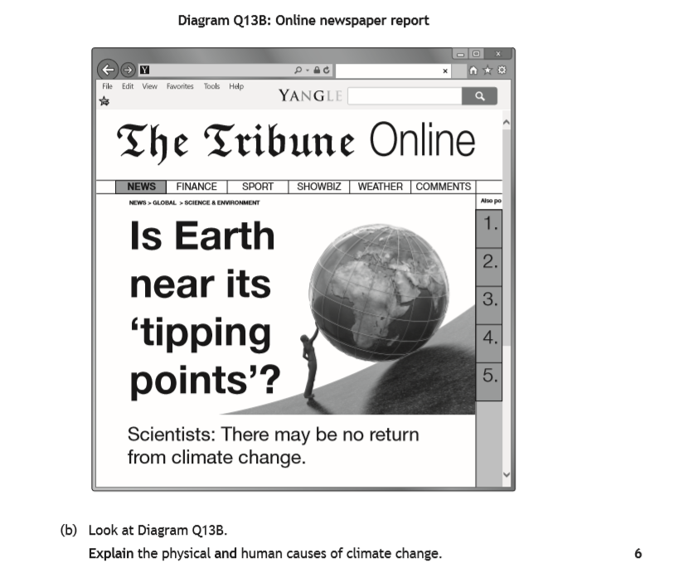

**Task 7**

Peer assess your partners answer. You should use the following criteria:

* 6 separate points
* BOTH physical and human causes mentioned
* Examples given.

Write two stars and a wish at the bottom of the answer.

**Impacts of Climate Change**

By the end of the lesson I will be able to: 

1. Describe and explain how climate change will impact different areas of the world.
2. .

**Task 8**

* **Collect a copy of the world map.**
* **Collect the impacts of climate change information sheet.**
* **Choose 8 effects of climate change and add them onto your map.**
* **Use the Atlas to find the countries, colour them and then add a note as to how that area will be affected.**
* **You could also colour code positives and negatives.**

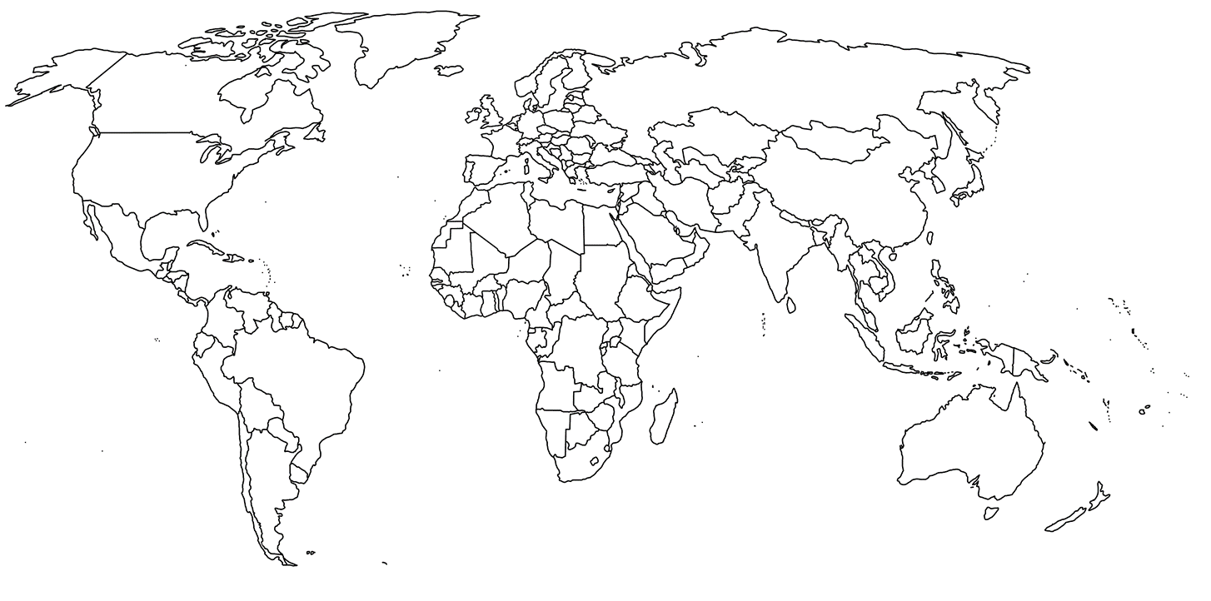

Increased bush fires in Australia due to temperature increases.

**Extension**

If you complete your map then collect the extension exercise.

**Climate Change Debate**

By the end of the lesson I will be able to: 

1. Understand how to participate in a debate.
2. Research and write debate points.

**Task 9**

Your teacher will divide the class into sub groups to prepare for the debate. You should use all of the information in previous lessons and ensure your points are backed up with evidence.

**Case Study: Bangladesh**

By the end of the lesson I will be able to: 

1. Describe at least 3 ways in which Bangladesh is affect by Climate Change.

**Task 10**

Either open your atlas at the page which shows Bangladesh or use the PowerPoint. Complete the tasks below using the outline map provided.

a) Label the Bay of Bengal, Burma (Myanmar) and India.

b) Mark on the capital city of Dhaka.

c) Using a red pencil draw and label the Tropic of Cancer.

d) Using a blue pencil draw and label the course of the Padma River.

Only if you are finished should you colour the land in green and the Bay of Bengal blue.

Watch Bangladesh documentary and take notes under the following headings:

**Landscape Floods People**

**Case Study: UK**

By the end of the lesson I will be able to: 

1. Describe at least 3 ways in which the UK is affect by Climate Change.

**Task 11**

Read: *UK Temperature*

According to the BBC, the UK should expect a 4°C rise in temperature by 2080. Heat waves are on the rise and, by 2080, summer temperatures of 40°C will be common. Winters will also be warmer.

*UK Rainfall*

Summer rainfall is set to decrease and the UK can expect more frequent droughts. Winters will bring less snow ad more rain, especially in the north and west. Storms will be more frequent and more severe.

Answer the following questions in your jotter:

1) If the average temperature in July is currently 18°C and the average temperature in January is currently 4°C, what will the average temperatures be in 2080?

2) What groups of people do you think will be most affected by heat waves (i.e. old, young, middle aged)?

3) If winters are warmer how do you think the ski industry in Scotland will be affected?

4) Why can we not be certain that these figures are accurate?

5) What problems do you think that more rain in winter will bring?

6) If a severe storm was to hit Ayrshire, what kind of impact would it have on the people and the landscape?

Imagine it is the year 2080. Using the diagram on the following page write a newspaper article entitled ‘Climate Change in the UK’. In the article you must include the following information:

* The type of weather that the UK is experiencing (i.e. very wet and warm).
* The problems of having this type of climate.
* What about the benefits of climate change? Include any that you can think of.
* Make up quotes from local people to show the impact it has had on them.

Low Lying Areas: **Low lying areas of the country such as Norfolk in South East England. London is also at risk as the Thames barrier will only protect the city from a 22cm rise in sea level.**

Stormy Weather**: Stormy weather would increase. Tornadoes and gale force winds which damage buildings and can kill/injure people would become more common.**

The Facts: **The IPCC says that sea level rise could rise by 81cm (32in) this century.**

**Loss of Habitat**



Sewer Flooding: **Happens when too much water enters the sewer system from heavy rainfall leading to streets being flooded with sewage.**

**Loss of Habitat**

**Severe Weather conditions**

**Flooding**

**Rise in Sea Levels**

Heat Waves**: Increase in heat waves would mean that there would be health problems with temperatures regularly reaching 40 °C.**

Flash Flooding: **More heavy rain would mean that the ground could not soak up all of the water, leading to flash flooding.**

Birds:  **Warmer temperatures could lead to the extinction of some birds such as the lesser spotted woodpecker.**

Fish:  **With an increase in water temperatures some fish such as salmon would no longer be able to survive.**

River flooding: **Rivers such as the River Tay, Ayr etc. will burst their banks more frequently.**

Fish

The Impact of Climate Change on the UK

**Case Study: Australia**

By the end of the lesson I will be able to: 

1. Explain the cause of the Australian bushfires.
2. Describe how the fires impacted landscapes and people.

**Task 12**

1. Watch the news clips of the fires and floods in Australia.
2. Read the personal accounts of Melinda Varcoe and Jessica Pickerings. Create a storyboard about their experiences of the bushfires.



**Climate Change Strategies 1**

By the end of the lesson I will be able to: 

1. Describe at least 6 strategies to combat climate change
2. Explain how these strategies will help to reduce the effects of climate change.

**Task 13**

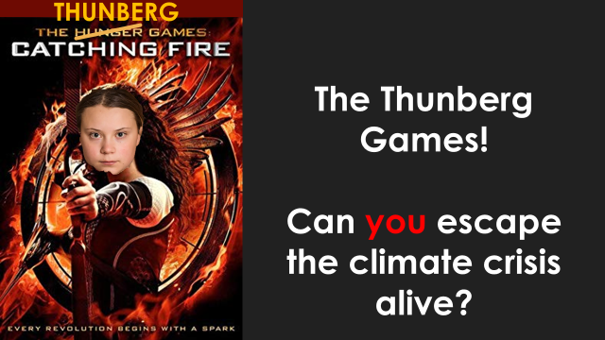

See PowerPoint and information sheets for this task

**Climate Change Strategies 2**

By the end of the lesson I will be able to: 

1. Describe at least 6 strategies to combat climate change
2. Explain how these strategies will help to reduce the effects of climate change.

**Task 14**

1. Place the cards in the order in which you think they happened.
2. Now place the cards under the correct heading: Local/National/Global
3. Looking at the solutions in your jotter, colour code them for mitigation and adaptation.

**Climate Change Strategies 3**

By the end of the lesson I will be able to: 

1. Describe at least 6 strategies to combat climate change
2. Explain how these strategies will help to reduce the effects of climate change.

**Task 15**

**Carbon footprint (noun)** – the amount of CO2 released by the action of a person or group

On a show me board or in your jotter, can you **order** these items into the **biggest** and **smallest** releasers of carbon (needed to make or power the following items)?

|  |  |  |
| --- | --- | --- |
| A banana | A burger | Driving TEN miles in a car |
| A return flight from Aberdeen to Spain | Taking a shower | A mug of tea with milk |
| Leaving a light on  for ONE year | A pair of jeans | Using a mobile phone for 2 minutes per day per year |

**Choose from the following amounts of CO2 produced:**

|  |  |  |
| --- | --- | --- |
| 500 kg of CO2 | 400 kg of CO2 | 47 kg of CO2 |
| 7.1 kg of CO2 | 6 kg of CO2 | 2.5 kg of CO2 |
| 0.5 kg of CO2 | 0.1 kg of CO2 | 0.05 kg of CO2 |

**Task 1** - Watch [this video](https://www.youtube.com/watch?v=G6X1UVySoaA) and then read through the five sustainable strategies shown on P22 – 24 and use this to create a [google doodle](https://www.google.com/doodles) to promote world earth day.

**Strategies to Tackle Climate Change**

On 25th September 2015, the United Nations agreed to 17 Global Goals to end extreme poverty and improve our world by 2030. A key driver to the success of the goals will be how well countries are able to become “sustainable”.

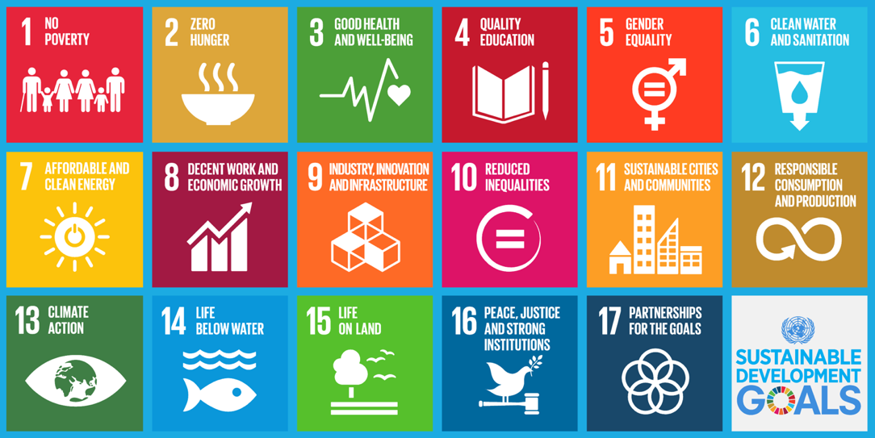

SDG 13 focusses on climate action and has many targets to achieve this from supporting governments to raising awareness through education. On P21 and 22 are just some of the strategies that can be used. Use at least one point from each of the five categories within your google doodle.

1. 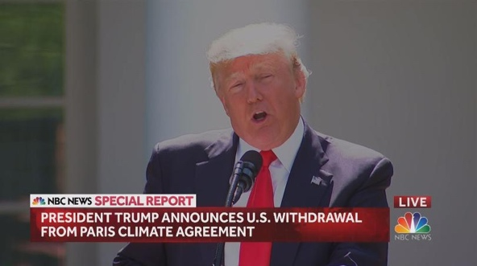**Global agreements – Paris Agreement (2016)**

All 195 countries in the world agreed to work together to reduce future temperature rises by 2040 to a maximum of 2°C with the focus being on keeping change to below 1.5°C.

Countries are not set targets to reach but wealthier countries must help less well-off countries to put in place new technologies or strategies to reduce future temperature increases.

In 2017 the newly elected US President Donald Trump announced that the USA would abandon the Paris Agreement. Iran and Turkey have also to fully commit as they have yet to get their parliaments to agree. With the USA not taking part in the agreement of keeping temperature change below 1.5°C some feel that it is unlikely to be achieved.

**Parliament (noun)** – A group of elected politicians who make the laws for their country

1. **Clean, renewable energy**

**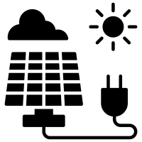*Solar Power:*** Solar Power is the usable energy you can get from the sun. Even here in Scotland solar panels can be used to generate power. Near Elgin, Milltown airfield (a disused WW2 airfield) will become Morays 1st Solar farm.

**Renewable (adjective)** – A source of energy that does not run out/disappear/end

**2. Clean, renewable energy (continued)**

***Wind Power****:* Wind power is usually generated via wind turbines and converts wind energy into electricity. In the first six months of 2019 wind farms such as Cairn Uish (south of Elgin) contributed to generating double the amount of electricity needed to power Scotland’s homes.

1. **Cleaner, more fuel-efficient transport**

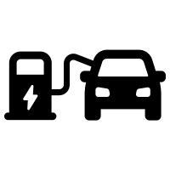On January 1st, 2035 the sales of new Petrol, Diesel and hybrid powered vehicles will be banned in the UK. To encourage more people to drive electric powered cars the government is spending more money on installing charging stations. There is one in Kyle Academy car park.

**Hybrid (noun)** – A vehicle (car/bus/van) that uses **BOTH** petrol **and** electric power

People are encouraged to use public transport and money has been spent by the government and bus/rail companies e.g. Stagecoach / Scotrail on upgrading buses and trains as well as making improvements to stations. The cycle to work scheme allows people to buy a new bicycle without having to pay tax, making the cost of a new bike cheaper

Aviation is the fastest growing cause of climate change in the world. The growth of low-cost airlines such as EasyJet or Ryanair has made flying more affordable and popular. Airliners produce the most amount of CO2 than any other single form of transport. Climate campaigners such as Greta Thunberg have become “flight shaming” influencers who use social media to promote rail/bus or ferry use instead of flying.

**Influencer (noun)** – A person with the ability to influence others through the use of social media to buy or change their behaviour/habits on social media

1.  **What can we do in our homes?**

15% of the UK's carbon emissions comes from the energy used up inside our homes (heating them and powering electrical items). The amount of carbon dioxide produced can be lowered by making three very simple changes to our lives.



1. ***Reduce heat loss in your home***

***-*** Insulating behind walls and the loft and installing double/triple glazing. Fitting thick underlay underneath carpets all help to reduce heat loss from housing.

1. ***Reduce our energy use:***

-Reduce the use of electrical appliances for example when making tea or coffee only boil the water you need.

- Turn things off when not in use and not leave on standby and do not leave items charging overnight e.g. Mobile phones to save electricity.

- Use low energy LED lightbulbs in our homes as they use less electricity.

- Taking a shower as this uses up less hot water than a bath.

1. ***Turn your home into a power station***

By fitting solar panels to the roof, our homes can become power stations. We could even sell our extra power to electricity power companies. For those who do not like the look of panels on the roof, new solar roof tiles have been created which turns the entire roof into a large solar panel.

**Task 16** – How can you do your bit to help the world achieve a less than 1.5°C increase and support achieving Sustainable Development Goal 13 “Climate Action”?

There are six areas of *positive action* that **YOU** can take part in, they are:

 Transportation Community Consumption and waste

****Water Food Home



Using two colours shade in the sections of the to show the actions you currently do and use a second colour for the sections you will do in future to play your part in keeping temperature increases below 1.5°C