S2 Empty Lands Unit

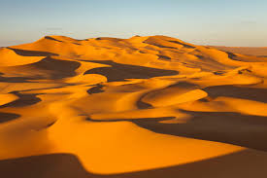

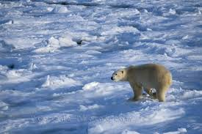

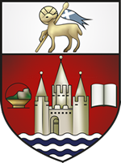

Ayr Academy

The “Crowded lands” have attracted people because the **physical environment** of these areas (*the landscape and climate*) is suitable for humans to live comfortably in. These areas usually have quite flat land (which makes building, farming and transport easy) and the climate is not too cold, hot, wet or dry.

In contrast, the physical environment of the “Empty Lands” is very harsh and uncomfortable for most humans.



**Task 1:**  **Copy and complete**: Fill in the blanks –

* The area could be **TOO H _ _ _** or **TOO C _ _ _** like the Himalayan mountains.
* The area could be **TOO H _ _ AND TOO D _ _** like the Sahara Desert.



**Task 2:** Use the internet to help you sort the areas of the world below into the correct area of the table.

|  |  |  |
| --- | --- | --- |
| TUNDRA | HOT DESERT | TROPICAL RAINFOREST |
|  | * Arabian | * New Guinea |

New Guinea – Arabian – North Siberia – Congo - Australian – Lapp Land – Alaska – Brazil – SE American – Greenland – Sumatra – N. Canada – Philippians – Sahara - Atacama Chile – Kalahari S. Africa – Amazon Basin

**Lesson Two - The Artic Tundra**

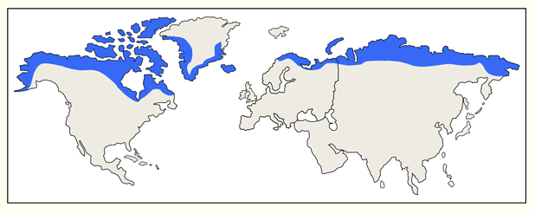

Tundra is located near the top of the world and covers around 1/7th of the Earths surface. It is one of the coldest and harshest places in the world and is the most fragile climate region on Earth.



Task 3: Describe the distribution of the Tundra from the map above map using named locations of countries.

The Tundra is located at the t_ _ of the E_ _ _ _. The Tundra runs through countries such as __________________ and ____________________.

You will not find tundra in countries such as __________________ and ______________________.



Task 4: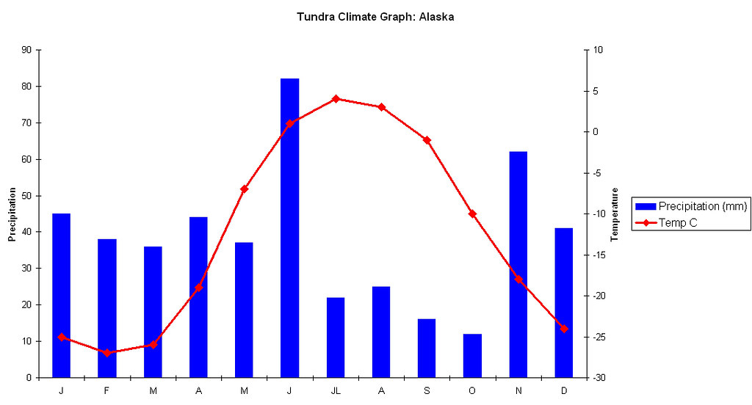Using the climate graph answer the questions below. Remember the Bar graph shows rainfall and the line graph shows temperature.

Q1. Describe the highest monthly temperature in Barrow?

______________________________________________________________________________________________________________________________________________

Q2. Describe the month has the lowest temperature?

______________________________________________________________________________________________________________________________________________

Q3. Describe the wettest month?

______________________________________________________________________________________________________________________________________________

Q4. What is the total rainfall for the whole year? ______________________________________________________________________________________________________________________________________________

Q5. Is the annual temperature for Barrow mostly above freezing or below?

______________________________________________________________________________________________________________________________________________



Task 5: Read Resource 1 below about the landscape of the Tundra. Answer the questions below.

Resource 1

The name Tundra comes from the Finnish word *tunturi*, which means treeless plain. For most of the year the Tundra is covered in snow, but in summer some of this will melt away. Plants and animals have to be well adapted to survive and both are very vulnerable to any slight changes in the environment. The foundation of the whole Tundra ecosystem rests on a layer of ground called the Permafrost. This permafrost is a frozen layer of soil. In much of the Arctic it is frozen all year round. In the southern regions, the surface layer above the permafrost melts during the summer and this forms bogs, marshes and shallow lakes.

Because of global warming, the autumn freeze comes later in the year and more of the permafrost is melting. Shrubs and spruce that previously couldn't take root on the permafrost now dot the landscape, potentially altering the habitat of the native animals.

Q1. Describe where the name Tundra come from? ____________________________________________________________________________________________________________________________________________________________________________________________________________________________________________________________________________________________

Q2. Describe what the Tundra covered in for most of the year? ____________________________________________________________________________________________________________________________________________________________________________________________________________________________________________________________________________________________

Q3.Explain why there is very little plant life in the Tundra? ____________________________________________________________________________________________________________________________________________________________________________________________________________________________________________________________________________________________

Q4. Explain what problems are caused by the melting of Permafrost? ____________________________________________________________________________________________________________________________________________________________________________________________________________________________________________________________________________________________

**Task 6: Complete the paragraph**

Not many kinds of _________ live year-round in the Arctic ________. Most birds and _________ only use the tundra as a summer home. Mammals that do live year-round in the tundra include the muskox, ______ ______, and brown bear; and each has its own way of ___________ to the extreme ___________ conditions. Animals need to find ways to stay warm and to provide nourishment for themselves in order to __________ the long, cold, winter months.

**Animals Tundra Mammals Artic Wolves Adapting Climate Survive**

**Task 7: Poster Exercise**

**Instructions:** Your task is to make a poster/PowerPoint presentation about the animals that live in the artic tundra.

1. Read the facts below for information to include in your poster
2. You must include how the animals adapt to the harsh conditions of the tundra
3. Must include at least 1 drawing or picture (if using word/PowerPoint)
4. Make your poster colourful and eye catching

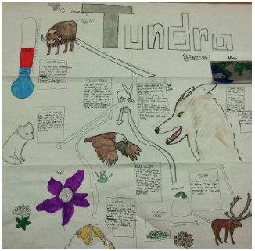

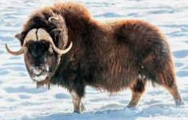

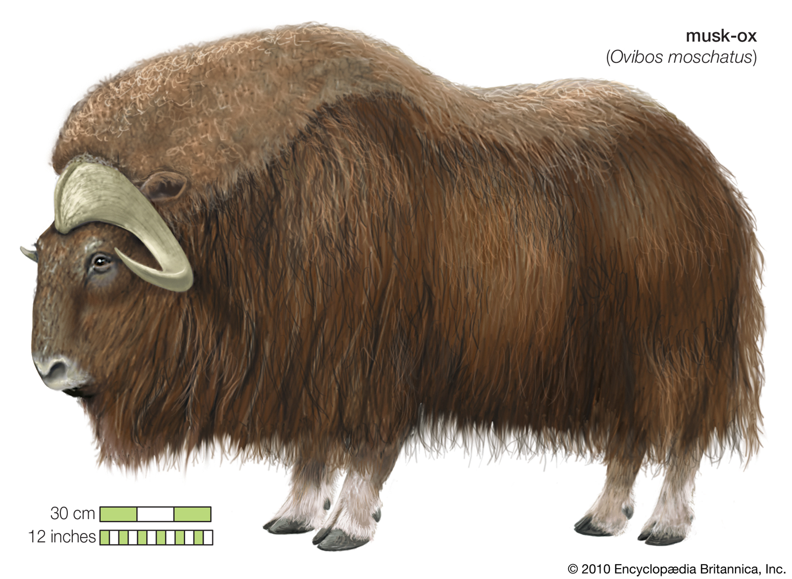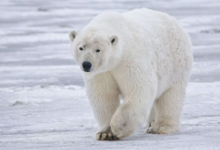

Animal Two: Musk Oxen

The Musk Ox is one of the most distinct animals in the tundra. Unlike the snowy owl, arctic hare, article fox, and many other arctic animals that blend into the white snow, this massive beast couldn’t care less. His fur may be dark, but it is also warm, for a number of reasons:

* **It is thick**
* **It is very long**
* **It has hollow hairs**

Air is a wonderful insulator, and the **hollow hairs of the Musk Ox keep the air warmed by body heat** close by where it is needed. And, when it comes to this citizen of the tundra, there is a whole lot of that hair. It hangs almost to the ground, creating a tent of sorts. The area directly beneath the animal is kept warm. That layer of warm air adds to comfort. Finally, as is true of many arctic animals, the fur is very thick. Relatively warmer air is not only trapped inside the hollow hairs, but all around them as well.

**Animal one: The Polar Bear**

Dominant among all of the land-based arctic animals is the Polar Bear. They **can handle just about anything the Arctic winters throw at them** for a number of reasons:

• Blubber layer

• Insulating fur

• Oily coat

Polar Bears **look all soft and furry in pictures and at the zoo**. In reality, the bear's fur coat is quite oily. This keeps the moisture at bay, even when they are frolicking in the water. Anyone who has been cold and wet realizes that it's far worse than just being cold.

Long, heavy fur essentially creates an insulating layer of moderated air between the bear and it's frosty surroundings. Body heat is not dissipated out into the cold. Rather, it is trapped in the fur where it adds a beneficial layer of insulating air.

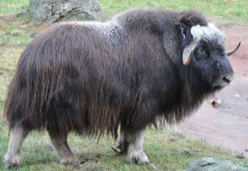

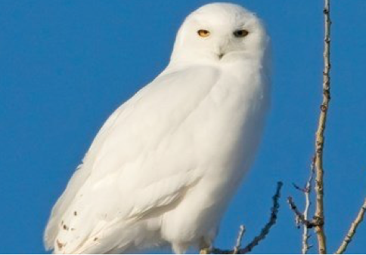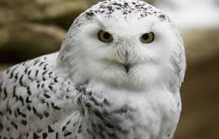

**Animal Three: The Snowy Owl**

Snow **owls** are capable of driving wolves away. They also swallow their prey whole. Physical **adaptations** include white feathers for camouflage, fully feathered feet, serrated wing feathers, sharp talons and beaks all enable it to survive temperatures that can fall far below zero and long winter nights.

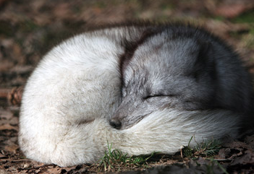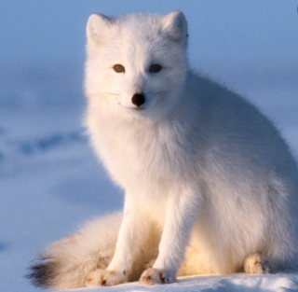

**Animal Four: The Artic Fox**

**Relatively low surface area** - Compared to other species of fox, arctic foxes have proportionally shorter legs, shorter necks and smaller ears. This means that there is less surface area to lose heat from

**Thick camouflaged seasonal fur** - The coat of the arctic fox is always thick and highly insulating. This keeps heat in for the fox. The luxurious winter coat is very thick making the fox look more rounded and is white so camouflaging it against a frozen background.

**Thick fur on the tail -** The tail acts to provide extra insulation when it is needed. When the fox curls up to sleep or to keep warm in extreme cold, the tail fur can be wrapped around the fox providing extra warmth and insulation.

**Thick fur on the paws** - Too insulate them from snow and ice and also provide for grip on slippery surfaces.