**Topic 9: Wealthy Suburbs**

**Location and Growth**

Barra da Tijuca is a modern coastal suburb in Rio’s West Zone, next to the Tijuca lagoon. Many of the residents of Rio’s South Zone have moved the 20 kilometres down the coast to Barra. It is the fastest growing part of Rio de Janeiro.

Until the 1970s, this area was inaccessible and cut off from the rest of Rio. The construction of a four-lane motorway with tunnels under Rio’s many mountains enabled this area to be developed. A new expressway, the Yellow Line, provides direct access to the centre of Rio.

This modern area is appealing as it has less crime, better housing and is much less congested. This process of people moving out of cities is known as ***counter-urbanisation*** and is unusual for a city in an ELDC.

**Housing in Barra da Tijuca**

Most of Barra’s 130,000 residents live in luxurious and spacious apartment blocks that are between 10 and 30 storeys in height.

***Barra apartment block***

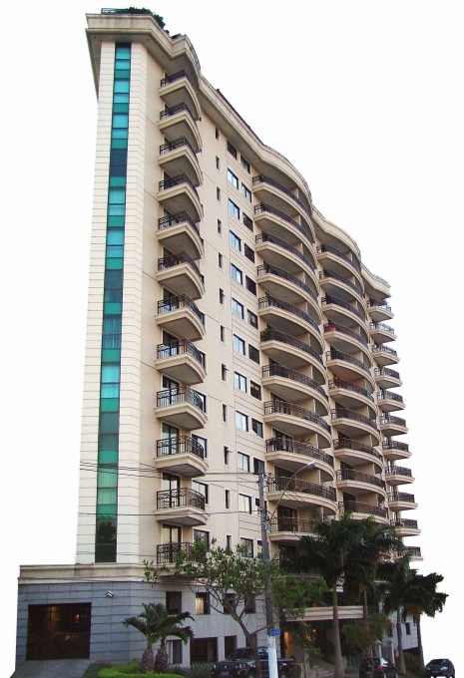

Security is a high priority and the residents are protected by modern security entrances with CCTV, underground parking, window shutters and bars, alarm systems and 24-hour security guards who are often armed to deter criminals.

Apartment blocks contain every modern convenience including satellite TV, swimming pools, jacuzzis and saunas; they often have shops and laundries in the basement.

People who live in Barra are usually from the wealthy classes and it is quite common for them to employ maids, cooks and gardeners.

**Services in Barra da Tijuca**

Barra da Tijuca has an American feel to it: it is very unlike Brazil and more typical of Los Angeles or Miami Beach. It is a self-contained city: it has everything that its residents need, including well-paid office jobs, modern schools, hospitals, a university, parks, restaurants and cinemas. A monorail and numerous dual carriageways allow easy movement around the town.

Barra has a 5-kilometre stretch of shopping malls and hypermarkets, the largest retail complex in South America with over 700 shops. Malls are spacious and air conditioned with large car parks. Retailers such as Wal-Mart and Makro have located here and in the São Conrado Fashion Mall, outlets sell luxury designer goods such as Armani. Barra’s wealthy shoppers are also well protected from pickpockets and criminals by armed security guards and CCTV cameras in each mall.

**Tourism in Barra**

Barra is a very popular area for tourism and recreation. It has an 18-kilometre beach, the longest in Rio, which has excellent conditions for bathing, sailing, surfing, windsurfing and fishing.

The beach front area is lined with many five-star hotels with spectacular views of the Atlantic coast. Numerous cafés, restaurants and nightclubs are also found along the promenade.

Barra also has a theme park called Terra Encantada, a championship golf course and a large concert hall. Due to its excellent services, Barra da Tijuca is the home to the athlete’s village for the 2007 Pan-American Games, which are being held in Rio.

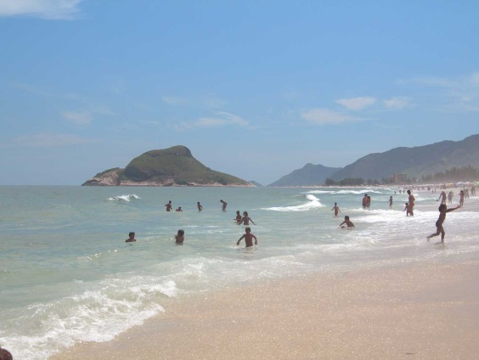

***Barra da Tijuca Beach***

**Barra da Tijuca**

Read previous pages and answer the questions below in full sentences.

(a) Give ***three*** reasons why people want to leave Rio and move to Barra to live.

(b) Describe what is meant by counter-urbanisation.

(c) Draw a spider diagram to show theways in which the apartment blocks in Barra are made safe and secure for the people who live in them.

(d) What evidence is there that Barra da Tijuca has an American influence?

(e) Explain why Barra is a very popular place for tourists (give at least ***five*** reasons).

 (f) Label the sketch of Barra da Tijuca (below) with the main features of the area (e.g. high rise apartments, dual carriageway, beach, Tijuca lagoon, shopping malls, mountains of Rio, Atlantic Ocean).

***Sketch of Barra da Tijuca***

**Topic 11: The Olympics**

**First Ancient Olympics**

The first Olympic Games were held in Olympia, Greece in 776BC in honour of the God Zeus. Zeus was thought of as the god of the sky.

The aims of the games were to show the physical qualities of the athletes and encourage good relations between the cities of Greece and lasted one day with just one event which was running.

Only men were allowed to compete and only unmarried women were allowed to watch the games so some women dressed as men and sneaked in.

Winners took part in two ceremonies, the first they received a palm bunch and had red ribbons tied round their hands and heads, in the second the winner had an olive tree wreath placed on their head.

**Women in the Olympics**

Women were not allowed to take part in the games as it was thought to be “impractical, uninteresting, anaesthetic and incorrect”,

Women first took part in the Olympic Games in Paris in 1900, four years after the first Olympic Games of the modern era in Athens. Despite the reticence of the reviver of the modern Games, Pierre de Coubertin, 22 women out of a total of 997 athletes competed in just five sports: tennis, sailing, croquet, equestrian and golf. In 1912 the sport of swimming was introduced for women, however, the American team would not allow their women to compete in an event in which they did not wear a long skirt.

The women’s 800m running race was banned between 1928 and 1960 due to too many of the competitors collapsing at the finishing line. Luigiua Giavotti holds the title for being the youngest Olympic medal winner when she won silver for the Italian gymnastics team at the age of 11 years and 302 days. Today participants need to be 16 years old within an Olympic year.

**The Olympic Rings**

The five-ringed Olympic symbol represents the union of the five continents and the meeting of athletes from throughout the world at the Olympic Game

There is a common misconception that the colours of the rings are linked with individual continents. The colours simply come from those colours which appear on all the national flags of the world which take part in the Olympics

**Tasks**

**Answer the following questions in full sentences.**

1. What were the aims of the ancient Olympic Games?
2. How did women ensure they were able to watch the games?
3. Why did the American team not allow their women to compete in the swimming event in 1912?
4. What age do Olympic participants have to be to compete in the games these days?
5. The Modern Olympics have been running for 116 years and have only been cancelled three times, in 1916, 1940 and 1944. Why do you think this was?
6. Take a copy of the Olympic Ring diagram and colour it the correct colours.
7. Why are the linked rings an Olympic symbol?
8. The table below shows the number of female participants that have taken part in the summer Olympic Games since 1900. On a line graph; plot the number of female participants from years 1900; 1920; 1936; 1960; 1976; 1992; 2008 and 2012.

**Olympic Games – Female Participants**

|  |  |  |  |
| --- | --- | --- | --- |
| **Year** | **Participants** | **Year** | **Participants** |
| **1896** | - | **1960** | 611 |
| **1900** | 22 | **1964** | 678 |
| **1904** | 6 | **1968** | 781 |
| **1908** | 37 | **1972** | 1,059 |
| **1912** | 48 | **1976** | 1,260 |
| **1920** | 63 | **1980** | 1,115 |
| **1924** | 135 | **1984** | 1,566 |
| **1928** | 277 | **1988** | 2,194 |
| **1932** | 126 | **1992** | 2,704 |
| **1936** | 331 | **1996** | 3,512 |
| **1948** | 390 | **2000** | 4,069 |
| **1952** | 519 | **2004** | 4,329 |
| **1956** | 376 | **2008** | 4,637 |
|  |  | **2012** | 4,676 |

**Extension**

Here is a list of some of the 205 countries taking part in the London 2016 Rio Olympics. Unfortunately, the names have been jumbled up. Unscramble the names and write the correct names in the spaces on the right.

|  |  |  |
| --- | --- | --- |
| A | ntdUie ttsSae |  |
| B | ocoorcM |  |
| C | yarGemn |  |
| D | naiBrti teGra |  |
| E | Iaytl |  |
| F | Nraywo |  |
| G | rguHnay |  |
| H | nliFnad |  |
| I | Ntelnsdarhe |  |
| J | aiChn |  |
| K | wdnSee |  |
| L | usaisR |  |
| M | aaadnC |  |
| N | aanpJ |  |
| O | wtelnSizrad |  |
| P | Asraitu |  |
| Q | daoPln |  |
| R | Suhto Kareo |  |
| S | arguBlai |  |
| T | uabC |  |
| U | krmenDa |  |
| V | zcehC eulicRp |  |
| W | gumBlei |  |
| X | liarAusta |  |

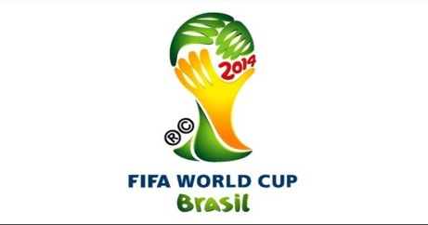 **Topic 12: The World Cup**

The **2014 FIFA World Cup** will be the 20th [FIFA World Cup](http://en.wikipedia.org/wiki/FIFA_World_Cup). The World Cup is an international [football](http://en.wikipedia.org/wiki/Association_football) tournament. It is scheduled to take place in Brazil from 12 June to 13 July 2014. This is the [second](http://en.wikipedia.org/wiki/1950_FIFA_World_Cup) time Brazil has hosted the competition. Brazil will become the fifth country to have hosted the FIFA World Cup twice, after Mexico, Italy, France and Germany.

It will be the first World Cup to be held in South America since the [1978 FIFA World Cup](http://en.wikipedia.org/wiki/1978_FIFA_World_Cup) in Argentina, the first time two consecutive World Cups are staged outside Europe and the first time two consecutive World Cups are staged in the [Southern Hemisphere](http://en.wikipedia.org/wiki/Southern_Hemisphere) (the [2010 FIFA World Cup](http://en.wikipedia.org/wiki/2010_FIFA_World_Cup) was held in South Africa). It will also be the first FIFA World Cup to use 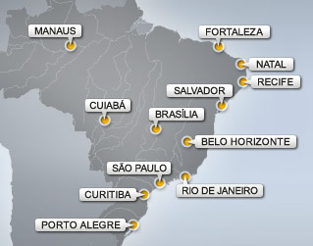[goal-line technology](http://en.wikipedia.org/wiki/Goal-line_technology). [Spain](http://en.wikipedia.org/wiki/Spain_national_football_team) is the defending champion.

The 12 cities hosting World Cup matches in Brazil

As the hosting country of the 2014 World Cup and the 2016 Olympic games, Brazil is faced with the significant challenge of improving its infrastructure to support the influx of visitors that these events will attract. This will require extensive investment into Brazil’s urban areas, sporting facilities and tourism sector. As a result, many of the world’s investment funds and financial institutions are preparing themselves for a boom in financing opportunities.

Construction and remodelling of stadiums alone will be approximately over €1.1 billion (£ 550 million). In addition to the stadium upgrades and renovations, there will be millions more spent on basic infrastructure needs to get the country ready.

**Task**

1. In groups of 2 or 3; from the list below, prioritise the projects Brazil needs to have started in order to be ready for 2014.

|  |  |
| --- | --- |
| Build new roads | Build hotels |
| Update airports | Update Health and Safety laws |
| Build stadiums | Advertise the games. |
| To clean up the shanty towns. | Train new personnel –policemen, translators, guides etc |
| Crack down on crime. | Build accommodation for the players. |
|  | Update national transport systems |