**Topic 10: Environmental Problems**

Although Rio is one of the world’s most scenic cities, it is also one of the most polluted.

**1. Air pollution**

Very often mist from the Atlantic Ocean mixes with exhaust fumes from vehicles and pollutants from factory chimneys, creating a brown smog that smothers the city. Air pollution is estimated to cause 5,000 deaths in the Rio area each year, as it causes respiratory diseases such as bronchitis and lung cancer.

The Brazilian government has not passed any laws to help limit atmospheric pollution, and toxins from vehicles and factories continue to pollute the air on a daily basis. Until major improvements are completed in public transport to encourage people off the roads, air pollution will continue to be a major problem in Rio.

**2. Water pollution in Guanabara Bay**

Pollution in Guanabara Bay is a major threat to wildlife and tourism. The bay is home to hundreds of species of marine birds, fish, dolphins and endangered mangrove swamps. At present, many areas are not suitable for swimming and smell very badly; if this pollution was to spreads to the tourist areas of Copacabana and Ipanema, the local economy and the thousands of jobs that tourism provides will be hit hard.

There are two main sources of pollution in the bay:

**(a) Pollution from sewage**

Rio’s sewer network has never been able to cope with the huge number of people. Four hundred tonnes of untreated sewage pours into Guanabara Bay each day.

**b) Pollution from Industry and Shipping**

Seventy tons of industrial waste enters the bay each day from factories in Rio’s industrial zone.

Oil spills from shipping and pipelines are also a problem. In January 2000, 1.3 million litres of fuel oil leaked from the Petrobras oil refinery causing an oil slick 40km2 in size, which killed thousands of fish and marine bids.

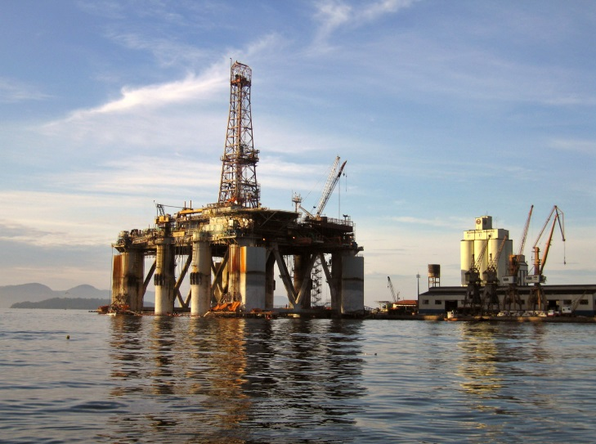

***Industry in Guanabara Bay***

Guanabara Bay is also polluted by ships emptying their fuel tanks into the harbour because the local port lacks the necessary equipment for proper disposal.

**3. Rio’s waste mountain**

The worst problems with waste disposal exist in the favelas. For instance Roçinha, Rio’s largest favela, has no proper roads, making waste collection by lorry virtually impossible. Much of this rubbish is dumped in locations where there is often very poor sanitation: this can lead to diseases such as diarrhea, cholera and other diseases, and to an increase in rat populations. The dumping of loose litter on the steep hillsides can cause landslides after periods of heavy rain.

Every two months, the city’s 6 million people produce enough rubbish to fill the Maracanã stadium, one of the world’s largest football grounds (it can hold 120,000 people). The traditional way of disposing of solid materials is to dump it in landfill sites. However, landfill sites are eyesores and often produce dreadful smells.

Near Rio’s University, an unusual method of waste disposal is being tried out, which brings benefits to the local area. A small power plant has been set up using methane gas (biogas) produced from rotting rubbish. This renewable form of energy will consume 30 tonnes of garbage per day and produce 1 megawatt of electricity for the local community, powering 1,000 homes. If this proves to be a success, more schemes could be put in place across the city.

**Solutions**

In 1994 the ***Guanabara Bay Clean Up Program*** was established. $300 million was spent on the construction of new sewage treatment plants in an attempt to improve this problem. Phase 2 of the Program started in 2004 with another $400 million being spent on 12 new sewage works. This will increase the number of homes in Rio with proper sewage disposal from 35% to 50%, although much still needs to be done.

The local government could also bring in new environmental laws and be stricter on those who pollute the environment. In February 2002, the state of Rio de Janeiro fined the owners of the cruise ship Caronia $400,000 after it deliberately released 7,500 gallons of gasoline into the Bay, but such large fines are uncommon.

**Environmental Problems in Rio**

Read the previous pages and answer the questions below in full sentences:

(a) What are the ***two*** main causes of air pollution in Rio de Janeiro?

(b) What species of wildlife are threatened by pollution in Guanabara Bay?

(c) What impact could coastal pollution have on Rio’s tourism?

(d) Give ***three*** reasons why Guanabara Bay is badly polluted.

(e) What are the solutions to improving water quality in Guanabara Bay?

(f) Describe ***three*** problems found in Rio’s favelas due to the lack of proper waste disposal.

(g) What are the problems of using landfill sites to dispose of waste?

(h) How can waste products benefit the local community?