Brazil
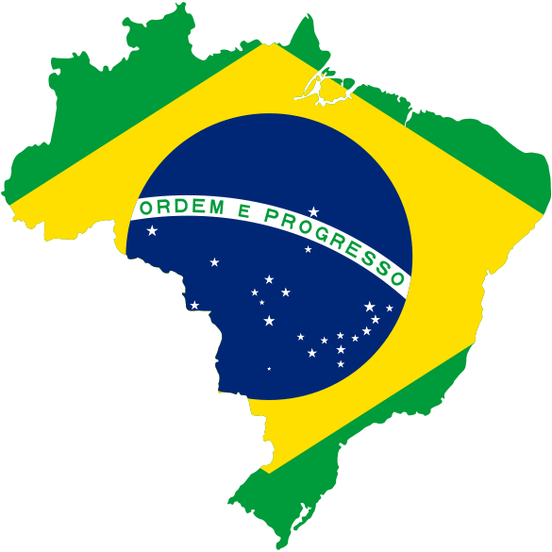

Girvan Academy
Topic 1: Where is Brazil?

Brazil is the fifth largest country in the world after Russia, Canada, China and the United States of America. It is the largest country in Latin America sharing its border with another ten countries. Its total area is greater than all the countries in Europe and is roughly 35 times the size of the UK. It is also the most populated country in Latin America. As a result, there are great variations in how people live, their wealth and overall quality of life.

Population of selected South American countries

Tasks
- Copy and complete the paragraph below.
Brazil is a huge c__________. Its total area is greater than all the countries of E_______. It is about 35 times as big as the U_________ K__________.
- Collect of copy of the map shown and use an atlas to complete the activities below.
  - Write the names of the main countries of South America onto the map in the correct places. Choose from: Brazil; Bolivia; Paraguay; Uruguay; Chile; Argentina; Peru; Ecuador; Colombia; Venezuela.
  - Some countries have no coastline. They are known as landlocked countries. Shade in the land locked countries of South America in blue.
  - Write the names of the capital cities of the countries shown on the map.
  - Which language is spoken in Chile and Brazil?
  - Which part of South America belongs to the United Kingdom?
- Copy and complete the fact file below using the atlas or computer to help you. When you have complete this; find out what Brazil’s flag looks like and make a copy in your jotter.
Brazil Fact File 2013
Official Country Name:
Area:
Population:
Capital City:
Largest City:
Number of States:
Official Language:
Currency:
President:
National Motto:
Birth Rate:
Death Rate:
Infant Mortality Rate:
Life Expectancy:
Literacy:
Topic 2: What are Brazil’s main physical features?
Physical factors include climate, natural vegetation, relief, soils and natural resources (raw materials). Brazil is a huge country with a great variety of physical features. Much of the land is flat and there are few mountains. These physical features affect where people live in the country. Read pages 16 and 17 of the “Places” textbook to learn more about Brazil’s physical features.
Tasks
- Complete tasks 1 and 2 on page 17 of the “Places” textbook.
One of the main physical features in Brazil is the River Amazon. It is the second largest river in the world at 6280km (3925 miles) in length. It’s source in the mountains of Peru at a height of 5200m. It has more than 1100 tributaries joining it and is over 300km wide at its mouth. It is very important for transport and trade in Brazil as sea going ships can sail 3200km up the river. It also holds 20% or one fifth of the world’s total river water.
- Write down a definition of the following words; source; mouth and tributary.
- What is the longest river in the world?
- Use the information above to complete the crossword (copy the grid into your jotter).
  - The River Amazon is important for ___________.
  - It is 300km _____ where it meets the seas.
¹
²
³
⁴
⁵
⁶
⁷
⁸
⁹
¹⁰
¹¹
  - It is the second longest ________ in the world.
  - It is Brazil’s g_______ river.
  - Its source is in _______.
  - It is important for _______.
  - More than 1100 s_____ rivers flow into it.
  - Big ships can ____ 3200km upriver.
  - The River Amazon is ________ greatest river.
  - It contains 20% of the world’s r______ water.
  - It is the second __________ river in the world.
Topic 3: What are the main regions of Brazil?
Brazil is divided up into five main regions and one of the most commonly asked questions in the exam is about the differences between these regions. The five geographical regions – North, North East, South East, South and West Central – are shown below. There are 26 states in Brazil.
Regions and States of Brazil
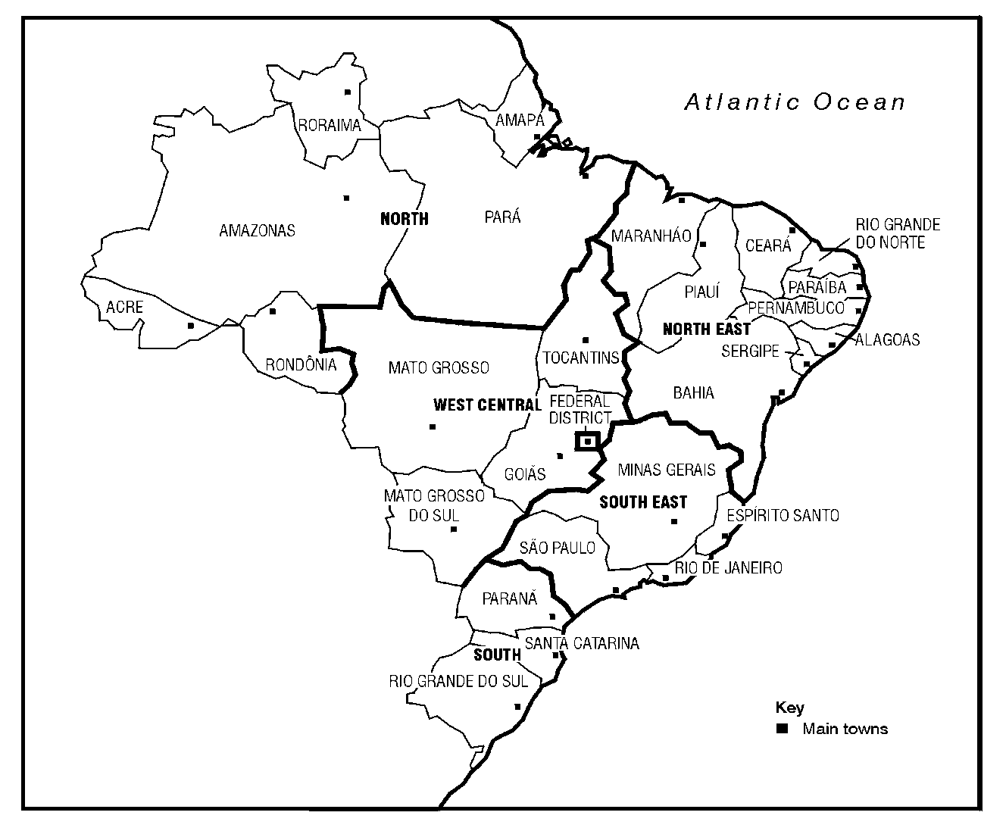

NORTH REGION
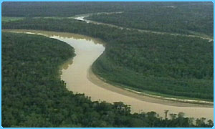
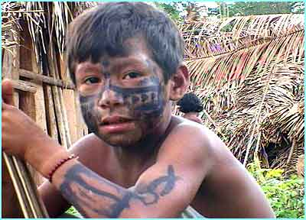

Population | 15 million (comprises 8 per cent of total population) – most live close to the rivers and the few towns and cities, like Manaus. There are vast areas of almost uninhabited forest.
Area | 3,869,634 km²  Almost the entire region is covered by the Amazon Rainforest, except the state of Tocantins, with savanna-like vegetation (known as ‘cerrado’). The River Amazon runs across the middle of the region from west to east before emptying into the ocean.
States | Acre, Amapá, Amazonas, Pará, Rondônia, Roraima and Tocantins.
Climate | Despite the popular image of the Amazon as a region of blistering heat, temperatures of more than 32 °C (90 °F) are in fact rare. Even so, the weather is hot with annual average temperature in the region at around  22-26 °C (72-79 °F), with little variation throughout the year. High temperatures and heavy rainfall (about 2500mm per year) ensure that the forest is always green.
Major Cities | Belem, Manaus.
Percentage of Urban Dwellers | 61%
Agriculture | Some cattle rearing on former forest land. Rubber production is very important.
Industry | The equatorial forest is being developed for valuable mineral resources. This is also true for the Carajas Mountains which are rich in minerals such as iron and copper. The Federal Government has given financial incentives for the setting up of industry in the state of Amazonas, in particular for the assembly of electro-electronic products.

NORTH EAST REGION
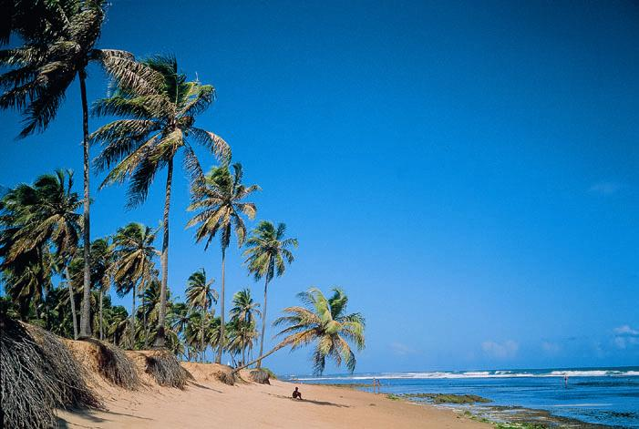
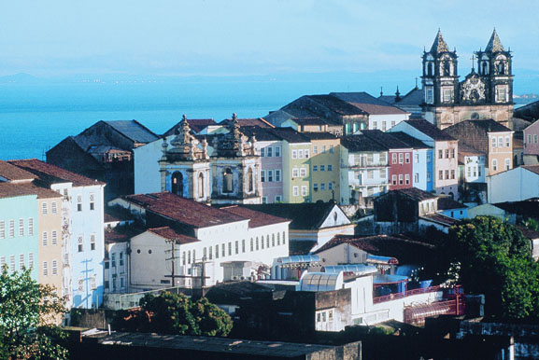

Population | 49 million (comprises 26 per cent of total population) - most people live near the coast, around old cities like Recife and Salvador.
Area | 1,558,196 km²  Semi-desert vegetation called ‘Caatinga’ grows in the hot dry climate, only thorny bushes, cacti and grasses grow well.
States | Maranhão, Piauí, Ceará, Rio Grande do Norte, Paraíba, Pernambuco, Alagoas, Sergipe and Bahia.
Climate | The hottest part of Brazil is the northeast, where temperatures of more than 38 °C (100 °F) are frequently recorded during the dry season between May and November. There is not a lot of rain (less than 1000mm per year) which makes it difficult to grow crops. Vast parts of this region are subject to drought.
Major Cities | Salvador, Fortaleza, Recife.
Percentage of Urban Dwellers | 60%
Agriculture | Farming - cacao, sugar cane and cotton are particularly important. Cattle-rearing is important in the dry areas. Fishing is also becoming more important.
Industry | Tourism, machinery manufacturing, textiles are important to this region.

SOUTH EAST REGION

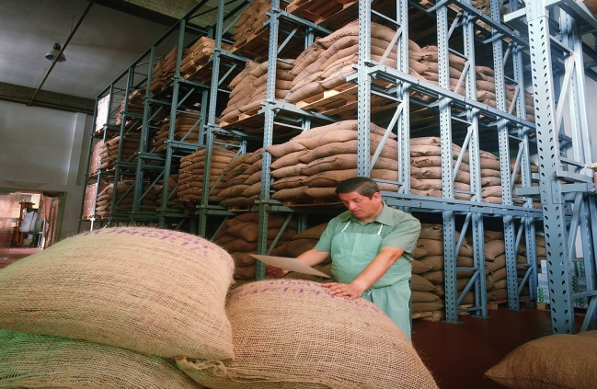
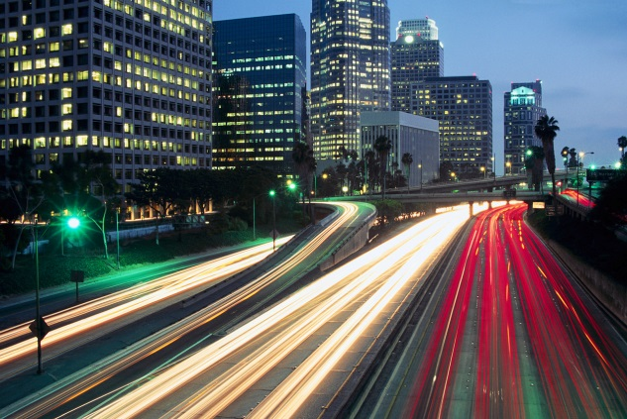

Population | 79 million (comprises 42 per cent of total population).
Area | 927,286 km²  Mainly tropical-like semi-deciduous forests, semi-arid in the north, with almost no vegetation, savanna-like vegetation in the west and in the northwest. Very little of the native vegetation still remains.
States | Espírito Santo, Minas Gerais, Rio de Janeiro and São Paulo.
Climate | Along the Atlantic coast from Recife to Rio de Janeiro, average temperatures range from 23 to 27 °C (73-81 °F). Inland, on higher ground, temperatures are lower, ranging from 18 to 21 °C (64-70 °F).
Major Cities | São Paulo, Rio de Janeiro, Belo Horizonte.
Agriculture | The area is rich in minerals and it has advanced agriculture, producing coffee, sugar cane, oranges and other products both for export and for domestic consumption.
Industry | This is the business-economic centre of Brazil. Multinational companies and foreign companies tend to have their headquarters set up in this region. It is a heavily industrialised region with machine and electronic manufacturing, automobile and aviation industry, tourism, oil and sub-products (gasoline, diesel, etc), textiles, and energy production (not sufficient, however, to attend its demand).
Percentage of Urban Dwellers | 89 per cent

SOUTH REGION
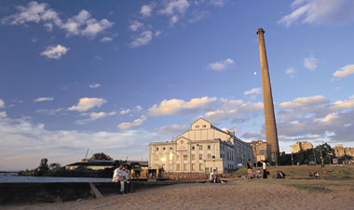
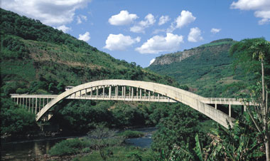

Population | 29 million (comprises 16 per cent of total population).
Area | 577,214 km²  Rainforest along the coast, subtropical grasslands grow on the lowlands of the cooler south called ‘Campos’. Little native vegetation still actually remains.
States | Paraná, Santa Catarina and Rio Grande do Sul.
Climate | The southern part of Brazil is semi-tropical. It is cooler with distinct seasons. It can even snow. South of Rio the seasons are more defined and the range of temperatures significantly wider, with the annual average falling between 17 and 19 °C (63-66 °F).
Major Cities | Curitiba, Porto Alegre, Londrina.
Agriculture | Cattle-rearing is important and has extended as forests have been removed. Crops such as oranges, apples and grapefruits are also grown.
Industry | The economy of the South has developed a significant industrial base over recent decades, with industries established in the city of Porto Alegre like textiles. The state of Santa Catarina contains coal reserves and meat processing industries that produce not only for the domestic market but also for export.
Percentage of Urban Dwellers | 75 per cent
West Central Region


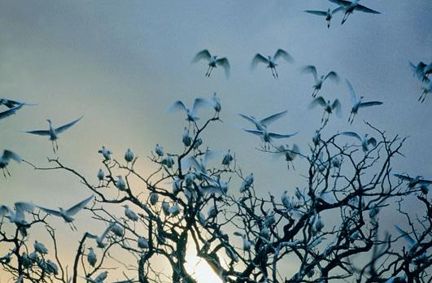

Population | 14 million people (comprises 8 per cent of total population).
Area | 1,579,635 km²  Mainly savanna-like vegetation, including the Cerrado, swamplands (called the Pantanal) in the west and equatorial rainforests in the north.
States | Goiás, Mato Grosso, Mato Grosso do Sul and The Federal District.
Climate | The weather can be split into two: one season is dry and colder, while the other one is humid and hot. The average temperature is of 20 °C (69 °F).
Major Cities | Brasília, Gioania
Agriculture | Cattle-rearing is very important as this region is the main supplier of beef to cities like São Paulo. Soya production is also developing in certain parts of the region.
Industry | There are few modern industries in this region. There are important mineral resources to be found here like diamonds and quartz. Tourism as a source of income has been developing rapidly in the region, attracting people from around the world who want to enjoy the rich fauna and flora of the Pantanal.
Percentage of Urban Dwellers | 83 per cent
Tasks
Take the heading ‘Regions of Brazil’ then answer the following questions.
- Copy and complete the following table

Region | Population in 1990 (mn) | Population in 2010 (mn)
North | 11
North East | 44
South | 23
South East | 64
West Central | 10
Total | 152

- Describe two similarities between two regions of Brazil.
- Describe two differences between two regions of Brazil.
- Study the pie chart below. What conclusions can be drawn about the percentage of wealth produced by the regions of Brazil?

Percentage of Wealth Produced (2006)
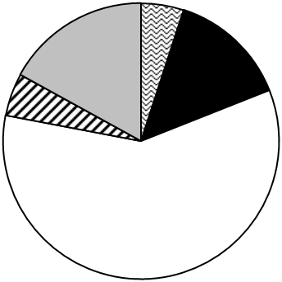
North 5%

North East 14%

South East 59%

South 5%

West Central 17%

- Working in pairs, design a poster advertising one of Brazil’s five regions as a holiday destination. Your teacher will assign each pair with a region.

- Try to include a map, labelled photos and short descriptions.

- Try to include famous sites of interest such as: Corcovado Mountain, statue of Christ the Redeemer, Sugar Loaf Mountain, Iguacu Falls, Amazon River, Ipanema or Copacabaña beach.

- Include an in-depth city profile within your region.

- Make the poster as colourful as possible.

Your teacher may have some travel brochures which could help you.

Topic 4: The People of Brazil

Brazil has the fifth largest population in the world after China, India, United States of America and Indonesia. Its population is approximately 186 million, and is predominantly young: 62 per cent of Brazilians are under 30 years of age.

Population of Brazil (millions)
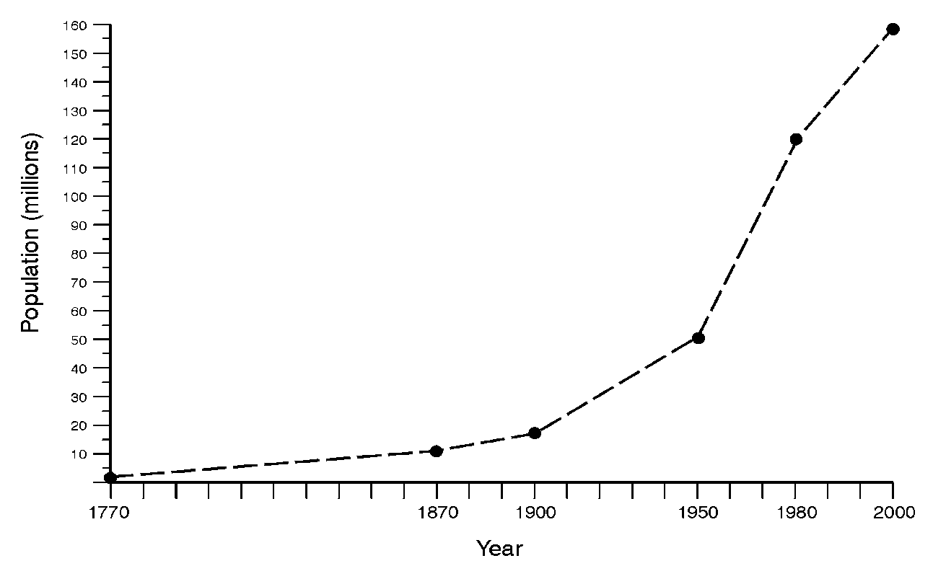

Brazil is an enormous country and it would be wrong to think of it as all being the same. Brazil has a great variety of people.
The original peoples of Brazil lived in the forests and along the rivers. They hunted, fished and collected wild fruit and nuts. In the year 1500 there were about 6 million of these Indian aborigines living in what is now Brazil.
The first Portuguese explorer, Pedro Cabral, landed in the state of Bahia on the 22 April 1500. He described it as ‘El Dorado’ (new paradise). The Portuguese colonists called the native people Indians and used them as slaves. Many thousands died from disease brought by the Europeans. Today many of the Native Indians, for example the Yanomamos, have been killed by land speculators. There are probably less than 300,000 Native Indians today.
The Portuguese settlers set up huge sugar plantations especially in the Bahai region. To work on these plantations, the owners used slaves from Africa. Approximately, four million black slaves were brought to Brazil by the Portuguese. Nearly half of all Brazilians trace their ancestry to black slaves imported during the colonial era.
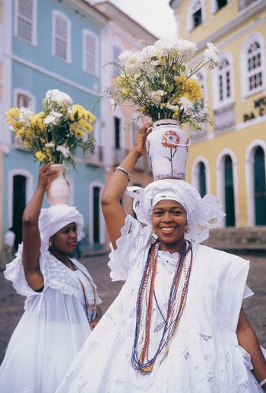
With mixed marriages between Europeans and Indians and Europeans and Africans, two new groups of people have developed: the olive-skinned mesticos and the darker mulattos.
In the twentieth century, the most significant immigrants have been Japanese. They are the most prosperous ethnic group in Brazil growing a fifth of the coffee, a third of the cotton and all of the tea. It is a little-known fact that today Brazil contains the largest number of people of Japanese ancestry outside Japan, most of whom live in São Paulo state or the south of the country.
The population of a country changes over time, as does the ethnic composition, or make-up. The pie chart below shows the current ethnic composition for the year 2006. We often refer to small sections of the population as ethnic minority groups.

Ethnic composition 2006

Tasks
Take the heading ‘People of Brazil’ then answer the following questions in full sentences.

- Draw a bar graph showing the increase in Brazil’s population from 1900. Remember to give your graph a key and an appropriate heading.

- Using the evidence from the graph, give one reason to support the following statement by Jose Nazário.
‘The population of Brazil has risen quickly since 1900.’
Jose Nazário

- Describe the original peoples of Brazil.

- Why did the Portuguese settlers need slaves?

- Who did they use as slaves?

- How important are the Japanese in Brazil today?

- Write out in sentences what the pie chart tells you about the ethnic composition of Brazil in 2006.

- Read pages 18 and 19 of the “Places” textbook and compete activities 1-5 on page 19.

Topic 5: The road to Rio de Janeiro from Minas Gerais.
- Why do you think the miners were religious?
- Who did they offer gifts to?
- What is a National Park?
- Describe in your own words the conflict between the economy and the environment.
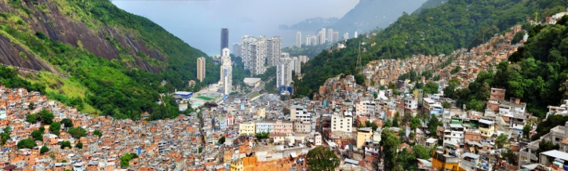
- How many tonnes of iron ore does the mine produce and where do most of the exports go?
- Describe the term subsistence farmer.
- What sector of employment would the farmer be? Formal or informal work?
- What is the state capital of Minas Gerais?
- What location advantages helped the site of the city to grow?
- Why do so many people love to drink coffee? Are there social factors at work?
- Who lost the match to take Rio?
- What are the classic features of Rio?
- When was Christ the Redeemer built?
- How long did it take to build?
- Who did Brazil first play at Fluminense in 1914?

- What metaphor is used to describe Brazilian football?
- How many poor people live in the favelas?
- What is the major challenge facing Rio?
- What stigmatises the residents of the favelas?
- How is class and society segregated on the beach?
- Describe the way BOPE is trying to help the favelas?
- How can the police break down barriers in the community?
- What infrastructure investments were built to help the inhabitants of the Complexo de Alemo favela?
- Describe how the cable car affects different groups of people.
- Explain the benefits that the social programs will create.
Topic 6: Rio de Janeiro
Location
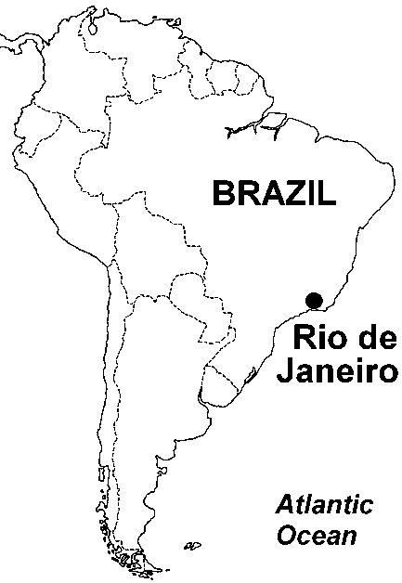
Rio de Janeiro is on Brazil’s Atlantic coast, in the south-east of the country. It is situated next to a large natural harbour known as Guanabara Bay.
Location of Rio
Rio was named by the Portuguese explorer, Gaspar de Lemos, in January 1501. He mistakenly thought that Guanabara Bay was a wide river mouth and he gave it the name Rio de Janeiro, meaning ‘River of January’.
The city is the second largest in Brazil and was the country’s capital city until 1960, when Brasilia took its place. Six million people live within the city boundaries, but 12 million actually live in the wider built-up area.
Geography
In terms of scenery, Rio is one of the most breath taking cities in the world. The city is squeezed into a narrow strip of land between the coastline and a steep range of forested mountains.
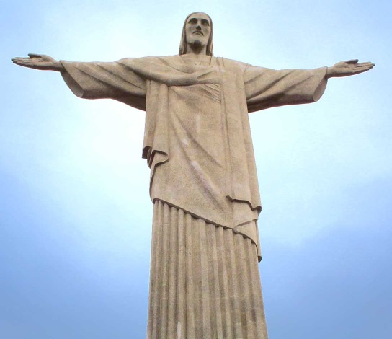
Miles of sandy beaches and coastal lagoons are overlooked by very steep mountains including Sugar Loaf Mountain and the Corcovado, which rises to over 700 metres. The Corcovado is world famous for the 40-metre high statue of Christ the Redeemer at its top, overlooking the city.
Christ the Redeemer

Industry
Rio is the top visitor destination in South America and tourism is the city’s biggest industry. The sandy beaches of Copacabana and Ipanema, the hot sunny climate, the magnificent scenery and the spectacular annual carnival attract visitors from all over the world.
For centuries Rio was Brazil’s largest and most important city. Although Sao Paolo has overtaken it in size and population, it is still very important to Brazil. Rio’s main manufacturing industries include chemicals, pharmaceuticals, clothing, furniture and processed foods. Service industries are also very important and Rio is a major centre for banking, finance and insurance.
Rio is also still a major port from where coffee, sugar, and iron ore are exported to all parts of the world.
The main areas of Rio de Janeiro are shown on the map below.
Map of Rio de Janeiro

Key
 | Tijuca National Forest Park |  | International airport
 | Shanty towns (favelas) |  | Motorways/expressways
 | Industrial areas | ❐ | Granite mountains

Main areas of Rio de Janeiro

Rio is separated into four main zones:
Centro
Centro (or Central Business District) is the oldest part of town and contains many historical buildings, including the Imperial Palace and the main cathedral, along with many shops and market stalls. Tall office blocks and service industries dominate the skyline of the city centre. Some of Brazil’s largest organisations have their headquarters in Rio’s CBD, including Petrobras (Brazil’s largest oil company) and CVRD (its largest mining firm).
South Zone
This South Zone was originally made up of small fishing villages including Copacabana and Ipanema. They only became connected to Rio when road tunnels were built under the mountains. The main tourist hotels and beaches are located here beside luxury flats. However there are large areas of poverty nearby on the steep hillsides overlooking the South Zone, notably Roçinha, which is South America’s largest slum.

The district of Ipanema
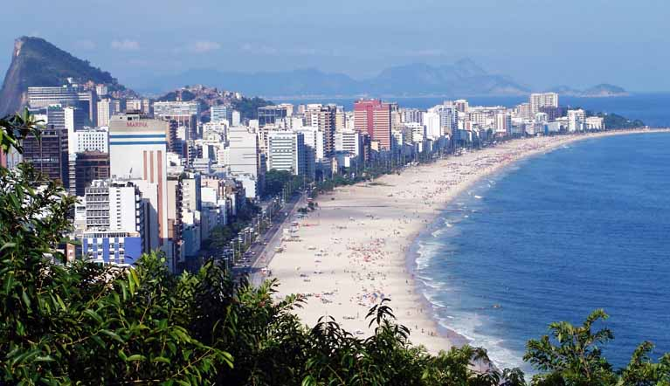

North Zone
This is the industrial part of Rio and includes the docks and warehouses around the main port area. The airport and the main football stadium, the Maracanã, are also located here. This part of the city is an area of mainly low quality housing and poor services, known as the ‘periferia’. Many shanty towns have grown up on the edge of the city, where migrants from rural areas of Brazil are forced to settle.
West Zone
This is the most modern area in Rio. It includes the areas of Jacarepagua and Barra De Tijuca, a wealthy coastal suburb to the south west of the city. Barra has many luxury apartment blocks, shopping malls, and recreational and tourist facilities such as hotels, restaurants and theme parks. New motorways connect this area with the rest of the city.

Rio de Janeiro
Read the previous pages and answer the questions below in full sentences.

(a) How did the city of Rio de Janeiro get its name?
(b) Rio is known as the ‘Cidade Maravilhosa’ which means marvellous city. Explain why Rio is one of the most picturesque cities in the world.
(c) Give four reasons why Rio de Janeiro is a popular tourist destination.
(d) Apart from tourism, what other industries are located in Rio?
(e) What goods are exported from Rio’s harbour?
(f) Complete the table on the next page using the information on the previous pages to show the main features of Rio’s four main zones.

Zone | Main types of housing | Other features/  main activities
Centro
North
South
West

Topic 7: Favelas

Over the last 50 years, millions of people have migrated from rural Brazil to large cities such as Rio, in the hope of better employment and a better standard of living.
In reality, there are not enough jobs or houses for all the migrants when they arrive. With no place to stay, they have set up their homes on many of Rio’s hillsides and unused areas (near swamps and rubbish dumps), and built their houses from basic materials. These illegal squatter settlements are known as favelas. The name comes from a wild flower which grows on the hillsides. Rio has over 600 favelas.

Population growth in Rio 1950–2000

Rio’s population has trebled since 1950 to 6 million. This rapid growth and lack of housing means that over 1.3 million live in the favelas. The population of Rio’s favelas is growing by 100,000 each year as people continue to migrate.
Roçinha
Roçinha is Rio’s largest and oldest favela with an estimated population of 150,000. This area of slum housing is found on a very steep hillside in Rio’s South Zone, overlooking the beach districts of Copacabana and Ipanema
Roçinha’s first shacks were built in the 1940s, but the main growth of the area was during the 1970s and 1980s with the construction of Barra da Tijuca, a nearby wealthy suburb. Migrants were attracted by the prospect of jobs in the construction industry.
Roçinha – Rio’s largest favela
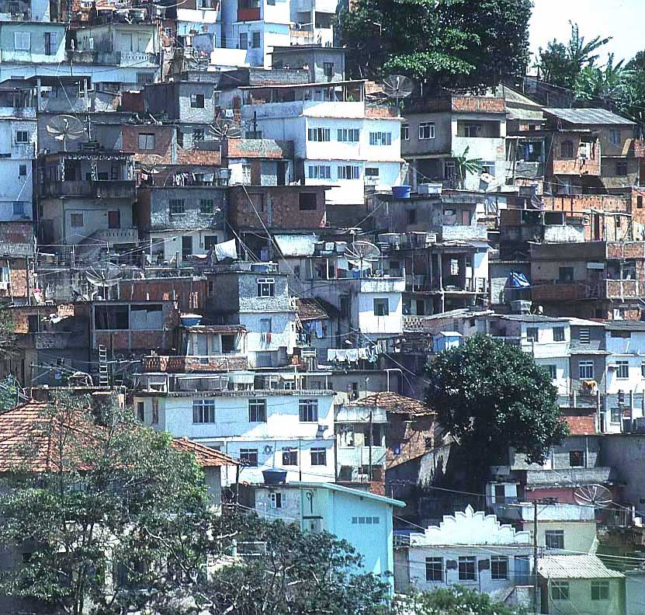

Rio’s favelas have a number of major problems:
Poor housing and services
Houses in favelas are built illegally with basic materials such as scrap wood, corrugated iron, broken bricks and even plastic sheets. About 12% of the households in Rio do not have running water, over 30% have no sewage connections and 30% have no electricity. Residents use illegal connections or ‘gatos’ to overhead pylons to secure electricity, which is very dangerous. This can cause fires to start and people to be electrocuted.
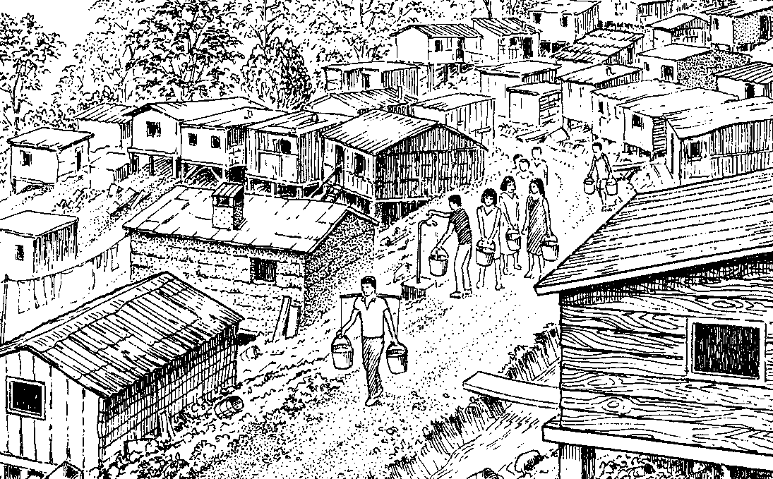

A typical favela in Rio de Janeiro

Overcrowding and poor health
Rio’s favelas are incredibly overcrowded. On average 37,000 people are crammed into each square kilometre of favela. With the poor sanitation, diseases such as cholera and diarrhoea spread quickly. The life expectancy in a Rio favela is only 56. Infant mortality rates are also high: 50 infants per 1000 will not reach the age of one.
Lack of jobs
Unemployment rates are high (around 20%). Most of those who are employed have jobs in the informal sector (black market) as street vendors, drivers, labourers, maids or producing sewing and handicraft work for the local street market. Jobs in the informal sector are poorly paid (less than $100 a month) and work is irregular.
Crime
Rio’s favelas are controlled by criminal gangs who are involved in drugs, gun crime, bank robberies, kidnapping and murder – 80 people are killed each day in Rio. Roçinha is one of Rio’s most feared areas and the police hardly ever patrol on foot unless they are heavily armed. If a problem develops they will often shoot down from a helicopter into the slum.
Landslides
Heavy rainfall from tropical storms can cause mudslides on Rio’s steep hills. In 1988 landslides killed 277 people and left another 13,000 homeless as their flimsy houses were swept away.
Rio’s Favelas
Read the previous pages and answer the questions below in full sentences:
(a) How did Rio’s ‘favelas’ get their name?
(b) Describe three different locations where favelas are likely to be found.
(c) What is Rio’s oldest favela and how many people live there?
(d) What materials are the houses in favelas made from?
(e) What are the health problems in Rio’s favelas?
(f) What are ‘gatos’ and why are they dangerous?
(g) What is the informal sector? Give three examples of jobs found in this sector.
(h) Describe two problems of working in the informal sector.
(i) Describe the methods used by police to control crime in the Rocinha favela.
Topic 8: Improving the Favelas

Rio’s authorities initally wanted to bulldoze the favelas as they are illegal, but they realised this would simply cause thousands of people to move elsewhere. Today, two different methods of improving the favelas are used in Rio de Janeiro:

1. Self-help schemes
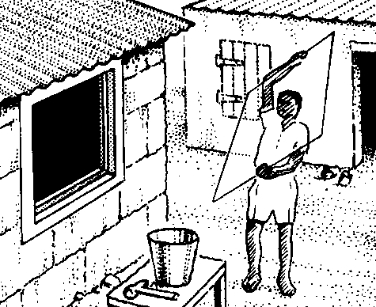
A self-help scheme is a small scale project, which uses the skills of the local people to upgrade their house and their neighbourhood.
A self-help scheme
Rio’s local authority does not have the money to build large housing areas, but it can provide the residents with basic materials such as bricks, tiles, wood, cement and glass to improve their own homes.
As a result of self-help schemes, most of the housing in Roçinha has been upgraded, and almost all the houses are now made from concrete or brick. 75% of homes now have electricity and many have satellite or cable television. Over time Roçinha has changed from a poor, illegal settlement to a legal area of low quality housing. Many services have since been established in Roçinha including shops, banks and cafés.

2. Site and service schemes
Unlike self-help schemes, with site and service schemes the local authority takes control of building projects. The Favela Bairro Project or ‘Slum to Neighbourhood’ project was an attempt to bring favela areas in line with the rest of Rio. The project was started in 1994 and targets smaller favelas with 500 to 2,500 homes. Larger brick houses are built, sanitation and water supplies are installed and people may be allowed eventually to buy their homes. Facilities in the area are also improved including the building of health clinics, schools and sports areas for recreation, and the widening of streets for emergency services and refuse collection lorries.
Success or failure?
These schemes have proved to be a success; 500,000 people in Rio have benefited in some way from these improvements. Installing water pipes and sewers has greatly improved health and reduced disease. The Favela Bairro Project also generates income for the council as families have to pay rent for the new homes. However, the Favela Bairro Scheme is no use to families without jobs who cannot afford the rent.
Improving the Favelas
Answer the questions below in full sentences.
(a) What is a ‘self-help scheme’?
(b) Describe in detail the improvements made to housing in the Roçinha favela.
(c) How is the Favela Bairro Project different from self-help schemes?
(d) What are the positives and negatives of site and service schemes? Do you think they have been a success?

Topic 9: Wealthy Suburbs

Location and Growth
Barra da Tijuca is a modern coastal suburb in Rio’s West Zone, next to the Tijuca lagoon. Many of the residents of Rio’s South Zone have moved the 20 kilometres down the coast to Barra. It is the fastest growing part of Rio de Janeiro.
Until the 1970s, this area was inaccessible and cut off from the rest of Rio. The construction of a four-lane motorway with tunnels under Rio’s many mountains enabled this area to be developed. A new expressway, the Yellow Line, provides direct access to the centre of Rio.
This modern area is appealing as it has less crime, better housing and is much less congested. This process of people moving out of cities is known as counter-urbanisation and is unusual for a city in an ELDC.

Housing in Barra da Tijuca
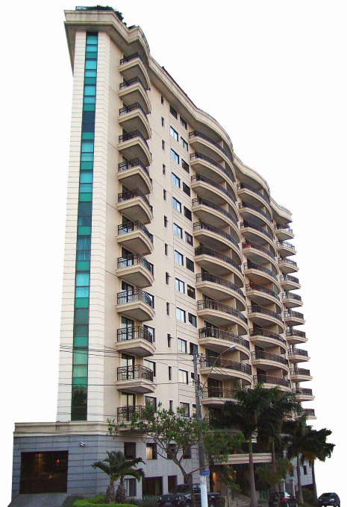
Most of Barra’s 130,000 residents live in luxurious and spacious apartment blocks that are between 10 and 30 storeys in height.
Barra apartment block
Security is a high priority and the residents are protected by modern security entrances with CCTV, underground parking, window shutters and bars, alarm systems and 24-hour security guards who are often armed to deter criminals.
Apartment blocks contain every modern convenience including satellite TV, swimming pools, jacuzzis and saunas; they often have shops and laundries in the basement.
People who live in Barra are usually from the wealthy classes and it is quite common for them to employ maids, cooks and gardeners.

Services in Barra da Tijuca
Barra da Tijuca has an American feel to it: it is very unlike Brazil and more typical of Los Angeles or Miami Beach. It is a self-contained city: it has everything that its residents need, including well-paid office jobs, modern schools, hospitals, a university, parks, restaurants and cinemas. A monorail and numerous dual carriageways allow easy movement around the town.
Barra has a 5-kilometre stretch of shopping malls and hypermarkets, the largest retail complex in South America with over 700 shops. Malls are spacious and air conditioned with large car parks. Retailers such as Wal-Mart and Makro have located here and in the São Conrado Fashion Mall, outlets sell luxury designer goods such as Armani. Barra’s wealthy shoppers are also well protected from pickpockets and criminals by armed security guards and CCTV cameras in each mall.

Tourism in Barra
Barra is a very popular area for tourism and recreation. It has an 18-kilometre beach, the longest in Rio, which has excellent conditions for bathing, sailing, surfing, windsurfing and fishing.
The beach front area is lined with many five-star hotels with spectacular views of the Atlantic coast. Numerous cafés, restaurants and nightclubs are also found along the promenade.
Barra also has a theme park called Terra Encantada, a championship golf course and a large concert hall. Due to its excellent services, Barra da Tijuca is the home to the athlete’s village for the 2007 Pan-American Games, which are being held in Rio.
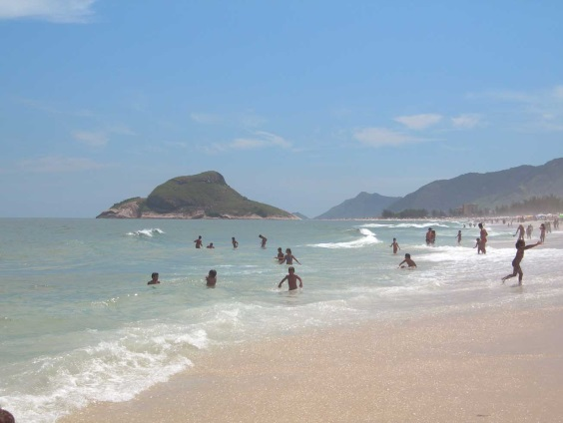
Barra da Tijuca Beach
Barra da Tijuca
Read previous pages and answer the questions below in full sentences.

(a) Give three reasons why people want to leave Rio and move to Barra to live.
(b) Describe what is meant by counter-urbanisation.
(c) Draw a spider diagram to show the ways in which the apartment blocks in Barra are made safe and secure for the people who live in them.
(d) What evidence is there that Barra da Tijuca has an American influence?
(e) Explain why Barra is a very popular place for tourists (give at least five reasons).
(f) Label the sketch of Barra da Tijuca (below) with the main features of the area (e.g. high rise apartments, dual carriageway, beach, Tijuca lagoon, shopping malls, mountains of Rio, Atlantic Ocean).
Sketch of Barra da Tijuca
Topic 10: Environmental Problems

Although Rio is one of the world’s most scenic cities, it is also one of the most polluted. Environmental problems in Rio can be put into three categories:

1. Air pollution
Very often mist from the Atlantic Ocean mixes with exhaust fumes from vehicles and pollutants from factory chimneys, creating a brown smog that smothers the city. Air pollution is estimated to cause 5,000 deaths in the Rio area each year, as it causes respiratory diseases such as bronchitis and lung cancer.
The Brazilian government has not passed any laws to help limit atmospheric pollution, and toxins from vehicles and factories continue to pollute the air on a daily basis. Until major improvements are completed in public transport to encourage people off the roads, air pollution will continue to be a major problem in Rio.

2. Water pollution in Guanabara Bay
Pollution in Guanabara Bay is a major threat to wildlife and tourism. The bay is home to hundreds of species of marine birds, fish, dolphins and endangered mangrove swamps. At present, many areas are not suitable for swimming and smell very badly; if this pollution was to spreads to the tourist areas of Copacabana and Ipanema, the local economy and the thousands of jobs that tourism provides will be hit hard.
There are two main sources of pollution in the bay:
(a) Pollution from sewage
Rio’s sewer network has never been able to cope with the huge number of people. Four hundred tonnes of untreated sewage pours into Guanabara Bay each day.
b) Pollution from Industry and Shipping
Seventy tons of industrial waste enters the bay each day from factories in Rio’s industrial zone.
Oil spills from shipping and pipelines are also a problem. In January 2000, 1.3 million litres of fuel oil leaked from the Petrobras oil refinery causing an oil slick 40km² in size, which killed thousands of fish and marine bids.
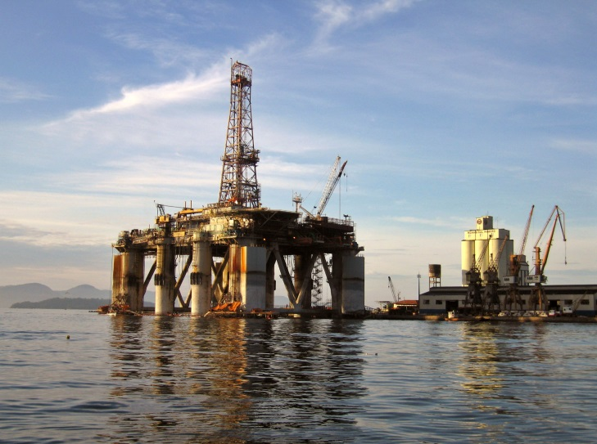
Industry in Guanabara Bay

Guanabara Bay is also polluted by ships emptying their fuel tanks into the harbour because the local port lacks the necessary equipment for proper disposal.

Solutions
In 1994 the Guanabara Bay Clean Up Program was established. $300 million was spent on the construction of new sewage treatment plants in an attempt to improve this problem. Phase 2 of the Program started in 2004 with another $400 million being spent on 12 new sewage works. This will increase the number of homes in Rio with proper sewage disposal from 35% to 50%, although much still needs to be done.
The local government could also bring in new environmental laws and be stricter on those who pollute the environment. In February 2002, the state of Rio de Janeiro fined the owners of the cruise ship Caronia $400,000 after it deliberately released 7,500 gallons of gasoline into the Bay, but such large fines are uncommon.

3. Rio’s waste mountain
The worst problems with waste disposal exist in the favelas. For instance Roçinha, Rio’s largest favela, has no proper roads, making waste collection by lorry virtually impossible. Much of this rubbish is dumped in locations where there is often very poor sanitation: this can lead to diseases such as diarrhea, cholera and other diseases, and to an increase in rat populations. The dumping of loose litter on the steep hillsides can cause landslides after periods of heavy rain.
Every two months, the city’s 6 million people produce enough rubbish to fill the Maracanã stadium, one of the world’s largest football grounds (it can hold 120,000 people). The traditional way of disposing of solid materials is to dump it in landfill sites. However, landfill sites are eyesores and often produce dreadful smells.
Near Rio’s University, an unusual method of waste disposal is being tried out, which brings benefits to the local area. A small power plant has been set up using methane gas (biogas) produced from rotting rubbish. This renewable form of energy will consume 30 tonnes of garbage per day and produce 1 megawatt of electricity for the local community, powering 1,000 homes. If this proves to be a success, more schemes could be put in place across the city.

Environmental Problems in Rio

Read the previous pages and answer the questions below in full sentences:

(a) What are the two main causes of air pollution in Rio de Janeiro?
(b) What species of wildlife are threatened by pollution in Guanabara Bay?
(c) What impact could coastal pollution have on Rio’s tourism?
(d) Give three reasons why Guanabara Bay is badly polluted.
(e) What are the solutions to improving water quality in Guanabara Bay?
(f) Describe three problems found in Rio’s favelas due to the lack of proper waste disposal.
(g) What are the problems of using landfill sites to dispose of waste?
(h) How can waste products benefit the local community?

Topic 11: The Olympics
First Ancient Olympics
The first Olympic Games were held in Olympia, Greece in 776BC in honour of the God Zeus. Zeus was thought of as the god of the sky.
The aims of the games were to show the physical qualities of the athletes and encourage good relations between the cities of Greece and lasted one day with just one event which was running.
Only men were allowed to compete and only unmarried women were allowed to watch the games so some women dressed as men and sneaked in.
Winners took part in two ceremonies, the first they received a palm bunch and had red ribbons tied round their hands and heads, in the second the winner had an olive tree wreath placed on their head.
Women in the Olympics
Women were not allowed to take part in the games as it was thought to be “impractical, uninteresting, anaesthetic and incorrect”,
Women first took part in the Olympic Games in Paris in 1900, four years after the first Olympic Games of the modern era in Athens. Despite the reticence of the reviver of the modern Games, Pierre de Coubertin, 22 women out of a total of 997 athletes competed in just five sports: tennis, sailing, croquet, equestrian and golf. In 1912 the sport of swimming was introduced for women, however, the American team would not allow their women to compete in an event in which they did not wear a long skirt.
The women’s 800m running race was banned between 1928 and 1960 due to too many of the competitors collapsing at the finishing line. Luigiua Giavotti holds the title for being the youngest Olympic medal winner when she won silver for the Italian gymnastics team at the age of 11 years and 302 days. Today participants need to be 16 years old within an Olympic year.
The Olympic Rings
The five-ringed Olympic symbol represents the union of the five continents and the meeting of athletes from throughout the world at the Olympic Game

There is a common misconception that the colours of the rings are linked with individual continents. The colours simply come from those colours which appear on all the national flags of the world which take part in the Olympics

Tasks
Answer the following questions in full sentences.
- What were the aims of the ancient Olympic Games?
- How did women ensure they were able to watch the games?
- Why did the American team not allow their women to compete in the swimming event in 1912?
- What age do Olympic participants have to be to compete in the games these days?
- The Modern Olympics have been running for 116 years and have only been cancelled three times, in 1916, 1940 and 1944. Why do you think this was?
- Take a copy of the Olympic Ring diagram and colour it the correct colours.
- Why are the linked rings an Olympic symbol?

- The table below shows the number of female participants that have taken part in the summer Olympic Games since 1900. On a line graph; plot the number of female participants from years 1900; 1920; 1936; 1960; 1976; 1992; 2008 and 2012.
Olympic Games – Female Participants
Year | Participants | Year | Participants
1896 | - | 1960 | 611
1900 | 22 | 1964 | 678
1904 | 6 | 1968 | 781
1908 | 37 | 1972 | 1,059
1912 | 48 | 1976 | 1,260
1920 | 63 | 1980 | 1,115
1924 | 135 | 1984 | 1,566
1928 | 277 | 1988 | 2,194
1932 | 126 | 1992 | 2,704
1936 | 331 | 1996 | 3,512
1948 | 390 | 2000 | 4,069
1952 | 519 | 2004 | 4,329
1956 | 376 | 2008 | 4,637
 |  | 2012 | 4,676
Extension
Here is a list of some of the 205 countries taking part in the London 2016 Rio Olympics. Unfortunately, the names have been jumbled up. Unscramble the names and write the correct names in the spaces on the right.

A | ntdUie ttsSae
B | ocoorcM
C | yarGemn
D | naiBrti teGra
E | Iaytl
F | Nraywo
G | rguHnay
H | nliFnad
I | Ntelnsdarhe
J | aiChn
K | wdnSee
L | usaisR
M | aaadnC
N | aanpJ
O | wtelnSizrad
P | Asraitu
Q | daoPln
R | Suhto Kareo
S | arguBlai
T | uabC
U | krmenDa
V | zcehC eulicRp
W | gumBlei
X | liarAusta

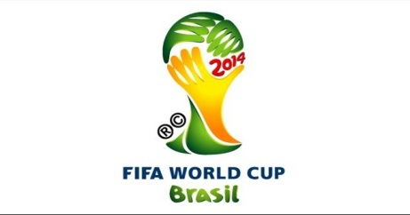
Topic 12: The World Cup

The 2014 FIFA World Cup will be the 20th FIFA World Cup. The World Cup is an international football tournament. It is scheduled to take place in Brazil from 12 June to 13 July 2014. This is the second time Brazil has hosted the competition. Brazil will become the fifth country to have hosted the FIFA World Cup twice, after Mexico, Italy, France and Germany.
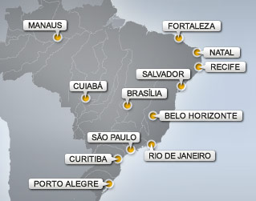
It will be the first World Cup to be held in South America since the 1978 FIFA World Cup in Argentina, the first time two consecutive World Cups are staged outside Europe and the first time two consecutive World Cups are staged in the Southern Hemisphere (the 2010 FIFA World Cup was held in South Africa). It will also be the first FIFA World Cup to use goal-line technology. Spain is the defending champion.
The 12 cities hosting World Cup matches in Brazil

As the hosting country of the 2014 World Cup and the 2016 Olympic games, Brazil is faced with the significant challenge of improving its infrastructure to support the influx of visitors that these events will attract. This will require extensive investment into Brazil’s urban areas, sporting facilities and tourism sector. As a result, many of the world’s investment funds and financial institutions are preparing themselves for a boom in financing opportunities.
Construction and remodelling of stadiums alone will be approximately over €1.1 billion (£ 550 million). In addition to the stadium upgrades and renovations, there will be millions more spent on basic infrastructure needs to get the country ready.
Task
- In groups of 2 or 3; from the list below, prioritise the projects Brazil needs to have started in order to be ready for 2014.
Build new roads | Build hotels
Update airports | Update Health and Safety laws
Build stadiums | Advertise the games.
To clean up the shanty towns. | Train new personnel –policemen, translators, guides etc
Crack down on crime. | Build accommodation for the players.
 | Update national transport systems

