**Ayr Academy**

**Child Protection Procedures**

ALL VISITORS SHOULD READ PRIOR TO ENTERING AYR ACADEMY

|  |
| --- |
| Children and young people have the right to be safe. It is everyone’s responsibility to ensure that we respect and uphold this right. |

If you think a child or young person is in need or a disclosure is made to you, you MUST do the following:

* Listen carefully, let the child/young person speak.
* Don’t show disbelief or panic.
* Take the allegation seriously, reassure the child/young person and ask how they feel.
* Avoid expressing your views on the matter.
* Don’t guarantee confidentiality and explain your reasons for this.
* Do not question the child/young person. This is not your responsibility.
* Do not carry out an investigation or take photographic evidence. This is not your responsibility.
* Act quickly and share the information with the Designated Child Protection Coordinators as soon as possible.

They are:

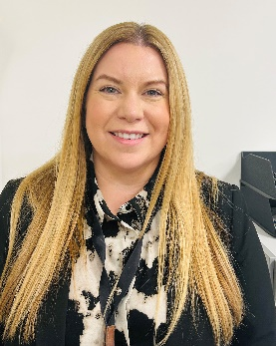



Claire Dunstall, DHT Laura Traynor, HT Kirsty Lawrie, DHT

**ALL INSTANCES OF CHILD PROTECTION CONCERNS OR DISCLOSURES SHOULD BE REPORTED TO THE CHILD PROTECTION COORDINATORS WITHOUT DELAY.**

Respect               Ambition                Community              Compassion                 Responsibility

Believe…Achieve