Trigger

What negative thoughts did you have after the trigger happened?

How were you left feeling?

Trigger

What negative thoughts did you have after the trigger happened?

How were you left feeling?

Trigger

What negative thoughts did you have after the trigger happened?

How were you left feeling?

Positive Counter Thought

How would you feel now?

Positive Counter Thought

How would you feel now?

Positive Counter Thought

How would you feel now?

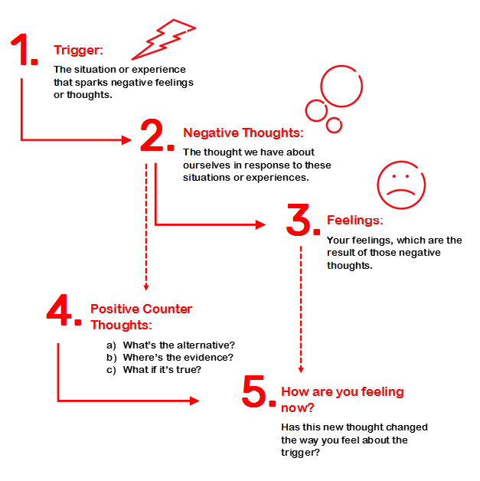

Challenging negative thoughts:

Technique 1: What’s the alternative?

Just like every cloud has a silver lining, there is more than one way to look at most situations.

- Is there another way to think about this situation, even if it seems unlikely?
- What advice would I give to a friend who was feeling the way I do?
- Are there positive things about this situation or myself that I am overlooking?
- When things like this have happened before, what have been the reasons?

Technique 2: Where’s the evidence?

Sometimes negative thoughts are so familiar, we don’t stop to question whether or not they are actually true.

- What proof do I have that my negative thought is true?
- Is there evidence that doesn’t support my negative thought?
- If I’ve had this negative thought before, has it always been accurate?
- Can I be 100% sure that my negative thought is true? If not, why not?

Technique 3: What if it’s true?

Sometimes we spend so much time feeling bad about negative thoughts, we don’t think about what it would mean if they really were true. Is it possible that it might not be that bad? How terrible would it really be?

- If my negative thought is true, how can I cope with this situation?
- How will thinking negatively about this situation help me? How might it work against me?
- If it is true, what’s the worst thing that can happen? How likely is it that this will happen?
- If it is true, will this matter in one week? One year? Ten years?

Having more fun

Social:

Physical:

Relaxing:

Entertainment:

Kindness to others:

Accomplishment:

You deserve a reward

What are some simple things that make you happy?

People: someone you’d like to spend more time with.

Places: places you’d like to spend more time.

Things: things you’d like to buy (e.g. books, clothes)

Treats: food and drink you like best

Activities: simple activities that you enjoy (e.g. going for a walk, listening to music)

