Alloway Early Years Centre
Handbook
2025-2026

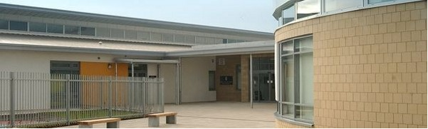

Educational Services

Depute Chief Executive and Director of Education: Scott Mulholland


Head Teacher – Mrs F Meney

Alloway Primary School

16 Doonholm Road


Alloway

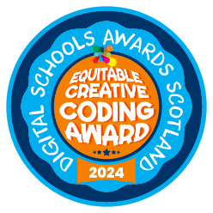
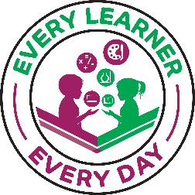
Ayr

KA7 4QQ

Tel: 01292 612490

Email: alloway.mail@south-ayrshire.gov.uk

Our Ref: Your Ref:

Date: 10 October 2025

Dear Parent/carer,

On behalf of everyone at Alloway Primary School, welcome to our Early Years Centre class. I hope you will find this handbook interesting and helpful. It is intended as a short introduction to our Early Years Centre for parents of new pupils in session 2025-2026.

Throughout this booklet we have tried to give you an impression of life in our Early Years Centre class and the ways we will cater for the individual needs of each child. If the answers to your questions are not here, please do not hesitate to contact me.

Parental involvement and working in partnership with parents are important features in our school life and we actively encourage close parent/staff liaison in a number of ways. You will find the Early Years Centre staff extremely approachable and only too willing to address any parental concerns.

I look forward to meeting you and your child and hope that you will soon feel a welcomed and valued member of our school community.

Yours sincerely

Fiona Meney

Fiona Meney
Head Teacher

CONTENTS
Aims Page 5
Coming to Our Early Years Centre Page 8
Early Years Centre Sessions Page 9
Applying for an Early Years Centre Place Page 10
Starting Our Early Years Centre Page 12
School Holidays – Session 2023-2025 Page 12
Staff Page 13
Fire Drills/Security Measures Page 14
Emergency Closure Arrangements Page 14
Quality Assurance Page 16
School Improvement Page 16
Working Together to Support Learning Page 17
Additional Support Needs Page 18
Getting It Right for Every Child (GIRFEC) Page 24
Child Protection Page 25 Attendance Page 26
Outings and Parental Consent Forms Page 26
Clothing Page 26
Transport Page 27
Valuables Page 27
Use of Social Media Page 28
Healthy Eating Page 30
Equality Page 32
Early Years Centre Curriculum Page 32 Planning/Assessment Page 38
Parental Partnership Page 40
Parent Council Page 42
Stay and Play Page 44
Coffee and Chat Page 45
Split Placements Page 45
Next Steps Page 45
Medical Information/Accidents Page 47
Data Protection Act Page 49
Freedom of Information Page 55
Suggestions and Complaints Page 57

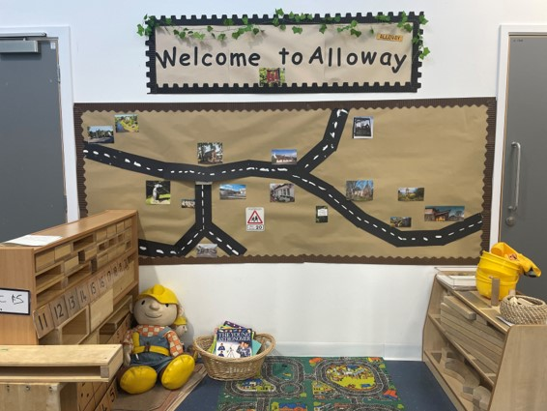

In Alloway Early Years Centre we aim to provide a service of the highest quality for you and your child by:
- Providing a safe, welcoming environment in which your child will feel happy, secure and valued.
- Providing a stimulating learning environment meeting the developmental needs and interests of your child.
- Offering a range of learning experiences and activities to foster the emotional, social, physical, creative and intellectual development of your child.
- Nurturing, challenging and supporting your child in all aspects of his/her development.

Here are our school and EYC vision and values, following consultation with staff, pupils and parents last session -
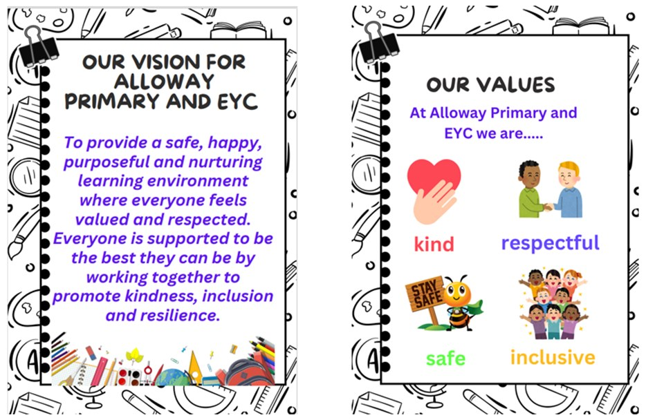

SOUTH AYRSHIRE COUNCIL AIMS AND VALUES
‘It is the intention of the department that the aims for the service will be delivered within an open
and rigorous climate of continuous improvement’

- Improve Attainment & Achievement by Promoting Effective Learning and Teaching
  - Raise standards of educational attainment in our schools
  - Maximise achievement for all learners
  - Develop an integrated programme for ICT to support learning
  - Establish an effective measuring, monitoring and evaluation performance system
  - Provide access to high quality specialist services to support learning and teaching
- Secure Best Value Consistent with High Quality Educational Provision
  - Improve the fabric of and access to our buildings to meet the needs of lifelong learning
  - Develop all personnel to reflect the changing needs of the service
  - Provide modern equipment and resources to address the needs of all learners
  - Strategically deploy resources to secure best value for the service
  - Embed rigorous quality assurance and quality management systems across the service

- Build Community Capacity and Advance Active Citizenship
  - Form partnerships to facilitate and support learning
  - Strengthen links among families, school and the community
  - Support the development of skills and confidence in community activists and organisations
  - Promote broad-based participation in community affairs

- Ensure Lifelong Learning is Inclusive and Promotes Equality and Fairness
  - Develop equality of opportunity for all learners
  - Create an ethos of support for learning for every individual
  - Provide a full range of learning opportunities
  - Encourage individual personal development

- Promote the Development of Cultural Activities
  - Develop positive links with Arts’ organisations throughout South Ayrshire in order
to maximise the impact of cultural activities in the area
  - Increase access to and encourage participation in cultural activity
  - Enrich learning through the experience of cultural activities
  - Widen opportunities for participation in cultural activities in local communities and among disadvantaged groups
  - Develop a strategic approach to the delivery of cultural services which takes account of the National Cultural Strategy and local priorities


Alloway Primary Early Years Centre is non-denominational and co-educational and provides Early Years Centre education for children between the ages of three and five. It has a maximum capacity for 60 children in a full day
placement. A full day placement is from 9am-3pm.
The Early Years Centre comes under the management, supervision and direction of the Head Teacher, Mrs Fiona Meney.
Mrs Lauren Miller, Depute Head is responsible for overseeing the Depute Manager and Senior who are leading EYC team. Mrs Miller also takes on the role of Pupil Support Co-ordinator for the EYC>
Mrs Kirsty McCallum, Depute Manager is responsible for the day-to-day management of the Early Years Centre.

COMING TO OUR EARLY YEARS CENTRE
This session children will enter and leave through the main EYC entrance. The doors will open at 9-9.10am for drop off and 2.45-3pm for pick up. We would ask that one parent brings their child in to sign in and then leaves again through the main entrance. It is essential that your child is signed in by the person dropping off, and signed out by the person picking up. A member of staff will be on the door during door opening times. Anyone arriving out with door opening times should use the main EYC entrance and press the buzzer. For safety reasons there is no parking directly outside the Early Years Centre entrance or in the school car park and we would ask parents to comply with this instruction. Crossing patrollers are located on The Loaning and Doonholm Road in the morning and at the close of the school day at 3pm.

EARLY YEARS CENTRE SESSIONS

Our Early Years Centre hours will be:
Full Days 9.00am-3.00pm Monday - Friday Term Time

*Additional hours can be purchased through the Local Authority, and children can attend from 8:30am-4:00pm

APPLYING FOR AN EARLY YEARS CENTRE PLACE


We offer places to 3 and 4 year old children with enrolment taking place each year in February. All places are allocated according to South Ayrshire Council’s Pre-5 Admissions Policy – a copy of which is available in the Early Years Centre.
Admission for three year old children is as follows:

If your child’s date of birth is on or between:

4 Year Olds
If your child's date of birth is on or between 1 March 2021 and 28 February 2022
He/she will be eligible for a funded early learning and childcare place from August 2025

3 Year Olds
If your child's date of birth is on or between 1 March 2022 and 28 February 2023
He/she will be eligible for a funded early learning and childcare place as set out as follows:
- 1 March 2022 - 31 August 2022
from August 2025

- 1 September 2022 - 28 February 2023
The first Monday after their third birthday (unless a public holiday or in-service day)

For children with a DOB from 21 August -31 August funding can start from the day of their 3rd birthday.

Following enrolment, children and parents will be invited to visit the Early Years Centre and meet the staff. These visits will be arranged by staff, and information sent out to parents.

STARTING OUR EARLY YEARS CENTRE

Pre-school children who have attended our Early Years Centre as an ante pre-school child, will be entitled to attend for the full session as of the first day of Early Years Centre.
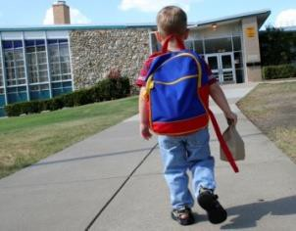
There is however a phased entry programme in place for children who may require longer to settle and for our ante pre-school children to ensure that each child is given time to settle happily into our Early Years Centre.
Initially each child will be encouraged to stay on his/her own for a spell, reassured that his/her parent is nearby.

SCHOOL HOLIDAYS SESSION 2025-2026

Teachers (Inservice)  Teachers (Inservice)  Pupils Return  local holiday  local holiday  Re-open (Pupils)  Schools closed  Teachers (Inservice)  Re-open (pupils)  Schools closed | Mon  Tues  Wed  Fri  Mon  Tues  Mon-Fri  Mon  Tues  Mon-Fri | 18 Aug 2025  19 Aug 2025  20 Aug 2025  20 Sept 2025  23 Sept 2025  24 Sept 2025  10-20 Oct 2025  20 Oct 2025  21 Oct 2025  19 Dec 2025-2 Jan 2026
Re-open (pupils)  Schools closed  Teachers (Inservice)  Re-open (pupils)  Schools closed  Re-open (pupils)  Schools closed  School closed (Teachers Inservice)  Re-open (pupils)  Schools closed  Re-open (pupils)  Last day of term | Mon  Mon  Tues  Wed  Mon-Mon  Mon  Mon  Thurs  Fri  Mon  Wed  Fri | 5 Jan 2026  5 Feb 2026  11 Feb 2026  12 Feb 2026  2 Apr – 21 Apr 2026  20 Apr 2026  4 May 2026  6 May 2026  8 May 2026  25 May 2026  26 May 2026  30 June 2026

STAFF RESPONSIBLE FOR MANAGING THE EARLY YEARS CENTRE CLASS
Head Teacher – Mrs Fiona Meney
Depute Head Teacher - Mrs Lauren Miller

EARLY YEARS CENTRE STAFF
Early Years Centre Principal Teacher (Tues) – Mrs Joanne Anley
Depute Manager - Mrs Kirsty McCallum
Senior Early Years Centre Practitioner - Miss Rebecca Macey-Lille
Early Years Practitioner - Miss Kayleigh Adgie
Early Years Practitioner – Mrs Victoria Cuff
Early Years Practitioner – Mrs Julie Lorimer
Early Years Practitioner – Mrs Anne Ahmed
Early Years Practitioner - Mr Ryan McGill
Early Years Practitioner -Mrs Libby Pollock
Early Years Practitioner - Mrs Haley Fraser
Early Years Practitioner - Miss Caoilin Gibson

Parents can be assured that all our Early Years Centre staff are suitably qualified, competent and have gone through careful selection procedures.

FIRE DRILLS


Fire procedure notices are displayed throughout the Early Years Centre. There will be fire drills throughout the school year. The first drills will be ‘announced’. That means that it will be explained to the children what will happen and what they are to do. The rest are “unannounced” with the children and staff actively encouraged to evacuate the
building as quickly and calmly as possible. Returns for these fire drills are completed and sent to the Council Offices every June.

SECURITY MEASURES

Entrances to the school and Early Years Centre class are security controlled for the safety of children and staff.

EMERGENCY CLOSURE ARRANGEMENTS

Contingency Arrangements

Should the Early Years Centre experience difficulties with severe weather, power failures, fuel supplies, etc., it will obviously be necessary to close the building.
In the event of an emergency during the school day where the children and staff are unable to re-enter the school building the children will be taken to Alloway Parish Church and may be collected by parents and carers from there. Please be reassured that your child’s safety and well being is our prime concern and we will endeavour to keep you closely informed via telephone, notices, press or radio releases.

QUALITY ASSURANCE

As a registered centre our Early Years Centre will be inspected annually by the Care Inspectorate and be included in a joint S.C.S.W.I.S./ HMIE programme. In addition, South Ayrshire Council has its own system for promoting quality in Council and Partnership Centres. The Head Teacher, Senior Management Team and all staff contribute to the on- going quality assurance systems that are in place for Alloway Primary School.

For our most recent Care Inspectorate Report please see our school website.

SCHOOL IMPROVEMENT

Each year, the school produces a School Improvement plan which will be shared with the Parent Council and posted on the school website – https://blogs.glowscotland.org.uk/sa/allowaypsandeyc/
The Early Years Centre is included in this plan, and each member of the EYC team, takes on a role within the School Improvement Plan. The school also produces an end of year Standards and Quality report which can also be accessed from our website. You will see our school and Early Years Centre priorities for the year contained in this document. The Early Years Centre accesses the Active School programme and, as we are part of the Belmont Academy Cluster of schools, we participate in numerous cluster projects and initiatives also. Luther Mavunga is our Active Schools Coordinator.

WORKING TOGETHER TO SUPPORT LEARNING

The school recognises the role of parents as the child’s first educator. When your child starts we will ask you to fill an ‘All About Me’ book and all about me picture which will give the staff background information about your child’s likes, dislikes, and special interests. We operate a key worker system in which each staff member is responsible for a small group of children. Please take time to share experiences daily as you bring and collect your child. We operate an open door policy and invite you into EYC regularly. Alloway Primary School has a ‘Participation Statement’. A copy of the Participation Statement is also on our Early Years Centre website. If you have any problems or concerns please come and discuss them. In order to work together to support your child, we work with other professionals that are involved in your child’s life, such as, Health Visitor, Speech and Language Therapist, Educational Psychologist, Occupational Therapist, or Physiotherapist. It is really important that we have strong links with any agency working with your child. If you have already made links with any other agency, please share this information with your child’s key worker.

SUPPORT FOR PUPILS – ADDITIONAL SUPPORT NEEDS

At all times we try to ensure that each child progresses as an individual. A range of support services are available to assist children with additional support needs. Advice may be sought, with parental agreement, from professionals such as the School Nurse, Psychologists, Speech & Language Therapists, Physiotherapists, Occupational Therapists, Dieticians, Teachers for the visually impaired and Social Services.

ADDITIONAL SUPPORT FOR LEARNING Supports available
Educational Services have developed a range of enhanced services to help meet the identified needs of children and young people. These services assist establishments in responding to the additional supports required.
These can be accessed throughout the staged intervention process. These supports include:
- Psychological Services
- Peripatetic Services e.g. Visual Impairment and Hearing Impairment
- Home Link Service
- Looked After and Accommodated Service
- Learning and Inclusion Team
- School Support Assistants
- Additional Support for Learning Teachers
- Home Tutoring
- Outreach services from Specialist Centres

Education Services will also access support where appropriate, from colleagues within the Health and Social Care Partnership in order to address a range of concerns. Where necessary, establishments can access advice and direct support from, for example, Speech and Language Therapy, Occupational Therapy and Physiotherapy.
How can parents help to support children and young people with additional support needs?
As parents/carers, you will be fully involved in both the assessment of your child’s needs and the plan of any outcomes detailed on your Child’s Plan. The views of the parent/carer and child should be taken into account and recorded through the Child’s Assessment and Plan. Opportunities are also given by South Ayrshire Council to parents/carers to contribute to policy and procedure development including the Additional Support for Learning Parents Forum, engagement during improvement visits and consultation on the Children’s Service Plan.

Parents should be fully aware of, and be involved in the arrangements to support their children. They can bring supporters or advocates to any meeting at school to discuss their child.

The school or education authority can give you more information if you require. If a CSP is being prepared for a child or young person, the Authority must take account of the views of parents. This should be when deciding to prepare a CSP and when reviewing the CSP. In addition, the views of parents on any aspects of the CSP should be written into the plan.
What role do children and young people play?
All children and young people will have the opportunity to make their views known about decisions that affect them. Children and young people’s views should be taken into account and recorded through the Child’s Plan. They will be encouraged to take part in any meeting where people are discussing them. They will help to set their own targets and to review these.
How can parents make requests for assessment?
Assessment is a process of gathering information to inform and direct strategy and intervention to support a child’s additional support needs. It should take account of a child’s strengths and areas of difficulty. Assessment can take the form of observations, samples of work, specific assessment tools, discussions with staff involved with children, discussion with the child and parents etc.

As a parent or carer you will be fully consulted and kept informed at all stages of the assessment process by the Pupil Support Co-ordinator or Named Person.

The Education (Additional Support for Learning) (Scotland) Act (2004) makes sure that parents or young people can ask an education authority to arrange for an assessment or examination. The request can be for an educational, psychological or medical assessment or examination. Requests for assessment must be in writing or some other permanent form which can be referred to in the future. The request should contain the reasons for the request and the education authority must meet this request unless it is unreasonable. Parents can expect a response to such requests within four weeks and will be notified of the person in the authority who is dealing with the request. These requests should be sent to the Inclusion Coordinator.
What can parents do if they don’t agree with the authority?
Separate information has been published giving details of the process involved in resolving differences which might arise between the authority and a parent. This might involve discussing things with your child’s head teacher or with an officer from the authority or it might involve voluntary mediation, which a parent can ask for and can be requested at any time. It might mean the formal process of dispute resolution and appeals tribunals. This information will be available in schools and also from the education authority.
Initially parents should discuss their concerns with the head teacher of their child’s school. If this is not possible, parents can also speak to the Quality Improvement Officer for their child’s school.

Parents can also use ‘Listening to You’. This is an online service which
allows you to log concerns and complaints. See Complaints - South Ayrshire Council (south-ayrshire.gov.uk)

If the above has been exhausted there are more formal avenues to resolve concerns and disputes including mediation, appeals and tribunal processes. Information on these will be available in schools and also from the education authority.

Where can parents get support and information relating to additional support needs?
If parents and young people are still unhappy at the decision, then they should be assisted to know their rights to seek alternative methods of resolving the matter, through mediation, for example or to make a
reference to the Additional Supports Needs Tribunal for Scotland.
Telephone numbers and webpages are listed below.

Quality Improvement Manager
County Buildings
Wellington Square AYR

KA7 1DR
Tel: 01292 612504

Principal Educational Psychologist Queen Margaret Academy Dalmellington Road
Ayr

KA7 3TL
Tel: 01292 612819

Co-ordinator (Inclusion) Educational Services
County Buildings Wellington Square
Ayr
KA7 1DR
Tel: 01292 612292 or 612426

Enquire
Scottish Enquire helpline: 0845 123 2303
Text phone: 0131 222 2439 Email: info@enquire.org.uk
Enquire, the Scottish advice service for Additional Support for Learning provides free, independent and impartial advice through its helpline.

GETTING IT RIGHT FOR EVERY CHILD (GIRFEC)
The GIRFEC approach builds on multi-agency joint working using the Wellbeing Indicators to record observations and concerns in order to put together an individual plan for a child. The approach supports the recording of information in a consistent way to provide a shared understanding of the needs of the child or young person.

Getting it right for every child aims to have in place a network of support to promote wellbeing so that children and young people get the right help at the right time. This network will always include family and/or carers, our Early Years Centre and the universal health services as appropriate and in some cases a social worker maybe involved. This approach looks at the whole child and considers the following factors –
- Safe
- Healthy
- Achieving
- Nurtured
- Active
- Respected
- Responsible
- Included.
Parents of children who require this level of support will be fully engaged with a multi-agency team.

CHILD PROTECTION
Early Years Centre staff provide support to children and young people in their daily work and have a vital role to help protect them from harm. Early Years Centre staff help keep children and young people safe and well by:
- Helping them learn about their personal safety, including internet safety.
- Being a trusted adult who children and young people may turn to for help, and who will take them seriously.
- Identifying when children and young people may need help.
- Understanding the steps that must be taken when there are
concerns for children’s and young people’s safety and wellbeing.

The Child Protection Coordinator for the Early Years Centre, and also the school is Mrs Fiona Meney (Head Teacher). She will coordinate the Early Years Centre’s response to concerns for children and young people’s safety and wellbeing. Mrs Lauren Miller (Depute Head Teacher) will coordinate the Early Years Centre’s response to any concerns raised, in the absence of Mrs Meney. The Authority has a designated officer for Child Protection who will ensure schools work effectively to keep children safe and well. If you have any concerns about the safety and wellbeing of a child or young person, including a ‘gut feeling’, talk to the Child Protection Coordinator or another member of staff.


Mrs Miller – Depute Head Teacher
Mrs Meney - Head Teacher



ATTENDANCE

Regular attendance at our Early Years Centre is encouraged. If your child is going to be absent, we would ask that you inform the school office on 01292-612490. If your child has not arrived at the Early Years Centre and we have not been notified either by telephone, letter or directly by parents/carers we have a duty of care to contact you directly to ensure that everything is alright. Notices are always posted to inform parents of any infectious illnesses.

OUTINGS AND PARENTAL CONSENT FORMS
When outings are planned, you will be asked to complete a consent form
giving your permission for your child’s participation.
Please note that children can only take part in outings when the necessary consent forms have been received by the Early Years Centre. We will ask you to sign a local walk consent form so we can take the children out on local walks.

CLOTHING
Within our Early Years Centre, your child will experience a range of fun and engaging activities to include sand/water play; art and craft activities; outdoor play.

Children should come to the Early Years Centre appropriately dressed in play clothes allowing them to be comfortable and free to make the most of the activities on offer. The Early Years Centre will of course provide aprons for ‘messy’ play. Children will be given a peg in the cloakroom area for their coat. We would ask that children keep outdoor clothes in the EYC at all times (e.g. puddle suit, wellie boots). Please have your child’s name on all clothing. In the event of hot weather, you should also include a sun hat to protect your child from the sun’s rays and apply sunscreen before coming into the Early Years Centre. Children are able to access the outdoors at all times, regardless of the weather.

TWITTER
Please follow us on Twitter@AllowayEYC for updates and information.

TRANSPORT
Transport is not normally provided for children attending pre-five establishments. The Council may, however, provide transport to and from the Early Years Centre for children with additional needs who may require to travel some distance to take up their placement.

VALUABLE ITEMS
The council is concerned at the level of claims being received regarding the loss of pupils’ clothing and/or personal belongings. Parents are asked to assist in this area by ensuring that valuable items and unnecessary expensive items of clothing are not brought to school. Parents should note that the Council does not carry insurance to cover loss of such items and any claims submitted are likely to be met only where the Council can be shown to have been negligent.

USE OF SOCIAL MEDIA

Online social media tools can be excellent for supporting teaching and learning, providing exciting opportunities for schools to engage, communicate and collaborate with pupils and the wider community.
Their use is carefully considered by the school to ensure the safety of the school community. The benefits of using social media tools should significantly outweigh any concerns and schools should be able to demonstrate the steps they have taken to reduce any identified risks.

In South Ayrshire we want to support collaboration amongst teachers and pupils and therefore we promote and support the use of the common platform, Glow/Seesaw.

If pupils are using online communities where they self-register the school will encourage them to read and follow the terms and conditions of the site and ensure they are aware of how to stay safe online.

When using any form of social media to communicate with pupils (including Glow) staff will ensure that they:
- only share information that you would be willing to share in school or a school-related setting;

- maintain a formal, courteous and professional tone when communicating with pupils;
- maintain professional boundaries ;
- do not exchange personal information such as phone numbers and personal e-mail addresses;
- do not discuss your own private and personal relationships with pupils;
- take care to avoid becoming personally involved a pupils’ personal
affairs;
- decline pupil-initiated ‘friend’ requests;
- manage your privacy settings and keep them under review;
- report any inappropriate use of social media by a pupil or concerning a pupil to your Head Teacher or line manager.
The school has a clear and documented process in place for the reporting and recording of inappropriate use of social media.
The Parent Council of Alloway Primary which includes senior management of the school have considered the use of Social Media as a communication tool. We have decided against this due to the potential for misuse. We will not tolerate inappropriate comments made about our school, our staff, pupils or parents.
We expect all pupils, parents, staff and students to adhere to this so that our values are instilled throughout our community as we pride our self on being a Rights Respecting School.

LEARNING JOURNALS
We will be using the Learning Journals communication app to communicate with parents. This is a new app which is currently being set up. When the app is ready, parents will be given a code to sign up and we would encourage you all to do so. We would ask that parents only communicate through the Learning Journals app during working hours and term time. The app is not monitored out with these hours or on holidays. We would also ask that any videos/photos shared on the app are not downloaded and shared by parents.
This app allows us to share experiences with parents, photos in the playroom, provide updates and share information.
Each user has a journal where we share information to all parents. Each user also has a private inbox where we can communicate directly with each parent. We will be using Learning Journals this year for our online profiles where we will share your child’s progress with you. More information on Learning Journals will be sent out shortly.


HEALTHY EATING
Healthy snacks are provided daily.
Children do not need to bring in their own snack with them. We follow the ‘Setting the Table’ national guidance for serving food in childcare settings.
Please let us know if your child has any food allergies. Children will be offered milk/water to drink at snack time. Children practise washing their hands, preparing and tidying up after their snack.

Lunch is provided by the school kitchen free of charge. Children are eating their lunch in the EYC lunchroom and we encourage this to be a social occasion where we teach good manners and reinforce hygiene.

If you wish your child to have a packed lunch please provide a healthy lunch for them. We will decant this into a bag that is stored in our fridge. We are unable to use carrier bags/packed lunch boxes due to infection control guidelines.

EQUALITY

We are committed to ensuring that no service user will be subject to discrimination. All children are encouraged to develop positive attitudes towards others whose gender, language, religion or culture for example is different from their own. Parents with different faiths or beliefs other

than Christianity who celebrate particular religious festivals may wish their children to be absent in order to attend these religious events. Such occasions will be supported by the establishment.

EARLY YEARS CENTRE CURRICULUM

In the Early Years Centre, children will experience a broad education with a focus on the development of literacy and numeracy skills and an active and healthy lifestyle. Children will develop these skills by learning through play and active learning experiences. Staff plan the learning using the outcomes and experiences from Curriculum for Excellence at the early level. This level spans the Early Years Centre and primary one, promoting better continuity and progression of learning. Experiences are tailored to each individual child’s needs and interests and children will be encouraged to progress at their own pace in an educationally stimulating environment enabling them to achieve their full potential. Staff are using Realising the Ambition as a planning and self-evaluation tool.

How we promote learning


The first five years of a child’s life encompass a complex period of rapid growth and development. The experiences which children have during these early years exert a powerful influence on their long- term development and more immediately, on their future learning.

- Literacy and English

Extending language through books, stories
Development of conversation, lengthening of listening skills

Further speech and listening through more complex activities Asking and answering questions
Exploring sounds and letters and how they work together Use language to find useful or interesting information
Exploring different materials for writing and ways of recording experiences Exploring the richness and breadth of Scottish literacy and heritage

- Numeracy and Mathematics

Matching, sorting, counting Exploring numbers
Patterns in the environment Using signs and charts Using media
Exploring and recognising different coins Time and seasons
Collect, gather, sort objects
Ask and answer questions, share ideas Solve patterns
Explore 2d and 3d shapes in the environment

- Health and wellbeing

Help the very young become aware of others, begin to encourage independence Enable children to share equipment with friends and adults
Encourage the development of friendships with others
Encourage the children to express their feelings and opinions and to make decisions
Prepare for future experiences in school and out Use of jigsaws, pencils, paintbrushes
Explore different ways to keep safe and healthy
Develop running, climbing, riding bikes, feeding and dressing skills Master scissors, buttons, zips, hopping, skipping, catching

- Expressive Arts

Introduce new experiences e.g. sand, water, and “gloop” to help with further
activities
New textures and ways of creating pictures

Develop drawing, painting skills and colour knowledge Pre-writing skills and more detailed activities
Explore movement and role play
Explore ways to move rhythmically by using and controlling the body Have opportunities to present to different audiences

- Science

Allow children to experience changes in their world
Develop and stretch this knowledge further e.g. water-ice / ice-water More science activities e.g. growing, baking, mixing colours
Looking at life cycles e.g. caterpillar – butterfly. Talk about seasons. Use senses

- Social Subjects

To explore, investigate, experience
The past – celebrations / special events The past – people
The local environment and the world around Caring for the environment
Journeys and travel
The community – people and places, shops and services Making decisions and choices

- R.M.E. Christianity World religions Beliefs and Values

- Technologies
Exploring different kinds and what they can do Take part in Eco schools projects
Explore ways to construct models and solve problems
To communicate with others in Early Years Centre and beyond Use technology to help solve problems
Gain confidence and develop skills in ICT.


PLANNING

We use information gained from parents, children
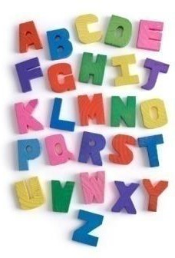
and staff, to plan and provide interesting, challenging and achievable learning experiences within the context of the national guidance contained in Curriculum for Excellence and Realising the Ambition. At all times staff take account of the individual needs, stage of development and interests of each child.

ASSESSMENT AND REPORTING
Sharing of information between parents and staff is very important. Staff observe the children and keep notes of their progress. A profile of each child’s learning is compiled via an online app throughout the year and kept in the Early Years Centre for the children to access at any time. Please feel free to discuss your child’s progress with staff and any concerns you may have. Staff track your child’s progress throughout their time in our Early Years Centre. Staff complete a developmental milestone checklist for pre-school children to help focus planning for their individual next steps. We will share this information with you. Staff will meet with parents termly to complete an individual care plan for each child. A summative report is also completed in May for children in their pre-school year.

PARENTAL PARTNERSHIP
We operate an open door policy and welcome your feedback and input in your child’s learning and progress.
We will use email and Learning Journals as our main forms of communication.
If you have any concerns at all about your child in the Early Years Centre, please feel free to contact us or speak to the person on the door at drop off and pick up time and we will arrange a time for you to discuss with your child’s key worker. Working together, we can usually sort them out very quickly. Termly newsletters are sent home to keep parents informed about activities within the Early Years Centre. We also seek parental opinion through questionnaires and surveys.

PARENT COUNCIL AND PARENT FORUM
Parent Councils are the formal representative body for parents with children attending school/Early Years Centre. Parent Councils are different in each school to enable them to meet the needs of parents locally. Parents are encouraged to be:

  - involved with their child’s education and learning;
  - be active participants in the life of the school; and
  - express their views on school education generally and work in partnership with their children's schools.
All parents / carers are automatically members of the Parent Forum at their child’s school/Early Years Centre. As a member of the Parent Forum all parents can expect to :-

    - receive information about the school and its activities;
    - hear about what partnership with parents means in our school;
    - be invited to be involved in ways and times that suit you;
    - identify issues you want the parent council, to work on with the school/Early Years Centre;
    - be asked your opinion by the parent council on issues relating to the school/Early Years Centre and the education it provides;
    - work in partnership with staff; and
    - enjoy taking part in the life of the school in whatever way possible.

The Parent Forum decides how their representatives on the Parent Council are chosen and how the Parent Council operates. Parents are encouraged to volunteer or put themselves forward to be chosen as representatives of the Parent Council if they wish.
The main aims of the Parent Council are to:
  - support the school/Early Years Centre in its work with pupils
  - represent the views of parents
  - promote contact between the school/Early Years Centre, parents, pupils, providers of Early Years Centre education and the community
  - report to the Parent Forum
  - be involved in the appointment of senior promoted staff.
  - raise funds for the school/Early Years Centre for the benefit of pupils (in some schools the PTA/PA fulfils this role).
  - Promote the work and standing of the school/Early Years Centre in the community positively.
For more information on parental involvement or to find out about parents as partners in their children’s learning, please contact the school or visit the Parentzone website at www.parentzonescotland.gov.uk.
The Scottish Parent Teacher Council is the national organisation for PTAs and PAs in Scotland, Parent Councils can join too, and it runs an independent helpline service for all parents. They can be contacted by phone on 0131 474 6199, fax 0870 706 5814 or email on sptc@sptc.info or write to SPTC, Mansfield Traquair Centre, 15 Mansfield Place, Edinburgh, EH3 6BB.

National Parent Forum of Scotland - enquiry@parentforumscotland.org The National Parent Forum of Scotland has been set up to give Parent Councils and parents an opportunity to discuss and raise educational issues of mutual interest or concerns at a national level.

STAY AND PLAY
Parents/carers/grandparents are invited into the Early Years Centre to play with your child. These sessions usually last around an hour. These opportunities will give you an insight into Early Years Centre life for your child. Your child will love showing you round the Early Years Centre and having you there to play with. Staff will share information on these and you will be given the opportunity to sign up.

CHURCH COFFEE AND CHAT
We hold different coffee and chat events throughout the school year and are always looking at ways to engage with parents. We hold four community coffee and chat days a session at Alloway Parish Church.
This gives you the opportunity to have a coffee with other parents then play with your child.

SPLIT PLACEMENTS

Sometimes children only attend Alloway Early Years Centre for part of the week and attend another Early Years Centre establishment for the other part. Split placements are either 3 days with us and 2 days elsewhere, or vice versa. If you child attends Alloway Early Years Centre on a split placement, your child’s key worker will contact the other Early Years Centre on a termly basis to share targets and information about your child. This is to ensure we are all meeting your child’s needs.

NEXT STEPS

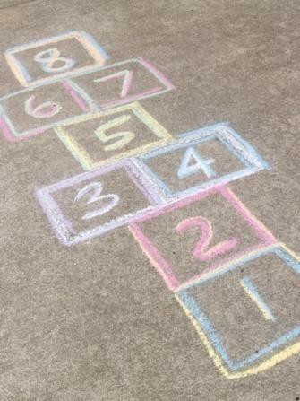
Most of the children who attend the Early Years Centre will progress to P1 at Alloway Primary School. Staff from the primary one class and Early Years Centre will work together throughout the year to ensure a smooth transition from Early Years Centre to primary one.

Staff will also liaise closely with other Early Years Centre establishments and primary schools to provide a smooth transition for children.

The Summative Report which details your child’s learning and
achievements, will be passed on to the receiving establishment.

MEDICAL INFORMATION

If your child has any medical problems, it is very important that staff are informed and made aware of any difficulties.

MEDICATION

If your child requires medication during his/her time at the Early Years Centre – please contact the staff. It is essential for you to keep us up to date with relevant medical information and it may be necessary for us to draw up a health plan. Kirsty McCallum (Senior EYP) will ensure the correct paperwork is completed/

IF YOUR CHILD IS UNWELL

The Early Years Centre staff require a telephone call if your child is not able to attend our Early Years Centre on a particular day. Please phone the school office. If your child becomes ill while at the Early Years Centre, we will try to contact you or the emergency contact, which you give us on your child’s admission to the Early Years Centre.

If your child has an infectious disease such as chickenpox, please inform the Early Years Centre as this will help to contain outbreaks.

ACCIDENTS

These will be dealt with within the Early Years Centre. We will always inform you about any minor accidents when you collect your child. If your child is seriously injured we will make every effort to contact you immediately. All accidents are recorded with a note of action taken.


VISITS BY MEDICAL STAFF

All children in their pre-school year are usually seen by the orthoptist. We will let you know if this is going to happen.

DATA PROTECTION ACT
When you enrol your child at school or early years centre you are required to provide some personal information about yourself and your child in order to access services provided by Educational Services.

How we will use the information about you and your child

All personal data is processed by Educational Services Staff. We will only collect personal data from you that we need in order to provide educational services and oversee the provision of these services to your child. We will use your personal data to contact you; if the school requires to discuss your child’s education, in an emergency and to keep you fully involved in your child’s educational journey.

Who we share your information with

Your child’s personal information will only be shared where it is appropriate to do so in order to ensure full access to services such as national assessments health promotion, transport, school meals, careers and online services.

In addition, the Council has a duty to protect public funds and to this end, we may check the information you have given with other information we hold, share your information with other Council Services and share your information with other local authorities, for the purpose of protecting public funds and to prevent or detect fraud or crime.

What are my rights?

You have various rights in relation to the personal data that the Council holds about you. This includes the right to ask us to provide you with access to your personal information and to rectify any inaccuracies contained with the personal information.

For more information about these rights please see the full privacy notice.
If you have a complaint
If you are unhappy with the way the Council has dealt with your personal data, you can complain to the Council’s Data Protection Officer:

Data Protection Officer
Information Governance Team
Legal & Democratic Services
County Buildings
Wellington Square
Ayr

KA7 1DR

Email : DataProtection@south-ayrhsire.gov.uk | Telephone : 01292 612223

If you remain dissatisfied, you have the right to complain to the Information Commissioner:

Information Commissioner’s Office
45 Melville Street
Edinburgh
EH3 7HL
Email: Scotland@ico.org.uk | Telephone: 0131 244 9001 (https//ico.org.uk/for-the-public/)

If you have no Internet Access

Please contact us at the above postal address or telephone number if you wish a copy of any of the above information and you do not have access to the internet. We will provide you with a hard copy of the information.

How to access our full Privacy Notice

The Educational Services full privacy notice is available from the school website or please ask staff in the school office and they will provide you with a hard copy.

Education Statistics Privacy Notice Transferring Educational Data About Pupils

The Scottish Government and its partners collect and use information about pupils in schools (e.g. the number and characteristics of pupils, their attendance, absence and exclusions, their attainment and their destination when leaving school) to help to improve education across Scotland. This note explains why we need this information, how we use it and what we do to protect the information supplied to us.

Why do we need your data?

In order to make the decisions about how to improve our education service, Scottish Government, education authorities and other partners such as the SQA and Skills Development Scotland need accurate, up-to-date data about our pupils. We are keen to help all our pupils do well in all aspects of school life and achieve better examination results. Accurate and up-to-date data allows us to:

- Plan and deliver better policies for the benefit of all pupils
- Plan and deliver better policies for the benefit of specific groups of pupils
- Better understand some of the factors which influence pupil attainment and achievement
- Share good practice
- Target resources better
- Enhance the quality of research to improve the lives of young people in Scotland

The full Education Statistics Privacy Notice can be found at the undernote link or by requesting a copy from the school office.

https://www.gov.scot/topics/statistics/scotxed/schooleducation/ESPrivacyNotices

Your Rights and Further Information

Parents have the right to request access to their child’s education record under the Pupils’ Educational Records (Scotland) Regulations 2003.

FREEDOM OF INFORMATION (SCOTLAND) ACT 2002
The Freedom of Information (Scotland) Act 2002 enables any person to obtain information from Scottish public authorities. The Act applies to

all Scottish public authorities; Scottish Government and its agencies; Scottish Parliament; Local Authorities; NHS Scotland; Universities and further education colleges; and the Police.

Public Authorities have to allow access to the following information:

  - The provision, cost and standard of its service;
  - Factual information or decision-making;
  - The reason for decisions made by it.

The legal right to access includes all types of ‘records’ information of any data held by the Scottish public authorities. From 1st January 2005, any person who makes a request for information must be provided with it, subject to certain conditions.

FURTHER INFORMATION/COMMENTS

SUGGESTIONS AND COMPLAINTS
We are always seeking to maintain and improve our service.

A complaint is an expression of dissatisfaction by one or more members of the public about the Councils action or lack of action, or about the standard of service provided by or on behalf of the Council.

If you have any comments or complaints please approach the Head Teacher in the first instance. If the Head Teacher does not resolve the issue to your satisfaction, you should:

    - Visit one of South Ayrshire Council’s Customer Service Centres, or
any local office.
    - Phone South Ayrshire Council Customer Services Team on 0300 123 0900
    - E-mail: listeningtoyou@south-ayrshire.gov.uk
    - Write to: Customer Services, South Ayrshire Council, Freepost NAT 7733, Ayr, KA7 1DR

Anyone can make a complaint to us, including the representative of someone who is dissatisfied with our service.

Depute Chief Executive and Director-People Lynsey McRoberts
South Ayrshire Council Educational Services County Buildings Wellington Square AYR

KA7 1DR

Elected Members Councillors:
Martin Dowey
Lee Lyons
Siobhian Brown Derek McCabe

South Ayrshire Council County Buildings Wellington Square AYR

KA7 1DR
0300 123 0900.

Scottish Commission for Regulation of Care Compass House
Discovery Quay Riverside Drive DUNDEE

DD1 4NY
0845 603 0890
PLEASE NOTE
Although the information in this handbook is correct at the time of printing there could be changes affecting any of the matters dealt with in it, either before your child’s placement begins or during the course of their placement. The Head of the Establishment will tell you of any important changes to the information.

