Alloway Primary School and EYC
Child Protection Policy
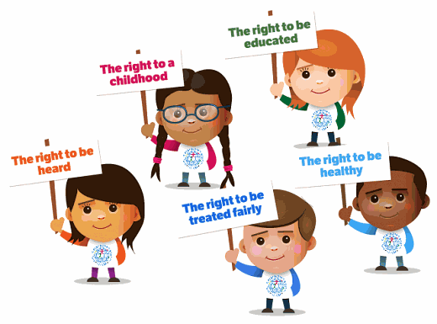

We are a rights respecting school –See article 36

“I have the right to be kept safe from the things that could harm my development.”
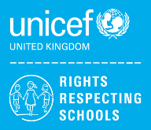

Contents
- Introduction
- Aims
- Rationale
- Responsibility
- Definitions
- Indicators of Concern
- Types of abuse
- Getting it Right for Every Child
- Children with Additional Support Needs
- Care Experienced Children
- Specific Concerns
- How concerns may arise
- Child Protection Co-ordinator
- Roles and Responsibilities of Staff
- Responding to disclosures or allegations
- Records and chronologies
- Legal Measures to protect children at risk
  - Appendix 1
  - Appendix 2

Child Protection/Prevent Co-ordinator  Mrs Fiona Meney  Head Teacher | Deputy Child Protection /  Prevent Co-ordinator  Mrs Lauren Miller  Depute Head Teacher
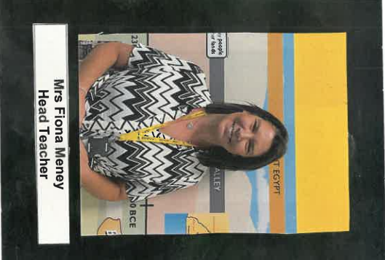 | 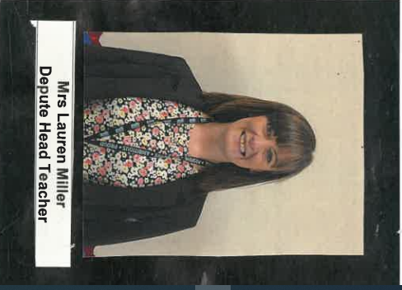

- Introduction

At Alloway Primary School and Early Years Centre we continually strive to keep children safe and protected from harm. This is the responsibility of all. We recognise our legal and moral duty to promote the well-being of children, and protect them from harm. We believe that every child regardless of age has at all times and in all situations a right to feel safe and protected from any situation or practice that results in a child being physically or emotionally upset or damaged. This policy addresses how, as a school, we ensure that staff are properly trained to ensure that they know how to recognise and respond in all areas of child protection and safeguarding. We have a very important role to play in the sensitive issue of dealing with known and suspected cases of abuse or neglect. It is essential that all staff in schools must be aware of the arrangements for protecting children, are alert to children’s needs and are clear about their own role in ensuring the safety of all children. Staff should follow the policy and procedure which has been laid down in South Ayrshire, (Management Guidance on Child Protection, Safeguarding and Wellbeing, July 2024) including annual training, and follow national guidance contained within the policy document ‘National Guidance for Child Protection in Scotland 2021 (amended 2023)’, when a case of child abuse is suspected. This policy is based on the South Ayrshire Council Management Guidance on Child Protection, Safeguarding and Wellbeing (July 2024).

We have consulted with children about how the adults around them keep them safe. This has helped form this policy. Scan the QR code to hear what our children have to say.

- Aims
- To ensure that children are effectively safeguarded from the potential risk of harm at Alloway Primary School and EYC and that the safety and well-being of the children is of the highest priority in all aspects of the school’s work.
- To help the school maintain its ethos whereby staff, pupils and parents feel able to articulate any concerns comfortably, safe in the knowledge that effective action will be taken as appropriate.

- Rationale
“All children and young people (including unborn babies) have the right to be cared for and protected from harm and abuse and grown up in a safe environment in which their rights are respected and their needs met. Children and young people should get the help they need, when they need it and their safety is paramount.” (National Guidance for Child Protection in Scotland 2021, amended 2023).

- Responsibility
South Ayrshire Council is committed to implementation of the United Nations Convention on the Rights of the Child and to the general principles of non-discrimination, best interests of the child, right to life, and respect for the views of the child. These overarching rights should be the foundation for any assessment of a child’s or young person’s wellbeing. This rights based approach emphasises the responsibility of all Public Services, and their partners to protect children’s rights and entitlements. UNCRC Incorporation Scotland Act 2024 brings children’s rights into legislation. At Alloway Primary School and EYC we are a Rights Respecting School and have achieved our Gold Award. The rights of the child permeate our school curriculum and community.

- Definitions
At Alloway Primary and EYC we adhere to the following definitions when discussing Child Protection.

“Child abuse” is defined in the National Guidance for Child Protection 2021(amended 2023) as; ‘Abuse and neglect are forms of maltreatment of a child. Somebody may abuse or neglect a child by inflicting, or by failing to act to prevent significant harm to the child. Children may be maltreated at home; within a family or peer network; in care placements; institutions or community settings; and in the online and digital environment. Those responsible may be previously unknown or familiar, or in positions of trust. They may be family members. Children may be harmed pre-birth, for instance by domestic abuse of a mother or through parental alcohol and drug use’

There are also definitions of abuse against a non-exhaustive list of areas of concern:
• Physical abuse;
• Sexual abuse;
• Neglect; and
• Emotional abuse.

“Child protection” means protecting a child or young person from abuse or neglect. Abuse or neglect need not have taken place; it is sufficient for a risk assessment to have identified a likelihood or risk of significant harm from abuse or neglect. Protecting children involves preventing harm and/or the risk of harm from abuse or neglect. Child protection investigation is triggered when the impact of harm is deemed to be significant.

“Significant harm” is a complex matter and subject to professional judgement. “Harm” means the ill-treatment or the impairment of the health or development of the child or young person, including, for example, impairment suffered as a result of seeing or hearing the ill treatment of someone else. In this context, 'development' can mean physical, intellectual, emotional, social or behavioural development, and 'health' can mean physical or mental health. Whether the harm suffered, or likely to be suffered, by a child or young person is 'significant' is determined by assessing the severity of ill treatment; the degree and extent of physical harm; the duration and frequency of abuse and neglect; the extent of premeditation; and the presence or degree of threat, coercion, sadism and bizarre or unusual elements. Significant harm can result from a specific incident, a series of incidents or an accumulation of concerns over a period of time.

“Risk” is defined by reference to a range of possible indicators in National Risk Framework to Support the Assessment of Children and Young People (see Appendix II).

“Welfare” under the Children (Scotland) Act 1995 and Children’s Hearings (Scotland) Act 2011, welfare is described as “the three overarching principles”, requiring that the child be given the opportunity to express views; that the child’s welfare must be the paramount consideration; and that minimum (or proportionate) state intervention be preferred over disproportionate intervention in family life.

“Wellbeing” is defined by reference to the eight indicators representing the key areas that are essential to enable children to flourish. These eight SHANARRI indicators are safe, healthy, achieving, nurtured, active, respected, responsible and included – provide a common language for staff to identify wellbeing concerns.

- Indicators of concern

These may be indicators of concern:
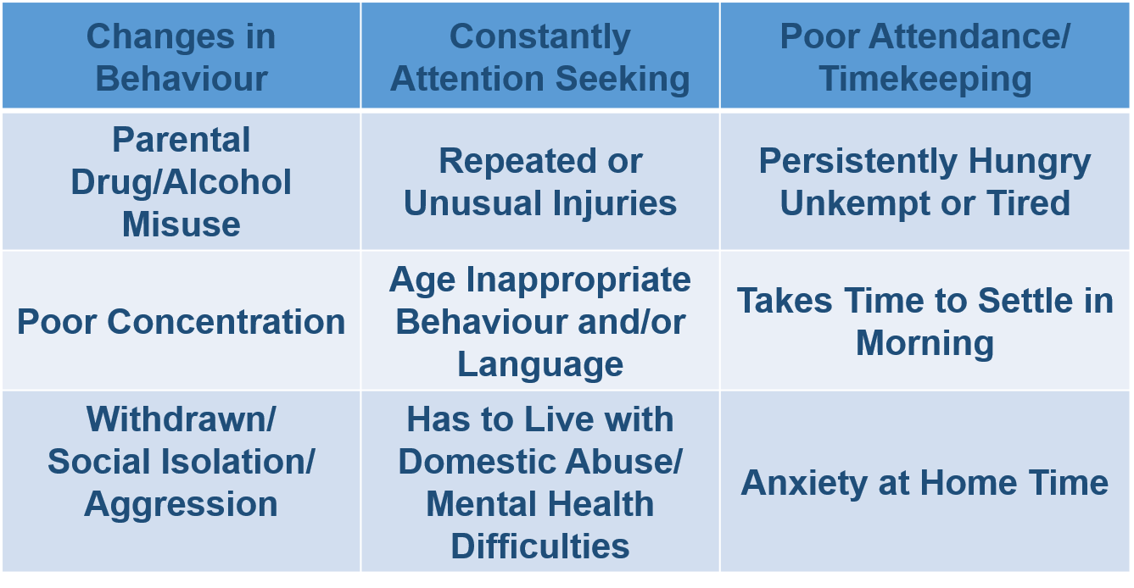

- Types of abuse
Physical Abuse
Physical abuse is the causing of physical harm to a child or young person. Physical abuse may involve hitting, shaking, throwing, poisoning, burning or scalding, drowning or suffocating. Physical harm may also be caused when a parent or carer feigns the symptoms of, or deliberately causes, ill health to a child they are looking after.
Possible signs of Physical Abuse:
- Unexplained bruising or bruising in an unusual place
- Unexplained injuries or burns
- Untreated injuries or delay in reporting them
- Arms and legs covered in hot weather
- Withdrawal of physical contact
- Fear of returning home
- Aggression towards others
- Running away (not specific to child abuse)

Emotional Abuse
Emotional abuse is persistent emotional neglect or ill treatment that has severe and persistent adverse effects on a child’s emotional development. It may involve conveying to a child that they are worthless or unloved, inadequate or valued only insofar as they meet the needs of another person. It may involve the imposition of age - or developmentally - inappropriate expectations on a child. It may involve causing children to feel frightened or in danger, or exploiting or corrupting children. Some level of emotional abuse is present in all types of ill treatment of a child; it can also occur independently of other forms of abuse.
Possible signs of Emotional Abuse
- Fear of new situations
- Sudden speech disorders
- Fear of parents being contacted
- Extremes of passivity or aggressive
- Continual self-deprecation
- Over-reaction to mistakes

Neglect
Neglect is the persistent failure to meet a child’s basic physical and/or psychological needs, likely to result in the serious impairment of the child’s health or development. It may involve a parent or carer failing to provide adequate food, shelter and clothing, to protect a child from physical harm or danger, or to ensure access to appropriate medical care or treatment. It may also include neglect of, or failure to respond to, a child’s basic emotional needs.

Possible signs of Physical Neglect :
- Constant hunger
- Poor personal hygiene
- Constant tiredness
- Repeatedly worn and dirty clothes
- Untreated medical problems
- Frequent lateness or non-attendance
- Untreated medical problems
- Destructive tendencies
- Low self-esteem
- Neurotic behaviour
- Poor social relationships
- Running away
- Compulsive stealing or scavenging
- Returning to an empty home

Sexual abuse
Sexual abuse is any act that involves the child in any activity for the sexual gratification of another person, whether or not it is claimed that the child either consented or assented. Sexual abuse involves forcing or enticing a child to take part in sexual activities, whether or not the child is aware of what is happening. The activities may involve physical contact, including penetrative or nonpenetrative acts. They may include non-contact activities, such as involving children in looking at, or in the production of indecent images or in watching sexual activities, using sexual language towards a child or encouraging children to behave in sexually inappropriate ways.
Possible signs of sexual abuse are:
- Regressed clingy behaviour
- Withdrawn attitude
- Increased anxiety
- Tearfulness
- Few or no friends of own age
- Inappropriate play with dolls and peer groups
- Unable to stay awake at school
- Fear of adults
- Poor concentration
- Angry/ aggressive behaviour towards peers and/or adults
- Sexualised behaviour
- Self-harming behaviour
- Depression
- Anxiety/panic attacks/phobias
- Eating disorders
- Substance abuse

Not all children who are abused or neglected will display these signs and equally a child may display some of the signs and symptoms for other reasons.

- Getting It Right For Every Child
At Alloway Primary we also ensure that we Get It Right for Every Child (GIRFEC) and we follow the wellbeing indicators for children; Safe, Healthy, Active, Nurtured, Achieving, Respected, Responsible and Included, and we ensure that children and their carers are central to the process of finding solutions and having their needs met. Everyone working with children is expected to use one consistent approach, actively sharing information to agreed protocols and working more effectively together to improve outcomes for children. Everyone needs to be clear about their personal responsibility to do the right thing for each child. Parents and children, together with schools, professionals and others working with children will benefit from a collaborative approach which results in the development of one plan to meet all the child’s needs. This will help them deal more effectively with hazards such as abuse or harassment and to report them. School staff are well placed to observe physical and psychological changes in a child which might indicate abuse. They are likely to have the greatest level of day to day contact with children and they are able to contribute a great deal to the assessment of vulnerable children.

While a child protection response may be required to make sure a child is safe and their immediate welfare needs are addressed, child protection is not something, which sits separately from wellbeing. Indeed, a series of low level indicators of wellbeing needs (whether obviously related or not) taken together, can amount to a welfare or child protection issue.

The Children’s Charter (2004) reflects the voice of children and young people, setting out a list of thirteen demands children and young people should feel entitled to make.

At Alloway Primary and EYC we have close partnership working, between parents, carers and all relevant agencies – primarily Social Work, Police, Health Services and the Scottish Children’s Reporters Administration (SCRA). We use information sharing through Pastoral Notes, Ayrshare and invite agencies to be part of our Team Around the Child meetings.

- Children with Additional Support Needs (ASN)
The Education (Additional Support for Learning) Act 2004, as amended in 2009, introduced a new legal framework for supporting children and young people who require some additional support with their learning. The Act provides the legal framework underpinning the system for supporting children and young people in their education, and their families. This framework is based on the idea of additional support needs. This broad and inclusive term applies to children or young people who, for whatever reason, require additional support, long or short term, in order to help them make the most of their education and to be included fully in their learning.

Most parents of children with additional support needs provide safe and loving homes. However, there is a significant body of international research to show that disabled children are more likely to be abused or maltreated than their non-disabled peers. Children with communication impairments, behavioural disorders, learning disabilities and sensory impairments are those most vulnerable. A range of factors has been cited to explain this increased vulnerability to abuse, include child or impairment factors; parental factors; and service factors. Despite this heightened risk, there is evidence that the abuse of disabled children often goes undetected and, even when suspected, may be under-reported and difficult to establish, due to communication issues.

- Care Experienced Children
The term care experienced refers to anyone who has been or is currently in care or from a looked after background at any stage of their life, no matter how short. This care may have been provided in one of many different settings such as in residential care, foster care, kinship care and looked after at home with a supervision requirement. (Scottish funding Council 2018)
Police Scotland’s Partnership Protocol with local authorities for looked after children who go missing from residential and foster care sets out how they will work together to minimise harm.

- Specific concerns
Child Sexual Exploitation
The sexual exploitation of children and young people is an often hidden form of child sexual abuse, with distinctive elements of exploitation and exchange. In practice, the sexual exploitation of children and young people under 18 might involve young people being coerced, manipulated, forced or deceived into performing and/or others performing on them, sexual activities in exchange for receiving some form of material goods or other entity (for example, food, accommodation, drugs, alcohol, cigarettes, gifts, affection). In most situations the child or young person is unaware that they are being exploited. Sexual exploitation can occur through the use of technology and without the child’s immediate recognition. Action to prevent and tackle child sexual exploitation is set within the wider context of activity to promote wellbeing and prevent and tackle other forms of child sexual abuse, physical and emotional abuse and neglect. The is a move towards tackling sexual exploitation through contextual safeguarding, which is an ecological approach that complements the use of the My World Triangle and the concept of resilience. There are principles and tools within this evolving approach which may add depth to understanding and response, particularly in relation to risks and harm young people face beyond the family home.

Child trafficking
Child Trafficking is a Child Protection issue. Trafficking can affect children of all ages. There is sometimes confusion between trafficking and people smuggling. Always take timely and decisive action due to the risk of the child being moved.

Female Genitial Mutilation
The unnecessary alteration or injury of the female genital organs. This procedure will be carried out for non-medical reasons by unqualified people sometimes referred to as the ‘cutter. Women and young girls may be trafficked outwith the UK to have the procedure. There is growing evidence that female genital mutilation is being arranged in Scotland. School summer holidays emerge as a particular time of risk as it is thought that the girls and young women will heal and recover for the procedure in time to return to education. FGM is a violation of the rights of the child. The practice is illegal in the UK and will cause severe physical and psychological trauma to victims both in the short and long term.

Radicalisation and Extremism
PREVENT is part of CONTEST, the government counter-terrorism strategy, it is designed to tackle the problem of terrorism at its roots, preventing people from supporting terrorism or becoming involved in terrorism themselves.
Prevent, is essentially about recognising when individuals, particularly those who are vulnerable, are being exploited, and responding effectively in partnership with other statutory agencies when concerns arise.
There is no single profile of a person who is likely to become involved in extremism or radicalisation. Also, there is no universally accepted view of why vulnerable individuals might become involved in such activities.
Mrs Fiona Meney (head teacher) is the Prevent Coordinator for the school and EYC with Mrs Lauren Miller deputising. All staff have been trained in Prevent processes and this information has been shared with parents.

Antibullying
Our anti-bullying policy provides a framework for proactive and reactive strategies and includes cyberbullying. Cyberbullying can be defined as the use of Information and Communications Technology, particularly smartphones and the Internet, deliberately to upset someone else. However, it differs in several significant ways from face-to-face bullying: The invasion of home and personal space; the difficulty in controlling electronically circulated messages; the size of the audience; perceived anonymity; and even the profile of the person doing the bullying and their target. Cyberbullying, like all bullying, should be taken very seriously. It takes different forms: Threats and intimidation; harassment or cyber-stalking (e.g. repeatedly sending unwanted texts or instant messages); vilification/defamation; exclusion or peer rejection; impersonation; unauthorised publication of private information or images and manipulation; It is important that pupils are aware that their actions have severe and distressing consequences and that participating in such activity will not be tolerated;

Use of photographs/videos
At Alloway Primary we use the following to keep our children safe:
- Staff should never use personal devices including mobile phones, cameras, tablets, etc. to photograph/film or record children and young people;
- No photographs or video footage should ever be permitted in areas of personal privacy by staff or children or young people (e.g. changing rooms, bathrooms and sleeping quarters);
- If using an external agency, ensure the photographer has been appropriately checked and is accompanied by a member of staff at all times;
- All images and videos of a child or young person taken for Local Authority/Educational purposes belong to the local authority and should be stored in line with Management Guidelines;
- Parents are asked to complete a consent form that allows them to consent or to withhold consent for the photographing and videoing of all relevant activities;
- Where appropriate, children and young people should be asked their views, and these must be taken into account;
- Images should not be shared with external agencies unless express, written permission is obtained from the parent and, where appropriate, the young person. Parents and young people must be informed as to how the images will be used;
- Staff should ensure that all copies of videos and digital photograph files are stored in a secure place. In line with data protection requirements, these should not be kept for any longer than is necessary having regard to the purposes for which they were taken;
- Staff should make sure all copies of images, including negatives or electronic copies, are deleted when no longer needed;
- Staff do not use images of children or young people unless express permission has been sought and obtained;
- Staff must use the image only for the purpose it was taken. It should not be used for purposes that the child or young person or their parent is unaware of or has not given consent to use; and
- Staff should advise parents, carers and young people that they must not upload images or video of other children or young people, to social media sites or otherwise in the public domain. This includes footage of performances, sporting events, competitions etc.

- How concerns may arise
At Alloway Primary and EYC concerns can arise in the following ways:
- A member of staff may raise a concern from knowledge of the child or from observing behaviour or appearance of the child or from what a child has said.
- A child discloses to a teacher or member of staff that abuse has taken place or that the child feels unsafe.
- A third party expresses concern to a member of staff; this could be a parent, guardian or other pupil.
- An anonymous allegation is received.

- Child Protection Co-ordinator
At Alloway Primary and EYC the Head Teacher, Mrs Fiona Meney is the Child Protection Co-ordinator. The DHT, Mrs Lauren Miller will deputise for her in her absence. If both are not available then staff should go straight to a Principal Teacher – Mrs Lisa Stewart, Mrs Lynsey Hopper, Mrs Emma Park or Miss Nicola Rainey (acting).

Role of the Child Protection Co-ordinator
- Co-ordinate action within the establishment in relation to specific children or young people, about whom concerns have been raised;
- Liaise with other agencies, (e.g. Police, Social Work, Children’s Reporter, Health staff) on general issues relating to child protection;
- Support investigations, Court proceedings, Children’s Hearings and case referrals or Significant Case Reviews;
- Listen and respond to general concerns raised by staff, children, young people and parents or carers in relation to child protection;
- Organise staff briefings and training on child protection and wellbeing, for the 'Specific Contact Workforce' in accordance with the National Framework for Child Protection Learning and Development in Scotland, Scottish Government;
- Oversee the planning of any curricular provision designed to give children and young people, the knowledge and skills to keep themselves safe from all forms of abuse;
- Ensure accurate record keeping of all information, related to a child or young person’s wellbeing and protection is carefully recorded using a chronology of significant events, together with relevant documentation; •
- Ensure child protection files and all confidential sensitive and personal information are securely stored in accordance with up-to-date File Management Guidance and the Data Protection Act 2018 and the General Data Protection Regulation;
- Ensure that all child protection chronologies are reviewed at least once every term; and • Whenever practicable, attend all Child Protection, multi-agency meetings and Children’s Hearings or delegate the Named Person to do so.

- Roles and Responsibilities of staff
At Alloway Primary and EYC every member of staff has a duty to be aware and up to date with Child Protection procedures and know their own role and responsibilities.

Head teacher
- Ensure that child protection procedures are known to all new and visiting staff.
- Conduct Child Protection training at the August In-service day using the most up to date SAC Child Protection Powerpoint. Record when staff have had this training.
- Ensure all new staff receive the same training and that the Child Protection and Safeguarding policy is shared with staff via staff shared area/email and with parents via the school website.
- Ensure that child protection procedures are followed within the school and that records are kept in a confidential file and contained within a locked cabinet in HT office.
- Include and promote child protection and child safety within the curriculum.
- Ensure that parents should be made aware of child protection procedures and general content of child safety and child protection within the curriculum.
- Establish positive working relationships with other agencies and follow child protection procedures.

Teachers and other school staff
- Must follow child protection procedures as laid down by South Ayrshire Council without delay.
- Should know how to respond to a disclosure or suspicion of abuse from yearly training.
- Should be clear that a guarantee of absolute confidentiality cannot be given to a pupil.
- Should be confident in delivering child safety and child protection as part of the school curriculum.
- Should report any concerns directly to Child Protection Co-ordinator and must not seek advice or discuss with others.

Pupils
- Should be encouraged to seek help from an adult they trust if they think they may be in an abusive situation or if one of their classmates is in an abusive situation.

Parents
- Should have access to the Child Protection Policy via the school website.
- Should be able to pass on any child protection concerns to the Child Protection Co-ordinator.

- Responding to disclosures or allegations
Whoever receives the information from the child or other person should:
- listen carefully, let the child speak
- not show disbelief or panic
- take the allegation seriously, reassure the child and ask how they feel
- avoid expressing views on the matter
- not guarantee confidentiality, whilst explaining the reasons for this
- explain that she/he will have to share this information with the Child Protection Co-ordinator and keep the child or young person informed
Do not question the child – this is the responsibility of agencies trained to carry out investigative interviews of children. Questions inappropriately phrased could be thought to be suggestive and then lead to evidence being held as inadmissible in possible future court proceedings.
NEVER Carry out an investigation or gather any photographic evidence into the allegation – this is not your role
All instances of disclosure/CP concerns should be reported to the establishment's Child Protection Co-ordinator without delay.
If the Child Protection Co-ordinator or Head Teacher/Head of Centre is not available, seek advice from either the Head of Service or their Senior Manager as a matter of urgency.

Follow SAC guidelines as detailed below:
- Observe carefully the child or young person’s behaviour and demeanour;
- Record in detail what the staff member has seen and heard and when;
- Any signs of physical injury should be described in detail or sketched;
- Exact words used by the child or young person should be quoted;
- A guarantee of secrecy or confidentiality must not be given to the child; • Use open-ended questions;
- The child or young person must be told that the Child Protection Co-ordinator (CPC) will have to be informed;
- Report suspicions or disclosure immediately to the Child Protection Co-ordinator;
- Take notes, date and sign them, as soon as possible and recording should not delay reporting;
- Even when no formal referral has been made to the Health and Social Care Partnership, Education notes should be kept in a confidential record in Pastoral Notes on SEEMIS and if relevant an Ayrshare record created;
- Be supportive and assure them you will only share this information with those people who need to know in order to prevent any further harm; and
- Take time to listen, without asking too many questions.

The exception is - Immediate Concern of Suicidal Ideation
If a child or young person discloses to you, it is important to allow them time to talk about how they are feeling and not to close down the conversation.
Explain you need to pass your concern to the Child Protection Co-ordinator and follow your standard Child Protection and Safeguarding processes. Advise you will remain available if they want to talk to you in the future.
Contact the Child Protection Co-ordinator or if not available a member of the Senior Management team, who will take advice from CAMHS in the first instance and liaise with the ASIST / LIAM trained member of staff.
The Child Protection Co-ordinator or the ASIST / LIAM trained member of staff will ask the young person if they are feeling suicidal and/or have a plan to complete suicide, in line with current training.
The Child Protection Co-ordinator will confirm with the person the child disclosed to and the child, how that person will remain in the process and where possible how they can continue to support the child or young person.

What should the Child Protection Co-ordinator do?
- Listen and respond to general concerns raised by staff, children, young people and parents or carers in relation to child protection;
- Collate all known relevant information about the child
- Co-ordinate action within the establishment in relation to specific children or young people, about whom concerns have been raised;
- Refer to named social worker (if child has social worker) or duty social worker (if child is not known to social services
- ) or no referral
- Decide who will inform parents
- Check that all relevant agencies are informed in referring
- Check all records are complete and kept in a confidential file

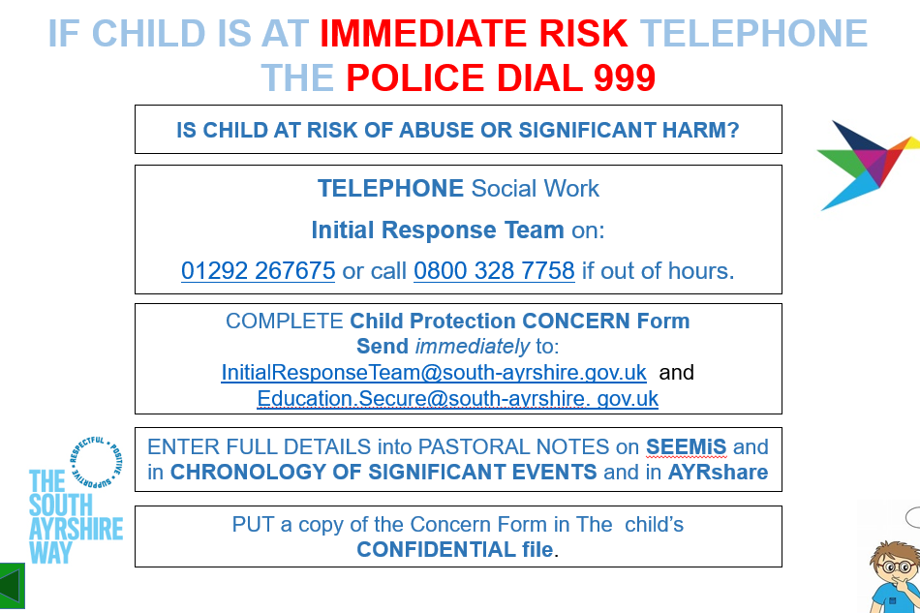

- Records and Chronologies

In our school the Child Protection (CP), Looked after Child (LAC) or Additional Support Needs (ASN) files are securely stored separately from a pupil's Educational record (PPR), and clearly labelled on the front as, “Confidential” LAC, ASN or Child Protection' with the child's full name and date of birth. A chronology should be at the front of the file and separate sections should be kept to make for easy access to relevant reports. Should this information require to be shared on a multi-agency basis an Ayrshare record should be created. Records include a note of: Child Protection, Safeguarding and Wellbeing, Child’s name; date of birth; CHI number; dates of staff contacts with children and families; Actions and decisions and the rationale behind them; outcomes of interventions; and The Child’s Plan, whether in-house, multi-agency or Child Protection Plan, where the child is assessed as being at risk of significant harm; and a chronology of significant events involving the child and their family/carers including who information was shared with.

- Legal measures to protect children at risk
There are measures in place to protect children when they are deemed at risk. A Child Protection Order (CPO) authorizes the applicant, (normally the Local Authority) to remove a child or young person from circumstances in which he or she is at risk, or keep him or her in a place of safety. A Sheriff may issue a CPO at any time day or night. When a CPO is made, the Children’s Reporter will arrange a Second Working Day Children’s Hearing. The Panel Members will consider whether to continue the CPO or to attach any measures, such as for direct contact with parents and/or siblings. On the eighth working day, the Children’s Reporter will arrange a further Children’s Hearing to consider the Section 67 Grounds of the Children’s Hearings (Scotland) Act 2011. The Children’s Hearing can discharge the case; instruct the Children’s Reporter to apply to the Sheriff Court for Proof; or make a substantive decision if the child or young person and the relevant persons have accepted the Section 67 Grounds. The Children’s Hearing may make an Interim Compulsory Supervision Order. The Child Protection officer in the school (Head Teacher) works very closely with Social Work under these circumstances to ensure children’s needs are met, children are safe and all legal requirements are adhered to.

- Data Protection
The Principles of The Data Protection Act 2018, must be adhered to, and data must be:
- Processed fairly and lawfully;
- Processed for one or more specified or lawful purpose;
- Be adequate, relevant and not excessive;
- Accurate and kept up to date;
- Kept for only as long as necessary;
- Processed in accordance with the rights of data subjects;
- Kept safe and secure, protected from unlawful or unauthorised processing.

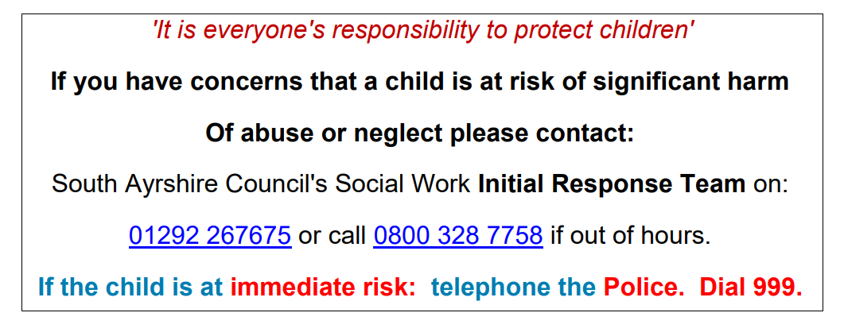

Written: September 2024
Reviewed: September 2025 (FM)

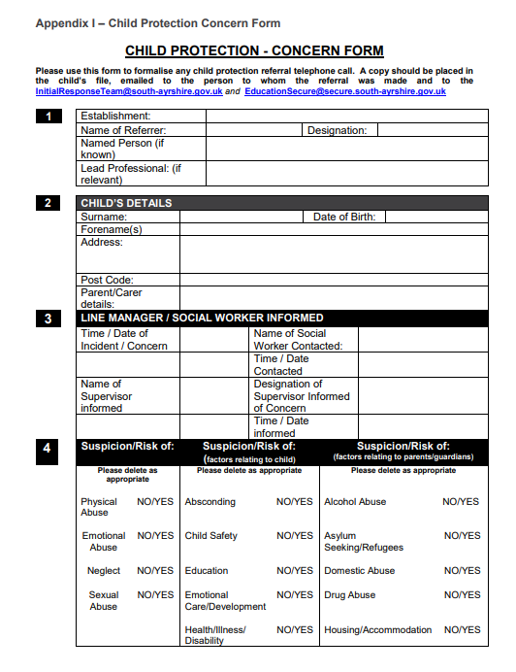

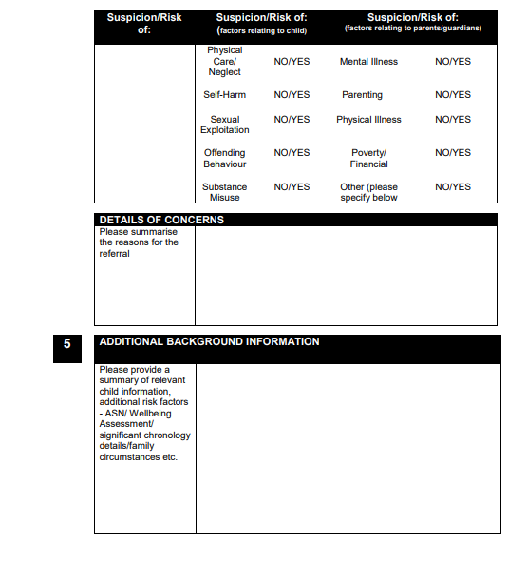

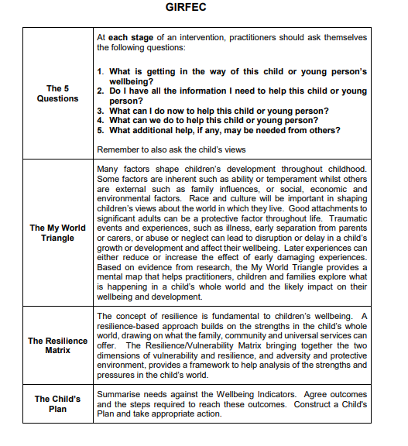
Appendix 2

Updated by Fiona Meney August 2023
Review date August 2024

