

SAC FAMILY LEARNING TEAM

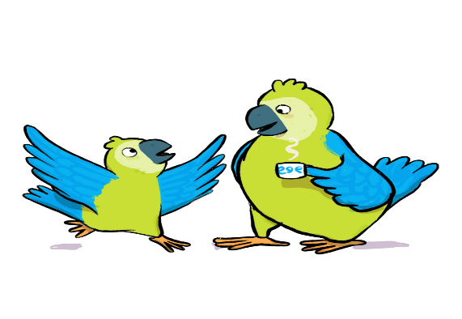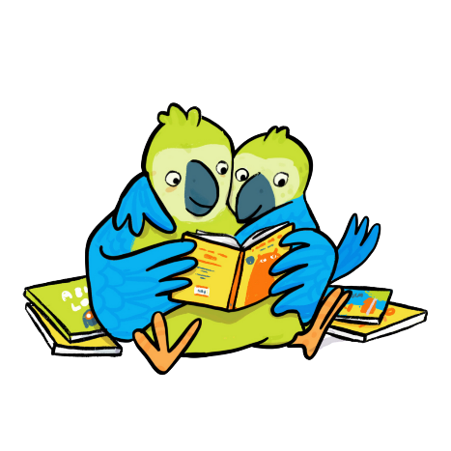

**HELLO ALLOWAY EYC PARENTS/CARERS AND GRANDPARENTS!**

PLEASE JOIN US WITH YOUR LITTLE ONE FOR FAMILY FUN AND LEARNING

ON: MONDAY THE 4TH, 11TH & 18TH NOV

TIME: 9.30 – 10.15 AM

WHERE: ALLOWAY EYC

WE LOOK FORWARD TO SEEING YOU THERE!!

HELPING TO MAKE MEANINFUL CONNECTIONS WITH OUR CHILD

HAVING FUN WITH MUSIC, SONGS AND RYHME

SUPPORTING YOUR CHILDS CONFIDENCE

[Nicola.Lawrence@south-ayrshire.gov.uk](mailto:Nicola.Lawrence@south-ayrshire.gov.uk)

TALKING AND LISTENING WITH EACH OTHER – HELPING DEVELOP GOOD COMMUNICATION SKILLS