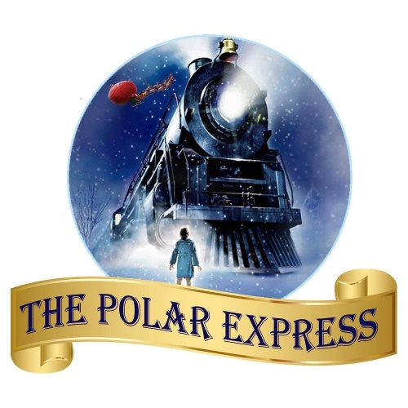**Choo, choo! All aboard the Polar Express…**

As part of our Christmas celebrations, we will be having a magical Polar Express day for the children in our EYC. This will take place on **Thursday 19th December**. Children are welcome to come to EYC dressed in cosy jammies, and will be treated to a magical day, ending with a visit from Fabulous Fraser. Please ensure your child is dressed in appropriate footwear, as we will be going outside too. We are so excited!