UNCRC Article 24 Every child has the right to the best possible health.

Alloway Primary School and EYC
Administration of Medicines and First Aid Policy

Alloway Primary and EYC
Reviewed (FM) March 24
First Aid and Administration of Medicines
Policy and Procedures Statement

This policy statement should be read in conjunction with the Supporting Young People with Healthcare needs in Education guidance (https://www.nhsaaa.net/media/9493/supporting-cyp-with-healthcare-needs-in-education-final-april-2020.pdf ) and the South Ayrshire Council
Educational Services Management Guidelines on First Aid and Administration of Medicines in Schools and Early Years Centres. It is also based on the Care Inspectorate guidance which can be found at https://hub.careinspectorate.com/media/1549/management-of-medication-in-daycare-of-children-and-childminding.pdf

FIRST AID
First Aiders
Teachers’ and Early Year Practitioners (EYP) conditions of employment do not include giving first aid, although any member of staff may volunteer to undertake these tasks. Teachers and other staff in charge of children and young people are expected to use their best endeavours at all times, particularly in emergencies, to secure their welfare. In general, the consequences of taking no action are likely to be more serious than those of trying- to assist in an emergency. School assistants should be trained in first aid and contribute to the first aid systems and procedures. At Alloway Primary School we ensure that School Assistants are first aid trained (Emergency First Aider at Work) as well as some members of EYC and office staff. Staff partake in the basic first aid one day course training. We have 2 named first aiders who complete the 3 day course ( First Aider at Work)– Mrs Jan Paul (office) and Miss Kirsty McCallum (Senior EYP). Mrs Paul and Miss McCallum are also the appointed person for the school and EYC. Posters are displayed with up to date information regarding First Aiders in school. A First Aid needs assessment is be completed and held in school (appendix 1).

First Aid Boxes
First aid boxes are provided within our school and are located in the medical room and EYC. School assistants carry a first aid pouch with them. They are adequately stocked, including (appendix 2):
- individually wrapped sterile adhesive dressings (assorted sizes)
- sterile eye pads
- individually wrapped triangular bandages
- safety pins
- medium and large sized individually wrapped sterile wound dressings 2 large sterile individually wrapped wound dressings
- disposable gloves.
- individually wrapped moist cleansing wipes
- microporous tape
- finger dressings
- foil blanket

Only specified first aid supplies will be kept. No creams, lotions, tablets or medicines, however seemingly mild, will be kept in these boxes. First aid boxes are clearly marked with the location, name of person responsible for their upkeep and marked on notice boards in the school. The location of first aid boxes and the name of the person responsible for their upkeep will be clearly indicated on notice boards throughout the school. Staff must inform Mrs Jan Paul or Miss Kirsty McCallum if supplies are running low. A travelling first aid kit must be taken on all outings outside of the school premises. First Aiders must be noted on risk assessment and On the Day Check must be completed.

Recording and Reporting First Aid Incidents
- In EYC accidents and incidents are recorded using readily accessible accident records. These are audited by DHT/Senior EYP.
- In the School accidents are recorded using an accident record kept in the medical room (appendix 7).
- These must be kept for 3 years.
- We record of any first aid treatment given by first aiders.
- This includes:
  - the date, time and place of the incident;
  - the name (and class) of the injured person;
  - details of the injury/illness and what first aid was given;
  - what happened to the person immediately afterwards( for example went home, resumed normal duties, went back to class, went to hospital)
  - name and signature of the first aider or person dealing with the incident
- The majority of incidents which happen in our EYC and School are minor bumps and bruises.
- If an incident is more serious then they must be recorded on the digital AR1 form within 10 days.
- Report an incident - The Core (south-ayrshire.gov.uk)
- A copy should be retained in an agreed location within your school.
- Where an incident results in admittance to hospital, or inability to continue work, the Head Teacher/centre manager must be informed immediately. The Head Teacher should inform their Quality Improvement Officer.
- In Early Years centres the Care Inspectorate should also be informed using the eforms system.
- Where an incident involves violence of any kind, whether verbal or physical, an online Violence & Aggression (VA1) form(JNCT 2.4 form for Staff in Education) should be submitted in the same manner (online form). A printed record of these forms is held in the school office.

Notifying Parents and Carers
- At Alloway EYC and Primary we inform parents/carers of any accidents, injuries sustained and /or first aid treatment given to their child whilst at EYC or school.
(appendix 8)
- We use written slips to communicate bumps and will phone if the injury requires this.
- Parents must be informed of all injuries. In EYC parents will sign the bump note.
- Staff are aware of the data protection act and don’t allow parents/carers to view personal information other than relating to their own child. If a parent in the school requests to see the accident/first aid record, all names/information about other children must be removed.

ADMINISTRATION OF MEDICINE

Parents or carers have the prime responsibility for their child’s health and should provide the school with information about their child’s medical condition.

Parents should contact the nursery and discuss the medical needs of their child in the first instance with their key worker, a member of the Senior Leadership Team and a designated First Aider.

If the child requires to be given medicine during the EYC session or school day, parents will then be asked to provide written details of the condition to include the following:

- Name of medication
- Dose
- Method of administration
- Time and frequency of administration
- Side effects

This information will be recorded on the South Ayrshire Council Administration of Medicines form. Normally staff would be given new and unopened medication although in some cases this is not possible if only one bottle has been given for home and EYC/school use.

Please see first aid notices in the EYC/School for designated EYC first aiders and school first aiders. If a first aider was absent , one of the other designated First Aiders would assume responsibility as directed by Senior Management.

Medicines are stored in the designated EYC cupboard and in the school medical room which is only accessible by staff. Normally EYC children will receive first aid in the EYC although if an EYC child needs to go to the medical room they will be either collected from the EYC by the First Aider and taken to the medical room or accompanied by a member of the EYC staff team to the medical room. The First Aiders will record details of medication given to pupils on the appropriate form.
In the school children will be brought to the medical room if they are able or the first aider will come to them.

STORAGE OF MEDICINE
- Medicine is stored in individual named ( with photos) containers in the EYC cupboard or school medical room with a copy of the child’s Heath Care plan.
- Emergency medication such as epi-pens and inhalers are stored in black first aid boxes in each class and accompanies the class should they move rooms.
- All medicines are stored in individual plastic wallets with the child’s photo on it.
- General Principles that apply to all medication whether bought over the counter (non-prescribed) or prescribed (by a GP, dentist, pharmacist etc)
- EYC and school staff must ensure parents hand over all the medication.
- If the medication requires storage in a fridge, the medication should be stored in a plastic type box with a lid. Medication will be stored in the fridge in the medical room which children cannot access. (appendix 6)
- All spoons, syringes, spacers for inhalers etc are labelled and cleaned appropriately. In EYC there is an expectation that medication should be reviewed and returned if necessary after 28 days.

ADMINSTERING MEDICINE
- Staff will not give the first dose of a new medicine to the child.
- An Administration of Medicine form must be completed by the Parent/Carer (appendix 3).
- Staff should follow Process for accepting medicine flow chart (appendix 9) and Medicine Checklist (Appendix 10).
- Parents should have already given at least one dose to ensure the child does not have an adverse reaction to the medication e.g. allergic to an antibiotic.
- The information leaflet should accompany the medication.
- Staff should always read the information leaflet.
- Do not administer medication if you do not know what it is or what it is for.
- If medication has to be given on a “when required” basis, it is important the provider has recorded the judgement made as to why the medication has been given e.g. child has high temperature, is wheezing, eyes running or itchy, sneezing etc. These judgements are recorded in the child’s personal plan.
- Check dosage with the parent and against the label.
- All medication should be clearly labelled or marked with the identity of the child.
- Check expiry dates and dispensed date. Is this medication for the current condition? If a medicine has not been dispensed recently is it still appropriate for use e.g. liquid antibiotics usually only have a 7 to 10 day shelf-life, eye drops should be discarded 28 days after opening etc. Something prescribed for a condition 6 months ago might not be appropriate now.
- All medication should be in the original container.
Time or course expired medication should always be returned to the parents.
Permission from parents should be time limited e.g. 28 days and then reviewed. EYC and school staff review this with parents on a monthly basis.
- Two members of staff will witness medication being given and countersign the administration of medication form (appendix 4/5).
- If too much medication has been given the staff should read the information booklet for advice and act on the advice given. They should also telephone the child’s parent and inform them what has happened. This incident should be reported to S.L.T.
- If the child spits out the medication please refer to the information leaflet, do not overdose the child by giving another dose. Phone the child’s parents to inform them and inform S.L.T.
- If the child refuses to take the medication please phone their parents. If the medication is given on a regular basis and this is becoming a habit please arrange a meeting with parents to work on a possible solution.
- If the medication has been given to the wrong child the child’s parents should be contacted immediately and this incident reported to S.L.T. In this case the medication information leaflet should be read for side-effects and take action based on the information given in the leaflet.
- Staff may require to have training appropriate to the administration of specific medication e.g. the use of epipens, how to use inhalers, injecting insulin via a pen, rectal diazepam. HT/DHT would arrange this training. Staff use the training on the NHS app.
- If children self medicate staff should be aware of this and supervise if necessary. Consideration should be given to the safety of other children e.g. children who self medicate and carry their own medication.
- Staff conduct a daily audit of medication i.e. records of medication brought in from home, medication administered and medication sent home. This is recorded.
- Parents are phoned to inform them if inhalers are administered in EYC.

Non-prescribed medication
This part of the guidance refers to non-prescribed medication e.g. bought over the counter in a pharmacy, supermarket etc. This could include, for example, any of the following:
- Paracetamol
- Teething Powders
- Teething gels
- Homeopathic medications
- Cough and cold medication
- Ibruprofen
- Eye drops
- Antihistimes (for hayfever, allergies)
- Creams
Staff should only ask parents to supply and give consent for staff to administer over the counter medicines when there is a genuine need for the child to have them. We do not have a policy that advocates all children being “signed up” to have Paracetamol etc. “just in case”.

If parents wish their child to receive non-prescribed medication they must provide the nursery with written permission by filling out the South Ayrshire Council Administration form which includes the details of what is to be administered, the reason for the medication, instructions on how/when and how much to administer. Parents should also provide written information about when it was administered, how much was administered and by whom and a record of parents being informed when last dosage was given. This is recorded on a record of medication given home/EYC link sheet.

General guidance for non-prescribed medicines
If staff have concerns over the instructions given by the parent’s e.g.
parents ask to give 2 x 5mls but the leaflet suggests maximum of 1 x 5ml dose at any time or:
leaflet suggests it is not suitable for the reason the parent wants to give it.
this should be queried by the staff with the parents, or checked with a pharmacist or NHS 24.
If appropriate the child should be offered a drink with the medication.

Prescribed medication
If parents wish their child to receive prescribed medication they must provide the EYC/school with written permission by filling out the South Ayrshire Council Administration form which includes the details of what is to be administered, the reason for the medication, instructions on how/when and how much to administer. Parents should also provide written information about when it was administered, how much was administered and by whom and a record of parents being informed when last dosage was given.

Health Care Plans and Medical Protocols

The child’s own health visitor/school nurse/specialised medical professional has responsibility for devising care plans for pupils who require additional support from their parent/carer or the First Aider in the school for the administration of medicine long term. The individual care plan is developed in collaboration with:
- the parent or carer
- the child’s GP
- the school doctor/health visitor/nurse
- school staff who have agreed to administer medication or to be trained in emergency procedures
- and any other supporting agencies for the benefit of the child.

Pink confidential medical files are prepared for all classes and SLT/office staff which contain all medical information including allergies, illnesses, conditions and medical protocols. These are updated when any changes occur.

Specific medical conditions
- Emergency medication such as epipens and inhalers are stored in named wallets (photo) in a Black first aid box in the classroom along with a copy of the child’s Heath Care plan.
- Regular medication for ADHD is kept in the medical room in a named container for the child, along with the child’s Health Care Plan.
- Staff use the NHS app for training for Epipens.
- We work closely with NHS diabetic paediatric team. They update medical protocols for diabetic children which includes where their specific medical kits are kept and procedures for managing diabetes. All key staff receive regular training from NHS diabetic staff.

General Conditions
Parents should contact the school and discuss the medical needs of their child in the first instance with their key worker, a member of the Senior Leadership Team and a designed First Aider.
Parents will then be asked to provide written detail of the condition to include the following:
- details of the condition and pupil’s individual symptoms
- information regarding medication where appropriate
- action to be taken in an emergency
- follow up care
- contact information
This information will be recorded on the school Medical Information Form.

Procedures when a child becomes unwell in EYC :
EYC staff should seek advice from the first aider in the EYC Miss McCallum or Mrs Paul (school first aider).
If the decision is made for the child to go home, EYC staff would ask a member of the office staff to phone home using the contact numbers provided.
Parents/carer should report to the school office and sign the sheet provided before taking the child home.

Procedures when a child becomes unwell in school :
- the class teacher should send the pupil to the medical room where he/she should report to Mrs Paul, First Aider;
- the child must be sent with a first aid note;
- If the decision is made for the child to go home, Mrs Paul or a member of the office staff would phone the contact numbers provided.
- Parents/carer should report to the school office and sign the sheet provided before taking the child home.
Useful Links/Further Reading
Care Inspectorate – Management of medication in daycare of children and childminding services 2014
http://www.scswis.com/index.php?option=com_docman&task=cat_view&gid=330&Itemid=378
The Administration of Medicines in Schools - published by the Scottish Executive provides useful background, format for consent forms, records etc. www.scotland.gov.uk/library3/education/amis.pdf
St Andrews Ambulance Association can provide guidance relating to content of First Aid boxes, training courses etc www.firstaid.org.uk
NHS 24 is a 24-hour telephone health advice and information service (08454 24 24 24)www.nhs24.com

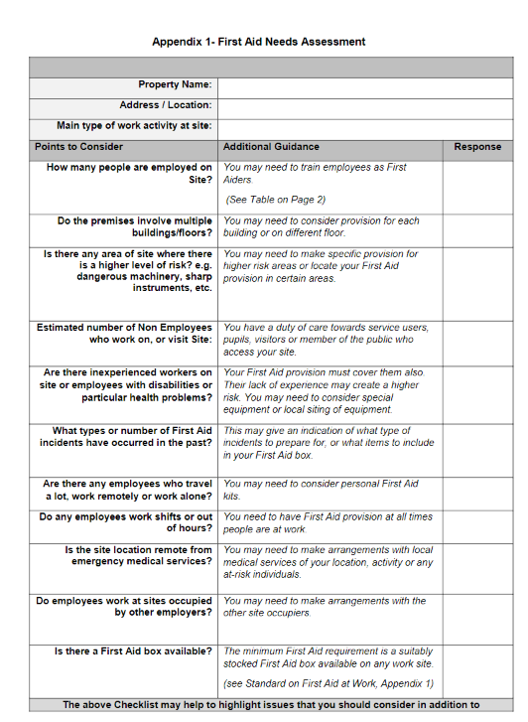
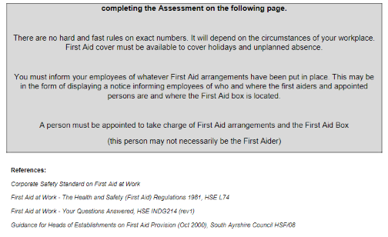

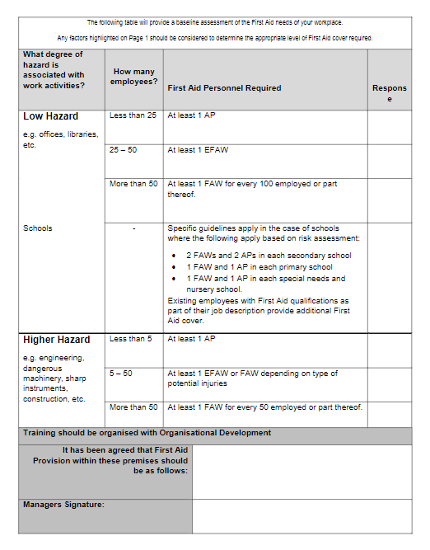

Appendix 2 – Contents of a First Aid Box examples
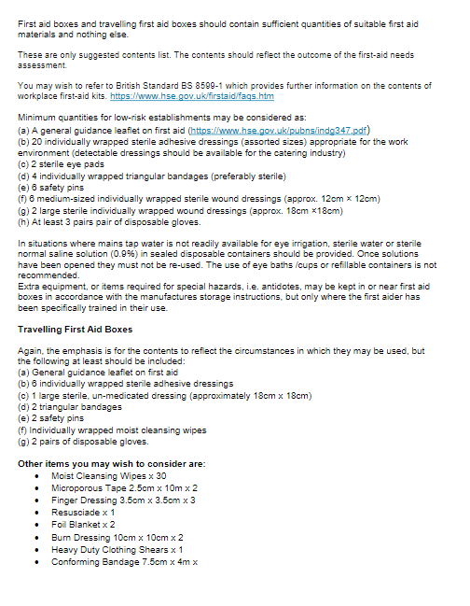

Appendix 3 – EYC and School Medicine Form
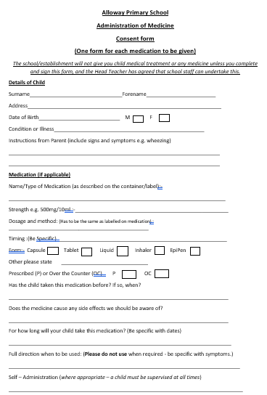
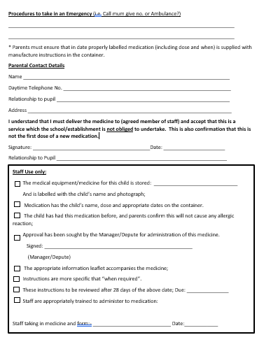

Appendix 4

Alloway Primary School Medicine Log

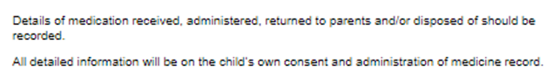

DATE | CHILD’S NAME | DOB | MEDICATION / DOSE | REVIEW DATE | ACTION /COMMENTS (INCLUDING QUANITY OF MEDICINE)

Appendix 5

Alloway Primary School Administration of Medicine Record

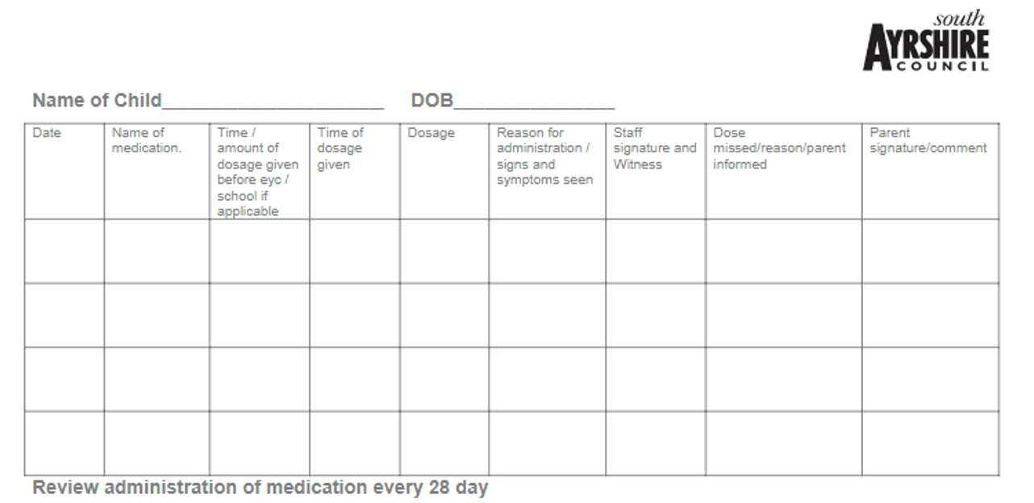
Appendix 6

Alloway Primary School
Refrigeration Temperature Record

DATE | TEMPERATURE | NAME | SIGNATURE

Appendix 7
Accident Log Alloway Primary School

DATE | NAME | CLASS | TIME | INCIDENT (INCLUDING PLACE)  REASON | TREATMENT / OUTCOME | STAFF | PARENT CONTACT

Appendix 8 – First Aid Parental Notification Slip

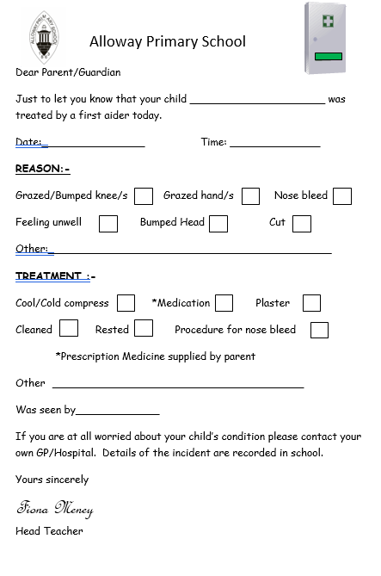

Appendix 9 – Process for accepting medication (for office use)
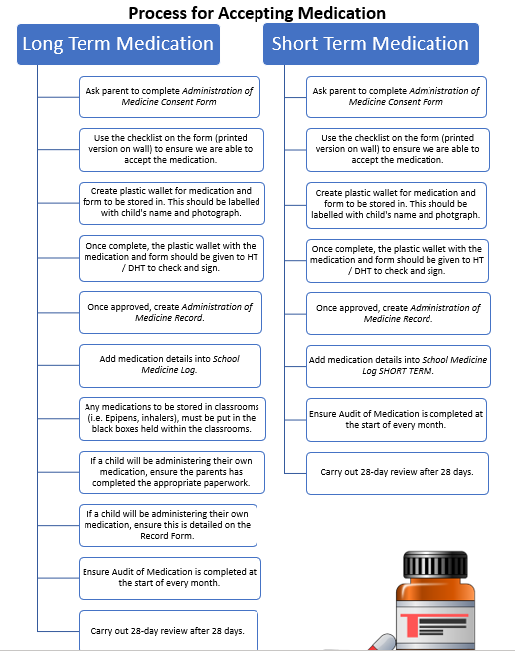

Appendix 10 – Medication Checklist (for office use)
