Alloway Primary School
and Early Years Centre

Care Experienced Children
Policy

RATIONALE
Children who are currently in care or are care experienced have the right to feel supported within our school and will have an allocated member of the senior management team supporting them to ensure the best possible educational outcomes for them whilst educated in our school and at points of transition. Being Care Expereinced is a Protected Characteristic.

UNCRC/Rights Respecting School
At Alloway Primary we are a Gold Rights Respecting School. Through the implementation of this policy we are safeguarding and promoting these rights in relation to Care Experienced children.
Article 9: we have the right to be with our parents if this is what’s best for us.
Article 12: we have the right to say what we think should happen and be listened to Article 13: we have the right to information
Article 19: we have the right to be looked after and kept safe from harm
Article 20: we have the right to be looked after properly if we can’t live with our own family
Article 21: we have the right to live in the best place for us if we can’t live with our parents

Who are our Care Experienced children and young people?

The term care experienced refers to anyone who has been or is currently in care or from a looked after background at any stage of their life, no matter how short. This care may have been provided in one of many different settings such as in residential care, foster care, kinship care and looked after at home with a supervision requirement. (Scottish funding Council 2018). Police Scotland’s Partnership Protocol with local authorities for looked after children who go missing from residential and foster care sets out how they will work together to minimise harm.
The majority of children and young people who become Care Experienced normally do so following a decision by a Children’s Panel who place a Supervision Requirement on a child or young person under the Children (Scotland) Act 1995. The most common routes by which a child or young person can become Looked After are when:
- a child or young person remains at home, under Section 70 (1) of the Children (Scotland) Act 1995, frequently referred to as Looked After at home.
or
- a child or young person becomes Looked After and Accommodated i.e. away from their normal place of residence, under Section 70 (3) of the Children (Scotland) Act 1995. If this is the case they will become part of the Looked After Children system which requires regular review by the Local Authority of the child or young person’s care, including their current location, care plan, education, health and other areas.
or
- a child or young person can also be Looked After and Accommodated when they are provided with accommodation by the Local Authority under Section 25 of the Children (Scotland) Act 1995, which is sometimes referred to as a ‘voluntary agreement’.
or
- a child or young person is the subject of a Permanence Order, Section 80 of the Adoption and Children (Scotland) Act.
Children and young people Looked After (Care Experienced) away from home may be accommodated in:
- kinship care, living with family or close friends
- foster care, provided by local authority carers or an independent foster care provider
- residential care, in a local authority home or private/independent children’s home or residential school
- Secure accommodation

The Additional Support for Learning (ASfL) Act (2004) amended (2009)
The ASfL Act clearly states that being Care Experienced is an additional support need and therefore it is the responsibility of ALL staff to ensure ALL Care Experienced children are well supported.
ALL children, unless exceptional circumstances apply, should be educated in their local children’s services network. Each child should be encouraged to develop so that he or she may achieve success and become a responsible citizen equipped for the transition to adult life. To achieve this, schools should provide a safe and a supportive environment in which pupils can learn and develop. Within this environment, pupils will receive opportunities, encouragement and direction to make the most of their abilities, and to develop personally and socially.

Key Documentation in relation to Care Expereinced Children

Children and Young People (Scotland) Act 2014 (Part 9)
Current legislation on corporate parenting. Statutory guidance on Part 9 (Corporate Parenting) of the CYP Act 2014 is also available.

Education (Additional Support for Learning) (Scotland) Act 2004
Covers all looked after children and young people as they are considered to have additional support needs until assessed. Additional support for learning: statutory guidance 2017 (Code of Practice) outlines the current statutory guidance.

Equality Act 2010
Current equality legislation. Care experience is not legally a protected characteristic however many corporate parents treat ‘looked after’ status or care experience as if it was.

Getting It Right For Every Child (GIRFEC)
Policy developed to support families by making sure children and young people can receive the right help, at the right time, from the right people.

United Nations Convention on the Rights of the Child
A treaty which comprehensively provides for the rights of children.

Independent Care Review
Set up to identify and deliver lasting change in the care system.

Scottish Care leavers Covenant
Established by stakeholders to close the gap between policy and practice for care leavers.

Core Tasks for Designated Managers
Ensures improvement in outcomes for looked after children and young people.

There have been a significant number of reports in Scotland which comment on the educational progress of Care Experienced children.

These include:
Home - The Promise
The Promise is responsible for driving the work of change demanded by the finds of the ICR, and calls for a “Relationship based approach”

Communities that Care
Communities that care: whole-school approach | Resources | National Improvement Hub (education.gov.scot)
Care Experienced people currently experience stigma and discrimination within their communities, which is underpinned by a lack of public knowledge and understanding of care experience. This can lead to care experienced people not feeling accepted, included or as though they belong within their communities.
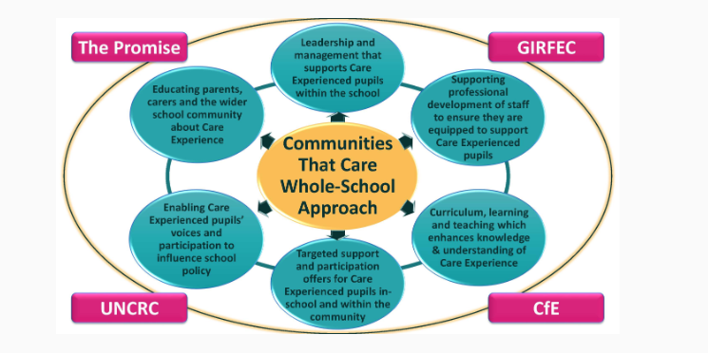

The Independent Care Review is a signal for huge changes in our practice across Scotland for those with care experience and their families, follow the link to the independent care review reports - Independent Care Review – The root and branch review of Scotland's care system.

Champions for Change (South Ayrshire's Champions Board) support young people with experience of care to work alongside those who make decisions about the care system. In this way, they are involved in the decisions that affect their own lives. Champions for Change - Health and Social Care Partnership (south-ayrshire.gov.uk)

Summary information relating to Corporate Parenting | Resources | Education Scotland
The information in this summary gives practitioners access to information, resources and policies to support professional learning and be even better corporate parents. It also provides connections to partners who can support this work.

Corporate Parenting and our Responsibilities

The Role of Corporate Parent

It is widely recognised that the role of the Corporate Parent is crucial in improving outcomes for Looked After children. Being an effective Corporate Parent means:
- accepting responsibility for Looked After children
- making their needs a priority
- ensuring appropriate outcomes in our role as ‘parent’

Collectively, all those working for South Ayrshire Council have a role as a Corporate Parent and therefore have responsibilities as if they were the parent of a Looked After child. These responsibilities are shared by all those in the public and voluntary sector, including the Police and NHS Boards.
,
Five key factors important in achieving success have been identified:
- having people in your life who care about you
- experiencing stability
- being given high expectations
- receiving encouragement and support
- being able to participate and achieve

These apply to all aspects of Care Expereinced children’s lives, including school.

Schools’ Responsibilities

All schools must have a designated senior manager with specific responsibility for Care Expereinced children. This person holds a co-ordinating brief in relation to all the Care Experienced children and young people in their establishment. At Alloway Primary the Care Expereinced Co-ordinator is the Head Teacher, Mrs Fiona Meney.

The Role of the Care Experienced Co-ordinator should:

- be an advocate for Care Experienced children within school
- act as the key liaison professional for other agencies and carers in relation to Care Experienced children, seeking advice from the Care Experienced team when appropriate
- ensure that Care Experienced children receive a positive welcome on entering school, especially mid year and, if necessary, offer additional support and a pre-entry visit to help the new pupil settle.
- liaise and meet with colleagues to ensure relevant information is passed on and appropriate support is in place.
- attend all Care Experienced reviews and case conferences.
- convene an urgent multi-agency meeting if a Care Experienced child is experiencing difficulties or is at risk of exclusion where required or necessary.
- ensure confidentiality on individual children, sharing confidential and personal information with all appropriate agencies.
- have a pastoral responsibility to develop a relationship with the individual in order to ensure that the pupil engages fully with all aspects of learning and teaching, school activities, residential visits ensuring any barriers are addressed.
- ensure a speedy transfer of information, records and coursework, where appropriate, when a Care Experienced child transfers to another educational Care Experiencedement.
- agree with the social worker the appropriate people to invite to parents’ evening and update this chronology within the GIRFEC paperwork.
- liaise with ATL (Admin Team Leader) in order to monitor any changes to SEEMIS information and pass any updated changes to all relevant staff.
- attend all relevant CLPL in relation to Care Experienced children and keep staff informed.
- ensure all Care Experienced children have a Care Experienced file which is securely locked away and kept up to date.

The role of the Class Teacher:
- When a young person becomes care experienced a BOXALL assessment should be completed by the class teacher who knows the child best.
- Strands from BOXALL should be used to set targets for staged interventions. This may be in partnership with educational psychologist.
- Children will be supported at STINT stage 4. Class teacher will work together with Care Expereinced co-ordinator to complete targets.
- To aim to overcome any identified barriers to ensure each child is fully involved in the life of the school
- Attend relevant CLPL
- Contribute to the child’s assessment plan

The role of Clerical Staff:
- To liaise with ATL in order to monitor changes to seemis information.
- To file relevant documentation in Child Protection files as directed by Head Teacher.

The role of a Parent or Carer:
- To attend reviews and case conferences as appropriate.
- To liaise with the school and where appropriate attend parents evenings.
- Notify the school of any relevant incidents or change or personal details/circumstances

Quality Assurance

How will we know if we have made a difference?

- when pre-Five centres, schools or other educational establishments are places that Care Experienced children, feel happy, safe and valued, through teaching and learning approaches which are sensitive to their needs.
- when young people who are, or have been, Care Experienced make the transition from school into sustained placements in further or higher education, employment or training.
- when you can give a positive answer to the question “Would this be good enough for my child?”
- where there is no difference in the rate of attendance or exclusion of Care Experienced children and young people as compared to their peers who are not Care Experienced.
- when Care Experienced children and young people are just as likely as their peers to participate in and out of school activities and wider school community activities such as sporting competitions.
- when Care Experienced children and young people receive the additional support they require to participate in mainstream education, regardless of whether they are placed out of authority.
- when the educational outcomes for Care Experienced children and young people and care leavers, in terms of attainment and achievement, are the same as those for their peers who are not Care Experienced

Care Experienced Children’s Rights to Care
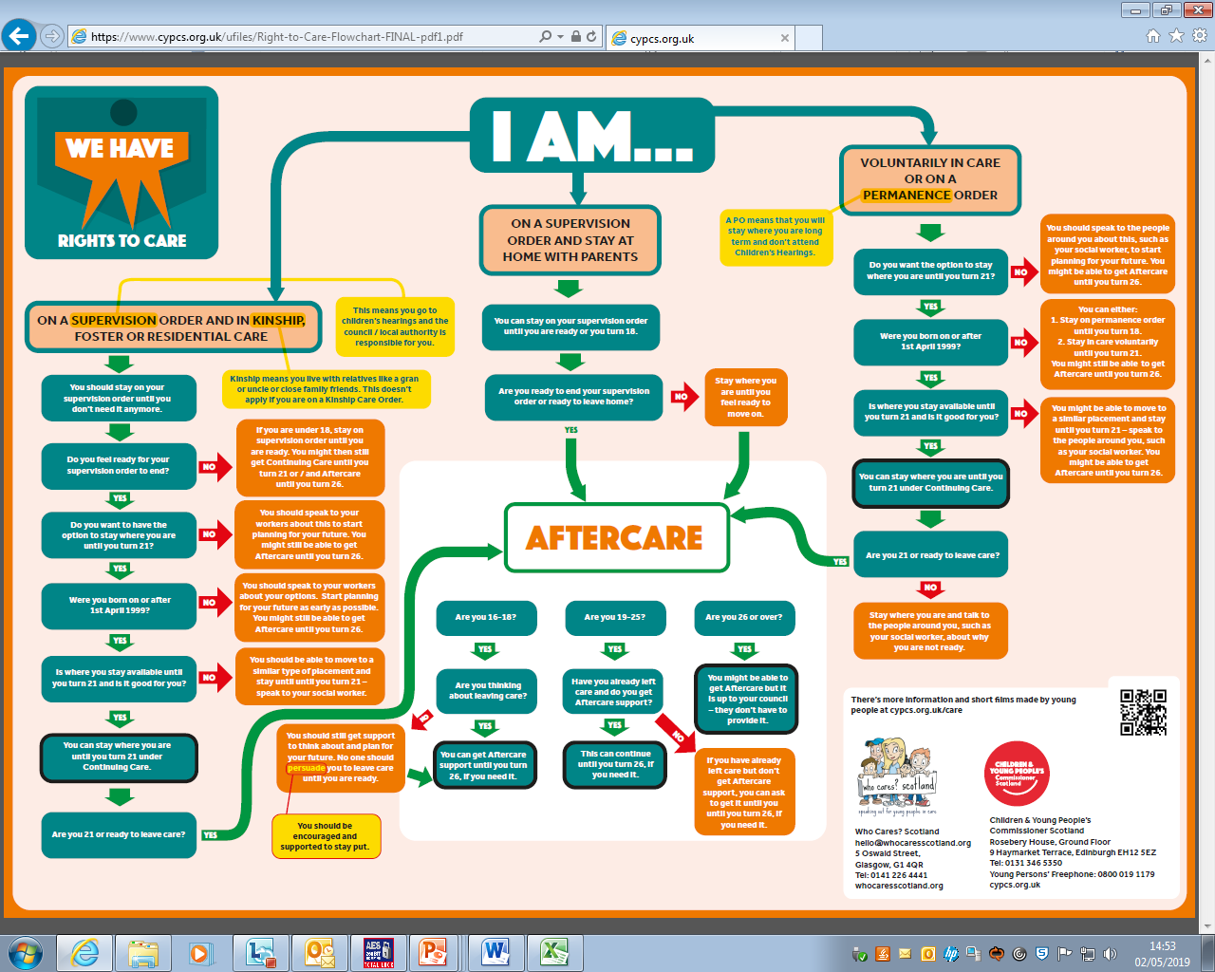

Local Authority Contact Telephone Numbers

JIM HENDRIE
Child Protection & Wellbeing Officer
01292 612719
Jim.Hendrie@south-ayrshire.gov.uk

GILLIAN CARROLL
Children’s Services Planning and Performace Lead Officer
01292 612003
Gillian.Carroll@south-ayrshire.gov.uk

GAYLE FERGUSON
Quality Improvement Manager
01292 612129
Gayle.Ferguson@south-ayrshire.gov.uk
Kimberley Keean
Virtual School Head Teacher 01292 612309
kimberley.keenan@south-ayrshire.gov.uk

Area Social Work Team: (01292) 267675

School Nurse: 07815992482
(Stacey Cannon)

Education Psychologist (01292) 268379
(Claire Masterman)

Updated January 2024 (F. Meney)

