|  |  |
| --- | --- |
| See the source imageEducational Services **Head Teacher: Fiona Meney**  Alloway Primary School  16 Doonholm Road  Alloway  Ayr  KA7 4QQ  Tel: 01292 612490 Fax: 01292 441802  Email:alloway.mail@south-ayrshire.gov.uk  Our Ref: KB/JP  Date: 15thJanuary 2024 | SAC New Logo Black fo#629D6 |

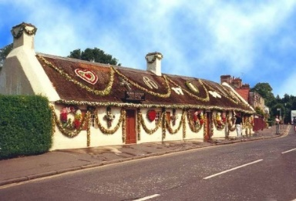

Dear Parent/Career

Primary 3s will be visiting the Robert Burns Birthplace Museum and the Cottage on Tuesday 23nd January 2024**.**

The children will leave school at 9.15am and return at approximately 2.00pm. School uniform should be worn as usual but as the weather can be changeable at this time of year, could you please ensure that all children have warm waterproof coats or jackets.

A packed lunch will be required along with a drink. Please indicate on Parent pay if you wish the school to provide a pack lunch.

The cost of this trip would normally be £6.10 per pupil but this will be subsidised from the generous donations from “Dance a thon” making the payment £3.00 required to cover the cost of full access to the Robert Burns Birthplace Museum and workshops.

Please pay via Parent pay if you can and contact the teacher if your able to help on the day. Parent pay will close for this trip on Monday 22nd January 2024.

**If there are any changes to the information you submitted on your Annual Parental Consent form please inform us as soon as possible to allow us to amend our records. Please visit the school website to view the full privacy notice regarding usage of data shared.**

If you are able to assist with supervision please indicate on the slip below.

Yours sincerely,

Fiona Meney

FIONA MENEY

Head Teacher