Eco Committee
Minutes for meeting on 27.10.23

Minutes created by: Felix

At today’s committee we:
. What we can do in the future of this committee
. We will divide into teams to find information about other committees, classes and even staff members.
. Today we will plan and prepare for gathering information from other people
. As groups we need to decide what questions we will ask to classes, member of staff etc.
. We will email people today that we want to interview about the school
. All the groups will discuss what there planning to do with their team/group

Dyslexia and Inclusive Schools

Minutes for meeting on _______

Minutes created by: (Pupil name)

At today’s committee we:

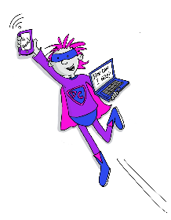
Digital Leaders
Minutes for meeting on _______

Minutes created by: (Pupil name)

At today’s committee we:

Health and wellbeing
Minutes for meeting on _______

Minutes created by: (Pupil name)

At today’s committee we:

Pupil Council
Minutes for meeting on _______

Minutes created by: (Pupil name)

At today’s committee we:

Rights Respecting Schools
Minutes for meeting on _______

Minutes created by: (Pupil name)

At today’s committee we:

Alloway News

Minutes for meeting on _______

Minutes created by: (Pupil name)

At today’s committee we:

JRSO

Minutes for meeting on _______

Minutes created by: (Pupil name)

At today’s committee we:

