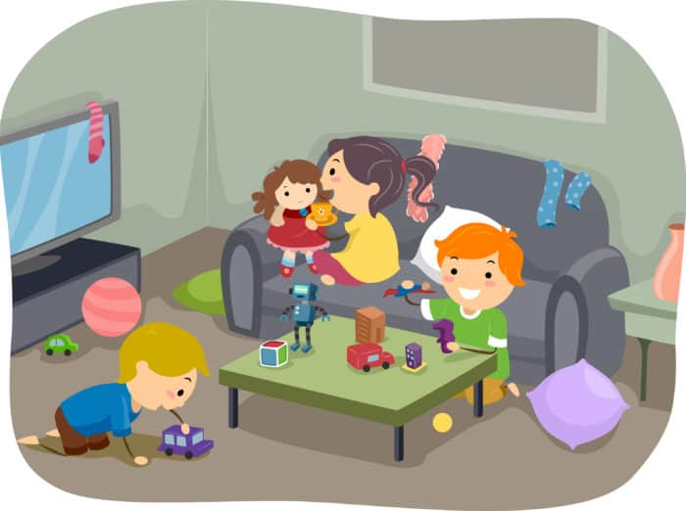
Alloway EYC Home Learning

Thursday 28th September 2023

Good Morning .

I hope you all had a lovely long weekend. We will miss all your little faces over the next few days, and look forward to hearing your long weekend news very soon.

Over the coming few days, I will upload some fun ideas of how you can continue our EYC curricular planning at home.

These experiences are completely free and can be done with materials and resources from the home. They are easy to set up and require minimal supplies.
Let your child be creative . Allow them to lead their own learning and be responsive to their interests. Discussions to promote learning can take place during every day routines.

Most importantly have fun .
See you all soon

Mrs Gilmour

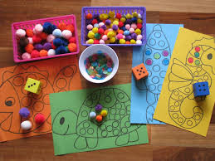
Numeracy and Maths

- Have fun subitising.
I recognise ‘how many?’ in regular dot patterns to 5, without having to count (subitising)

Children start by being able to subitise up to 3 dots, however in the EYC one of our South Ayrshire Developmental Milestones is that children can subitise a regular dot pattern of 5 dots by the time the enter primary one. Children who play board games and who are used to playing with a dice find this much easier.

Tasks
- Play board games which require a dice. The dot pattern on the dice is classed as a regular dot pattern. If your child is not familiar with a dice, they will probably start by counting the dots. This is ok initially until they learn how the dots look together. The more they play, try and encourage them to look and say what they see.
- Once they have the idea, you could draw spots on the ground outdoors in regular dice patterns and play a gave of spot and jump.
- You could ask your child to draw, recreate dot patterns using a range of materials.
- Use pom poms to make a subitising picture, or a lady bird with spots

- This is quite a hard skill for children to grasp, therefore we recommend that it something that you explore through play regularly

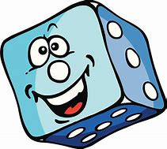

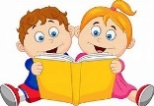
Literacy
Snuggle in, and have fun reading together .

Tasks
- Encourage your child to choose their favourite book.
- Ask your child to name the following parts of the book; spine, front and back cover, blurb, discuss the author and illustrator and their job.
- Read the story to your child
- Reflect on the story and discuss words that rhyme, alliteration, different styles of texts to show expression etc
- Ask your child if they can retell the story in order/ sequence. Using pictures where appropriate.

- Use the following link to extend learning using higher order questions (Blooms Bears) https://www.twinkl.co.uk/resource/cfe-l-52559-blooms-taxonomy-early-level-reading-challenge-cards
- Follow up by asking your child to draw a picture of their favourite part of the story/ character/ scene
- Where necessary, support your child to annotate their picture with key words, names phrases

Health and Wellbeing

Food technology
Why not try to create a snack creature. Use your skills of chopping, spreading, peeling, pouring to make an edible creature. Discuss health and not so health foods (we don’t say unhealthy), and how everything is ok in moderation.
- Try out some Cosmic Kids Yoga- Betsy the Banana.
- https://www.youtube.com/watch?v=40SZl84Lr7A

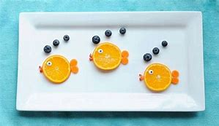
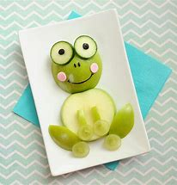

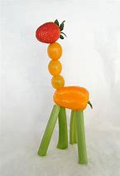
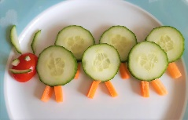

FUN FOCUS

