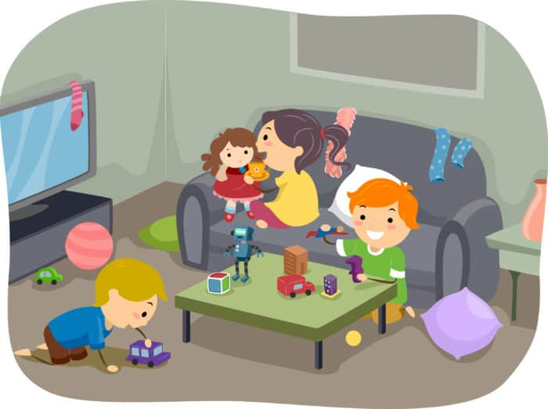
Alloway EYC Home Learning

Wednesday 27th September 2023

Good Morning .

I hope you all had a lovely long weekend. We will miss all your little faces over the next few days, and look forward to hearing your long weekend news very soon.

Over the coming few days, I will upload some fun ideas of how you can continue our EYC curricular planning at home.

These experiences are completely free and can be done with materials and resources from the home. They are easy to set up and require minimal supplies.
Let your child be creative . Allow them to lead their own learning and be responsive to their interests. Discussions to promote learning can take place during every day routines.

Most importantly have fun .
See you all soon

Mrs Gilmour

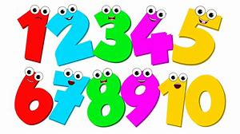
Numeracy and Maths

Continue fun with numbers. We would focus on the following EYC;

Number
- I can recite numbers forwards 5 / 10 / 20
- I can recite numbers backwards 5 / 10 / 20
- I can recognise numerals to 5 / 10 / 20 and beyond.
- I can order numbers to 5 / 10 / 20 and beyond.
- I can write numbers to 5 / 10 / 20 and beyond.

Tasks
- Singing number and counting songs such as;
- Rote/ chanting numbers 1-10/ 10-20+
  - Make this fun by clapping as you count/ touching different body parts/ jumping as you count etc
- Number games using gross motor skills outdoors
  - Jump 8 times
  - Hop like a bunny 10 times
  - Bounce the ball 5 times
  - Run round the cone 7 times
- Look for numbers in your home and when you are out a walk
  - Tv remote
  - Numbers on clothing
  - House numbers
  - Car registrations
  - Chalk numbers on the ground
- Order numbers
  - Cut up numbers and support your child to put these in order.
  - Write them in order with chalk or water
  - Use a ruler to look at order
  - Try this game for ordering
  - https://www.topmarks.co.uk/maths-games/3-5-years/counting
- Writing numbers
  - Trace over numbers with your finger
  - In shaving foam, sand, water

Literacy
Have fun with early mark making/ writing. We would focus on the following in the EYC;

- Gross motor movements from the shoulder’s arms and elbows
- Gross motor mark making
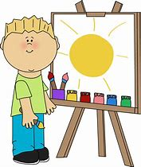
- Fine motor skills/ games
- Fine motor control
- Emergent writing/ drawing
- Pencil grip
- Letter/ number formations

Tasks
- Sing and join in in action songs such as Head Shoulders Knees and Toes.
- Develop upper gross motor skills by fun games such as catch, spinning hoops and dance.
- Support your child to use gross motor skills to mark make in or outdoors. Provide them with paint brushes and water, large pieces of paper or old wallpaper rolls to encourage your child to use large stroke like movements (ensure they do not get carried away and paint your Livingroom walls ).
- Then focus on the development of fine motor skills. You can support these by providing the following experiences;
  - Threading- pasta and laces
  - Play dough pinching
  - Putting pennies into a money bank
  - Using a colander and pipe cleaners to make a spikey rainbow hedge hog
  - Transient art using small objects
  - Picking up items with plastic tweezers
- Support your child to transfer these skills by providing experiences to draw/ mark make in shaving foam, sand, rice or paint with their fingers
- Then move on to introducing different mark making objects. Start with wider objects like chunky calk and cubby crayons before moving onto pens and pencils. Allow your child to time explore with these, find comfort in holding and manipulating them.
- If and when appropriate you can support your child’s pencil grip which will in turn develop their formation and control.

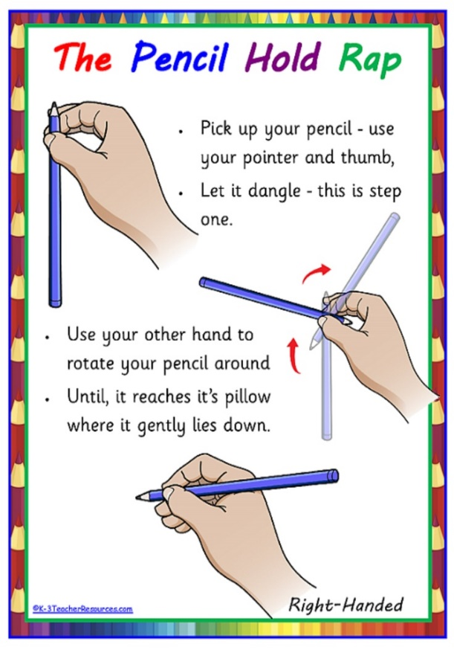
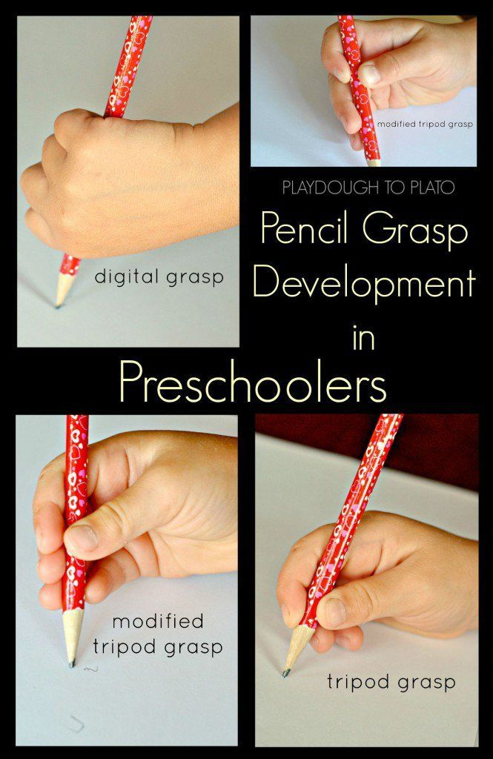

Helping to develop pencil grip in the early years
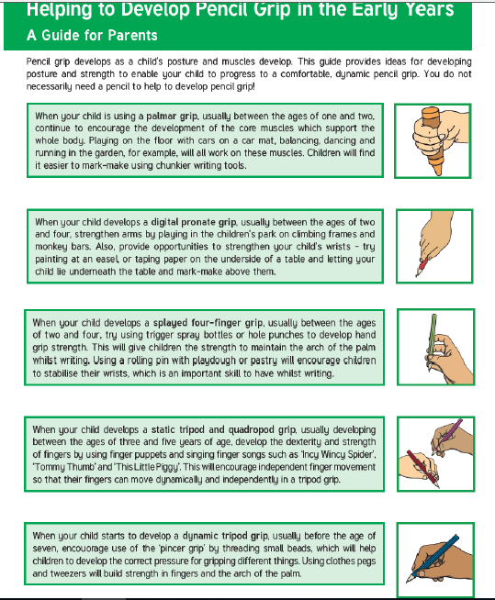
A guide for parents

FUN FOCUS

STEM

Science, Technology, Engineering, Maths

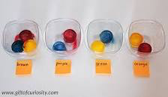
Can you work out which colours will be made?

Red + Yellow =
Blue + Yellow =
Blue + Red =
Blue + Red + Yellow =
You could use paint to work it out.
It is also REALLY fun with coloured ice cubes, made with food colouring! This link gives top tips.
https://www.broogly.com/project/color-mixing-ice

Children are curious and are always keen to explore, discover and experiment.

Let’s get them asking:
How does it work?
How does it change?
Why?

