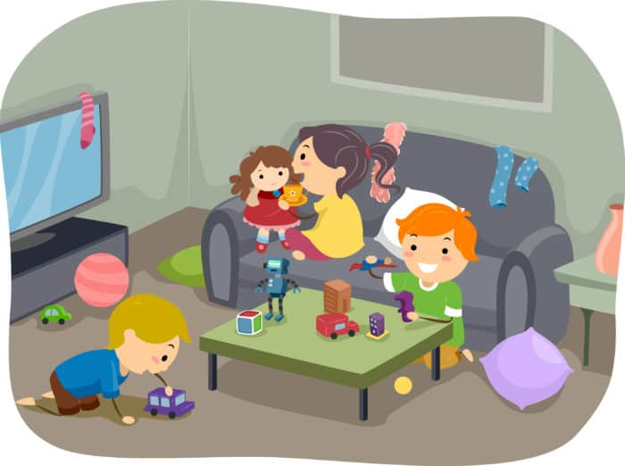
Alloway EYC Home Learning

26th September 2023

Good Morning .

I hope you all had a lovely long weekend. We will miss all your little faces over the next few days, and look forward to hearing your long weekend news very soon.

Over the coming few days, I will upload some fun ideas of how you can continue our EYC curricular planning at home.

These experiences are completely free and can be done with materials and resources from the home. They are easy to set up and require minimal supplies.
Let your child be creative . Allow them to lead their own learning and be responsive to their interests. Discussions to promote learning can take place during every day routines.

Most importantly have fun .
See you all soon

Mrs Gilmour

Numeracy and Maths

Have fun with numbers and counting. We would focus on the following in the EYC;

- Singing/ rhymes
- Chanting
- Counting games
- Touch count
- Exploring a number line

Tasks
- Singing number and counting songs such as;
  - 1,2,3,4,5 Once I caught a fish alive
  - 5 current buns
  - Baa baa black sheep
  - 10 green bottles
- Rote/ chanting numbers 1-10/ 10-20+
  - Make this fun by clapping as you count/ touching different body parts/ jumping as you count etc
- Number games using gross motor skills in the gym/ outdoors
  - Jump 8 times
  - Hop like a bunny 10 times
  - Bounce the ball 5 times
  - Run round the cone 7 times
- Touch count large objects such as bottles/ people/ cups (one to one correspondence between finger and object) 1-10/ 10-20+
- Transfer these skills when ready to small objects like beads/ buttons/ stones
- Let you child explore counting on a number line. This may have pictures or objects on it rather than numbers at this stage.
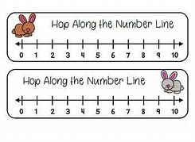
- Practise your counting skills by playing ‘Teddy Counting’ https://www.topmarks.co.uk/learning-to-count/teddy-numbers or ‘Underwater Counting’ https://www.topmarks.co.uk/learning-to-count/underwater-counting
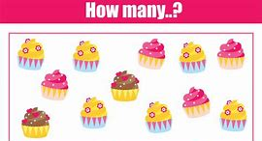

Literacy
Have fun with rhyme. We would focus on the following EYC;

- I can join in singing simple rhymes and songs
- I can fill in missing words from a familiar nursery rhyme
- I can listen and recognise words that rhyme
- I can listen and suggest words that rhyme

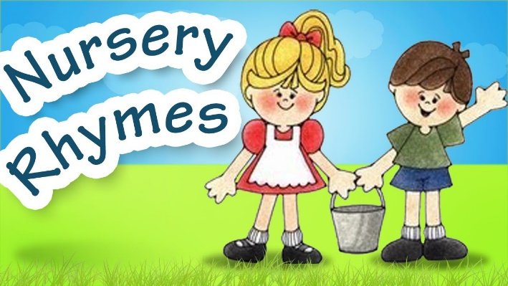
Tasks
Have fun singing your favorite nursery rhymes together. Why not have a look online at some new nursery rhymes, try the link below. There are some that are not so common you could practice together.

Sing familiar rhymes and miss out a word and encourage your child to fill in the silence. Try this with rhyming books too, discuss rhyming words throughout the book.

After singing nursery rhymes, or reading a book with rhyming words, ask your child if they heard any words that “sound the same”. Repeat some of these, ask them to help you find some more.

Play a game where you give a word and your child has to suggest a word that “sounds the same”. These can even be nonsense words. Find simple objects around the house and try and make nonsense rhyming words to go with them.

The Book Bug Bags sent home by the EYC have a super little CD which has many familiar rhymes on it.

Rhyming information and videos
https://fun-a-day.com/rhyming-songs-for-preschool

Nursery Rhymes
https://www.youtube.com/results?search_query=nursery+rhymes+for+preschool

Book Bug Sessions
https://www.youtube.com/watch?v=qsUGCkwqq1o

FUN FOCUS

