People Directorate    Head Teacher – Mrs F Meney  Alloway Primary School  16 Doonholm Road  Alloway  Ayr  KA7 4QQ  Tel: 01292 612490 Fax: 01292 441802  Email:alloway.mail@south-ayrshire.gov.uk  Our Ref: Your Ref:  Date: 27.9.22 |   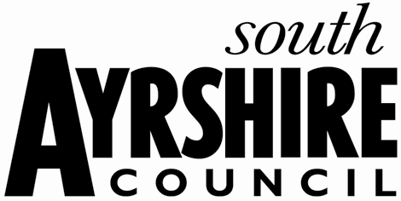
Dear Parents and Carers,

Owl Magic Visit – Tuesday 4th October

Owl Magic are visiting the school on Tuesday 4th October to work with our EYC and P1 pupils. They will work with small groups from the EYC in the morning, and then provide a session for each P1 class in the afternoon.

Owl Magic will provide a fun and truly unique educational experience for our children, and an opportunity to get up close and personal with the birds of prey. Children will learn about the birds, and will have the opportunity to hold or touch the birds of prey, should they wish.

If you have any questions, please don’t hesitate to contact me.

Yours sincerely,

Lauren

Lauren Miller
Depute Head Teacher

