People Directorate  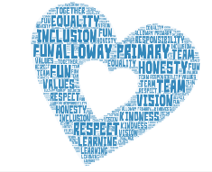  Head Teacher – Mrs F Meney  Alloway Primary School  16 Doonholm Road  Alloway  Ayr  KA7 4QQ  Tel: 01292 612490 Fax: 01292 441802  Email:alloway.mail@south-ayrshire.gov.uk  Our Ref: FM/SEC Your Ref:  Date: 26.09.22 | 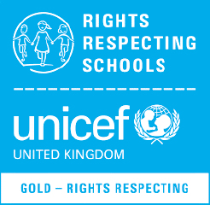  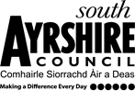
Dear parent / carer,

Childsmile Toothbrushing Programme

Now that COVID restrictions have been lifted, we will be resuming our toothbrushing programme in the EYC. I have attached a letter which provides further information regarding the Childsmile Programme. Elise Girvan from Childsmile will be visiting the EYC on Monday 3rd October to set us up ready to start.

Your child will be enrolled in the toothbrushing programme automatically, however, if you do not want your child to take part, please write to us ASAP.

Yours sincerely

Lauren

Lauren Miller
Depute Headteacher

