

Class P2 Date – Thursday 11th February 2021
Alloway Primary School Home Learning

Area Of Learning | Today’s Learning Tasks
Literacy | Spelling  This week’s spelling focus is ‘oa’  Writing Instructions: How to play a game  walt: write instructions  wilf:  - Title  - What is needed  - Object of game  - How to play  - Timed openers: first, then , next, finally  - Imperative verbs: bossy verbs e.g. count, roll, shout , cover etc  Teaching video: https://youtu.be/NhK1Jtr9KUM
Maths | 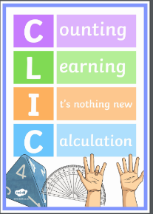  Numeracy  Watch the following teaching video with Mrs McLeod to practise your CLIC.  Have your maths jotter or whiteboard ready. This video is intended to be watched in short blocks throughout the week. Thanks  CLIC- Mrs McLeod: https://youtu.be/8SCeWzSu4v4  - Investigate quarters: https://youtu.be/Kl6mkPT3EIc    - Complete worksheet: Flag Designs: Colouring quarters and finding quarters  - Sumdog challenge continues. Complete the challenge to win a bonus 200 coins! Yay!
Other Curricular Areas | Maybe you don’t know it, but February 5th was World Nutella Day!  The World Nutella Day was established on February 5th 2007 by Sara Rosso, an American blogger and a Nutella lover …like me!  To celebrate World Nutella Day, you can create some yummy art which you can eat with your friends, based on the artwork of a famous American artist Jackson Pollock. Pollock was part of a group of artists called the abstract expressionists and they used their art to show their emotions, like happiness!  Visit this link to make a chocolate painting based on Jackson Pollock artwork and inspired by the World Nutella Day.
These tasks do not have to be carried out in the order they have been set out. Please use these tasks as a guide for learning that should be carried out today. Thank you for your efforts and cooperation.

