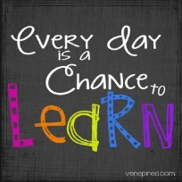

Class P2 Date – Wednesday 20th January 2021 Teacher
Alloway Primary School Home Learning

Area Of Learning | Today’s Learning Tasks
Literacy | Good morning P2! Do what you can today. Remember any of these  activities can be carried out as and when suits. Please complete your Seesaw    check in this morning.  Spelling  This week’s spelling focus is ai.  Task: Bubble Writing  Spelling city  https://www.spellingcity.com/users/MelMcLeod9  Grammar – Verbs  Join the Supermovers and get active with grammar:  https://www.bbc.co.uk/teach/supermovers/ks1-english-verb-tenses-with-karim-hacker/zr7gt39  Today we are learning to identify and use verbs in a sentence.  Teacher Video:  https://www.youtube.com/watch?v=Bi42mY5876Y&feature=youtu.be  Follow up Task – Page 3 of Grammar workbook. Page 4 can be used as a challenge or extension activity (optional)  Reading Book  Please re-read this week’s book. We are working on our fluency and expression. Try to put on different voices for characters. Change the tone of your voice to show expression and understanding  of the story.  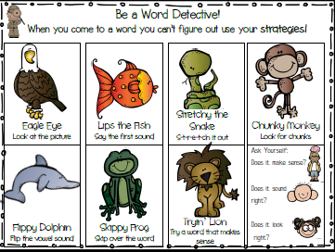  Task – can you find 5 verbs in your reading book?
Maths | 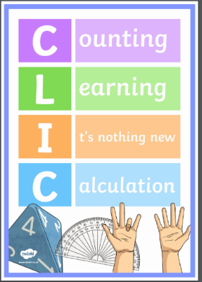  Numeracy  C- COUNTING  L- LEARN IT’S  I- IT’S NOTHING NEW  C- CALCULATIONS  Watch the following teaching video to practise your CLIC.  Listen carefully and join in with the teaching activities.  You can continue to practise these skills throughout the week using the teaching video.  Mrs Clark: https://youtu.be/IBokzIatyDw  Measure  - BBC Super Movers – an active start to your maths – Length and Height with Mr Pumpernickel.  https://www.bbc.co.uk/teach/supermovers/ks1-maths-length-height/zdrx92p  - Teaching video: Measuring using metres.  There has been a Sumdog challenge set for you today. Please login to Sumdog to complete this. The challenge has been set for a fortnight so you can dip in and out of it. We will check your scores once the challenge has ended.    https://www.youtube.com/watch?v=Z9IhwKuHXp0&feature=youtu.be  Before watching this video you may wish to cut out and make the paper metre stick that can be found in page 2 of your worksheets.  Follow up task – page 3 of worksheets.  - Log into Sumdog: The fortnightly challenge continues. Please message class teacher on Seesaw if you need a copy of your child’s password. Sumdog works best using Google Chrome or the app.
Other Curricular Areas | Katie Morag – Mapping and Coordinates  https://youtu.be/srpJxJTI7OM  walt- use map coordinates  Wilf-  - Use coordinates to find different places on a map  - Write coordinates (letter, number)  - Talk about when you would need to use these skills in real life  Please find copy of the map and questions on Microsoft teams.
These tasks do not have to be carried out in the order they have been set out. Please use these tasks as a guide for learning that should be carried out today. Thank you for your efforts and cooperation.

