Priorities
Renfrewshire’s Council Plan and Community Plan set out a vision for Renfrewshire, identifying the challenges and opportunities and provide a framework for improving outcomes for the citizens of Renfrewshire. From this, Children’s Services has developed an action plan setting out how it intends to achieve the outcomes identified in the Council and Community Plan.
As part of Children’s Services, St James’s Primary School has developed their school improvement plan which provides a framework for how we intend to continue our work towards achieving better outcomes for those associated with our school community.

In both the national and local context, Curriculum for Excellence, Getting it Right for Every Child and closing the poverty attainment gap are the focus for education and responding to these priorities will be a central aspect for St James’s Primary School since they are central to preparing and supporting children and young people for the future.
As ever, if you have any comments or suggestions about any of the information contained in this leaflet, or if you would like a full copy of our annual Improvement Plan, please do not hesitate to contact me at the school or use the space provided below and return to the school office.
Michelle Ferguson
Acting Head Teacher
Parent Comments

St James’s Primary
School
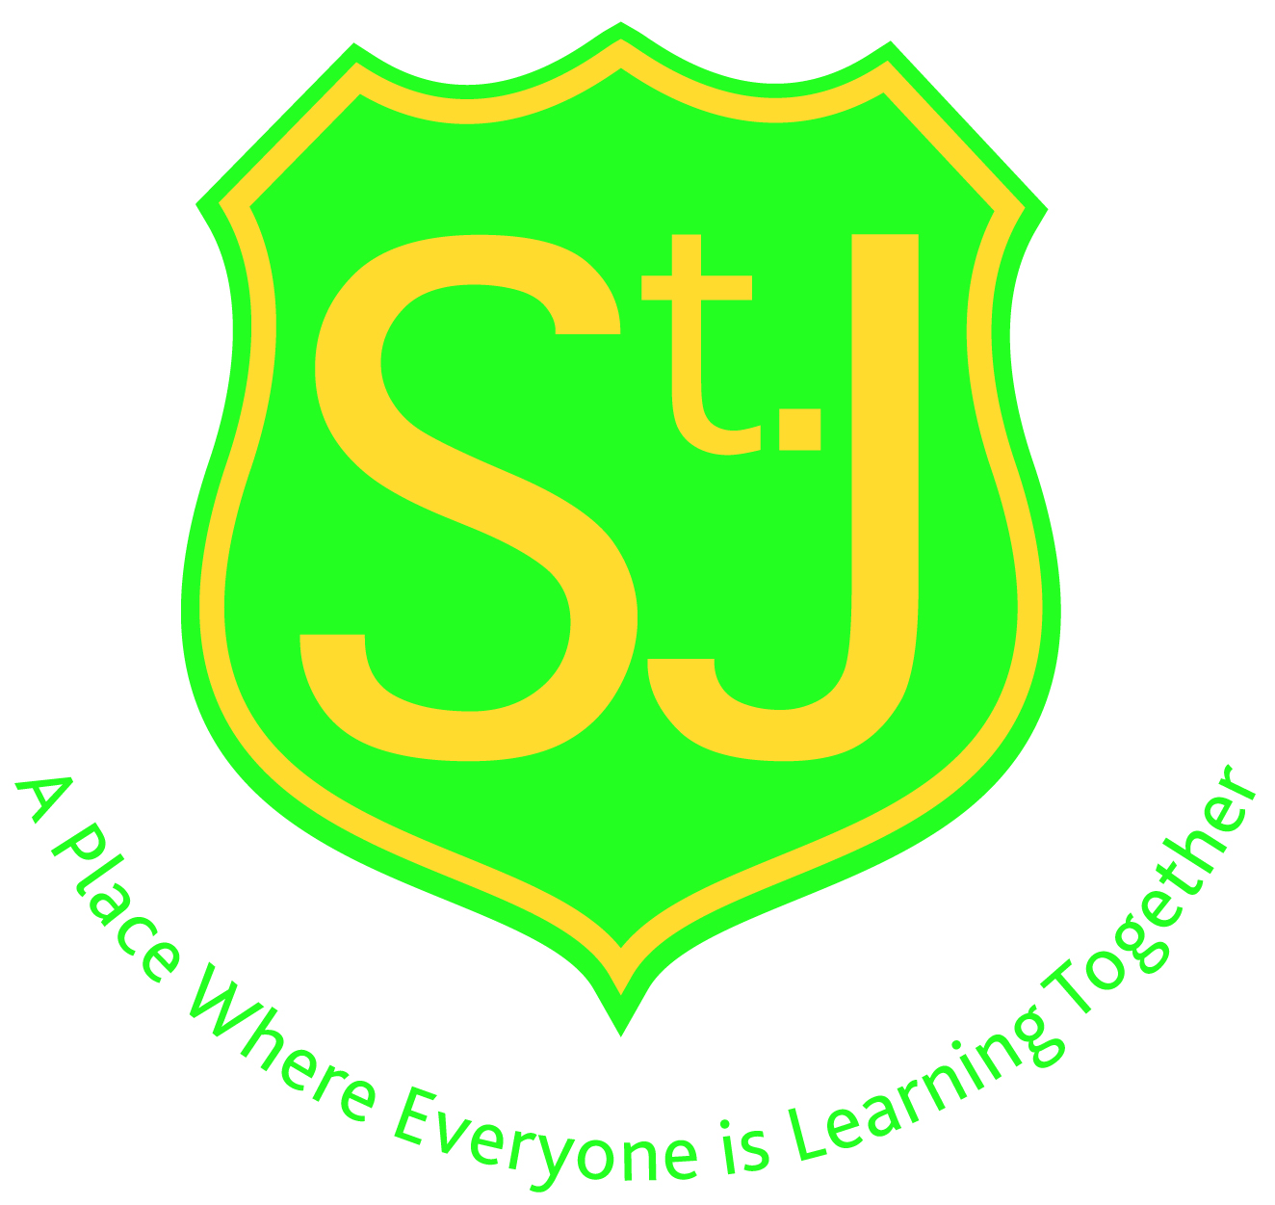

Improvement Plan Session 2015/16
This leaflet provides a summary of our annual Improvement Plan approved by Renfrewshire Council. It enables parents and carers to see what St James’s Primary School aim to achieve during the forthcoming school session.
A copy of the full plan is available on request from the school office.

Our Vision
To provide every pupil with a range of experiences which will equip them with the skills, understanding and knowledge required in order to meet the challenges they will face throughout their lives.

Our Aims
In St. James’s Primary we aim to provide a stimulating and caring environment in where all children are offered an education of the highest quality. Our aims are as follows:
1. We aim to provide a broad, balanced coherent and progressive curriculum, which offers challenge and enjoyment and is consistent with National and Local Guidelines.
2. Enable our pupils to be successful learners, confident individuals, responsible citizens, effective contributors and to achieve the standard of attainment which is appropriate to age, aptitude and ability.
3. Provide equal learning opportunities for all pupils within an effective system that takes account of educational, pastoral and social needs.
4. Provide a range of teaching and learning approaches, which take into account the individual needs and achievements of pupils.
5. Promote an ethos which develops and fosters wisdom, justice, compassion and integrity and which respects and values all members of the school community, encouraging a sense of pride and commitment to global citizenship.
6. Establish a team led by the Head Teacher, which works effectively towards the successes of the school.
Improvement Tasks for 2015/2016:

- Implement GIRFEC (Getting It Right for Every Child) in relation to the introduction of the named person and child’s plan. Continue to implement GIRFEL (Getting It Right for Every Learner) policy to ensure the needs of all learners are met.
- Ensure policies are assessed for impact and we are compliant with the Equalities Act 2010.
- Continue to embed Reciprocal Reading as a strategy to develop Reading skills across all stages in the school.
- Embed Local Authority Numeracy and Mathematics Guidance documents including the introduction of a numeracy champion within the staff to cascade information across all stages.
- In partnership with St Andrew’s Academy and the Primary Cluster Schools develop curricular transitions across and within levels (Early - Third) focusing on Science.
- Introduce standardised assessments at key stages across the school.
- Adapt assessment and tracking approaches to ensure appropriate support and challenge for learners.
- Organise a homework club to ensure IT opportunities for all and to support pupils and parents with homework activities.
- Continue to improve procedures for reporting to parents including arrangements for Parents’ Evening and the format of written reports.
- Undertake a review of our curriculum rationale.
- Continue to use quality indicators to self-evaluate performance in line with How Good Is Our School 4.
- HT and Staff to engage in the Literacy Coaching Programme in conjunction with Strathclyde University.

