Talk for Writing: A Guide for Parents/Carers
https://www.talk4writing.com/
Talk for Writing was developed by authors Pie Corbett and Julia Strong.
It is a whole school approach to develop our children as readers, writers, speakers, and listeners.
Talk for Writing starts with enjoying and sharing songs, rhymes and stories. There is a strong emphasis on children reading stories and enjoying a range of different books. Through regular reading, we want children to build on communication and language, sharing their thoughts and ideas, developing imaginative skills to creating their own unique stories.
Children learn language, by hearing it, saying it and reading it, through adults role modelling language and communication, repeating and extending ideas.
Here are the steps we will use for our children within Williamsburgh ELCC to achieve this-
Imitation
- learning stories or rhymes that they want to hear again and again, until in the end they know it word for word.
Innovation
- Once children know their stories well, they will begin to make changes to create a new version of the story.
- Choosing new characters.
- Change the setting, objects or events.
Invention
- Involves children creating their own stories independently, drawing on life experiences and stories they are familiar with.

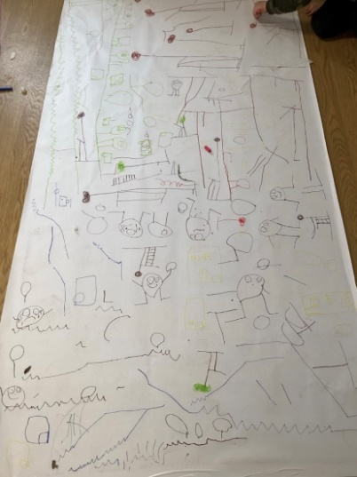
We are introducing the “language of stories” – Adults will model this when the children are creating their own unique stories, for example (Once upon a time, first, next, unfortunately, luckily and finally). This language challenges children thinking, ideas and adds depth to their imagination and creativity. We encourage you and your children to explore and have fun with this at home, add props and clothing etc.

For more hints and tips to support this at home, come and speak to a member of the staff team.
Mapping stories -When children are ready, adults will model and encourage children to map out familiar stories, or their unique stories, using pen and paper, Microsoft paint, props, and real items to spark imagination.

