That’s Not My Nursery…

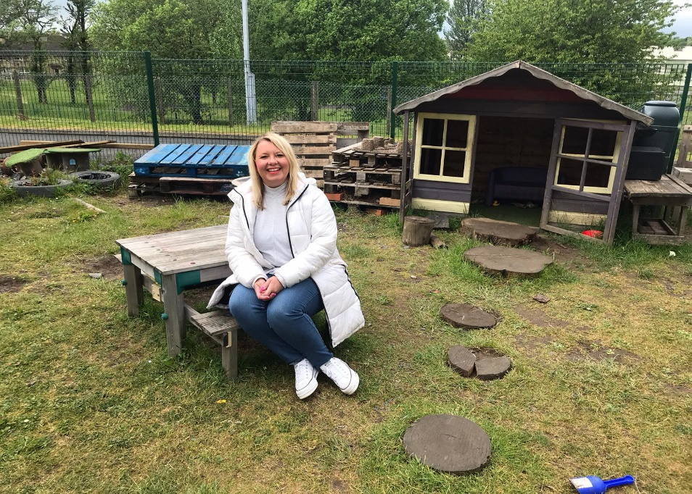

The grass is so green!
That’s not my nursery…
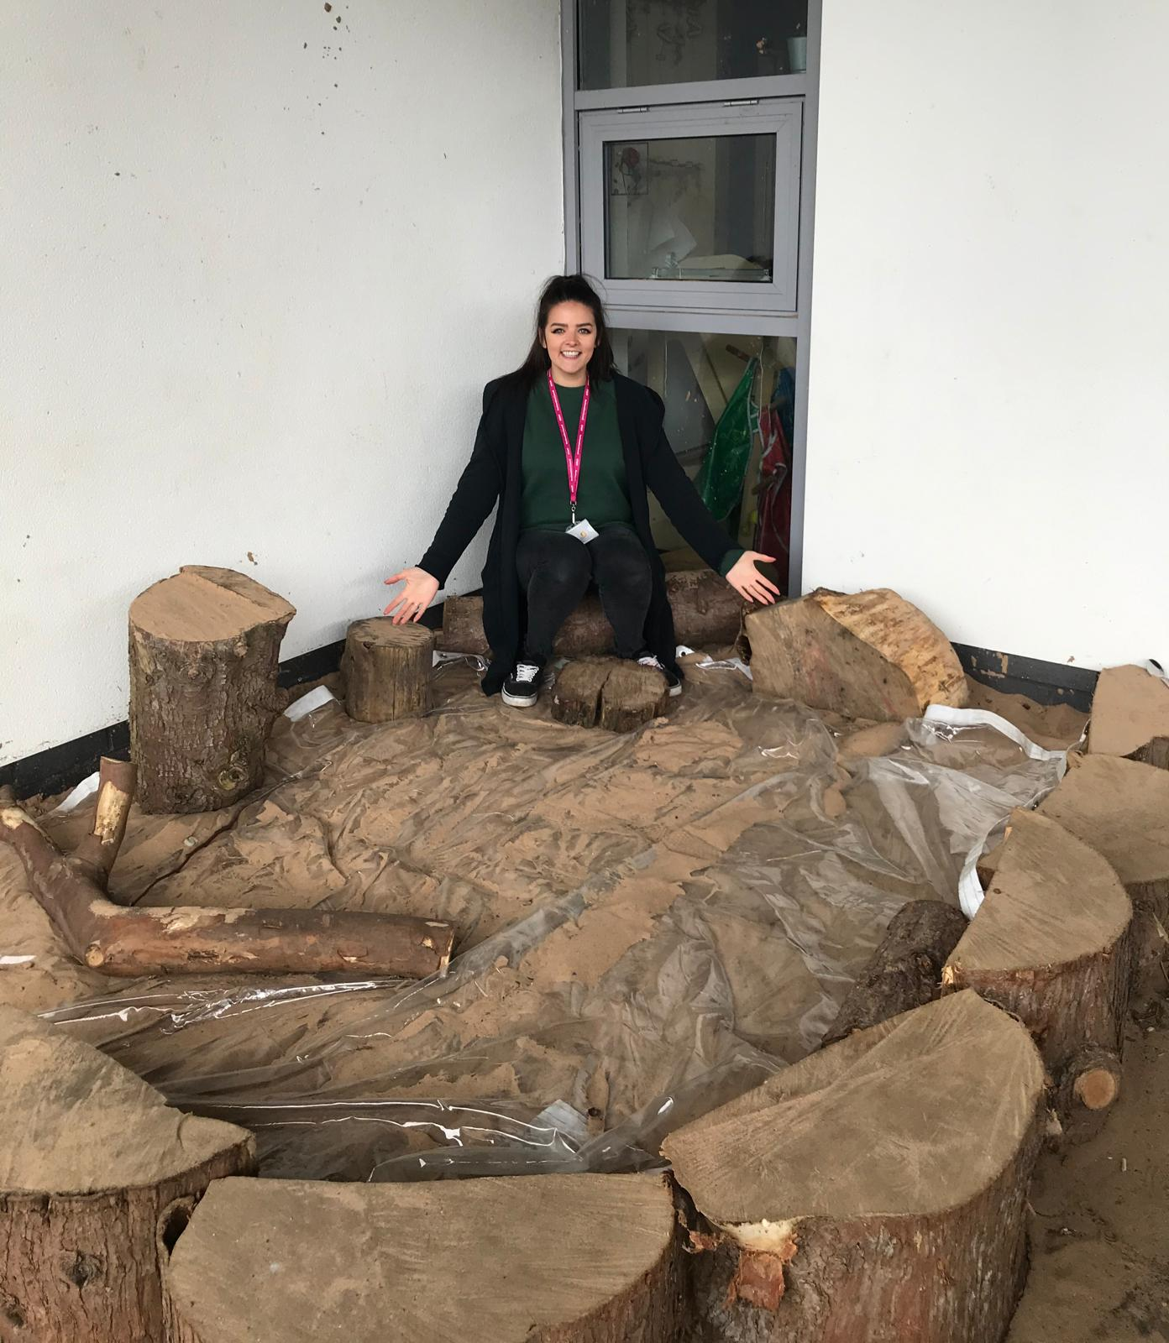
The sand tray is so big!
That’s not my nursery…
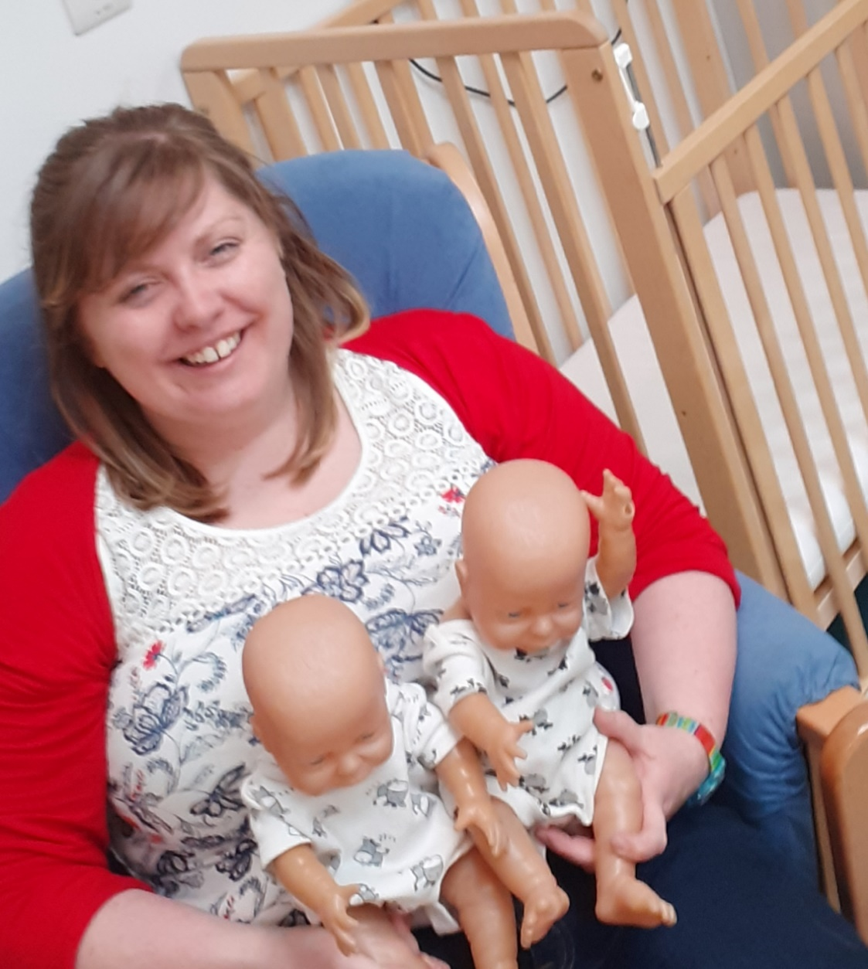
It has a room just for babies!
That’s not my nursery…
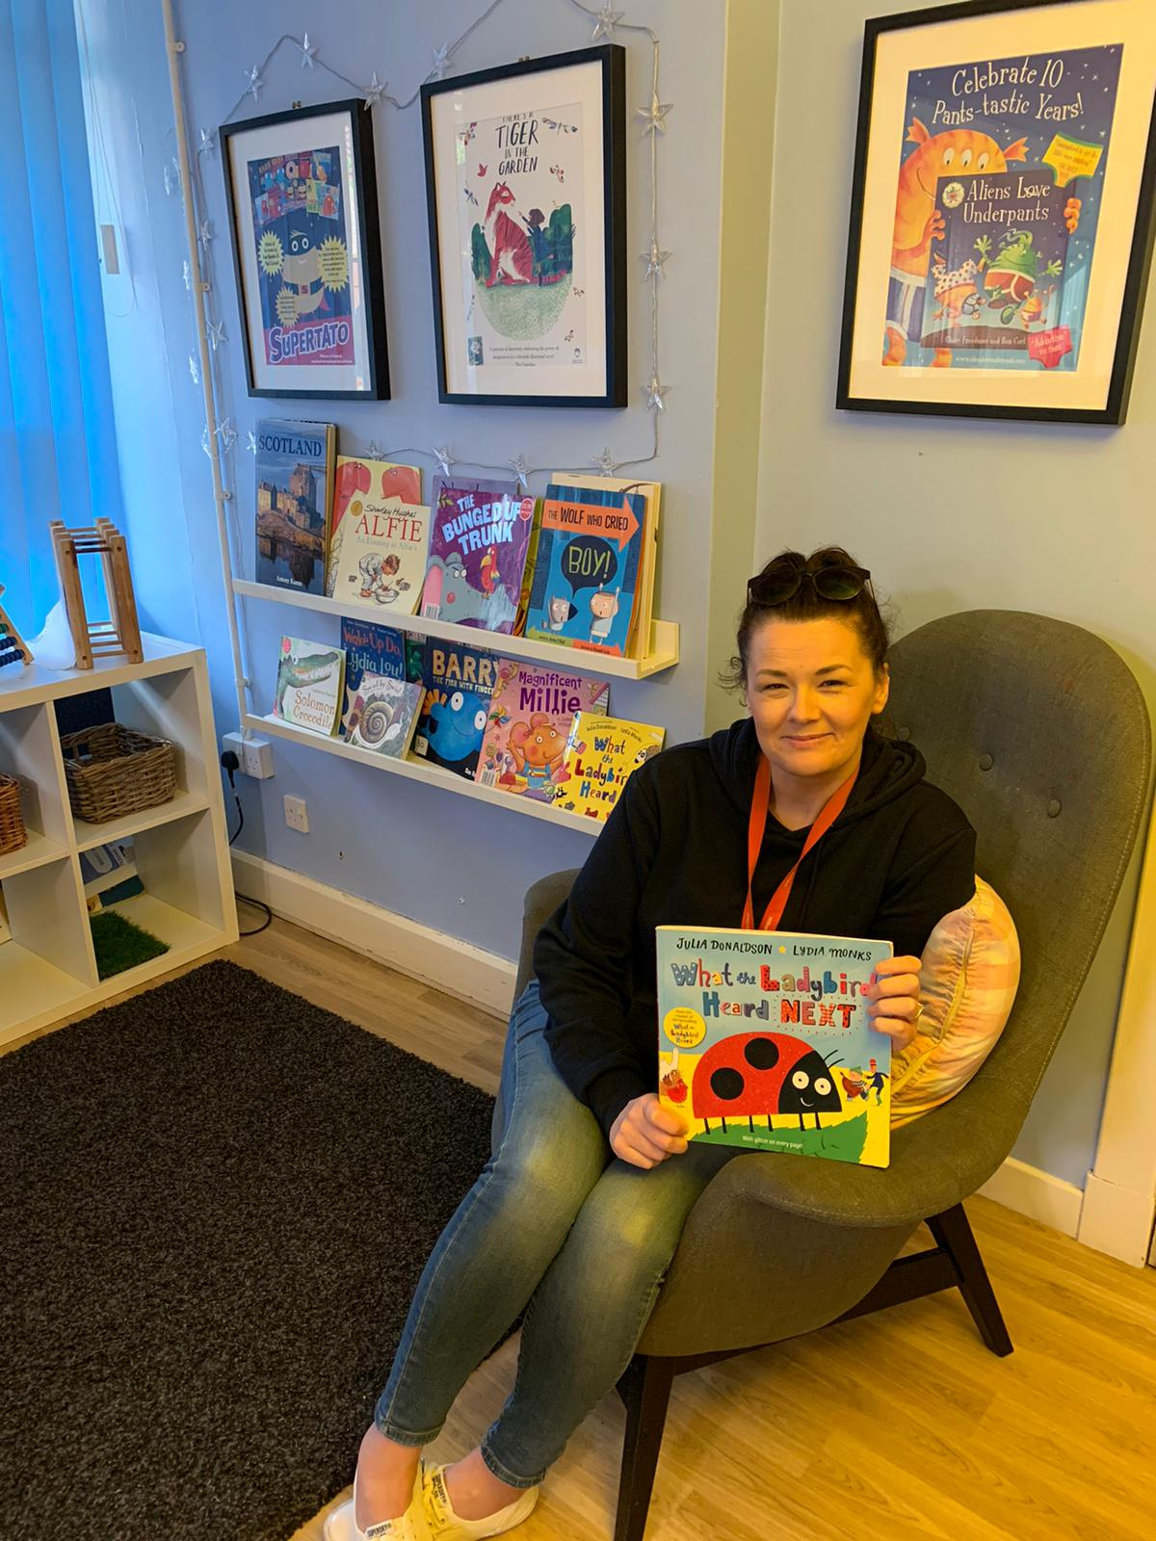
There is no sofa!
That’s not my nursery…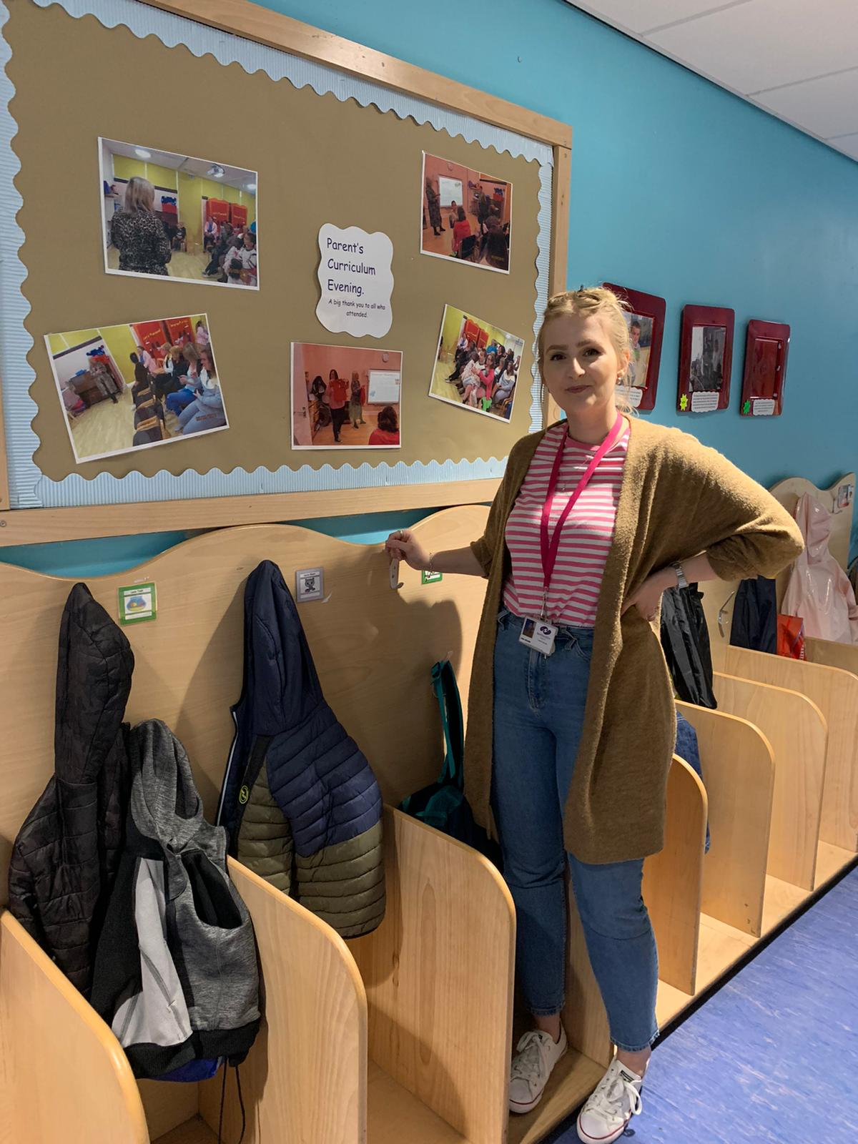
The cloakroom is so big!
That’s not my nursery…
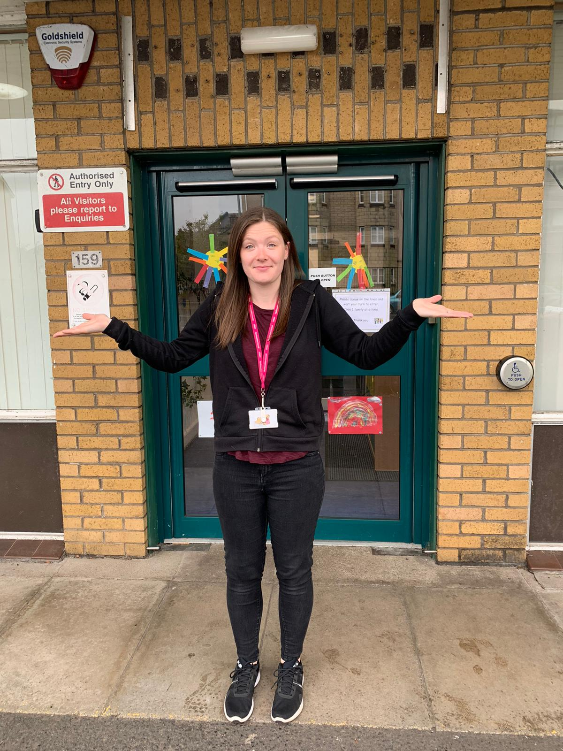
The entrance door is blue!
That’s not my nursery…
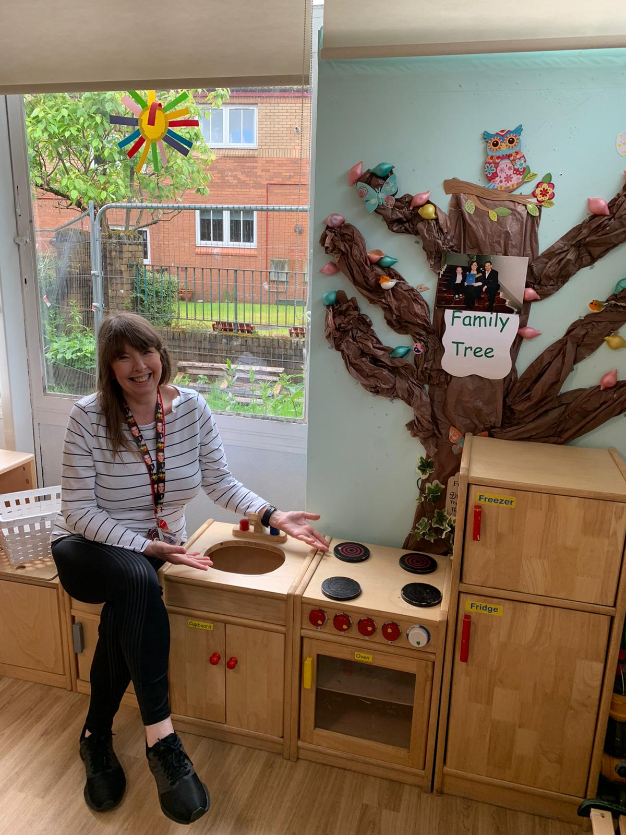
There’s no food to chop!
That’s not my nursery…
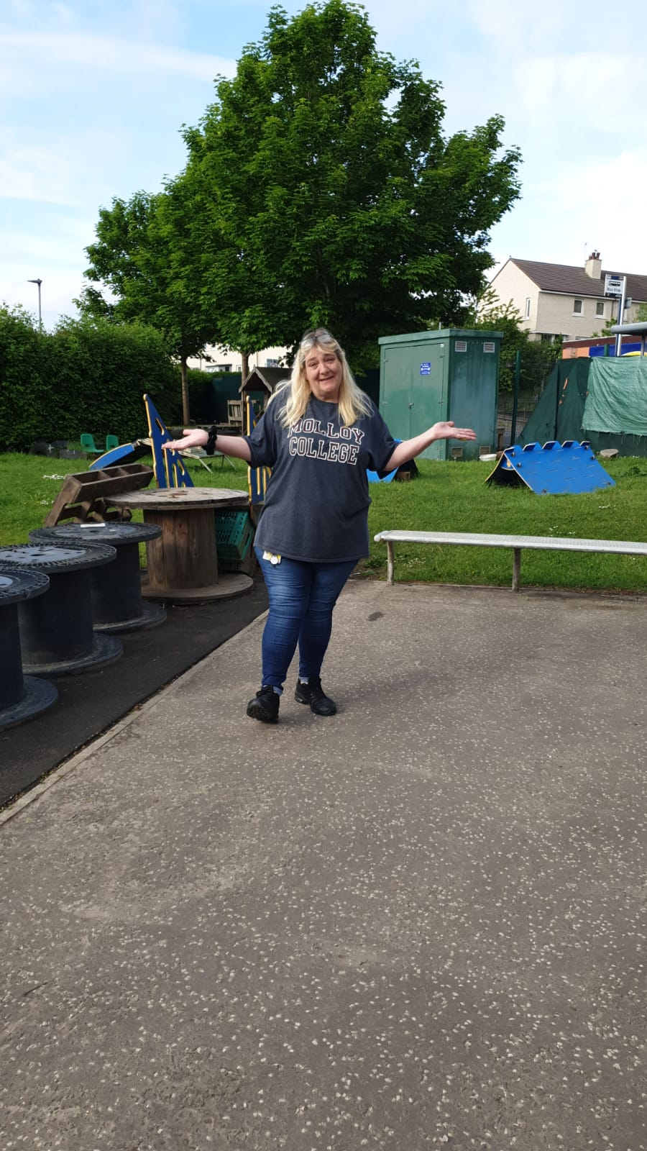
Its outdoor area has no children!
That’s not my nursery…
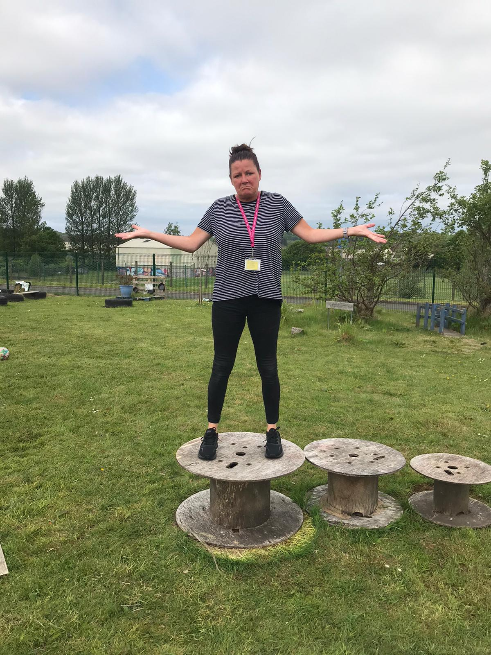
The cable reels are too small!
That’s not my nursery…
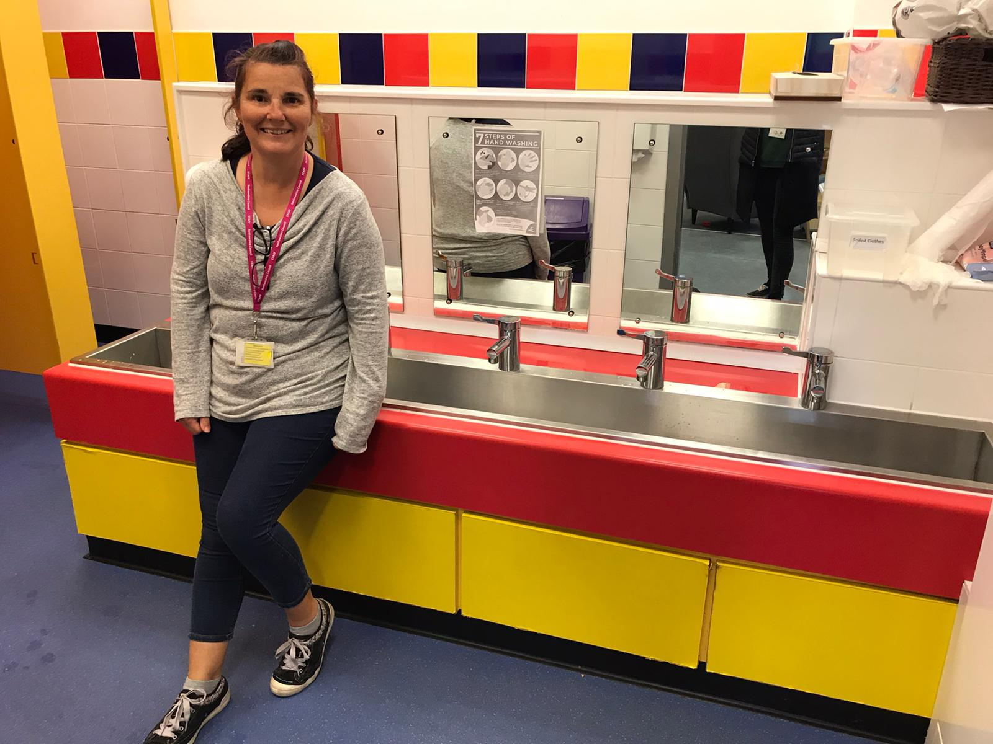
The sink is too shiny!
That’s not my nursery…
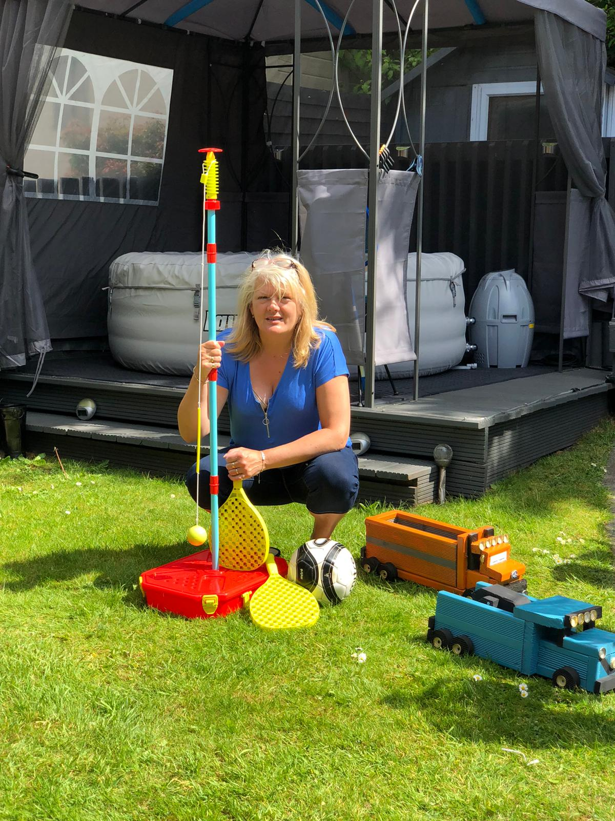
There is no one to play with.
That’s not my nursery…
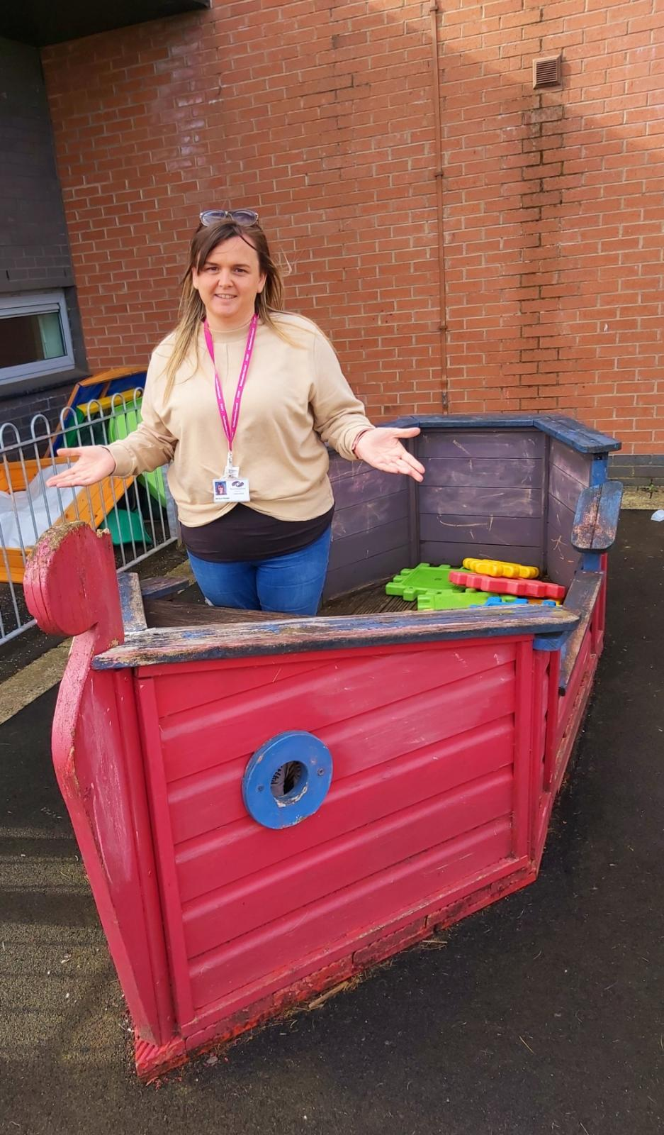
It has a pirate ship!
That’s not my nursery…

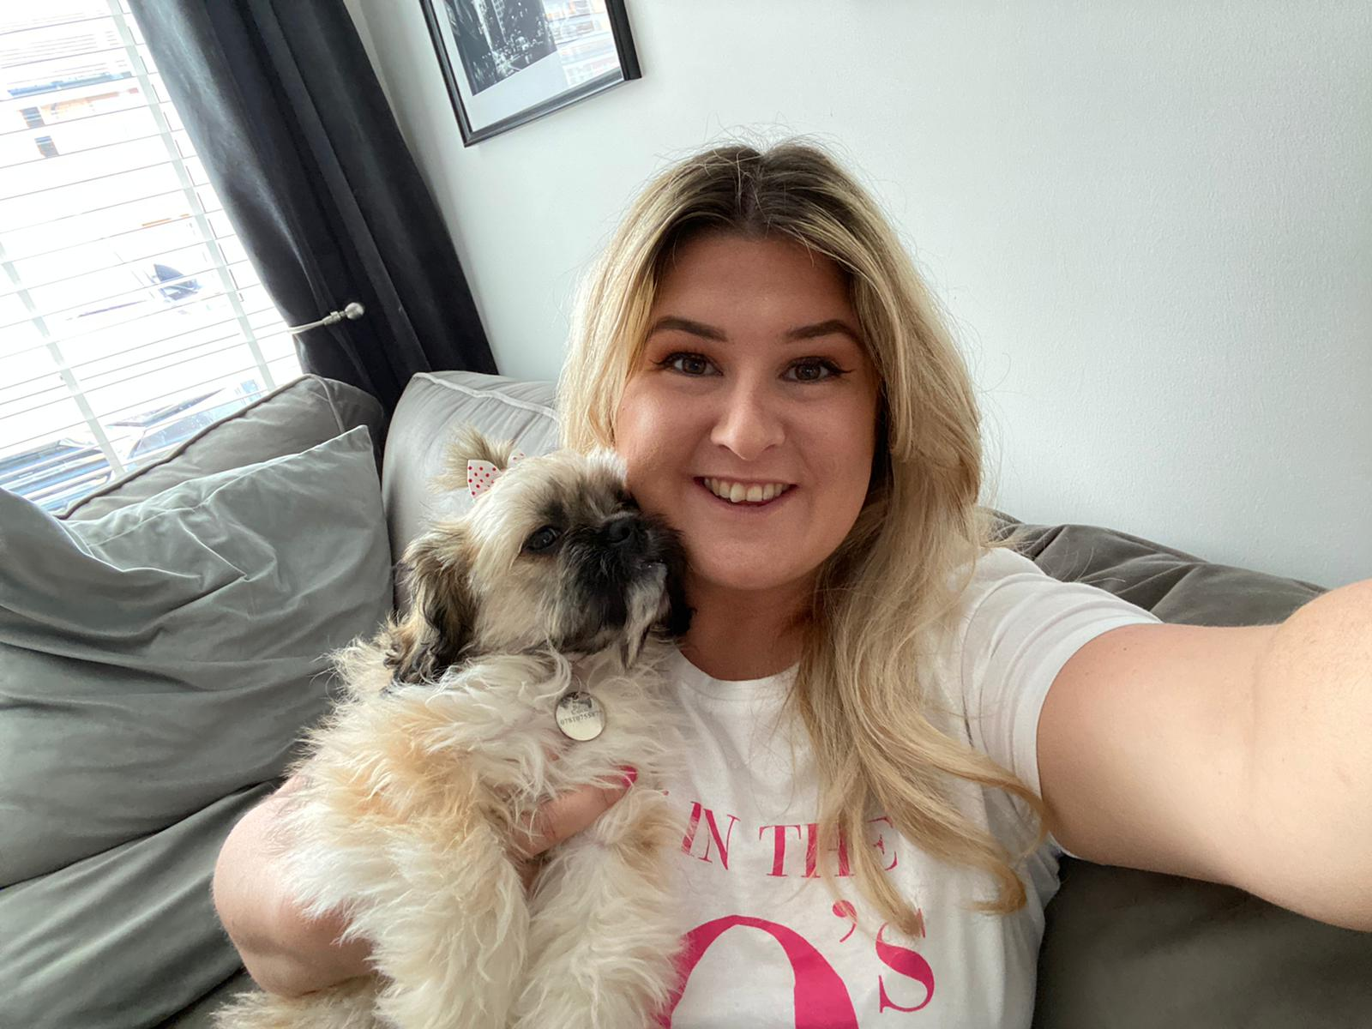

My puppy Coco lives here.

This book is inspired by the Usborne Collection of books.
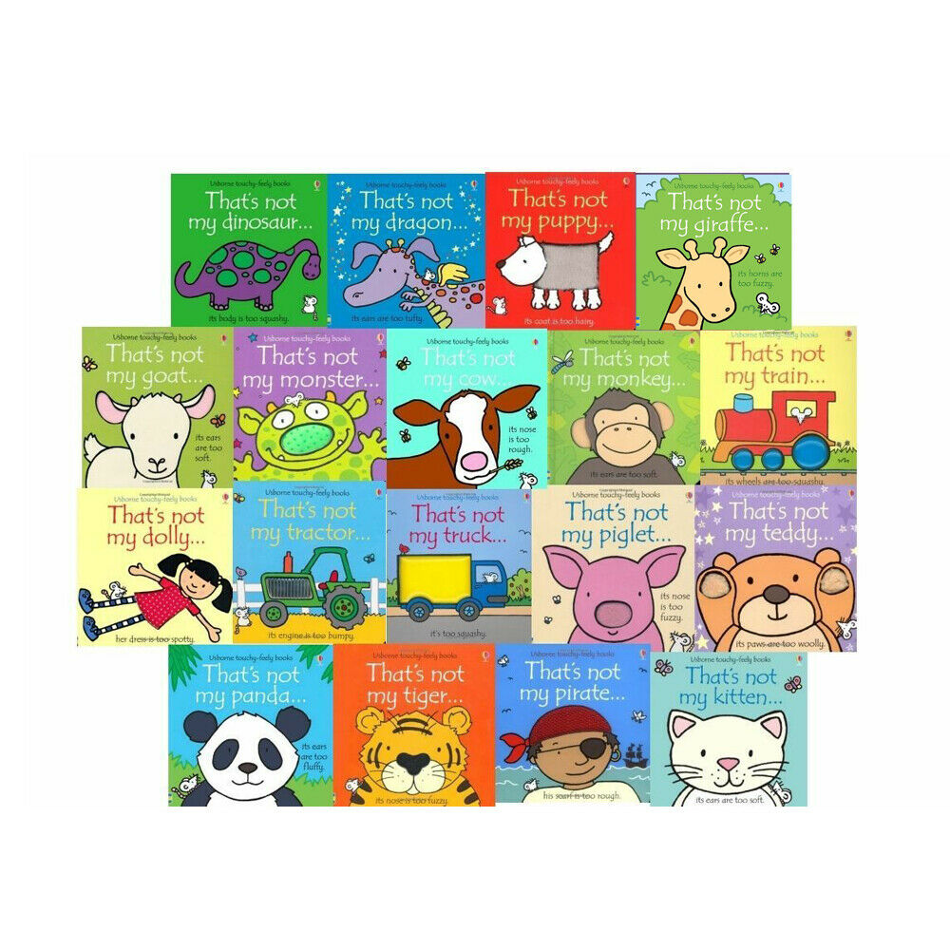

And is dedicated to all the children and families of Williamsburgh Nursery.
From all the staff at Williamsburgh,
We miss you and hope to see you very soon.

