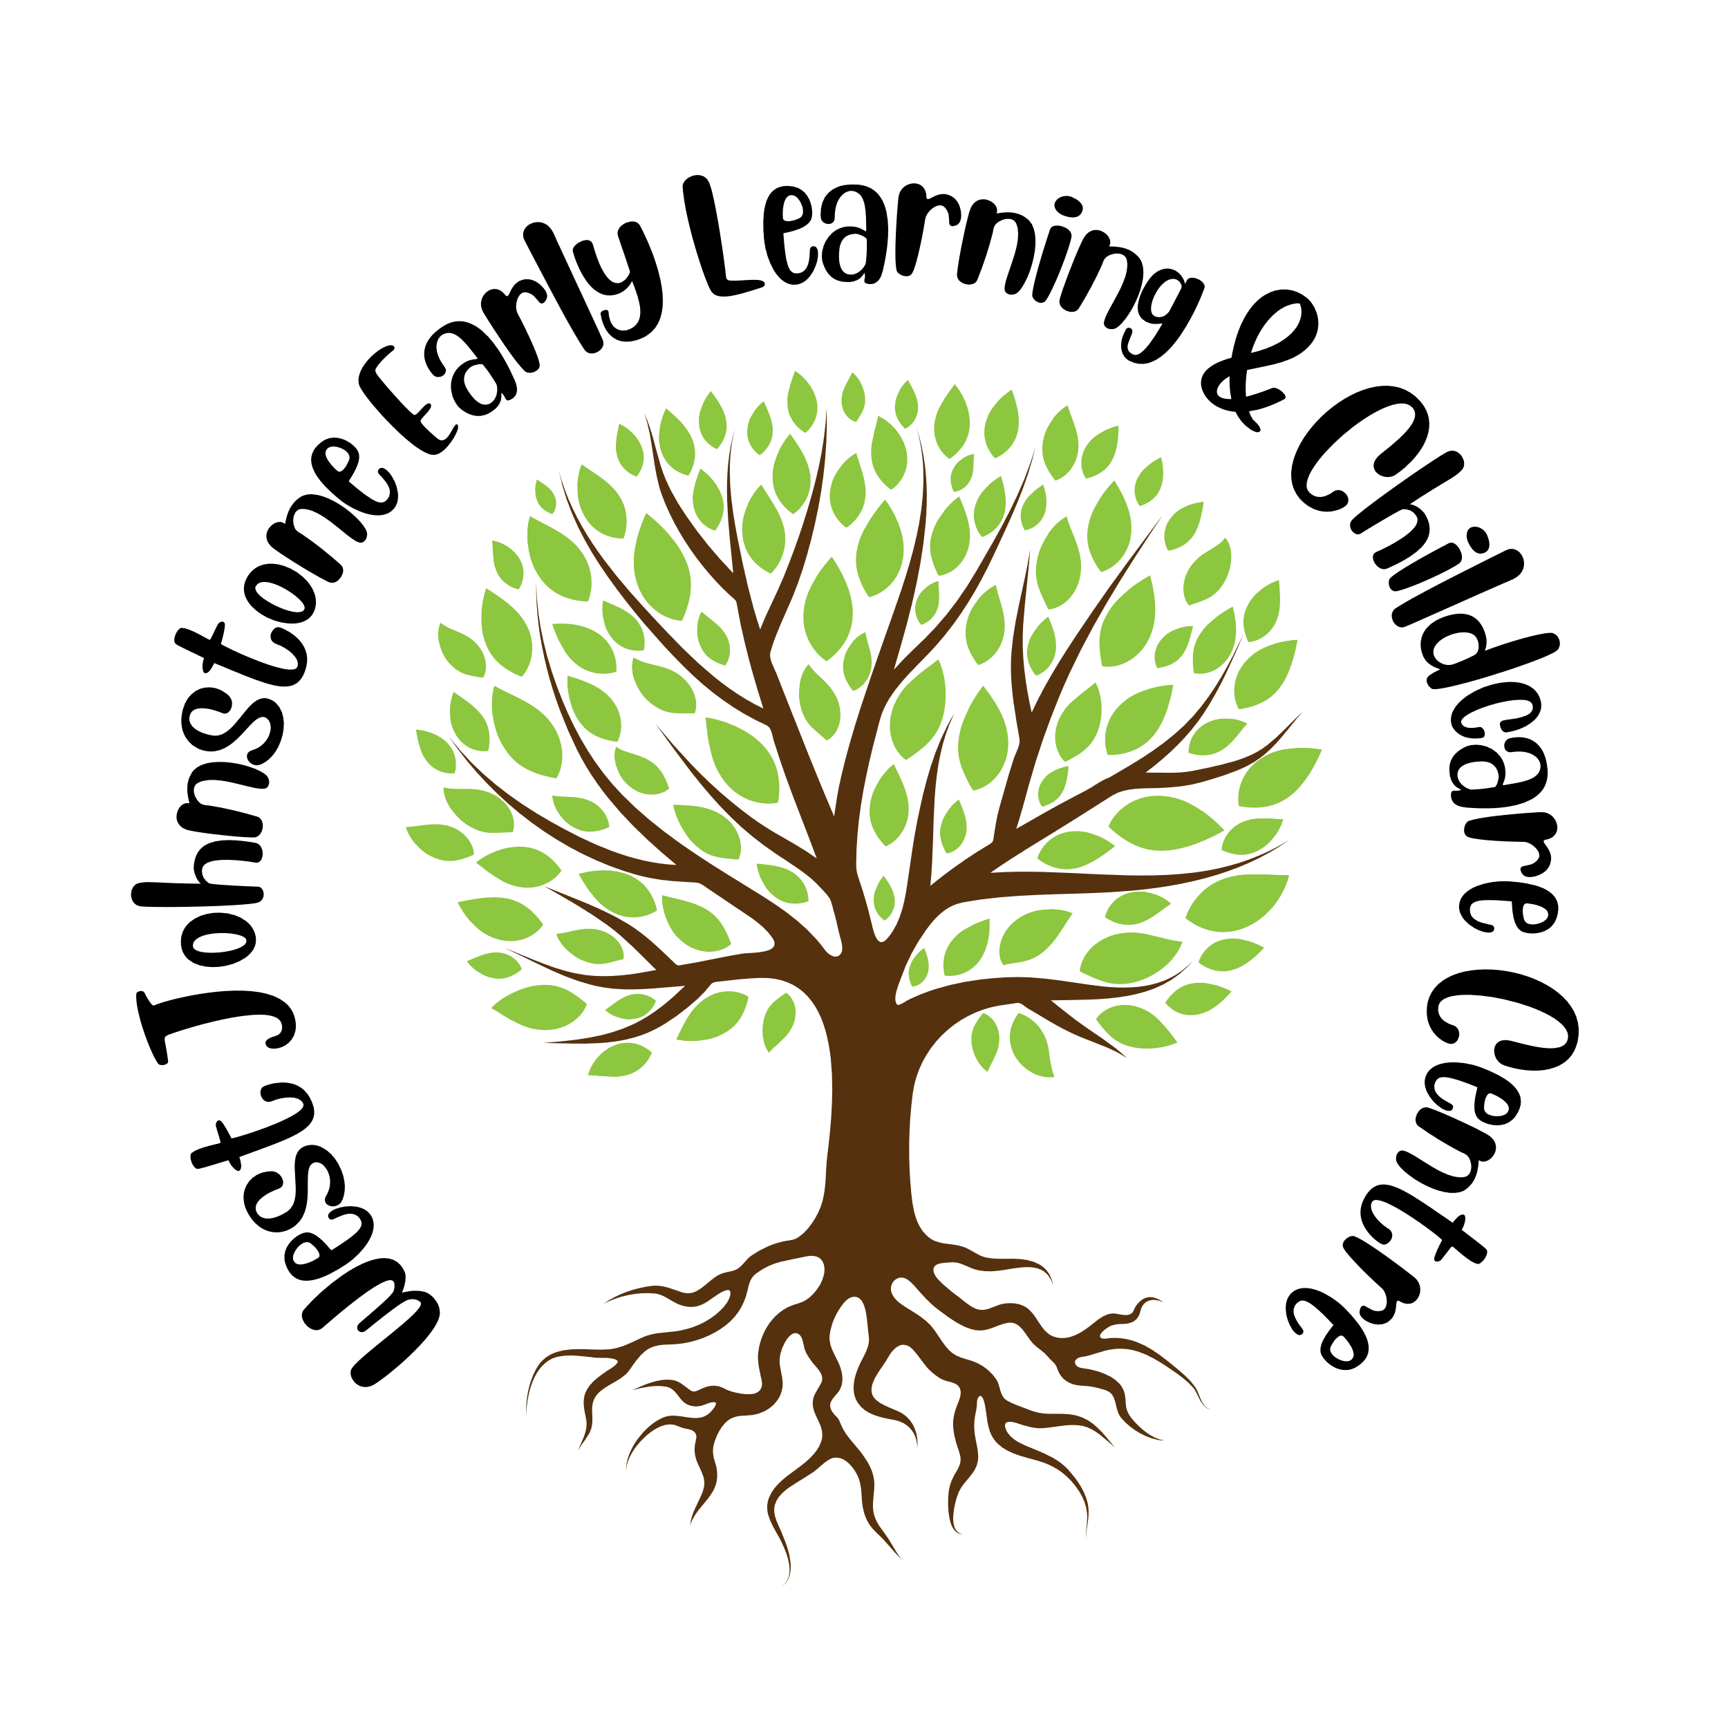

West Johnstone Early Learning and Childcare Centre

Improvement Plan

2025/26

Planning framework

As part of Children’s Services, West Johnstone Early Learning and Childcare Centre has developed this improvement plan to address the needs of our setting in line with the local and national priorities listed below.

**National Improvement Framework Key Priorities**

* Placing the human rights and needs of every child and young person at the centre of education.
* Improvement in children and young people’s health and wellbeing.
* Closing the attainment gap between the most and least disadvantaged children and young people.
* Improvement in skills and sustained, positive school-leaver destinations for all young people; and
* Improvement in achievement, particularly in literacy and numeracy.

**National Improvement Framework 7 Key Outcomes**

* A globally respected, empowered, and responsive education and skills system with clear accountability at every level that supports children, young people and adult learners to thrive. The system enables the development of their knowledge, skills, values and attributes that give them the best opportunity to succeed and contribute to Scotland’s society and economy.
* Young people experiencing the benefit of schools and early years settings working in excellent partnerships with wider children’s services and other partners, families, and communities, in line with the GIRFEC approach.
* Inclusive and relevant curriculum and assessment which gives young people the knowledge and skills necessary to contribute to society, and shape a sustainable future, while celebrating and supporting progression for all.
* High levels of achievement across the curriculum for all learners, with action to close the poverty-related attainment gap.
* Highly skilled teachers and school-leaders driving excellent learning, teaching and assessment for all, especially those with additional support needs.
* Improving relationships and behaviour, and attendance, with increased engagement in learning and a culture of dignity and respect for all.
* An education system engaging in digital technology to enhance all aspects of learning and teaching, supported by a digitally skilled workforce and tackling digital inequality.

**Renfrewshire Council Plan Strategic Outcomes**

Cross cutting theme: Improving outcomes for children and families

|  |  |  |  |  |
| --- | --- | --- | --- | --- |
| We will encourage kind and  connected communities—  where our citizens take pride  in their **place**, attracting  others to move here and  share in the opportunities  Renfrewshire has to offer. | We will support a strong and  flexible local **economy**—with  Renfrewshire able to adapt  after the pandemic, building  up resilience to support good  green jobs and skills for all  local people to enjoy the  benefits of both living and  working here. | We want Renfrewshire to be  a **fair** place—where all our  people have the best chances  to live happy, healthy and  fulfilled lives, to feel safe,  supported and empowered  to unlock the strength of our  collective potential. | We are working towards  a **greener** future—taking  responsibility for our impact  on the planet and taking  brave, bold steps to protect  the natural environment that  supports and benefits us all. | We want our employees  to feel proud to work for  Renfrewshire Council because  we are a **values** driven  organisation, where we all  understand and value our  contributions, and we are  passionate about making a  difference for Renfrewshire. |

**Renfrewshire Council’s Values**

|  |
| --- |
| We are **fair**, we treat each other and everyone we deal with respectfully and work hard to build trust in Renfrewshire Council.  We are **helpful**, we care about getting things right and are always approachable.  We are great **collaborators**; we work as one team and with people who care about this place.  We value **learning** to help us innovate, improve and deliver better services. |

|  |  |  |  |  |  |
| --- | --- | --- | --- | --- | --- |
| **Children’s Services Vision**  Working together to get it right for children, families and communities – protecting, learning, achieving and nurturing | | | | | |
|  | | | |  |  |
| **Renfrewshire’s Education Improvement Plan Priorities** | | | | | |
| **Reduce child poverty in Renfrewshire and improving outcomes for children and families currently living in poverty** | **Place children and young people’s human rights at the heart of the planning and delivery of services that affect them** | **Protect the most vulnerable members of our communities, including children and young people who are at risk** | **Support and nurture our children, families and communities** | **Create the best possible learning estate to allow children and young people to thrive** | **Raise attainment and enhance learning and teaching in an inclusive environment** |

|  |
| --- |
| **Our Vision, Values and Aims** |

Who did we consult?

To identify our priorities for improvement, we sought the views of staff, families, children & partner agencies, we used a variety of methods of getting the views of those who are involved in the life and work of staff communication meetings, self-evaluation activities, discussions with families, key worker meetings and Professional Review and Development sessions.

All information gathered is collated and used to assist us to identify next steps and areas for improvement. The priorities and actions within our plan meet the needs of the establishment and articulate with the local and national priorities.

**How will we know if we are achieving our aims?**

We will measure and evaluate the progress we are making to achieve the key outcomes set out in this plan. We do this using quality assurance activities that include –

* A quality improvement framework for the early learning and childcare sectors: early learning and childcare, February 2025
* Professional dialogue meetings with all staff and Senior Leadership team.
* Analysis of tracking & progress data
* Self-Evaluation and monitoring calendar detailing account of monitoring strategies to be carried out.
* Parent, staff & children consultation
* TAC meetings
* Multi-agency meetings

Each year we also complete a Standards and Quality report and self-evaluation document which are monitored by Renfrewshire Council Children’s Services’ staff.

|  |  |  |  |  |
| --- | --- | --- | --- | --- |
| **Improvement Priority 1 – Improvement in children’s Health and Wellbeing** | | | | |
| **NIF Priorities**  Placing the human rights and needs of every child and young person at the centre of education  Improvement in children and young people’s health and wellbeing  Closing the attainment gap between the most and least disadvantaged children and young people  Improvement in skills and sustained, positive school-leaver destinations for all young people  Improvement in achievement, particularly in literacy and numeracy | | **NIF 7 Key Outcomes**  Develop knowledge, skills, values and attributes to support children and young people to thrive  Excellent partnerships in line with GIRFEC  Inclusive and relevant curriculum and assessment  High levels of achievement across the curriculum with action to close the poverty-related attainment gap  Highly skilled practitioners and leaders driving excellent learning, teaching and assessment  Improving relationships behaviour and attendance with increased engagement in learning  Engaging in digital technology supported by a highly skilled digital workforce & tackling digital inequality Highlight as appropriate | | |
| **Rationale for change** | **Outcome and Expected Impact** | | **Measures** | **Interventions** |
| **RNRA**  During session **2023/24** we embarked on our Renfrewshire Nurturing Relationship Approach (RNRA) with a focus on adult/child relationships and the development of our whole centre nurturing approaches. During this session we have continued to identify an increasing number of children who require support. We therefore want to build on staff knowledge to ensure consistency of practice.  During session **2024/25** it became apparent that many of our ante-preschoolers with significant language and communication needs became dysregulated during daily transitions impacting on their emotional wellbeing. During staff consultation **100%** of respondents agreed that the transition period could be improved. In **May 2025** Inservice day we identified, as a staff team, an approach to small group working to support daily transitions using Bookbug and Attention Builder for session **2025/26.**  Attendance upholds the child’s right to access play and education. Through monitoring of wellbeing overview and weekly wellbeing meetings, staff have Identified target children who’s learning opportunities are impacted by reduced attendance at nursery. Using Emotional Based School Avoidance (EBSA) strategies working alongside our Educational Psychologist we will support parents and carers to identify the barriers impacting attendance and make improvements.  **Family Engagement**  The Scottish Government, as a key priority, draws our attention to improving outcomes for learners, parents, and families. In order to achieve this, we therefore need to ensure there is an ongoing commitment to improving our family relationships and further engage families in their children’s learning, including our Care Experienced children and families in line with “Keeping the Promise”.  This will also offer opportunities for parents/carers to see staff role model positive re-enforcement and co regulating strategies in line with our RNRA focus principle “all behaviour is communication” as this is an area parents fed back that they found challenging.  Due to diversity growing in the Johnstone area attributed to employment and new housing being generated. West Johnstone ELCC has seen an increase in diversity within the setting families from a variety of cultures. To embrace this diversity and offer families representation in our service we will be having a Culture Café once a month for families to attend in our Centre. | By **December 2025**, supporting Nurture Principles to be upheld as part of daily practice at West Johnstone ELCC and we will be striving to meet the wellbeing needs of our children and their families.  By **December 2025,** all staff will be more skilled and have developed a better understanding of the principle all behaviour is communication, reducing frustration levels in children by increasing opportunities to de-escalate and co-regulate making a link between distressed behaviours and what the child is trying to communicate will better enable us (the practitioner/adult) to meet the child’s needs and build more effective communication strategies.  Better managed daily transitions by the introduction of small group working promoting engagement at key transition times at nursery for example, transitioning to lunchtime. By **March 2026** improved wellbeing during daily transitions, will be observed using the Leuven Scale. Demonstrating –   * Improved children’s engagement * Reduced stress and dysregulation * Improved areas of development: vocabulary; listening and attention; confidence with communication.   Parents understand the correlation of good attendance and increased learning achievement alongside social development.  There will be a significant increase in children attendance.  Monthly Family Engagement Forest Events supporting our RNRA Action Plan to involve parents and community more in our children’s learning through play, high-quality interactions and improve overall wellbeing for families saw a 60% increase in families attending events. By December 2025 we hope to see an increase to 95% of our families attending through targeted support.  Building and establishing positive, trusting relationships with families. Keyworkers come along to events, so parents always have a familiar face to improve parental engagement. Inclusive of our Care experienced families upholding the values of “The Promise”.  Families from all cultures will attend and share different foods from their culture and develop an awareness of the different cultures represented at West Johnstone ELCC.  Increase parental engagement throughout the centre. Parents gain knowledge of the importance of songs in rhymes in building vocabulary. | | * Data recording of incidents where distressed behaviours and its impact on other service users are significantly reduced. * Staff feedback during wellbeing & planning meetings. * Feedback of staff knowledge during Core Group. * RNRA Action Plan and evaluation processes, leading to further accreditation. * Staff observation using Leuven Scale. * Wellbeing Wheels.   Dialogue during planning and wellbeing meetings.   * Attendance increases for identified children. * Wellbeing web achievement score increases for baseline assessment for identified target children. * Progression Toolkit. * Questionnaire to parents to establish knowledge of importance of attendance. * Absence diary recording children’s non-attendance * Feedback from parent questionnaire shared via social media. * Feedback from parents – questionnaires relating to impact these have had at home. * Wellbeing webs demonstrate an increase in areas such as nurtured and achieving as children are accessing nursery more ready to learn. * Attendance and feedback Forest Family Events. * Parents feedback in person and parental questionnaire. * Monitor attendance and manage barriers to attending sessions. * Feedback from parents – questionnaire or verbally | * Relationship Policy with working group. * RNRA Action Plan for session 2025/26 * Working/Steering Group within Centre for RNRA role modelling change within playrooms. * Small group working with children in our 3-5 room to support with daily transitions * During session 2024/25 in consultation with our Educational Psychologist we have continued to develop staff knowledge on nurture principles to deepen their approaches to nurturing relationships with a particular focus on the “all behaviour is communication” principle through in-service days and in house training events. * Attention builder approach and Bucket time Stage 1 and Stage 2Divided group - taking small group for focus on attention, listening and communication. * Reducing the number of transitions supports regulation – nurture principles. * Using concrete objects of reference and visual/signs all support communication and structure. * Bookbug – for all children. * Continue to work alongside Renfrewshire Educational Psychological Services EBSA programme with locality Educational Psychologist supporting attendance. * Bespoke session times for children/families who need support to attend. * Raise the profile of children’s right to access play and education by improving children’s attendance. * Support attendance through a flexible approach to placement hours tailored to meet family’s needs where we can provide this. * Calls/texts to home for non-attending children. * Support from new family support workers supporting families across the campus. * Wellbeing HomeLink Bags to support parents with wellbeing strategies and co -regulation at home. * This will be included in our RNRA Action Plan for 2025-26. * Colour Monster Emotion Bags to go home will be made by staff. * Notices on room door and social media prompting parents to ask for HomeLink wellbeing support. * Family Engagement working Group, led by our 2 Senior ELCO’s, meet once a term to evaluate engagement, identify barriers and feedback from parents ensuring the service is meeting their needs. * Range of Family Forest Events. * Monthly Bookbug Sessions Space - use of parents rooms to hold Bookbug sessions. * Invite to parents sharing when these sessions will be running. * At the end of Session 2024/25 3 members of staff have completed Bookbug training and will be running Bookbug sessions within our centre. This will offer families to attend these sessions during their nursery day and reduce cosy of travel as they will be held within the centre |
| **Improvement Priority 2 – Continue to raise levels of attainment across the curriculum with a priority focus on literacy & numeracy** | | | | |
| **NIF Priorities**  Placing the human rights and needs of every child and young person at the centre of education  Improvement in children and young people’s health and wellbeing  Closing the attainment gap between the most and least disadvantaged children and young people  Improvement in skills and sustained, positive school-leaver destinations for all young people  Improvement in achievement, particularly in literacy and numeracy | | **NIF 7 Key Outcomes** (see page 2 for full descriptors)  Develop knowledge, skills, values and attributes to support children and young people to thrive  Excellent partnerships in line with GIRFEC  Inclusive and relevant curriculum and assessment  High levels of achievement across the curriculum with action to close the poverty-related attainment gap  Highly skilled practitioners and leaders driving excellent learning, teaching and assessment  Improving relationships behaviour and attendance with increased engagement in learning  Engaging in digital technology supported by a highly skilled digital workforce & tackling digital inequality Highlight as appropriate | | |
| **Rationale for change** | **Outcome and Expected Impact** | | **Measures** | **Interventions** |
| **Literacy**  Our Early Years Progression Tool data has highlighted where a high percentage of our returning children are in early stages of literacy milestones.   * **91%** of returning children were showing early stages of letter recognition * **85%** of returning children showing early stages in syllable recognition and rhyme * **85%** if returning children showing early stages of drawing and mark making and describing what mark means.   We will focus on these identified milestones as a main area for improvement to strengthen early literacy experiences and outcomes across the Centre.  **Pedagogical Approach**  During session **2024/25**, as a staff team, we embarked on documentation training with Dierdre Grogan from Strathclyde University. This led to a streamlining of planning and evidence collecting which will continue into session **2025/26** ensuring consistency of the delivery of high quality learning and development opportunities for all children.  **Numeracy**  Our Early Years Progression Tool data has highlighted where a high percentage of our returning children are in early stages of numeracy milestones.  **85%** of returning children were showing early stages of touch & counting objects to 10, with number recognition.   * **91%** of returning children showing early stages number recognition to 5 without counting   We will focus on these identified milestones as a main area for improvement to strengthen early numeracy experiences and outcomes across the Centre. | By **October 2025** and **May 2026** our literacy data will evidence measurable progress for children within identified milestones. By **October** **2025** we will see a **20%** reduction across early stages with a further **30%** reduction in **May 2026.**    Data collated will allow for early interventions and planning for individual needs and learning styles.  By **October 2025** and **May 2026** our numeracy data will evidence children’s progress within identified milestones.  By **October 2025** will see a **20%** reduction across early stages with a further **30%** reduction in **May 2026**.  Data collated will allow for early interventions and planning for individual needs and learning styles.  By **October 2025** and **May 2026** our numeracy data will evidence children’s progress within identified milestones. By **October 2025** will see a **20%** reduction across early stages with a further **30%** reduction in **May 2026.**  Data collated will allow for early interventions and planning for individual needs and learning styles | | * SMT will collate data which will be recorded within our ‘Tracking of Children’s progress’ floor book. * Keyworker tracking & progression meetings October 2025, February 2026, May 2026. * Keyworker tracking & progression meetings **October 2024, February 2025, May 2025.** * Weekly wellbeing & planning meetings, professional dialogue with staff. * Monitoring of documentation children’s profiles, floor books, planned &spontaneous observations. * Keyworker tracking & progression meetings **October 2024, February 2025, May 2025.** * Weekly wellbeing & planning meetings, professional dialogue with staff. * Monitoring of documentation children’s profiles, floor books, planned &spontaneous observations. | * Learning zones will promote familiar and new vocabulary with a particular focus on syllables, rhymes, storytelling and mark making. * **Block play** – Designing maps, mark making opportunities, skilled questioning from practitioners, visible print. * **Staff training** – Boog bug and talk for writing. * Identify another 2 practitioner leads whom will engage with Talk for Writing approach and lead within the playroom. * **Resources -** Nursery will make own resources such as story stones, resources linked to stories & characters, Rhyming dices etc. * **Communication Cottage –** this area will be utilised for small group focusing on offering challenge or support in literacy and numeracy where appropriate. * **Talk for Writing –** our approach to Talk for Writing will enable our children to mark make for a variety of purposes. * In-house training on Quality Indicators from “A Quality Improvement Framework for the Early Learning and Childcare Sectors”. * Pedagogy/curriculum working group led by HOC will discuss progress at termly meetings. * monitoring calendar. * Staff training in new evidence collecting/sharing process within floorbooks and children’s learning journal.   Learning zones will promote number confidence and increase use of mathematical language.  **Block Play**   * Small world play to encourage number recognition and one-one correspondence and how many objects * particular focus on use of mathematical language of more than, less than   **Outdoors**   * Meaningful play experiences such as water/sand play – measuring. * Transient art * Mud Kitchen. * Further research on purposeful use of turf trays.   **Baking/snack/sharing games**   * Counting out objects |

|  |  |  |  |  |
| --- | --- | --- | --- | --- |
| **Improvement Priority 3 – Actively develop leadership at all levels to improve the overall capacity of the setting, in particular learning, teaching and assessment.** | | | | |
| **NIF Priorities**  Placing the human rights and needs of every child and young person at the centre of education  Improvement in children and young people’s health and wellbeing  Closing the attainment gap between the most and least disadvantaged children and young people  Improvement in skills and sustained, positive school-leaver destinations for all young people  Improvement in achievement, particularly in literacy and numeracy | | **NIF 7 Key Outcomes** (see page 2 for full descriptors)  Develop knowledge, skills, values and attributes to support children and young people to thrive  Excellent partnerships in line with GIRFEC  Inclusive and relevant curriculum and assessment  High levels of achievement across the curriculum with action to close the poverty-related attainment gap  Highly skilled practitioners and leaders driving excellent learning, teaching and assessment  Improving relationships behaviour and attendance with increased engagement in learning  Engaging in digital technology supported by a highly skilled digital workforce & tackling digital inequality Highlight as appropriate | | |
| **Rationale for change** | **Outcome and Expected Impact** | | **Measures** | **Interventions** |
| **Leadership of learning**  Throughout session **2024/25** we experience staff changes – with new staff starting at the Centre and existing staff requesting room changes or change of learning zone identified through dialogue with SLT regarding their professional development.  SLT identified that to promote best opportunities for staff and provide a consistent high-quality service further training would need to be accessed affording staff to develop new skills and knowledge within a new age group or learning zone.  **Sharing Leadership of learning**  In **January 2025** we piloted sharing learning stories from each learning zone across all age ranges online through our closed Facebook group. In **March 2025** we saw an increase of **50%** of parents/carers commenting on children’s learning and nursery life, sharing wider achievements and extending learning at home. We plan to continue this into session **2025/26**. | Staff would be confident in leading an area of focused improvement – developing their learning zone and/or working with a new curriculum framework.  Enhance staff knowledge, understanding & skills set through training opportunities.  continually improve on practice.  Empower & motivate staff to feel confident within their role.  Overall improved outcomes for children and families.  Achieve consistency of practice across all the Centre.  By **May 2026** we would like parental engagement to rise **50%** to **80%** with parents/carers having a shared understanding of learning taking place in our setting and can replicate and extend this at home.  Parents/carers will have an awareness of the skills their child is learning at nursery, and an awareness of their child’s stage of learning development. | | * Minutes from planning meetings. * Feedback from in-house training/other training opportunities accessed by staff and leadership team. * CPL paperwork updated at PRD meetings demonstrating staff progression. * Monitoring of learning floorbook * Parents/carers sharing learning at home and wider achievements. * Parent/carer online questionnaires. * Floorbook evidencing feedback from parents on learning being shared. * Parents feedback in person and parental questionnaire. | * Sharing of practice inhouse and across the local authority. * Fortnightly planning meetings. * Opportunities to visit other Centre’s and share practice – professional dialogue, coaching and modelling. * A learning story for each learning zone is generated once a month by staff members. * Learning story for each learning zone is posted on Facebook Closed Group once a month by SLT. * SLT collate feedback from parents/carers, and this is added to a Floorbook to evidence learning shared with parents. |