

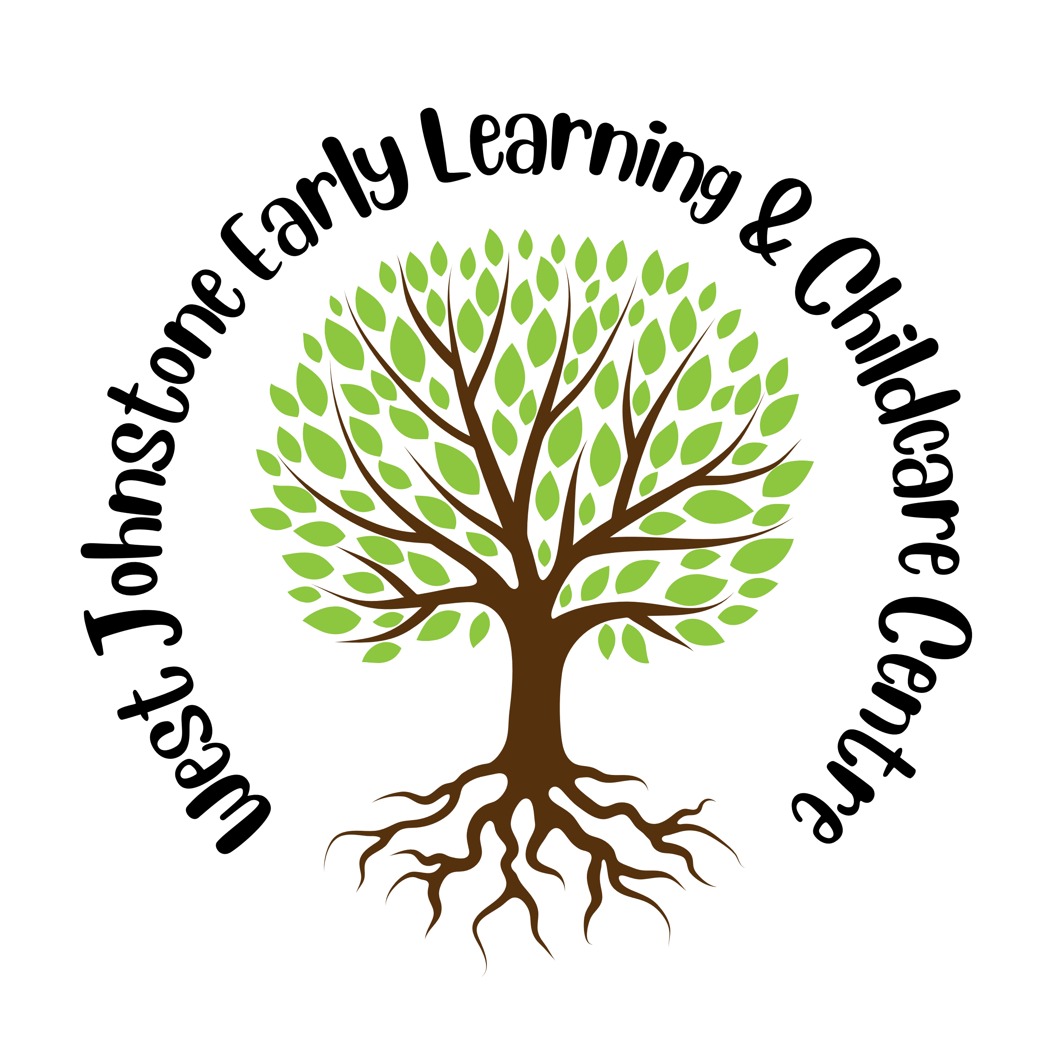

|  |
| --- |
| West Johnstone Early Learning & Childcare Centre |

|  |
| --- |
| STANDARDS AND QUALITY REPORT  June 2025  This report will inform you of our progress and achievements in the last session and let you know about our plans for 2025-2026. I hope that you find it helpful and informative.  Head of Centre  (Elaine Stevenson) |

|  |
| --- |
| **OUR CENTRE**  West Johnstone Early Learning and Childcare Centre (ELCC) is a local authority childcare provision situated within a purpose-built building which also consists of 2 Primary Schools and an Adult Learning Centre. We are registered with the Care Inspectorate to provide education and care for 89 children at any given time. 56: 3-5 -year-olds, 24: 2-3-year-olds and 9:0-2-year-olds. Our children attend ELCC provision for 50 weeks a year, 8.00am – 6.00pm through a variety of different attendance patterns.  The staff team comprises of a Head of Centre and a Depute Head of Centre, 2 Senior Early Learning and Childcare Officers, 1 Graduate Practitioner, who form the Senior Leadership Team (SLT). There are 15.5 Early Learning & Childcare Officers and 5 Support Workers. All staff are registered with the Scottish Social Services Council (SSSC). The staff team all have roles to play in the continued development of the Centre and undertake leadership positions in different areas of the Centre which we are very proud.  Our Centre offers play spaces and experiences which support children’s learning and development. We have open plan access to large garden areas and provide quieter spaces which children can access throughout the free flow of the nursery day. We aim to support and challenge children as they grow through providing a safe and inclusive environment  As a Centre we continuously look at ways to gather the views of our children, families, and staff to ensure there is a shared vision which focuses on improvements and outcomes for all children and their families.    Our Improvement plan takes account of local priorities alongside those in the Scottish Government National Improvement Framework (NIF). As a Centre we strive to further enhance achievement and attainment and ensure we promote respectful, supportive relationships between children, staff, and parents.  The priorities and actions within our 2024/25 Improvement plan focused on meeting the needs of all children and supporting every child to achieve their best outcomes. Our identified priorities for improvement were:   * **Priority 1**: To improve our children’s health and well-being through effective multi-agency planning, upholding, and embedding the rights of the child. * **Priority 2**: Continue to raise levels of attainment across the curriculum with a priority focus on literacy & numeracy. * **Priority 3**: Actively develop leadership at all levels to improve the overall capacity of the setting. |
| **OUR VISION, VALUES AND AIMS** |
| **SUCCESSES AND ACHIEVEMENTS**  Celebrating success and achievements are an important part of our Centres ethos and helps to maintain motivation and commitment to continuous improvement.  During 2024/2025 we are delighted with the success we have achieved and the impact this has had on creating a high-quality learning provision for our children, families and staff. At West Johnstone Early Learning & Childcare Centre we believe our approach to success and achievement focuses on creating a play-based nurturing, stimulating and engaging environment where children can develop holistically.  We emphasise strong communication and collaboration between practitioners, children, families and colleagues across the authority.  **Sharing practice and approaches**       * **Celebrating of RNRA In May:** At West Johnstone ELCC we opened our doors to practitioners from across the local authority to share with them our RNRA approach to promoting Renfrewshire’s Inclusive Communication Environments (RICE). This event allowed us to showcase our Centres nurture-based approach using RICE principles. Feedback from all attendees was very positive and indicated they would be implementing strategies of good practice gained from their visit within their own setting.   Eco Schools Green Flag Award with Merit   * **The Green Flag Award:** During session 2024-2025 we were successfully awarded with our Eco-Schools Green Flag award. This is an excellent achievement which recognises our commitment to learning for sustainability.      * **Forest Families:** During session 2024 – 2025 we have seen an increase in family engagement, in particular, attendance at our Forest Family events. As a Centre we believe our families and community are at the heart of our children’s learning and thus inspires us to look for innovative and inclusive ways for everyone to engage in. Events through out the session have included “An afternoon with the Gruffalo”, as well as “A magical Christmas”, “Easter crafts” and meet and greet sessions.     **Scotland’s Finest Woods awards**  Schools and Early Years Awards ...  We were delighted to announced winners of the 2025 Scotland’s finest Woods Awards early years category. This award clearly identifies all the hard work our Centre has done to build a strong connection with our local woodlands and local community.  The work carried out by the staff and children continues to be acknowledged by Strathclyde University as excellent practice, with examples of play and provision used regularly to support training events. |

|  |
| --- |
| **HOW SUCCESSFUL HAVE WE BEEN IN IMPROVING OUR CENTRE/NURSERY?**  Celebrating success and achievements is an important part of our Centres ethos and helps to maintain motivation and commitment to continuous improvement.  During 2024/2025 we are delighted with the success we have achieved and the impact these have had on developing our Centre.  **Improvement Priority 1 – To improve our children’s health and well-being through effective multi-agency planning, upholding, and embedding the rights of the child.**   * During session 2024/25 we continued to strive to meet the wellbeing needs of all our children and families and continue our Renfrewshire Nurturing Relations Approach (RNRA) journey. We have developed a whole Centre nurturing approach in line with the principle “All Behaviour is Communication” staff have become more skilled in delivering a nurturing approach, responding to children’s needs with empathy and insight by understanding this principle. * All staff participated in in-service training delivered by our Educational Psychologist on the Nurture Principle “All Behaviour is Communication” impact of this training has increased staff’s ability to respond to and support children more effectively, and role modelling positive reinforcement and co-regulation for parents/carers.      * Staff continue to use visual timetables, “Now and Next Boards”, Choice Boards, and Attention Builder with targeted groups of children to support and extend communication, listening and attention and to support children with daily transitions and therefore having a positive impact on lunchtimes by making these a more calm and sociable experience for children. Visual timetables have been introduced to main areas within all our playrooms to support children to use these independently or easily access to reduce stress and anxiety around daily transitions. Strategies are now being replicated and implemented within our Forest Kindergarten Approach offering continuity across our setting. * Creating a physical environment enhances and promotes opportunities for speech, language, and communication for all children by continuing to use RICE Principles.   A picture containing text, indoor  Description automatically generated A picture containing person, indoor, floor, person  Description automatically generated A child looking at a blue wall  Description automatically generated A sign on a tree  AI-generated content may be incorrect.  In line with United Nations Convention on the Rights of the Child (UNCRC) all staff at West Johnstone ELCC believe that children’s rights are central to their everyday practice and our approach to Getting it Right for Every Child (GIRFEC) continues to be at the heart of our practice and ethos for our Centre. To make children’s rights more visible across our Centre we:   * Continue to show commitment to upholding the values of “The Promise” and ensure our care experienced children and families are included within an environment that fosters dignity, respect and belonging. Our Head of Centre continues to raise awareness to all staff of current and new legislation relating to The Promise. During session 2024/25, In line with Keeping the Promise, we have held several family forest events. These were very well attended and enjoyed by all and has resulted in improved relationships with our families. In February 2025, to highlight the first 5 years of Renfrewshire’s Approach to Keep the Promise, we held a Gruffalo Forest Event, in which 100% of our care experienced children & families attended.        * Family engagement, we believe plays a crucial role in our children’s overall learning & development. At West Johnstone we ensure to create and maintain meaningful relationships between ourselves and our families to support children’s overall wellbeing and learning. During session 2024-2025 we have seen a vast increases in family engagement through our closed Facebook group discovering that parents have preferred to respond digitally. This has demonstrated a 50% increase in families commenting on children’s learning and nursery life with a further 25% of families sharing their children’s wider achievements and learning.     **Improvement Priority 2 – Continue to raise levels of attainment across the curriculum with a priority focus on literacy & numeracy.**  At West Johnstone   * We continued to use Renfrewshire Early Level Progression tool as a method of collating quantitative data to record children’s progression and identify gaps in areas of learning. Our most recent analysis of data evidenced improved progression within literacy & numeracy between May 2024 and May 2025. There was a **58%** increase within numeracy and a **49%** increase within literacy of children making progress across the year. Qualitative data ranging from floor books, children’s individual profiles, observations, planning meetings and professional judgement has contributed to ensuring more effective assessment of children’s progress provides us with vital holistic information for all children.      * We continue to provide attractive, well-resourced and well-planned spaces to ensure our learning environments both indoors and outdoors promote high-quality experiences for all children. Learning zones within the Centre were revisited and consideration given to meeting the needs of individual children. Each learning zone comprises of well-resourced areas which children can access independently, supporting them to consolidate and extend their learning.      * We have further embedded our “Talk for Writing” approach” which has provided our children with opportunities to develop literacy capacities including marking their stories, expressing their ideas through texts and talking to staff and peers about their scripts. We are very enthusiastic about this approach as it allows our children to develop the ability to be creative with their writing’s drawings story mapping and expressive language.       **Improvement Priority 3 – To actively develop leadership at all levels to improve the overall capacity of the setting**   * **Strategic Leadership Sharing Practice Event:** Both Head of Centre and Depute Head participated in the Early Learning and Childcare Strategic Leadership Sharing Practice event giving them the opportunity to showcase their practitioner enquiries sharing their research journey and the impact of this change with colleagues across the authority. The research carried out by both Head and Depute highlighted the importance of continuing lifelong professional learning and the positive impact this can have on the quality of learning experiences and outcomes for our children & families.      * We continue to secure children’s progress holistically and have re-established leadership working groups, with staff who are passionate in driving the vision of the centre forward. * Head of centre has been involved in developing the Aspiring Head Teacher training for the Local Authority.This opportunity allowed her to share her skills and knowledge on how to build leadership capacity within the learning environment.   In line with United Nations Convention on the Rights of the Child (UNCRC) all staff at West Johnstone ELCC believe that children’s rights are central to their everyday practice. To make children’s rights more visible across our centre we:   * Have created a UNCRC working group formed o Senior Leadership Team and staff who ensure communications to children and families are inclusive and ensure children have daily opportunities to express their feelings and talk about their learning. * We uphold the UNCRC principles identified by our working group and ensure these are visible throughout the Centre, on wall displays and within our floor books. |

|  |
| --- |
| **KEY STRENGTHS**  **Forest Kindergarten Approach**  At West Johnstone Early Learning & Childcare Centre our approaches and links to the forest and outdoor environment continue to be key to supporting and nurturing our children’s curiosity. Our Forest Kindergarten full day approach, children attending a full day session in the forest from 9.00am to 3pm, is now embedded within our centre and has been running consistently for 4 years. Each year with different groups of children have the freedom to explore, play and learn in natural outdoor spaces.  **Forest Families**   * We have had another successful year inviting our families to our Forest Family sessions. During the sessions families spend time together, exploring the woodland area and engage in a variety of forest experiences such as reading, investigating, tree climbing, den building, relaxing in the hammock and arts & crafts using natural resources. Families who attend are not only forming and strengthening closer relationships with each other, they have opportunities to meet up with other families within their community.     **Collaborative approaches to self-evaluation**   * Senior Leadership Team (SLT) continue to ensure that our vision statements for the Centre fosters innovation, motivation and underpins continuous improvements. A variety of approaches and strategies such as self-evaluation meetings, in-service training, questionnaires, floor book, wall documentation and verbal dialogue are utilised. We monitor our vision statement through self-evaluation meetings, verbal dialogue, looking inwards to identify our improvement priorities and evaluate performance and looking outward to learn from parents, staff and relevant agencies. * As part of our monitoring processes in January 2025 we decided to look monthly at a cross section of Learning Stories from each learning zone across all age ranges. This allows us to collect data to ensure we are offering breadth and balance of curriculum and identify gaps in learning. Learning is the shared with parents via our closed Facebook group affording them the opportunity to continue and extend learning at home and gain knowledge of the learning taking place the Centre.     **Happy, Welcoming Ethos/Communication Rich Environment**   * We have continued to seek feedback from children, parents and staff, alongside relevant agencies and visitors to our Centre. Returned questionnaire demonstrated that 100% of the parents, who returned the questionnaire, are satisfied with the service and learning taking place. Equally, questionnaires sent to other agencies and partners demonstrated 100% satisfaction with the service and interventions/strategies jointly taken forward. * A key strength of West Johnstone ELCC is the focus we place on the individual learning needs and styles of all children and the intervention and approaches we take to support their care, play and learning. Each child’s progression is discussed with key workers and staff to ensure gaps in learning are identified and actioned. Partnership working with other agencies such as Speech & Language has allowed staff to incorporate language & communication programmes into their daily practice as well as changes required to the physical environment. * The professionalism of our staff is a key strength within our centre. Throughout session 2024-2025 staff have engaged in in-house training events as well as training from visiting services including Educational Psychologist, Nurture Principles, Dierdre Grogan, Documentation and Early Years Teacher, Circle Document Training. The impact being that staff have enhanced knowledge, skills and confidence which has lead to more informed responsive and reflective planning, directly benefitting children’s learning and wellbeing. |

|  |  |
| --- | --- |
| OUR NEXT STEPS – PRIORITIES FOR 2025-26  We have made very good progress during session 2024-25 and we will use the improvement priorities listed below to build on this progress moving forward.   * Continue on our RNRA and RICE Accreditation journey, creating a new action plan for session 2025/26 and embed this throughout our Centre’s life and work. This will promote a consistent, whole Centre approach to a nurturing and inclusive communication environment. Building on previous progress to achieve accreditation demonstrating commitment to high quality practice. * Continue to raise attainment through our holistic learning approaches, striving to close the attainment gap and improve outcomes for all our learners and their families. * Continue to improve family relationships through HomeLink experiences and support, parents’ groups and utilising services to support our parents through adult learning services. * Continue to strive for improvement through staff development opportunities, utilising training identified as part of our Professional Review and Development process which support the quality of the learning provision and the knowledge, skills, development and confidence of staff. * Continue to involve staff in monitoring and evaluating processes by looking at a Learning Stories from each Learning Zone to ensure breadth and balance of Curriculum design.   Full details of the improvement priorities and actions are detailed on the establishment improvement plan which can be accessed via our website or on display in our Family room. | |
| **West Johnstone ELCC**  **West Johnstone Shared Campus**  **Beith Road**  **Johnstone**  **PA5 0BB**  **0300 300 1474**  [**https://blogs.glowscotland.org.uk/re/westjo/**](https://blogs.glowscotland.org.uk/re/westjo/)  **@westjohnstoneelc**  **West Johnstone Early Learning and Childcare Centre – Facebook Closed Group** | **HAVE YOUR SAY!**  Please take the opportunity to share your thoughts with us as we use feedback to help us make improvements to the Centre/nursery. You can do this by speaking to staff, participating in parent/carer meetings, responding to questionnaires/surveys and by completing evaluations at events. |