
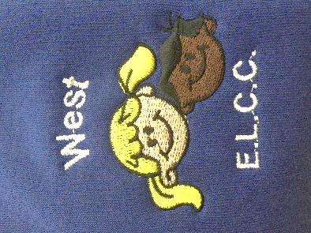

A warm welcome to
West Early Education and Childcare Class.
We hope your association with us will be a happy one.



Mrs McGinn
Mrs Wiszniewski

Mrs McGinn is the Head Teacher of the School and Nursery. Mrs Wiszniewski is the Depute Head Teacher for Early Years and has responsibility for the day-to-day running of the Nursery.

West ELCC Family Team

At West Early Learning and Childcare Class our Family team consists of a Pre-5 Senior Early Education and Childcare Officer, an Early Years Graduate, four Early Education and Childcare Officers and a Support Worker to assist with school lunch.


Ms Russell

Ms Russell is our Acting Pre-5 Senior Early Education and Childcare Officer and is very experienced practitioner. Mrs Russell has responsibility for day-to-day organisation of the nursery and ensuring effective learning for all children. She has a responsibility to monitor that staff plan and provide a safe, secure, and stimulating learning environment for the children in our care. Ms Russell also ensures that policies and procedures are always adhered to for the protection of children and staff.
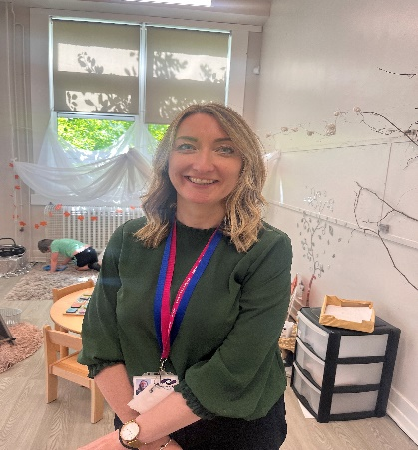

Mrs Harding

Mrs Harding is our Early Years Graduate. Her role is to ensure that all children are accessing high quality learning and teaching experiences within the nursery setting. Her remit includes taking a lead in promoting parental involvement in the nursery and she works alongside our Parent Committee. She also supervises and supports training/development activities for the nursery staff team. Mrs Harding also takes responsibility for the implementation of new local and national initiatives in Early Education and Childcare as required.

West ELCC Family Team

Mrs McIntosh, Mrs Simpson, Mrs Haggerty and Miss Jones are our Early Education and Childcare Officers. Miss Donachie is our Early Education and Childcare Support Worker. Our team, with their wealth of experience, will nurture and care for your child as well as working in partnership with yourself, to enable your child to grow and develop their interests and skills.

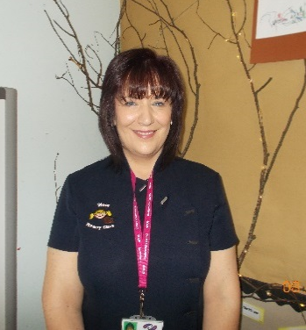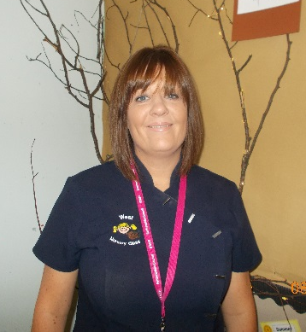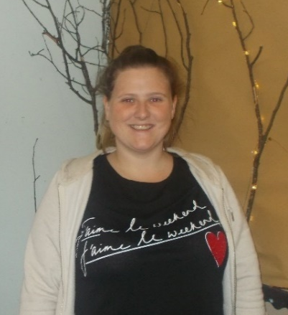
Mrs Haggerty
Mrs Simpson
Mrs McIntosh




Miss Donachie
Miss Jones

At West Early Learning and Childcare Class, we have characters which represents our Vision, Values and Aims.


Vision

This is Captain West and her moto is:

“Where Everyone Succeeds Together”

Values & Aims

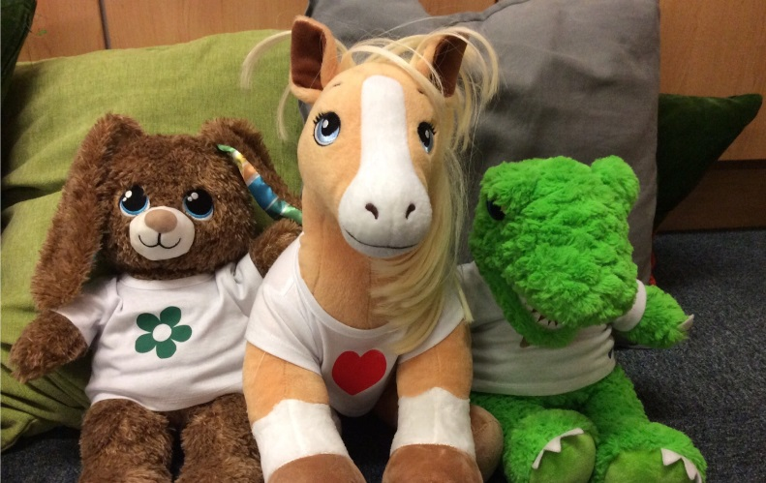

Trust T-Rex
Respect
Rabbit

Honesty
Horse



West Early Learning and Childcare Class
West Early Learning and Childcare Class provides 32 places for children aged 3 - 5 years. Our daily hours to accommodate 1140 hours are 8.50am to 2.50pm.

Application forms for a nursery place are available online from the Renfrewshire Council Website. Our school office will also be happy to assist you with this. Parents may register an application for their child from the age of 2 years.

Admission to Nursery
Nursery class provision is non-denominational. Placement in the nursery class does not guarantee a place in the primary school if a placing request is necessary. All Renfrewshire nursery classes adhere to the Council’s Admission Policy and all applications are dealt with in line with this policy.

The school’s nursery class is a member of the local Admissions Panel, which is made up of nearby St Mary’s ELCC, Hugh Smiley Nursery, Maxwellton Park Partnership Nursery, Abbey Partnership Nursery and Wallace ELCC. All Early Learning and Childcare applications are discussed at a meeting of this panel, following the Admissions Policy, and agreement about the allocation of places is made by the members. Parents will receive notification when their child is allocated a place and information will accompany this about starting dates and times.

Early Learning and Childcare Entitlement
All three and four-year-old and some two-year-old children are eligible to up to 1140 hours of free funded early learning and childcare per year. The expansion in hours is intended to support child development, help close the attainment gap through the provision of high-quality service; and support parents and carers to return to work, train or study.

All children aged 3 and 4 are eligible for an early learning and childcare place, with three-year olds becoming eligible as follows:

Birthday | Eligible Month
March, April, May, June, July or August 2024 | August 2024
September, October, November or December 2024 | January 2025
January or February 2025 | April 2025

This information can be found on our website here; Who-can-get-free-nursery-places-or-childcare

Register of Applicants
A register of applicants will be kept in the establishment. Please note the length of time a child’s name has been on the register will not affect the child’s priority for admission. Parents can ask to see their application form at any time.
If your circumstances changes, please notify West ELCC as soon as possible.

Purchasing Wraparound Care
Parents can access wraparound care by purchasing additional sessions or additional hours before or after their child’s funded early learning and childcare entitlement, to support employment, training, or education. Access to wraparound care is dependent on the availability of places in Renfrewshire Council’s Early Learning and Childcare Centres and Classes. Parents should contact the establishment and complete an ‘application for wraparound care’ if you wish to be considered for this. The Deputy Head of West ELCC will inform you of the current fee rate and of any concession available.
Further information can be found here; Pay for additional hours of nursery or childcare (wraparound care) - Renfrewshire Website

Arrangements for Entry
Arrangements for entry, induction meetings for parents, home visits prior to entry, key worker interviews are in accordance with the Admissions Policy guidelines and are explained when a place is offered.

The Curriculum

Our Aim is to provide an Educational, Friendly and Supportive learning environment that encourages every child to achieve their full potential.

At present, there are 8 main components in the early level of Curriculum for Excellence. The playrooms are set up to support these 8 curricular areas and ensure all children have an interesting and stimulating time at Nursery. We have a great focus on literacy, numeracy and health and wellbeing across all areas within our nursery in order to help raise attainment in all children within West Early Learning and Childcare class. We strive to provide each individual child with opportunities to ensure the best start in their educational journey.

How We Promote Learning
At West Early Learning and Childcare Class we use our skills to observe children and decide when to intervene through play and learning. We support and encourage children’s learning by:

- understanding and treating every child as an individual
- embracing children’s individuality and tailoring learning to their needs
- knowing how each child learns and valuing their individual learning styles
- providing a free-flow learning environment indoors, outdoors and beyond
- developing skills for learning, life and work
- being responsive to children’s needs, learning and interests
- ensuring depth of learning is explored through invitations and provocations
- providing open-ended resources such as block play and loose parts to promote curiosity, exploration, discovery and creativity
- inspiring every child to reach their full potential
- celebrating children’s achievements and provide appropriate praise and encouragement for all efforts

Staff use information given by parents to help extend learning at home and develop interests. They work in partnership with parents and families to ensure we provide a collaborate approach between home and nursery.

Curriculum for Excellence
Within the nursery active learning is an appropriate way for children to develop vital skills and knowledge to foster a positive attitude to learning.

Within our setting, we aim to challenge children’s thinking using real life and imaginary learning. Children take the lead in their own learning journeys which is supported when necessary by staff through sensitive intervention that supports or challenges children to extend their learning.

We aim for children to develop in all 4 capacities by becoming:

- Successful Learners through use of imagination and creativity, tackling new experiences and learning from them. Developing important skills including literacy and numeracy through exploring and investigating while following their own interests.

- Confident Individuals through succeeding in their activities, having the satisfaction of a task accomplished, learning about bouncing back from setbacks, and dealing with risk safely.

- Responsible Citizens through encountering different ways of seeing the world, learning to share and give and take, learning to respect themselves and others, and taking part in making decisions.

- Effective Contributors through playing together in leading or supporting roles, tackling problems, extending communication skills, taking part in sustained talking and thinking, and respecting the opinion of others.

In order for each individual child to engage, develop and successfully achieve at a level that best suits them, the staff are responsible for developing an area within the nursery setting. We ensure every child is given experiences based around their interests that can also support and challenge them. We strive to provide children with experiences that develop skills for life-long learning throughout all our areas.

West ELCC Environment
Our Early Education and Childcare class consists of 3 different experiential areas.

Area 1

Area 1 consists of self-select arts and crafts, junk modelling,
a large sandpit, loose parts play and home corner.

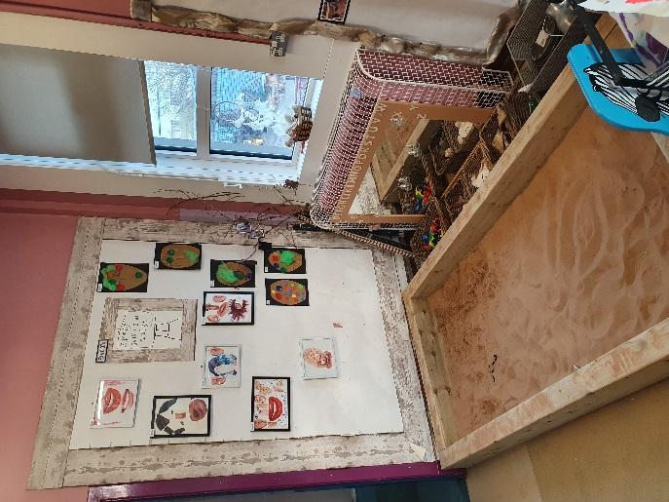
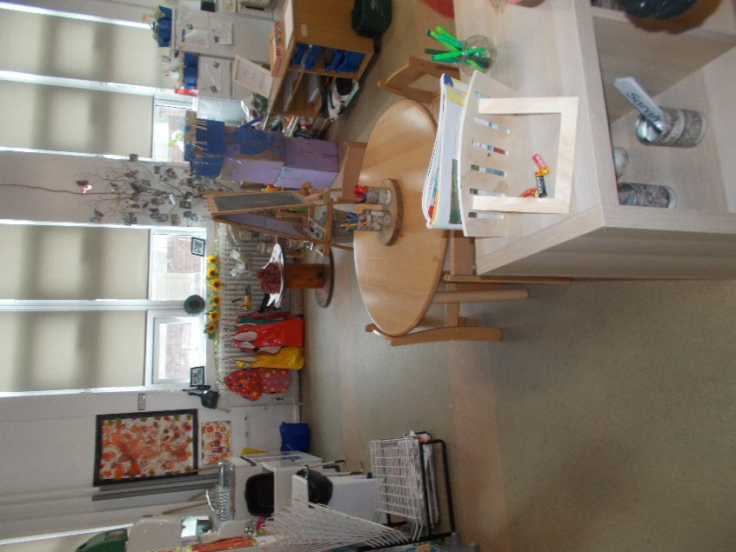

This area provides a range of artistic materials for children to explore at their own leisure. There are plenty of opportunities for children to explore their world, spark their creativity and improve their imagination. With the range of open-ended resources, the children can invent, construct, modify, evaluate, and see solutions in their own ideas with the support of an adult if required. With the addition of loose parts, it provides limitless play and learning opportunities. It brings a sense of excitement and adventure to children’s play as they indulge in their own world of imagination.

This area promotes multiple opportunities for children to get lost in their own world. They can explore real and imaginary situations through role-play, story books and even through creating their own stories. Children can explore real life materials such as food, utensils and a variety of dressing up. Through this range of play, children can make sense of their world.

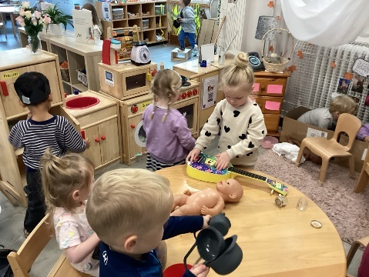
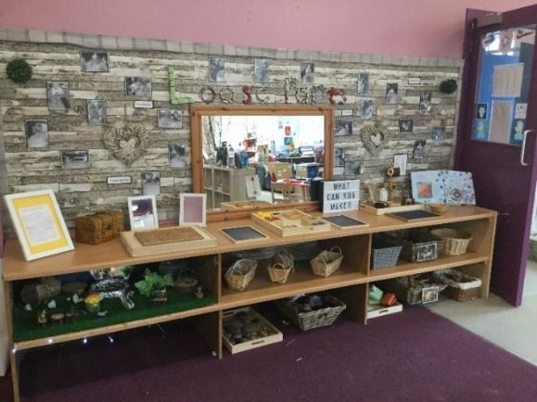

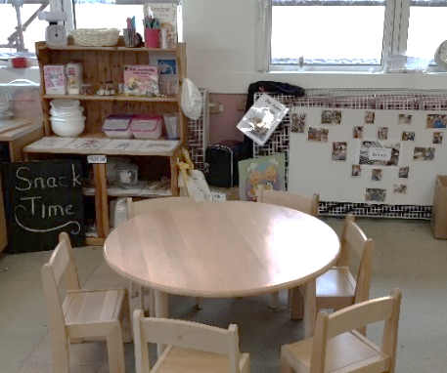
Area 2

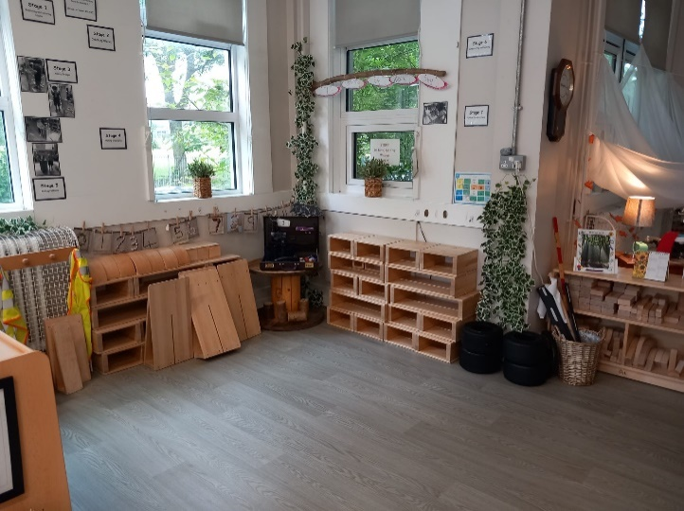

Area 2 consists of snack, DIY baking and block play.

The DIY baking area provides children with a range of skills and knowledge for life-long learning. They are encouraged to listen and follow instructions, follow a recipe, develop communication skills, turn-take and share, risk assess, develop mathematical language, build upon their fine and gross motor skills, have a feeling of empowerment, and most importantly have fun!

This area also provides a full range of opportunities for children to explore, investigate and enhance their curiosity. It offers quality open-ended, creative and valuable play and learning experiences for all children. The open-ended resources include block play and loose parts to allow children to think imaginatively and see solutions plus extend or enhance their play and learning. It brings a sense of adventure and excitement to children’s play allowing children to enter a world of ‘what if’. We provide a range of experiences for children to learn invaluable skills for learning, life and work. Children who access this play have the potential to develop important skills in science, engineering and mathematics and gain a sense of power, satisfaction and accomplishment.

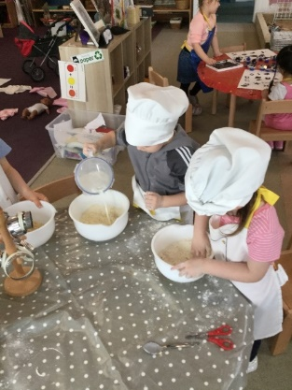

At West Early Learning and Childcare Class, we promote healthy eating for all children. Children at West ELCC are offered a drink and a snack each day. Fruit will be offered every day and other choices such as cheese and biscuits, toast and cereal will also be offered. The children are encouraged to drink milk with their snack and water is also available to the children.

Snack is provided throughout the nursery day. This allows children to participate in snack time when they feel ready to and encourages independence. Children help staff to prepare snack for the session by cutting and peeling fruit using knives to encourage children to risk assess independently. We promote good hygiene by reminding children to wash their hands before eating. Children are encouraged to tidy-up when they are finished by placing any unwanted food in the green recycle bin and placing tableware into the sink.

When your child is enrolled you will be asked about food allergies or any special dietary requirements your child has, and we will ensure that your child’s needs are met.

We kindly request a weekly contribution of £3 and this should be paid through Parent Pay. Please note this is voluntary. This donation pays for additional snacks and subsidises Christmas gifts, summer and Christmas parties, outings, workshops, entertainers and food technology.

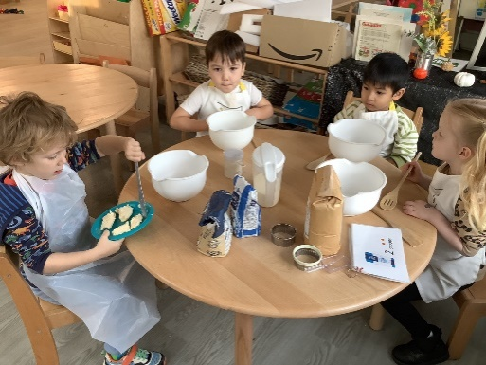

Area 3

Area 3 consists of a relaxing story corner, DIY playdough station, workbench/tinker table, science, music and ICT.

The story corner has been designed for children to be comfortable and enjoy stories at their own leisure. This space is comfortable and cosy, where children can also access for some quiet time or to wind down after a busy session. They have opportunities to play alone or together, express their feelings, use language to communicate and respond to one another’s needs.

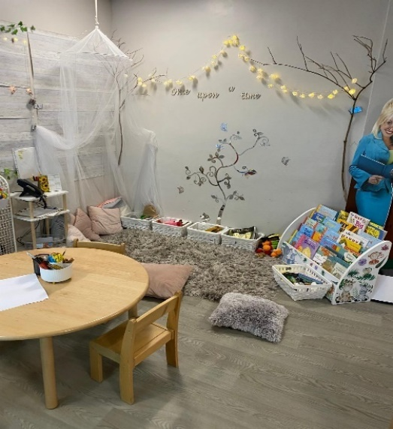
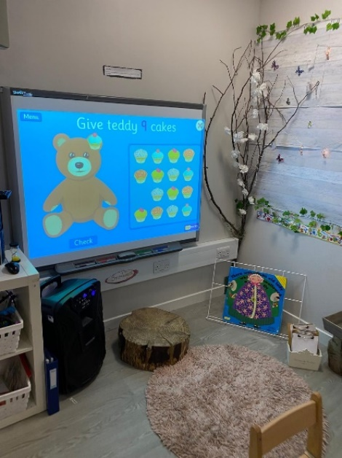
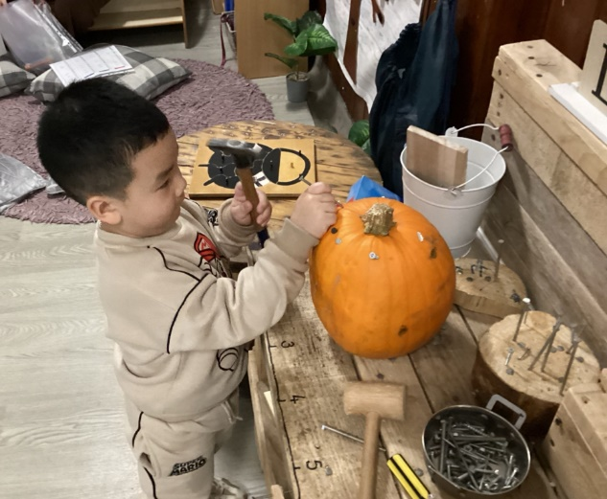

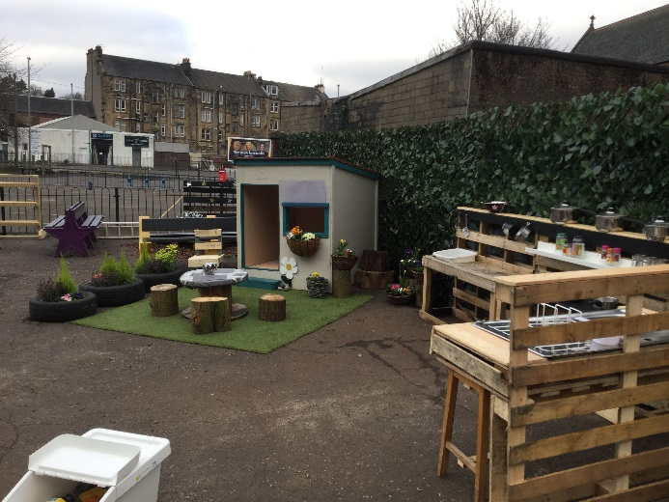
Outside Area

Area 4 is the outdoor learning environment which consists of a mud kitchen, loose parts junk yard, role play area, planting, greenhouse, stage, reading corner, quiet spaces, risky play opportunities, music area and so much more!

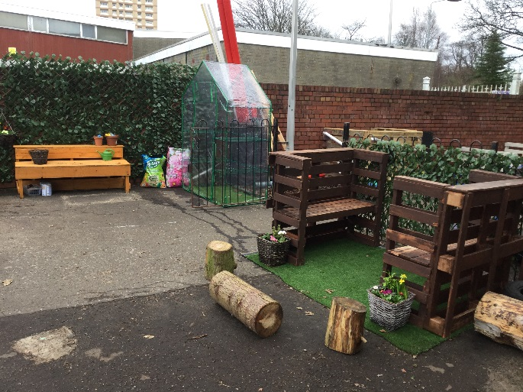
The garden has been developed in recent years to incorporate aspects of nature, greenery and plants to allow children to understand the natural world, begin to appreciate its beauty and take care of it.

The outdoor learning environment is central to all learning. It is a place where children can grow and learn at their own pace. It provides a vast range of different experiences which indoor learning environments cannot. It is a space for children to be free and have space to explore, discover and be curious. It has endless play and learning opportunities for all children.

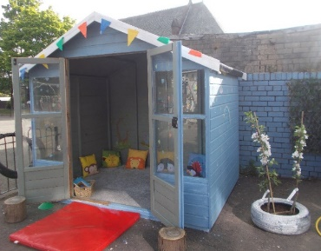
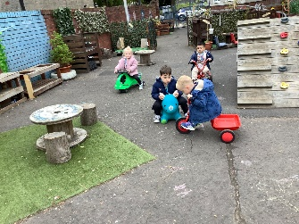

Observation and Assessment
Assessment of children’s learning is based on day to day observation and interaction. When staff interact with children, or stand back and observe their play, they can gather important information about each child’s development and learning. The purpose of assessment through observation and interaction is therefore to build up the knowledge and understanding of each individual child to identify their progress and next steps in learning. Children’s individual needs are observed and discussed daily as this enables the staff to plan and evaluate effectively.

We capture your child’s learning journey in many ways, e.g. Learning Journey Folders and Seesaw. Each child’s learning journey reflects on their development of skills and knowledge gained through their individual interests. When your child starts nursery, we ask that you complete an ‘All About Me’ form with your child, so that staff can have an insight into your child which also helps staff to gently settle your child into the nursery setting. Your child’s learning journal is available to look through at any time where you can see the progression your child is making whilst at nursery. To link with home, we also regularly throughout the session ask you to complete a Learning Journey form with events that may be happening at home or your child’s interests in the house.
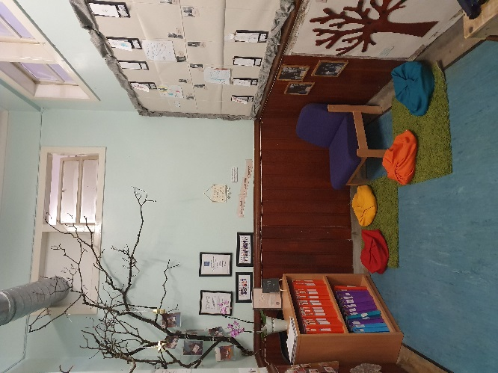
The information within your child’s learning journey and the progress they have made at nursery is shared with you at our end of the session parents’ evening. We plan carefully to ensure children’s developmental needs are met in a challenging and interesting way.

If you would like to discuss your child’s progress or view their learning journal at any time, please do not hesitate to ask staff.

We are keen to hear about any achievements your child has made out with nursery so that we can add this to their journal and our achievement wall too. We love to celebrate children’s successes and achievements with them!

Lunchtime Procedures
Within West Primary Nursery and Childcare Class, we aim to make lunch time a pleasurable experience for children and adults. Children have their lunch in our fabulous Family Room which aims to give a home from home experience. Lunch time represents a calm, social occasion where children can talk to each other, learn about good table manners, making good choices and healthy eating.

To support children and their families we adhere to the following procedures:

- Parents have the choice to send their child with a packed lunch or for their child to have a free, hot meal provided by Renfrewshire Council. Menus for hot meals are provided, allowing parents to discuss choices with their child and their preference. Packed lunch boxes are stored in the fridge in the nursery playroom.
- Prior to a child starting nursery we find out from parents/carers if there are any dietary needs or allergies. All staff are informed regarding specific allergies, dietary and cultural needs and children are catered for accordingly.
- Lunchtime begins at 11:50 and continues to approximately 12:30. The children will assist a staff member to wash and set the table and collect lunch boxes from the fridge. The table will be set up with mats, napkins, cups, water jug and cutlery.
- The staff member will sit at the table with the children while they are eating their lunch supporting them to use cutlery and encouraging them to eat their food. Staff will rotate on a weekly basis. Staff will gently encourage children to eat their food, starting with their savoury food.
- The Support Worker will collect the hot meals from the school canteen and bring them to the Family Room.
- All children bringing a packed lunch will be offered a cup, plate and cutlery. Any food not eaten will be placed back into the child’s lunch bag.
- Children will be encouraged to tidy up after lunch.
- Children will not be expected to eat everything, and fresh fruit & vegetables will be available if they are still hungry. Verbal feedback will be given to parents/carers on what and how much their child ate.

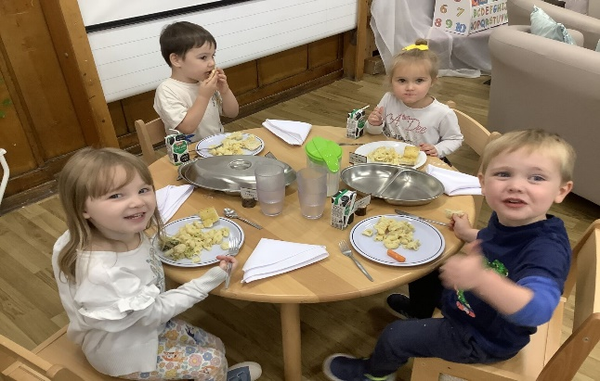
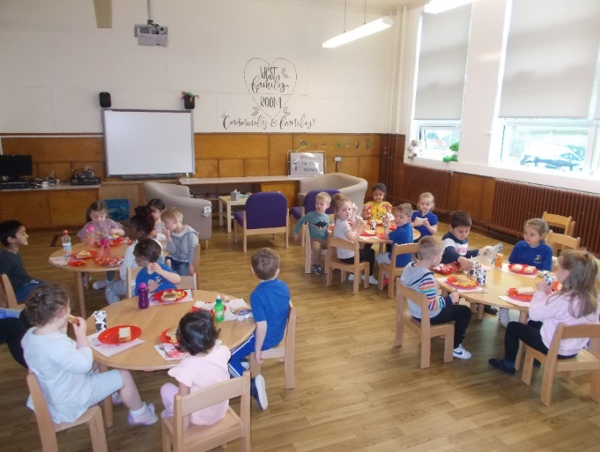

Clothing

Nursery education is all about experimenting and trying new experiences, so we suggest that your child does not wear their best clothes to Nursery. We will provide aprons for messy play, but accidents do happen! We have a supply of spare clothes and we will change your child if they are wet or uncomfortable. However, you can provide spare clothes on your child’s peg for any necessary changes if you wish. The nursery has a uniform that is available to purchase, please see staff for further details if you would like to do so.

Transfer from Nursery to Primary
Arrangements are in place with all local primary schools to support children as they make the transition to school. West Primary School has a very extensive programme, and a full outline will be given to parents prior to their child starting school. Before leaving Nursery a Transfer of Information record for each child will be prepared by Nursery staff to ensure a smooth transition and continuity of education for the children transferring to Primary School.

Parental Partnership
Parental involvement and engagement in your child’s education is actively encouraged and our centre encourages parents to:
- be involved with their child’s education and learning.
- be active participants in the life of the establishment.
- express their views on early learning and childcare education.
- work in partnership with their child’s early learning and childcare centre.

Parents are children’s prime educators. The staff of West Early Learning and Childcare class value the role of parents in their children’s learning and they work hard to create a genuine partnership with parents.

We welcome the opportunity to talk to you and share your knowledge about your child so that we can find ways to use that knowledge to benefit your child’s education. We are also keen that you share information about your child’s achievements outside of the Nursery.

Parent helpers are very welcome in the Nursery and if you would like to help out, please let one of the nursery staff know. There will be opportunities throughout the year for visits with your child to the Family Room and the School Library. We have Stay and Play sessions where you can explore nursery with your child and see how they learn and play at nursery. We also offer coffee mornings for you to come along and meet other parents. At times we invite speakers in. We also have Bookbug Sessions which we would love for you to be part of.

Parents are invited to answer our ‘Question of the Month’ and you can add comments to the suggestion box and Graffiti Board located in the cloakroom. We also actively encourage our parents to use the Seesaw app as a means of communication and for feedback and you have a platform to highlight any specific issues or concerns you may have.

We use the app Seesaw to enhance our communication with parents and families. It allows us to post photographs, video clips, voice notes and announcements/reminders with any important information to each individual child’s journal. You can see what your child explores and learns at nursery to discuss this at home with your child. It allows working parents to be in more contact with staff and see regular updates. Seesaw has been a great asset for children who are settling-in. We will happily send photos directly to parents to reduce any concerns as your child settles in. Seesaw has been a great success here at West ELCC and a valuable resource that staff, parents and children alike enjoy.

From time to time we send simple activities home, which allow you to work with your child on something that is related to activities being done in Nursery. We also have “Travelling Ted” for our pre-schoolers and story sacks and maths bags will come home too.

Parent Committee
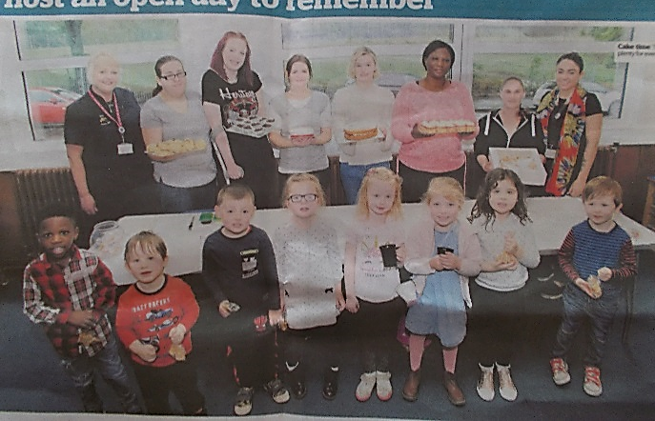
The Parent Committee is run by our Early Years Graduate, Mrs Harding. The Committee is to help develop the nursery to meet the needs of the community and to be consulted on nursery policies. The Committee also take a major role in organising fund-raising events.

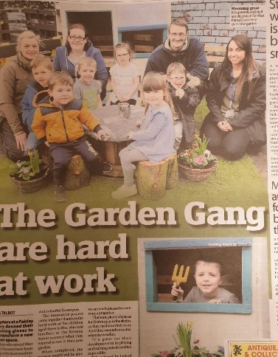

In the past, they have supported us in developing our nursery garden in order for the children to have a space to learn and play in the outdoor environment. We do really appreciate your support and it is important to us that the parents have their say in the running of the nursery.

Trips

When you enrol your child, you will be asked to give your consent for your child to take part in local outings. We try to take the children out in the local community on occasions. An outing can be simply to the park, to the shop to buy snack or baking resources or to other nearby places of interest. Trips are carefully risk assessed beforehand to ensure the children’s enjoyment is not compromised by safety issues. We appreciate our duty of care and responsibility, and value your trust in us.

Forest Kindergarten
We provide our pre-school children with block visits to our Forest Kindergarten site in Ferguslie Park. Research shows that children are a lot more stimulated and engaged through exploring nature and the outdoors. Forest Kindergarten allows for children to learn in a different context and develop knowledge and skills which cannot be provided for within the nursery setting. Children are encouraged to build their confidence and independence through participating in practical but small achievable activities. These allow for children to set their own boundaries, assess risk independently and test their own abilities in a real-life context. On the last week of the Forest Kindergarten block, parents are invited along to take part with their child.

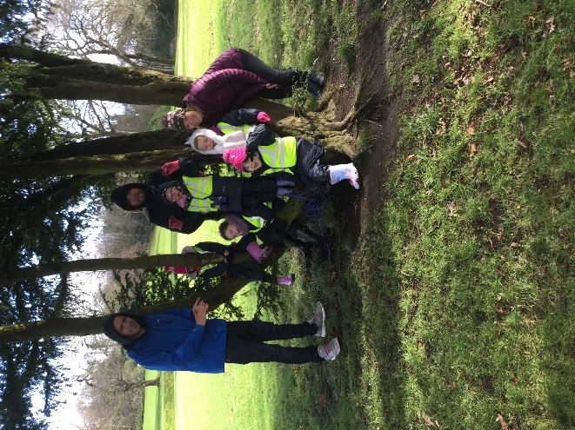

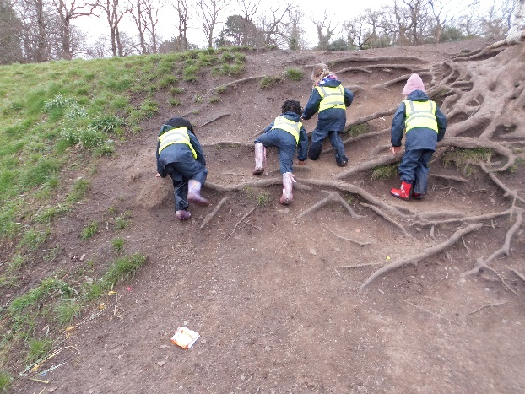

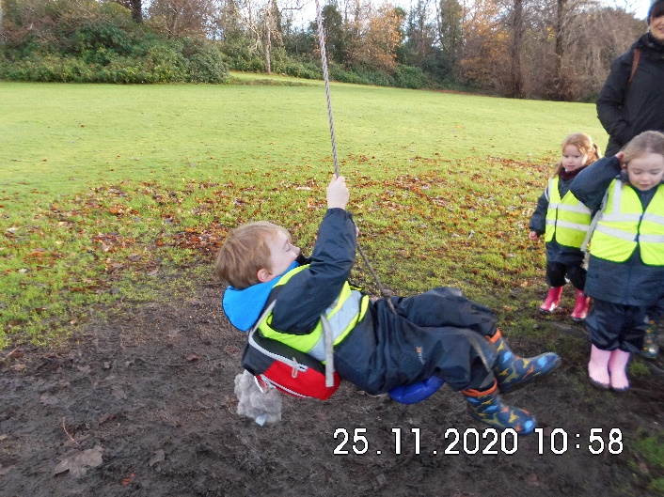

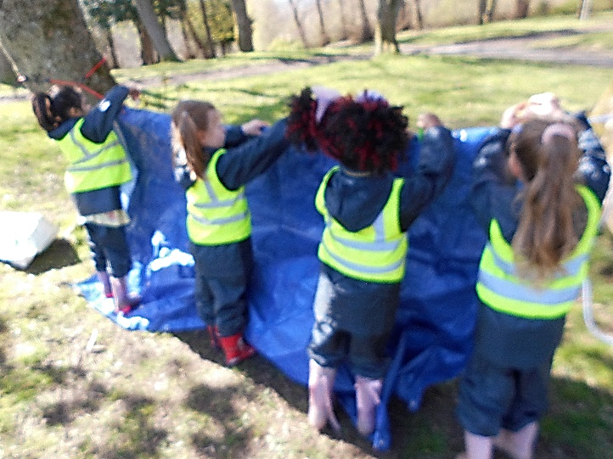
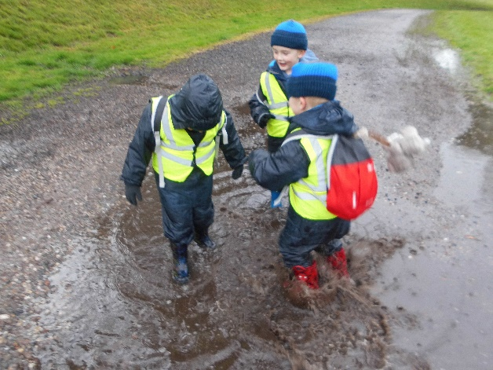

Illness
Please telephone the nursery before 9.15am if your child is not able to attend nursery on a particular day. If we do not receive a phone call, we will contact you. We ask that you do not bring your child to nursery if they are unwell as this can cause the child distress and may spread infection.

If your child takes unwell during the session, we will telephone you or your emergency contact to inform you and ask for your child to be collected. It is very important to notify us if you change your telephone number or employer, even if it is only temporary so that or records are kept up to date.

Please note: Children with diarrhoea or vomiting should stay away from nursery for 2 days after their symptoms have gone. This will prevent the spread of infection. You will find current NHS guidance on many childhood illnesses (including the most recent guidance on coronavirus) here; NHS is-my-child-too-ill-for-school or nursery.

Absence
We respectfully ask you to telephone nursery on 0300 300 0177 if your child will be absent. If we do not hear from you, we will message you via text asking you to telephone the nursery.

Security - Arrival and Collection of Children
Renfrewshire Council has introduced procedures to ensure the safety and security of children and staff when attending or working in an early learning and childcare establishment. We use a number of security measures including a visitors’ sign in book, badges and escorts, while visitors are within the nursery building. Normally, anyone calling at an early learning and childcare establishment for any reason, will be asked to report to the school office. The early learning and childcare staff can then make the necessary arrangements for the visit.

Children’s attendance is registered on arrival by a staff member. You will be asked who is collecting your child from nursery that day and this will be recorded. If plans change, we ask that you contact the nursery to make them aware. Children must be accompanied to and from the ELC by an adult. Please ensure that the adult collecting your child is named on their enrolment form and the nursery staff immediately informed of any changes to this. No child will be allowed to leave the centre with an adult unknown to staff.

You will also be asked to complete a Child’s Plan, which gives us important information about your child. We, of course, keep this confidential and ask that you ensure that we always have up-to-date information.

Care and welfare
Your child’s well-being is central to the ethos of the establishment. Please contact us to share any concerns you have about your child’s welfare or wellbeing. As mentioned previously a personal plan will be created to support your child’s wellbeing. The staff will work with you as parents to make sure children are safe, happy, and able to benefit from the educational opportunities we offer.

Safeguarding including child protection
All children have a right to be protected from harm, abuse, and neglect. The vision of the Renfrewshire Child Protection Committee is that “It’s everyone's job to make sure that children in Renfrewshire are safe."

Renfrewshire Council has a child protection policy and guidelines in place to make sure that all staff receive training each year and are confident in responding to any child protection or safeguarding issue, including e-safeguarding, child sexual exploitation and radicalisation. Staff ensure the wellbeing of children they encounter and work closely with other agencies to protect children and keep them safe.

All early years staff are trained in Child Protection and must report any concerns they have about the welfare of children to the centre’s management team.

Equalities
Renfrewshire Council is committed to ensuring that all employees, customers, and partners are treated fairly and with respect at all times. We are committed to promoting equality and tackling discrimination through the way services are planned, delivered and purchased. The council promotes and encourages a culture whereby equality of opportunity exists across all the protected characteristics of age, disability, race, gender reassignment, pregnancy and maternity, religion and belief, marriage and civil partnership, sex and sexual orientation.
Early learning and childcare is open to all eligible children and all reasonable measures will be taken to make sure that the curriculum is available to every child. The Equality Act 2010 introduced a new public sector general equality duty which requires Scottish public authorities to pay 'due regard' to the need to:
- Eliminate discrimination, victimisation, harassment or other unlawful conduct that is prohibited under the Equality Act 2010.
- Advance equality of opportunity between people who share a characteristic and those who do not.
- Foster good relations between people who share a relevant protected characteristic and those who do not.

The council supports the right of each citizen to a quality of life which is free from violence, discrimination, and harassment. The council will take steps to ensure that all citizens, regardless of race, ethnic or national origin, religion, social background, marital status, gender, disability, age or sexuality have full access to its services, taking all possible measures to prevent discrimination in the way its services are delivered.
Parents can help to monitor our success in promoting equality of opportunity for all by providing equalities related information when asked.

Medical and Health Care
Vision and dental examinations may be carried out during your child’s time at nursery. Parents will be given notice of these and can attend if you wish. Following the examination parents are informed by letter of any recommended action or treatment for your child. All examinations are carried out by NHS Greater Glasgow and Clyde Health Board.
Parents should notify the establishment of any medical requirements or allergies that their child may have. Wherever possible, where a child requires medication, it is better if this is provided at home. In cases where it is necessary that the child receives medication during their time at the early learning and childcare establishment, parents should contact the Deputy Head Teacher to make appropriate arrangements. Early learning and childcare staff are under no obligation to give medicines to children’s and staff will advise parents of local arrangements. Administration of medication paperwork must be filled out and signed by a parent prior to any prescribed medication being administered. All medicine must be given to staff and will be stored safely in the establishment following Care Inspectorate Guidance.

Minor accidents are dealt with by the establishment’s qualified first aider(s) or appointed person. If a child takes ill or has an accident at the centre which requires that they be sent home or for treatment, the centre will provide first aid and contact parents. It is very important that the centre has up to date contact details for all parents and an additional contact person in case parents can’t be contacted. This information should be current, and the centre notified of any changes.

Mrs McIntosh – First Aider
In the event of a serious illness or accident, a member of staff will accompany the child to a doctor or hospital and parents will be notified immediately.

Child Smile
The Child Smile programme is delivered in early learning and childcare establishments with the aims of improving the oral health of children. This is a national programme which is designed to support with a range of preventive care interventions for children from an early age until they leave primary school who are at increased risk of dental disease.

Parents will be asked to complete a permission form for their child to participate in toothbrushing when completing a registration form.

Transfer from Early Years to Primary
Traditionally in Scotland, children aged between 4 and a half and five can start school in August. The date for registration of new school entrants is advertised in all local nurseries, national and local press and on the council’s website www.renfrewshire.gov.uk. Pupils should be registered in only one school for their catchment area. Please refer to the following guidance: enrolling your child at primary school.
Parents who want to send their child to a school other than the catchment school must make a placing request. Information on how to make a placing request is contained in the leaflet ‘Sending your child to school.’ The leaflet is also available from any school, by phoning our customer contact centre on 0300 300 0300. It is important to note that a successful placing request into a primary school does not guarantee a successful placing request when a child is transferring to secondary school.
Parents of pupils who have moved into the catchment area or, who wish their child to transfer to the school, should contact the school office for information.

Deferred Entry to Primary School - An additional year of funded Early Learning and Childcare
The law (set out in the Education (Scotland) Act 1980) states that children must start school in the August following their 5th birthday, therefore parents/carers have a legal right to defer entry for 4-year-old children if they wish to do so.

Children born between August (if a child is still 4 years old on the date they are eligible to start school) and February are automatically entitled to an additional year of early learning and childcare.
If you wish to defer your child’s entry to primary school, you should discuss this with the Head of Centre. Parents should register children for primary school and update the school when an additional year of early learning and childcare has been confirmed.

Further information can be found here; Apply for an additional year of free nursery or childcare - Renfrewshire Website

Transition
When your child is ready a transfer of information record for each child will be prepared by the child’s Keyworker. Primary Teachers will often arrange to visit children in the early years establishment and a series of induction days within the school will be arranged. This will ensure a smooth transition and continuity of education for the child transferring to primary 1. Information on the importance of high quality transition can be found here; Transitions | BSL | Parent Zone (education.gov.scot)

Your child’s keyworker will complete a Progression Tool to provide a summary view of your child’s progression towards the early level of Curriculum for Excellence. The early level of Curriculum for Excellence guides practitioners and teachers who work with children aged 3 years to the end of Primary One. The purpose of the Progression Tool is to identify key milestones that practitioners have observed your child achieve. This will also support the creation of your child’s next steps in learning. The progression tool will be shared with your child’s primary school at point of transition. This evidence of progress will provide a bridge between early years and primary contexts, helping to ensure progression in your child’s learning opportunities.

Policies
We have a wide range of policies to ensure the smooth running of the nursery. For example, we have policies on:

- Health and Safety | - Security
- Resources | - Participation Policy

All the policies are available within a folder in the nursery for your perusal and any comments you have are very welcome. Please see Mrs McGinn or Mrs Wiszniewski.

Getting it Right for Every Child (GIRFEC)
Getting it Right for Every Child (GIRFEC) is the national approach in Scotland to improving outcomes and supporting the wellbeing of our children and young people by offering the right help at the right time from the right people. It supports them and their parent(s)/carers to work in partnership with the services that can help them.
All education staff have a statutory responsibility to promote and support the wellbeing of children and young people in their care. There are 8 wellbeing indicators and you can find out more about these here: https://www.gov.scot/policies/girfec/wellbeing-indicators-shanarri/

Realising The Ambition
Realising the Ambition: Being Me builds upon the original principles and philosophy of Pre-Birth to 3 and Building the Ambition. The new guidance retains the relevant content from the previous guidance which it replaces, extending and strengthening it in line with current research and evidence about how children develop and learn.
This refreshed early years national practice guidance for Scotland presents key information about the characteristics of child development based on research and evidence.
It explores the range of interactions, experiences and spaces we need to provide for babies and young children to help them learn and grow best from their earliest days through to being a young child in early primary school.
In essence, ‘Realising the Ambition: Being Me’ increases expectations of high quality but still provides the necessary support for all who work in the early years sector and beyond.

Inclusion
Information on additional support needs for children and young people in a Renfrewshire nursery or school can be found here; Additional support for learning (ASN) - Renfrewshire Website
Renfrewshire's inclusive approach affords all children and young people the opportunity to be part of their learning community, boosting their emotional wellbeing and aiding the development of social skills. This approach is based on the core inclusive value of providing education for children within their own community as much as possible. Wellbeing assessment and individual planning is in place for all young people who require additional support.
Support
The needs of the child or young person should always be central to the identification, planning and provision of support. Support should be appropriate, proportionate and timely.
Universal support
Universal support starts with the ethos, climate and relationships within every learning environment. It is the responsibility of all practitioners and partners.
An environment which is caring, inclusive, fair and focused on delivering learning to meet individual needs will encourage all children and young people to strive to meet their learning potential.
Personal learning planning is at the heart of supporting learning. The conversations about learning, reviewing progress and planning next steps are central to this process. Planned opportunities for achievement which focus on the learning and progress made through activities across the full range of contexts and settings in which the curriculum is experienced also contribute to the universal aspect of support. In addition, all children and young people should have frequent and regular opportunities to discuss their learning and development with an adult who knows them well and with whom they have a mutually trusting relationship. This key member of staff has the holistic overview of the child or young person’s learning and personal development.
Targeted support
Children and young people can benefit from additional or targeted support, tailored to their individual circumstances. This could be at any points of their learning journey or throughout the journey.
Barriers to learning may arise from specific learning / health difficulties, disability, social, emotional or behavioural needs, bereavement or family issues.
This 'targeted' support is usually, but not exclusively, delivered by staff with additional training and expertise.

Renfrewshire Health and Social Care Partnership
There are many children and young peoples health services available across Renfrewshire. This includes services such as Speech and Language Therapy, Renfrewshire Psychology of Parent Project (PoPP) and the local Health Visiting Team. Please click on the links for further information.

Educational Psychology Service
Educational Psychologists (EPs) support equity, inclusion and attainment and deliver evidence-based intervention to support pupils’ wellbeing in Renfrewshire’s schools, Early Learning and Childcare Classes, establishments and other learning centres.

EPs work with Early Learning and Childcare Classes, schools, parents and support staff to help children and young people make the most of their lives and support schools, Early Learning and Childcare Classes and other learning centres to improve and develop supportive healthy learning environments through approaches such as the Renfrewshire Nurturing Relationships Approach, Language and Communication-Friendly Environments, Video Interaction Guidance and Non-Violent Resistance.

Our Early Learning and Childcare establishments have a system in place for monitoring and reviewing the progress of all our young people and we have a link EPs who visits on a regular basis and is part of the extended support team. When concerns are raised about a child or young person, the nursery takes action to address these concerns and may involve a link EP. Parental permission will always be obtained before we request to involve the link EP.

Independent sources of information and advice nationally
Enquire – the Scottish advice service for additional support for learning:
Telephone – 0345 123 2303
Email – info@enquire.org.uk
Resolve (Children in Scotland) - Resolve: ASL is an independent mediation service for parents and carers of children and young people with additional support needs.
Telephone – 07955 788967
Email – resolve@childreninscotland.org.uk

Health and Wellbeing Education
Learning in health and wellbeing ensures that children and young people develop the knowledge and understanding, skills, capabilities and attributes which they need for positive mental, emotional, social and physical wellbeing now and in the future. Learning through health and wellbeing enables children and young people to:
- make informed decisions in order to improve their mental, emotional, social and physical wellbeing.
- experience challenge and enjoyment.
- experience positive aspects of healthy living and activity for themselves.
- apply their mental, emotional, social and physical skills to pursue a healthy lifestyle.
- make a successful move to the next stage of education or work.
- establish a pattern of health and wellbeing which will be sustained into adult life, and which will help to promote the health and wellbeing of the next generation of Scottish children and young people.
- and, for some, perform at high levels in sport or prepare for careers within the health and leisure industries.
Health and Wellbeing in early learning and childcare covers:
- Mental, emotional, social and physical wellbeing
- Planning for choices and changes
- Physical education, physical activity and sport
- Food and health
- Substance misuse
- Relationships, sexual health and parenthood
Effective health and wellbeing education requires exchange of information, mutual support and collaboration with community partners, ELCC settings and parents.

Listening to learn - complaints, comments and suggestions
We aim to provide good quality service. Users of the service are generally very pleased with what is provided in nursery. We hope that you will not need to complain but sometimes things go wrong, and we would like to hear from you as soon as possible so that we can put things right. You can telephone or write to the school to make an appointment for an informal chat. Many difficulties can be resolved quickly and easily.

Renfrewshire Council encourages feedback on its services from parents and children as part of our overall commitment to giving the best possible service and to working in partnership. We are interested in feedback of all kinds, whether it be compliments, suggestions or complaints.
If you want to register a comment of any type about the centre you can do this by writing, telephoning or making an appointment to see someone. All feedback is welcome and keeps us in touch.
If, in particular, you have a complaint about the early learning and childcare centre, please let us know. It is better that these things are shared openly and resolved fairly, rather than being allowed to damage the relationship between the family and the centre. There will be no negative consequences from making a complaint and we will deal with the issue confidentially. If we have made a mistake, we will apologise quickly and clearly and try to put things right.
There are some things which you should be aware of when making a complaint:
Stage 1 complaint:
- Complaints about the centre should be made first to the head of centre.
- It is helpful if you can give some details of the issue and ask for an early appointment to discuss it.
- We want to resolve complaints as quickly as possible. You will get a decision on your complaint in five working days or less unless there are exceptional circumstances. If it is going to take longer than five working days, we will let you know.
Stage 2 complaint:
- If you are not happy with the response to your complaint, you have the right to take it further and submit a complaint to Children’s Services. This is also known as a stage 2 complaint. You can do this by completing a complaints form (available from the school or any council office), fill in the online form via your ‘my account’, write to us, email us at complaints@renfrewshire.gov.uk, or call us on 0300 300 0170. At this stage, we will carry out an in-depth investigation. We will acknowledge receipt of your complaint within three working days and give you a full response within twenty working days. If the investigation is going to take longer than this, we will contact you to inform you.
- If you remain dissatisfied following the stage 2 outcome, you can contact the Scottish Public Services Ombudsman and our response will include the contact details.
- You should also note that you have the right to raise unresolved concerns with your local councillor, MSP or MP.
Care Inspectorate
All Early earning and Childcare establishments are registered with and regulated by the Care Inspectorate. Therefore, parents with a complaint about a service may wish to complain to the Care Inspectorate. The contact details for the Care Inspectorate are:
Telephone: 0345 600 9527
Email; concerns@careinspectorate.gov.scot
Fill in a complaints form online
Write to: Care Inspectorate, Compass House, 11 Riverside Drive, Dundee, DD1 4NY

Data Protection
Information on pupils, parents and guardians is stored on a secure computer system and may be used for teaching, registration, assessment and other administrative purposes. The information is protected by data protection laws, including the UK General Data Protection Regulation (UK GDPR) and the Data Protection Act 2018, and can only be shared or disclosed in accordance with those laws. To find out more about how your personal information is used, please consult the Council’s general Privacy Policy, here: https://www.renfrewshire.gov.uk/article/2201/Privacy-policy
Children attending any type of establishment have a right of access to their own information by virtue of the Data Protection Act 2018. This is known as the right of subject access. When a child cannot act for themselves or the child gives permission, parents will be able to access this information on their behalf. The Pupils' Educational Records (Scotland) Regulations 2003 give parents and carers a specific right of access to their child's educational records. You can find out how to make a Subject Access Request or a request for Educational Records, by visiting the Council’s Data Protection page, here: https://www.renfrewshire.gov.uk/article/2059/Data-protection
For specific data protection queries, please contact the centre directly.

Information in Emergencies
We make every effort to maintain a full educational service, but on some occasions, circumstances arise which lead to disruption. Early learning and childcare establishments may be affected by severe weather, traffic and transport disruption, power failures or fuel shortages. In such cases, we will do all we can to let you know when we are closing and reopening the nursery.
We use a variety of methods to keep you updated in emergency situations including: e-mails, newsletters, text messages, the centre and council websites and Renfrewshire Council's social media channels (Facebook Renfrewshire council and Twitter - @RenCouncilNews).

Further information may also be provided through letters, announcements in the local press, local radio, or notices in local shops, churches and community centres.

Please ensure we have the most up-to-date emergency contact information for your family, and you are following the council's social media channels. You can sign up for the centre’s digital newsletter via www.renfrewshire.gov.uk/e-alerts.

Important Contacts

Director of Children’s Services

Janie O’Neill | Renfrewshire House  Cotton Street  Paisley  PA1 1LE | Email  csdirector@renfrewshire.gov.uk  Phone: 0141 487 0885
ELC Team | Renfrewshire House  Cotton Street  Paisley  PA1 1LE | Email  elc@renfrewshire.gov.uk  Phone: 0300 300 0170

Community Learning & Development

Community Facilities Section | OneRen  3rd Floor  Renfrewshire House  Cotton Street  Paisley  PA1 1LE | Email  comfac@renfrewshire.gov.uk Phone: 0300 300 1430
Adult Learning Services | West Johnstone Shared Campus  Beith Road  Johnstone  PA5 0BB | Email  als.els@renfrewshire.gov.uk  Phone: 01505 382863
Youth Services | West Primary School  Newton Street  Paisley  PA1 2RL | Email  youth@renfrewshire.gov.uk  Phone: 0141 889 1110
Customer Service Centre

Customer Service  Centre | Renfrewshire House  Cotton Street  Paisley  PA1 1AN | Email  customerservices.contact@renfrewshire.gov.uk  Phone: 0300 300 0300

Useful Websites
You may find the following websites useful.
- https://education.gov.scot/parentzone/ - This site offers information for nursery aged children through to young people who have left school. It also lists relevant publications for parents and provides hyperlinks to other useful organisations
- https://education.gov.scot/education-scotland/inspection-reports/ - parents can access school and local authority inspection reports and find out more about the work of Education Scotland
- https://education.gov.scot/inspection-and-review/find-an-inspection-report/ - parents can find out about individual schools and Early Learning and Childcare Settings. They can choose a school or ELCC Setting and select which type of information they need such as Education Scotland reports, website links, contact details and address.
- https://education.gov.scot/- provides information and advice for parents as well as support and resources for education in Scotland
- SSSC Codes of Conduct - Employees of the Scottish Social Services Council (SSSC) must comply with standards of professional conduct and practise set out by the regulatory body which applies to their professional occupation.
- Welcome to the Care Inspectorate – Parents can access Care Inspectorate Inspection Reports and find out more about the work of Care Inspectorate.
- Personal Planning Guidance – Personal planning Guidance for Services of ELC from care Inspectorate.
- How good is our early learning and childcare? (education.gov.scot) – contains information on the self-evaluation framework used to support settings to improve their quality and aim for excellence.
- Health and Social Care Standards: My support, my life (careinspectorate.com) - These Health and Social Care Standards (the Standards) set out what we should expect when using health, social care or social work services in Scotland.
- Out to Play - Play Scotland - Practical guidance for creating outdoor play experiences in early learning and childcare
- My World Outdoors | Care Inspectorate Hub - My World Outdoors set out our position on the risks to children from playing outdoors and addressed some of the myths that had built up regarding regulation.
- space-to-grow.pdf (careinspectorate.com) – design guidance for ELCC through expansion of 1140hrs.
- http://www.renfrewshire.gov.uk/ - contains information for parents and information on Renfrewshire schools
- http://www.childline.org.uk/Explore/Bullying/Pages/Bullyinginfo.aspx - contains information for parents and children on varying forms of bullying and provides help for parents and children who are affected by bullying
- http://www.respectme.org.uk/ - Scotland’s anti-bullying service. Contains information for parents and children on varying forms of bullying and provides help for parents and children who are affected by bullying
- http://www.equalityhumanrights.com/ - contains information for everyone on equality laws within the government and local authorities.

West Early Learning and
Childcare Class

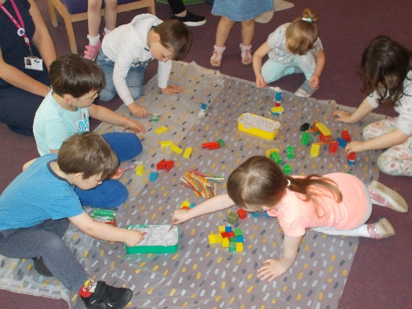
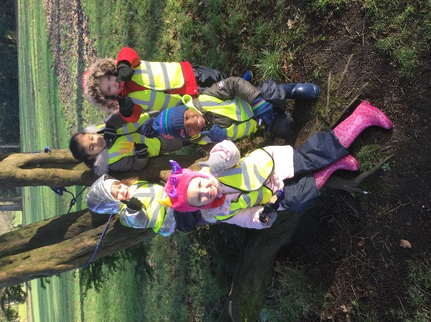
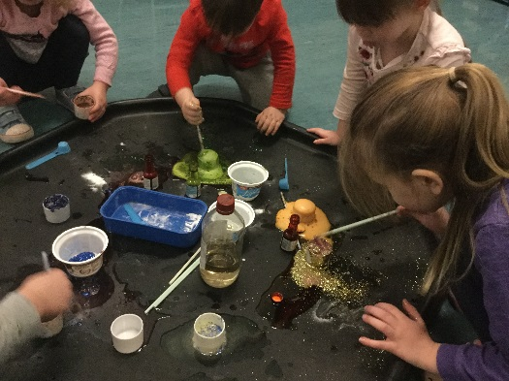

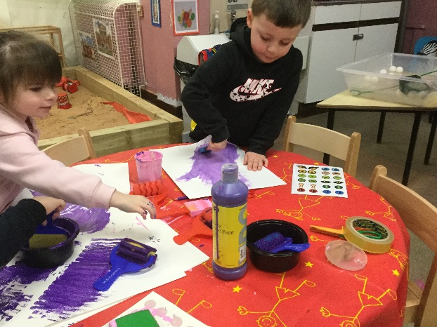
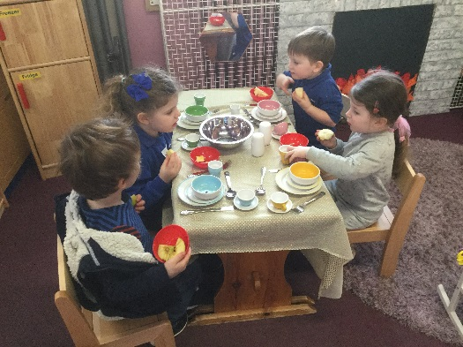
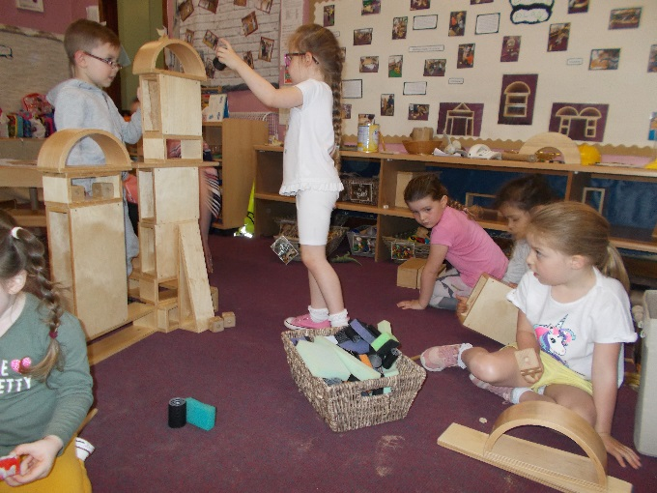
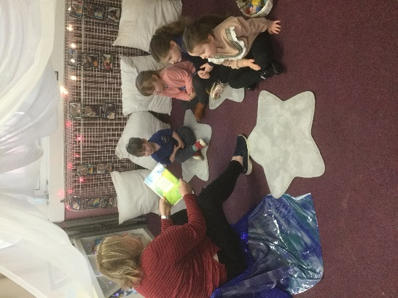
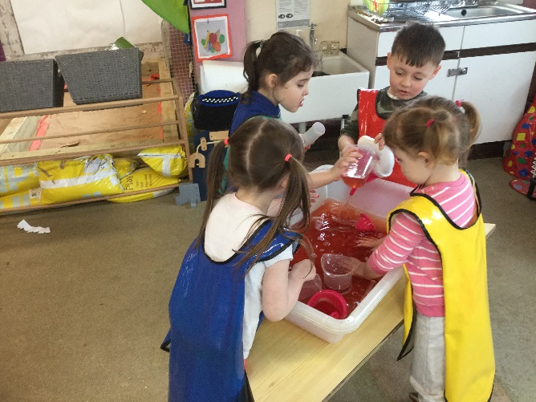
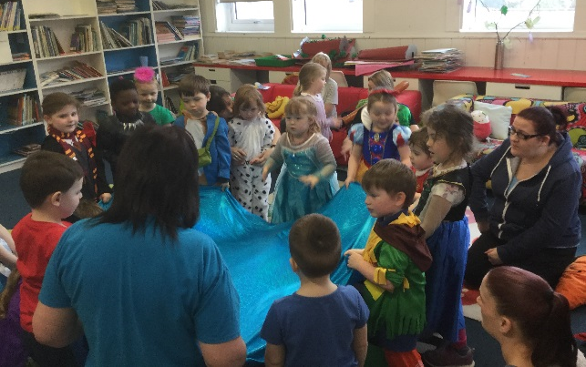
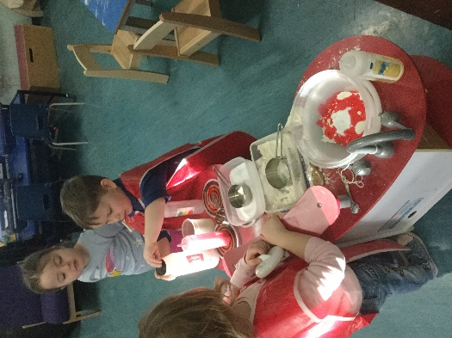
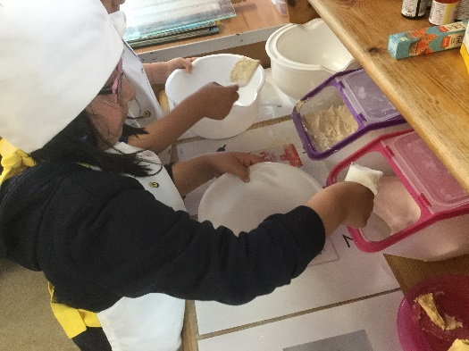
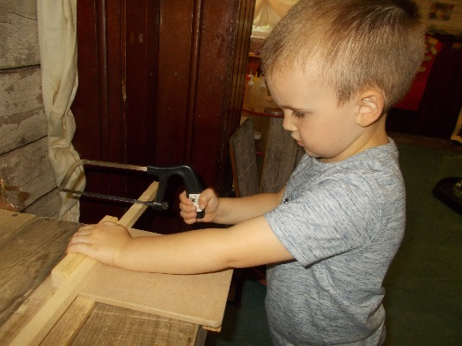
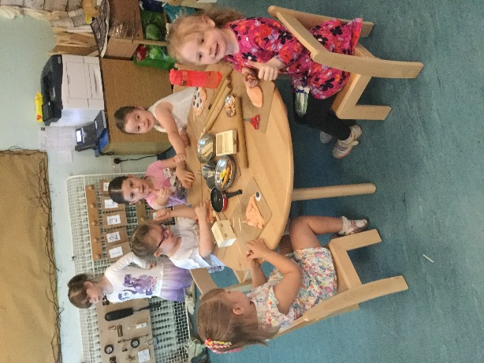
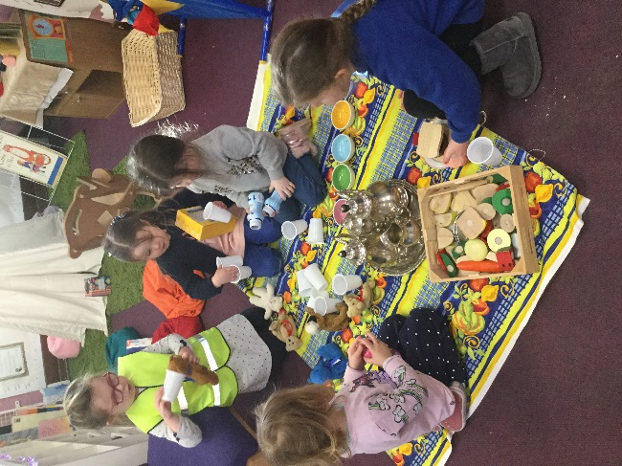
Where Everyone Succeeds Together

