Welcome to

West Primary School

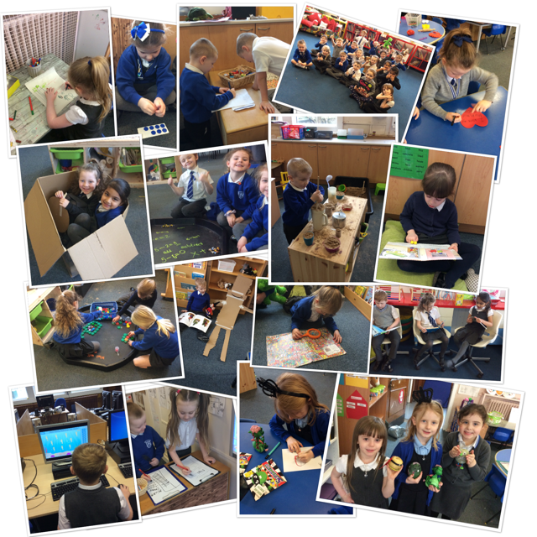

**Preparing For School**

Session 2023/2024

**How can I help my child prepare for school?**

**The period before a child starts school for the first time can be an anxious time for parents.**

***Here is a simple guide to how you can best prepare your child for this exciting time in their lives!***

**Promoting Independence**

Your child will really benefit from being as independent as possible when they start school. Of course, teaching staff will always be on hand to help but children feel a real sense of achievement when they can accomplish things by themselves!

For example:

*being able to dress and undress independently, as this will really help with PE sessions.

*being able to put their coat on and zip it up independently will really help them-as will being able to put on a pair of shoes or taking off their jumper when they get hot.

*being able to use the toilet independently, including washing and drying their hands.

*If they will be having school dinners, practise using a knife, fork and spoon. If they are taking a packed lunch, practise opening the packets and containers of food they will be taking. Encourage them to help choose and make their lunches.

*Encourage your child to tidy away after playing.

**Communication and Language**

Teachers do not expect children to know their alphabet or be able to write sentences when they start school. A good foundation in sound awareness skills such as rhyming and identifying what sound a word begins with is key. Sharing songs and books is a good way to support this. You could also say the sounds that letters make, along with their names as you come across them day-to-day.

It is important that your child can recognise his/her own name and that they know his/her own property with name tags on them. Ask your child to help name their uniform/clothes and school equipment like drinks bottle and lunch box. This will aid name recognition and help them to identify which things are theirs!

Encourage your child to develop an interest in books and other forms of text, for example comics, postcards, labels and posters. You could visit your local

Library and encourage your child to choose books they would like to listen to and look at.

Read with your child and discuss what you have read, for example, ask what they liked about it, what questions they may have about the book and does it remind them of anything in their own lives.

Encourage your child not to interrupt but to listen to other people before having their say.

Finally, starting school can be the cause of a huge bag of mixed emotions for both child and parent. Both the excitement about growing up and moving onto the next step, and watching them become more independent and not needing you as much. We will do our utmost to make this exciting journey from nursery to school as smooth as possible, for both child and parent.

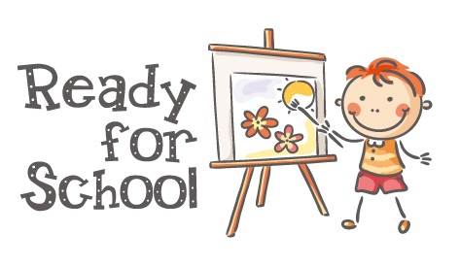

Getting Ready for School

Arrival at School

The playground is supervised from 8.50am until 9.00am when the school day begins. Mrs McGinn (Head Teacher,) Senior Leadership Team and Support staff welcome the children and supervise them in the playground. Once children have entered the playground, they are not permitted to leave. During wet or severe weather, children will enter the school building from 8.50am.

Children are expected to arrive at school in time for 9am and ready to begin the day.

Playtimes

There will be an adult presence in the playground initially. Buddies from Primary 7 will support the children too. During wet weather intervals and lunchtimes, children will stay in the classroom supervised by monitors from Primary 7. The support staff will also supervise classroom areas at these times. It would be helpful if children did NOT bring toys to school, unless requested by the class teachers. This will prevent accidental damage or loss to treasured possessions.

Toilets

Children can go to the toilet whenever they ask but should be encouraged to get into the habit of always going before school, at playtime and again at lunchtime. If your child has a problem in this area e.g. needs to go to the toilet frequently, please let the class teacher know.

Snacks

As a Health Promoting School, parents are encouraged to provide children with a healthy snack. A small snack is all that is required. Playtime is a time for playing with new friends. We also ask that your child brings a water bottle daily as research shows that drinking water regularly.



**What should children bring to school?**

* The Parent Council will issue children a homework pack to all Primary 1; this should come to school every day.
* A pencil case containing sharp pencils please.
* Soft indoor shoes to be left in school.
* Shorts, for P.E., should be kept in a bag on your child’s peg.

**SCHOOL UNIFORM**

* Our uniform is **grey** – skirt, pinafore or trousers.
* Jumpers, sweatshirts, and cardigans should be grey or royal blue.
* All pupils will need a white shirt and tie for the numerous events that they take part in throughout the year.
* Polo shirts should be white.
* Hair accessories are best in a colour that complements our uniform.
* No hooded sweatshirts to be worn in school.

ALL PROPERTY SHOULD BE CLEARLY NAMED

Labelled items are usually

##### A.N. Other

reunited with their owners.

Unnamed items may disappear

without trace!

Dear Parent, 

I understand that you are scared   
to wave your child goodbye  
and leave them in a teacher’s hands  
don’t worry if you cry!

I’m used to weeping parents  
It’s hard to leave I know.   
But it’s time to share them (just a bit)  
To help them learn and grow.

Let me reassure you  
That I’ll give your child my best  
I’ll wipe their tears, soothe their fears   
And change their dirty vest!

It’s true they'll grow to love us  
They’ll talk of school a lot  
It doesn’t mean they hate you  
And that you should lose the plot!

I’ll tell you a secret…  
That when your child is here  
They talk to me as much of you  
Of this please have no fear.

You’ll always be their parent  
Whilst teachers come and go  
To them you are their number one  
This I truly know.

Soon you’ll see some changes   
In your little girl or boy  
They’ll become more independent   
And to see this, it’s a joy!

I’ll teach them all I have to give   
To share, climb and to write  
But to you they safely will return  
To tuck them in at night.

With love from a teacher… xx

West Primary School

Director of Children’s Services: Steven Quinn



Newton Street, Paisley, PA1 2RL

Tel: 0300 300 0177

e-mail: [westenquiries@renfrewshire.gov.uk](mailto:westenquiries@renfrewshire.gov.uk)

website: [www.west.renfrewshire.sch.uk](http://www.west.renfrewshire.sch.uk)

**Head Teacher: Mrs Lynne McGinn**

Date: March 2023

Ref: VW

Dear Parent

Hours for 1st Week

We recognise that starting school is a big step. To ensure your child settles as quickly and painlessly as possible we operate a “phasing in” policy for the first few days.

**Wednesday 16th August 09.30am – 2.30pm.**

**Thursday 17th August 09.30am – 2.30pm.**

On the morning of the 16th August the teachers will come and collect the children from the Primary 1 area to bring them round to class. The teachers will also bring the children out to the playground at 2.30pm. Parents can drop off and collect children from the playground.

From **Friday 18th August** children will attend 9.00am – 3.00pm. External doors will be open at 8.55am and at this time children will be met by their teacher and taken to class. The playground will be supervised by the Senior Leadership Team and Support Staff at this time.

It is a good idea for your child to bring a small snack to school. Children can bring a water bottle for the classroom, and these should contain plain water.

A free school dinner is available, or children may bring a packed lunch instead. Menus will be published in August.

Have a lovely Summer Holiday and we look forward to seeing everyone in August.

Yours sincerely

Vicki Wiszniewski

Vicki Wiszniewski

Depute Head Teacher