Information For

Parents and Carers

Primary 1

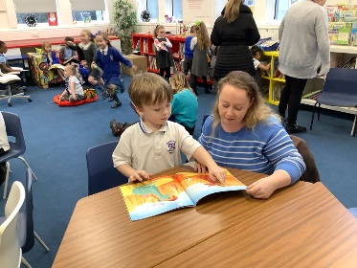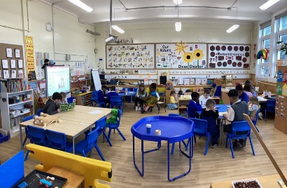

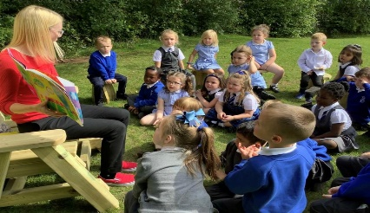

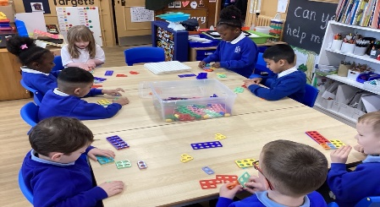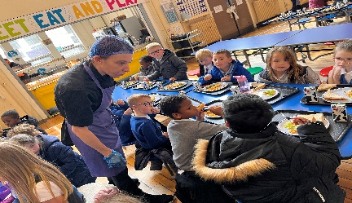

West Primary School

Session 2023 – 2024

Firstly, can I congratulate you on your choice of school for your child, we genuinely hope your association with us will be a happy and productive one. We believe in partnership and value your contribution to your child’s school life.

At West Primary School we have an open-door policy and if you have any concerns, please let us know as soon as possible so that we can hopefully put your mind at rest. The teachers are usually available to speak to at the end of school day if it is a quick question. We also use ‘Seesaw’ which is simple way for teachers and pupils to share information with parents of learning that is happening in the classroom. For other queries/concerns that need a more in- depth conversation you can speak to the Infant Depute, Mrs Wiszniewski who will be happy to help.

**Staff…**

Primary 1a Miss Emma Hartley (Principal Teacher) 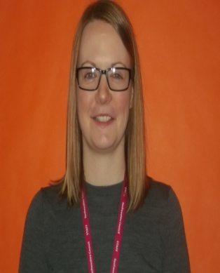

Depute Head Techer Mrs Vicki Wiszniewski (Nursery. Primary 1 and Primary 2) 

Head Teacher Mrs Lynne McGinn 

**Curriculum for Excellence**

Your child has already started their education journey in nursery and Primary 1 is the next step in this exciting journey through the Early Level and onwards.

Our curriculum endeavours to educate the whole child and enable him/her to become:

* **A Successful Learner**
* **A Responsible Citizen**
* **An Effective Communicator**
* **A Confident Individual**

We aim to ensure that ALL…

* Children will work at a pace that suits, with enough challenge and support to stretch them.
* Lessons will be engaging, inspiring and relevant to everyday life.
* Teachers will make connections between subjects, helping children make sense of the world.
* Children will learn *how* to learn and how to use their learning. This will give children the ability to think for themselves, make sound judgements, challenge, enquire and find solutions.
* Children will focus on knowledge *and* skills – including vital skills: literacy and numeracy, which underpin all learning and are critical in life.

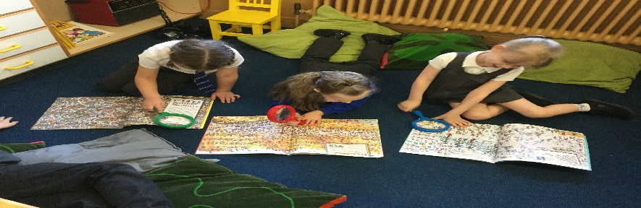

**Numeracy**

Number

At the start of Primary 1 we focus on counting skills and forming the numerals correctly. The children are involved in lots of practical activities, when working directly with their teacher and through play. There is also some written work, so the children can transfer their skills. We reinforce counting skills through songs and rhymes.

Practical Maths

During the year, your child will learn lots about mathematical concepts such as:

* Shape
* Length
* Graphs
* Pattern and sequence

This will be in meaningful contexts with lots of play-based activities to support their learning. There is an emphasis on the language/terminology of these topics.

Mental Maths

It is important that children become confident with mental calculations. In Primary 1, there is a daily focus on this. Your child will take part in a range of activities and games and further develop their mental maths skills. Daily use of these skills will help to improve their confidence.

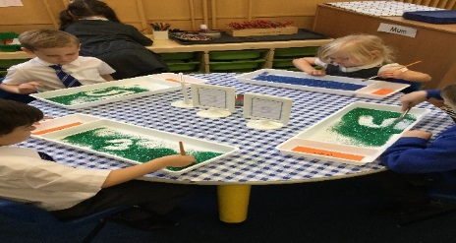

**SEAL – Stages of Early Arithmetic Learning.**

**What is SEAL?**

SEAL is a Maths approach which we use in school. It helps teachers to ensure that a child understands what is going on and moves them along in very detailed steps.

Children develop and use a range of methods to solve number problems. The strategies they use increase in sophistication as children gain experience and develop better ways of solving problems. SEAL is very specific in the terms and equipment it uses, and we have listed some of these below.

**What does that mean?**

Below are several words which we use within the SEAL scheme.

***Rekenrek* –**A piece of equipment which looks like an abacus. Children use it for adding and subtracting.

***Array* –**Putting dots into rows and columns so children can see what they are multiplying or dividing.

**o o o o**

**o o o o**

**o o o o**

*E.g. this shows ‘3 x 4’ ‘4 x 3′ or ’12 split into 3 groups of 4’.*

***Backward Number Word Sequence* –**Counting backwards from any number. This can be done in ones (e.g., 10, 9, 8…) or in groups (e.g., 80, 75, 70…).

***Forward Number Word Sequence –***Counting forwards from any number. This can be done in ones (e.g., 81, 82, 83…) or in groups (e.g., 25, 30, 35…).

***Combining* –**Another way of saying number pairs or number bonds. *E.g., ‘5 + 3’ or ‘3 + 5’ or ‘What goes with 3 to make 5?’.*

***Sequencing Numerals* –**Putting numbers into order. Either smallest to biggest or biggest to smallest

**Literacy**

**Reading**

At the beginning of Primary 1, your child will learn the skill of reading in a variety of ways. This in the first instance will be from storybooks with meaningful contexts. With this approach, we aim to ensure that children’s enthusiasm for listening to stories and learning the skills of reading is enhanced, in an enjoyable and realistic context making it more meaningful. With this experience, they will learn sight vocabulary as well as common words that appear regularly in the written text.

The children are encouraged to discuss books and talk about their feelings. What did they like/dislike about the story? Did the story remind them of anything in their own life? Did the story create questions and puzzles? Our aim is to encourage children to be readers for life and to have a love for books that will stay with them as adults.

Alongside rich texts, we will develop reading strategies and increase sight vocabulary through our reading scheme called Oxford Reading Tree. The books are very colourful to capture the children’s imagination and build the children’s confidence with reading.

Some weeks your child may have two to three books home to read. One of the books will be a **‘Read to me’** book chosen from the class library and one that a child can enjoy listening to and discussing with an adult. One of the books will be a **‘Challenge’** book that the child has read with the teacher and can adopt reading strategies to read independently. Lastly a **‘Chill Time’** book. This book is at an easier level for your child that they can read independently to build confidence.

Your child will have a marker in their reading folder, and this explains what pages we have looked at in class from their reading book. We would ask that you read over these pages with your child as well as going over common words on their word wall.

**Phonics**

In West Primary, we use a scheme called Jolly Phonics. With actions for each of the 42 letter sounds, the multi-sensory method is very motivating for children. We start with the six letters s,a,t,p,i and n as you can use them to make many different words.

The children enjoy singing the songs for each sound and you can access this on You Tube.

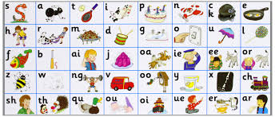

On our Primary 1 Seesaw group we will also share weekly videos to support your child’s learning in the home.



**Writing**

Initially, we encourage children to express their ideas in drawing and this allows them to see the correlation between their idea and a mark on paper. The teacher teaches formal handwriting and work is sent home for extra practice.



Talking is an important aspect of preparation for writing. Not only does it clarify thinking that may, later, be expressed in writing, but talking can also motivate and stimulate ideas.”

Talking with your child is a very easy and effective way of encouraging good language and writing skills.

“Parents, carers and other family members can and do make a real difference to

children’s education. When parents are actively involved in their children's

learning, it has a positive effect on attainment and achievement.”

Quote taken from the Learning and Teaching Scotland website: www.parentzonescotland.gov.uk

**West Vision and Values**

**‘Where Everyone Succeeds Together’**

At West, we have high expectations for all pupils; we expect children to be West Standard by demonstrating our West Values. This is recognised through weekly Values Certificates such as Star of the Week, Class Act at assembly and in class, regular house points, positive reinforcement strategies and end of year awards.

Honesty Trust Respect

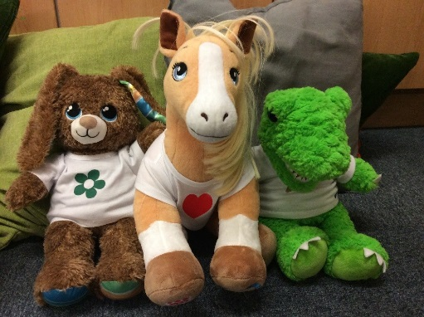

In Primary 1 we use 3 characters to represent our values. We have Honesty Horse, Trusty T- Rex and Respectful Rabbit. These characters reinforce the values in various ways within the classroom. This helps the children to understand what it means to be honest, trustworthy and respectful.

In addition, we wish to give recognition to pupils who go ‘Over & Above’.

‘Over and above’ behaviours include, exceeding our school values, affecting the wider West community and showing West initiative.

**Positive Strategies**

All adults in the school will use the following positive strategies consistently. They are designed to ensure ‘first attention goes to best conduct’ and to create clear, simple routines and expectations that make children feel valued members of our learning community and motivated to always try their best.

Teachers will create a welcoming environment by greeting pupils every morning through a formal meet and greet at the classroom door. This may be a simple, ‘Good morning’ or offering a handshake to provide a consistent check in and enthusiastic welcome to every child.

All adults will be looking out for children who show West Values and go over and above.

We will celebrate positive behaviours by the following ways:

**A Positive Note Home/Letter Home**

The Positive Note is also a high-level recognition for consistently going over and above. Any adult in the school, staff members or visitors can give it to any child. There is no set amount each week- again it must be sincere to keep its value. The Head Teacher may recognise outstanding children by sending letters home.

*‘***Recognition Board**

A Recognition Board is used to encourage social or learning behaviours. For example, ‘Walk Proud not Loud’, ‘Kind words’ or ‘Over and above’ may be written on the board. Adults or pupils in the class can nominate names for the board and there is emphasis on children working together as a team to get everyone’s name on the board.

There is no material prize for class completion. Each class chooses a celebration when all names are on the board.

**Phone Calls Home**

Promoted staff or teacher phones parents to share child's success.

**West Values Certificates**

Awarded at assembly.

**House Points –** Your child will be given a house and house badge when they start school.

We have four House Groups in West Primary…

Broomlands – blue badge

Newton – yellow badge

Maxwellton – green badge

Wellmeadow – red badge.

**Achievement Book**

Children with an achievement outside of school can share it at the weekly assembly or in class. Our Primary 1 classes have an achievement book to celebrate things like riding a bike, tying shoelaces, swimming badges; dancing medals, the list is endless. We love to hear about it. Parents and Carers can pass this information on through our online platform ‘See-saw.’

**Restorative Meetings/Conversations**

*‘The positive relationships you form with pupils depend on a restorative approach being your default mode.’*

Paul Dix

At West, we believe that nurturing and restorative practice, as well as high expectations, are key to building positive relationships. Restorative meetings and/or conversations aim to help the child realise how their behaviour affects others, teach what appropriate behaviour looks like and equip the child with tools they can use to avoid a similar incident occurring in the future.

When a particular anti-social behaviour is repeated, we operate positive behaviour strategies to target the unwanted behaviour. We work co-operatively with parents. We usually find that once children realise the parents and school are working in partnership the unwanted behaviour quickly diminishes. Our policy at West Primary is to inform you as early as possible. We pride ourselves on our consistent and fair approach in dealing with behaviour issues. Your involvement is very important to us and we look forward to working alongside you.