Wallace Primary School and Early Learning & Childcare Class

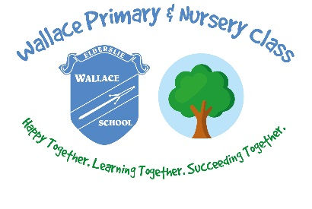

First Aid Policy

“Children have the right to the best health care possible”
(United Nations Convention on the Rights of the Child)
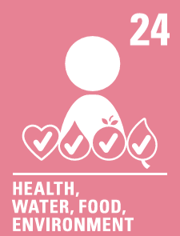

Purpose
This policy sets out the circumstances in which we may administer medicines or provide first aid within school (including on trips), and the procedures that we will follow.

Introduction
The administration of medication and medical treatments is an essential part of the overall care and support provided to pupils. It is therefore important that all school and ELCC staff, who are involved in the administration of medication or carry out medical treatments are fully aware of this policy to ensure the safety of the pupil is paramount whilst ensuring that risks to themselves and others are minimised.
In ensuring duty of care to pupils, Wallace Primary School must ensure that the level of care provided promotes the fundamental importance of sensitive caring relationships, and acknowledges individuals’ value, dignity, confidentiality and independence.

Purpose & Aims
This policy aims to:
- Ensure consistent practices are applied when administering medicine and medical treatments.
- Comply with the National Institute for Health and Care Excellence’s guidance on the six rights of medicine administration which are:
  - Right person
  - Right medicine
  - Right route
  - Right dose
  - Right time
  - Right to decline

Legal Requirements
There is no legal duty that requires any member of school staff to administer medicines or undertake health care procedures; this is a voluntary role (even where the person is a qualified first-aider)
At Wallace Primary School our First Aiders are Mrs Nicola Jackson (Classroom Assistant) and Miss Natalie Morris (Early Learning & Childcare Officer).

First Aid Equipment
Every classroom has a small box with basic first aid items such as antiseptic wipes, gloves and plasters for minor injuries.
Playground staff have a small grab bag of basic first aid items that is taken out to the playground for immediate treatment of minor injuries.
A full first aid kit is located in the school office to treat more serious injuries.
First aid kits and boxes are checked and replenished on a weekly basis by the school First Aider.
It is also the responsibility of the First Aider to prepare first aid kits for school trips.

Treatment of Injuries or illness
All staff are able to volunteer to treat minor injuries such as cuts, grazes or sickness. The school First Aider is trained to deal with more serious first aid issues such as fainting or head bumps.

Head Injury
Although a member of staff may attend to your child and administer first aid if they have bumped their head, the First Aider will often check for signs of concussion. You will always be informed if your child has had an injury to the head area via a ‘head bump’ letter.

Toileting Accidents
If your child has had a toileting accident they will be supported by a member of staff to change into dry, clean clothes. Your child’s wet clothes will be sent home in a plastic bag within their school bag. We would ask that you wash and return the clothes your child has borrowed.
If your child has an accident that requires physical intervention e.g. diarrhoea, one member of staff will support them with a second member of staff acting as a chaperone. PPE will always be worn.

Emergency Procedures
In the event of a medical emergency (e.g. collapse, seizure, breathing difficulty, severe head injury, uncontrolled bleeding, anaphylaxis):
- 999 will be called immediately
- First aid will be administered within training limits
- The Head Teacher/Depute Head Teacher will be informed
- Parents/carers will be contacted
- A staff member will accompany the pupil to hospital if required

Administration of Medication
Medication will only be administered where:
- A Parental Consent / Medication Form has been completed
- Medication is in its original container, clearly labelled
- Dosage and timing are clearly stated
- Trained and authorised staff are available
Further information can be found in our administration of medicine policy.

Recording & Reporting of Accidents
- Accident/incident forms will be completed for:
    - All head injuries
    - Any injury requiring more than minor first aid
- Records are stored securely and uploaded to SEEMiS
- Serious incidents will be reported under RIDDOR where required

Training & Review
- First aid training will be renewed as required
- Medication training will be provided as needed
- This policy will be reviewed annually by the Senior Leadership Team

