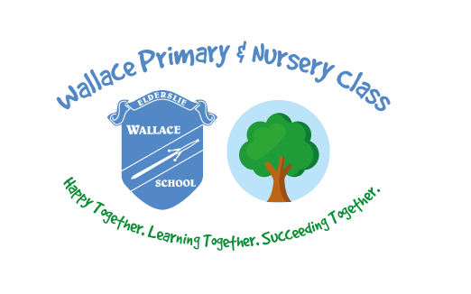

**Wallace Primary School**

**Home Learning Pack**

**Lower School**

**MATHS****LITERACY****CREATIVE****OUTDOOR LEARNING**