HAPPY TOGETHER  OUR VISION  LEARNING TOGETHER  SUCCEEDING TOGETHER |  | RESPECT HONESTY  OUR VALUES  KINDNESS  FRIENDSHIP AMBITION | READY RESPECTFUL  OUR RULES  SAFE
Visible Consistencies  The adults will:  - Meet and greet the children every morning  - Notice and respond to good behaviour from pupils across the school.  - Praise positive choices.  - Ensure a safe and calm environment across the school.  - Celebrate children going over and above.  - Ensure every class has an effective recognition board.  - Model our school values.  - Support and nurture relationships  - RIP / PIP reprimanding in private and praising in public.  - Use the classroom plan, 30 second script and restorative approach when required, with all pupils across the school and nursery. |  | Celebrating Success  - House points and rewards  - HT Awards  - Positive Notes Home  - HT Fun Friday  - Red carpet for wider achievement | Visible Consistencies  The children will:  - Demonstrate our school values in all of their actions.  - Go over and above showing respect and manners at all times.  - Make positive choices, including being honest.  - Show ambition by giving their best in every aspect of their school day.  - Have positive relationships with all adults and pupils which show kindness and friendship.  - Show ‘wonderful walking’ at all times throughout the school.  - Follow our playground charter during all break times.  - Wear appropriate school uniform.
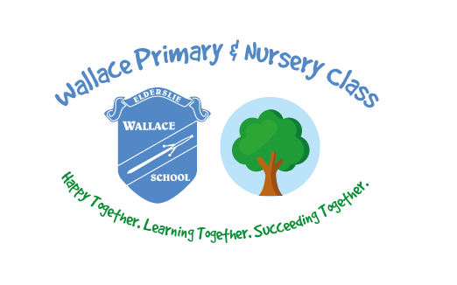
30 Second Script
- “I noticed you are…”
- “You are not showing our school rule/ value of…”
- “You have chosen to…” or “If you continue you will be choosing to…” (e.g. stay in for 2 minutes at playtime/ finish your work at lunchtime)
- “Do you remember earlier/ yesterday when you…? That is who I need to see today.”
Classroom Plan  - Reminder  - First attention to best conduct  - Last chance  - 30 second script  *Time out  - Restorative conversation  *Support step | Consequences  - Appropriate consequences linked to behaviour.  - Use of a communication card after all 5 steps in plan.  - Use of reflection for violent and aggressive behaviours |  | Restorative Conversation  - What happened?  - What were you feeling/ thinking at the time?  - What have you thought since?  - How did your action make other people feel?  - Who has been affected and how?  - What can we do to put things right?  - How can we do things differently in the future?

