

**Wallace Primary School and Early Learning and Childcare Class**

**Anti-Bullying Policy**

This policy has been written following consultation with all stakeholders -pupils (pupil voice sessions led by House Captains), parents (online survey and parental workshops) and staff (learning conversations). *The sections in italics represent pupil voice.*

**Policy Statement**

Wallace Primary School and Early Learning and Childcare Class’ (ELCC) vision is that all children are **Happy Together. Learning Together. Succeeding Together.** B*ullying makes children sad* and is a breach of their rights. Wallace community agree that bullying impacts a person’s ability to be happy, learn and succeed, thus not fulfilling the school’s vision. At Wallace we work to create an environment in which bullying does not thrive and is not acceptable. Wallace Primary School and ELCC aims to create an environment where children have the right to learn in a happy, safe and secure environment.

Draft

Renfrewshire Council is committed to the personal and social wellbeing of all children and young people. In line with ‘Respect for All – The National Approach to anti-bullying for Scotland’s children and Young People’, Getting it Right for Every Child (GIRFEC), United Nations on the Rights of the Child (UNCRC) and The Equality Act (2010), Renfrewshire Council aim to create environments where children feel safe and bullying cannot thrive. Wallace Primary School and Nursery Class Anti-bullying Policy is written in line with Renfrewshire Council Anti-bullying Policy.

**Definition**

Wallace Primary School and ELCC adopts the following definition of bullying:

‘Bullying is both behaviour and impact; the impact is on a person’s capacity to feel in control of themselves. This is what we term as their sense of ‘agency’. Bullying takes place in the context of *relationships: it is behaviour that can make people feel hurt,* threatened, frightened and left out. This behaviour happens face to face and online.’ (Respect Me, 2015)

Wallace community see bullying behaviour as:

* *Emotional Abuse* - *Being unkind, hurting another’s feelings*, *hurting people inside, when someone picks on someone else,* Being Excluded/Isolated, Targeting a Child

\**Physical Abuse* - *Hitting*, *kicking*, *punching*, *pushing*, threatening behaviour/language

*Verbal Abuse - *Name Calling*, *Teasing, Swearing*

*Breaking a child’s property, stealing

*Peer Pressure

*Online Bullying - *Cyber Bullying: when people are mean to you online*

*Targeting Specific Traits** – *discrimination – not including people because of who they are*

**Targeting specific traits or characteristics can result in prejudice based bullying. Prejudice

based bullying include the protected characteristics as covered by The Equalities Act

(2010):

* Age * Disability

* Gender Reassignment * Pregnancy and Maternity

* Race * Religion and Belief

* Gender * Sexual Orientation

* Marriage and Civil Partnership

**Preventing Bullying Behaviour**

**Values**

Wallace Primary School and Nursery Class sets high behaviour expectations and at the heart of this is the values of:

* Ambition

* Friendship

* Honesty

* Kindness

* Respect

Pupils, parent and staff recognise that the school values sets high expectations of behaviour and encourage positive relationships. One parent noted, ‘I believe that Wallace Primary makes it clear to all students that bullying is not acceptable in school and the creation of the school values and vision help to reinforce this.’ Through embedding the school values we strive to make Wallace a bullying free school in which all children feel happy, safe, included and able to reach their full potential with the support of others.

Draft

**Relationships**

Wallace pupils, parents and staff pride themselves in the positive relationships across the school. This ensures that bullying does not thrive, pupils recognise *that teachers deal with bullying straight away and they always understand.* Parents commented on the effective open door policy and approachable staff which allows for concerns to be dealt with quickly and effectively.

**Health and Wellbeing Curriculum**

The implementation of an effective health and wellbeing programme which focuses on building positive relationships, friendships, discrimination, types of bullying and how to prevent/deal with bullying.

**Rights Based Education**

The school promotes the UNCRC weekly at stage assemblies, through the work of the Rights Committee and through rights based education being integrated into topics across the curriculum.

**Pupil Voice Sessions**

Pupils have a weekly opportunity to work with P1-P7 pupils within their house. This builds effective relationships and allows pupils to influence the life of the school.

**P7 Buddies/Nursery Ambassadors**

P6 pupils adopt the role of Nursery Ambassadors and P7 pupils are paired up with a P1 pupil as buddies. This allows for effective relationships to be built with the younger and senior pupils within the school and nursery. It was recognised by pupils, parents and staff that this is effective in encouraging peer mediation in relation to bullying.

**Whole School Strategies**

Weekly assemblies focus on the school values. Children are rewarded for demonstrating these as well as stories/videos to reinforce them. Annually, there are focussed anti-bullying assemblies.

**Classroom Strategies**

Worry Boxes are in a number of classes which allows children to share their worries. In addition, the Review of the Week in the upper school allows children to note down their unique response to the week. Staff valued this as a tool to supporting pupils and dealing with their concerns.

**Areas for Action**

Wallace Primary School and Nursery Class are committed to creating an ethos in which bullying does not thrive. As a result of the consultation process the following action points will be included in the School Improvement Plan:

* Consistent Positive Relationships Policy

* Implement consistent methods for allowing children to report bullying

concerns

* Peer Mediators *(*this comes as a result of staff and pupil comments –

*bullying monitors, anti-bullying club, monitors for P1-P6)*

* Implementation of a progressive Health and Wellbeing Programme

(including staff training)

* Improved parental engagement/consultation in relation to anti-bullying

Draft

**Responding to Bullying Behaviour**

Pupils, parents and staff all agree that the school and parents should work in partnership to deal with bullying. In addition, all agree that support needs to be provided to the pupil being bullied and restorative work with the person displaying bullying behaviour. Where appropriate there may be joint restorative work.

There are times in which bullying does take place. Staff at Wallace follow the following steps to ensure all reports of bullying are dealt with in a consistent manner. Initial investigations may take place by teaching and support staff. Where there is evidence of bullying a member of the Senior Management Team (SMT) would carry out further investigations.

* Investigate:

- What was the behaviour?

- What impact did it have?

- What do I need to do about it?

- What does the child or young person being bullied want to happen?

(Almost all parents believe that all children involved should

be spoken to)

* Communicate with Staff/Parents/SMT

* Work towards giving ‘the victim’ back what was taken away

* SMT work with person displaying bullying behaviour according to the

Positive Relationships Policy (e.g. *Reflection Time during intervals*)

* Record (SMT will record on Pastoral Notes and within the Bullying and Equalities

module within SEEMIS)

**Review**

Wallace Anti-bullying Policy will be reviewed every three years in line with National Guidance.

**Published** - January 2019

**Review Date** – January 2022

**Appendix One – Parental Survey Results**

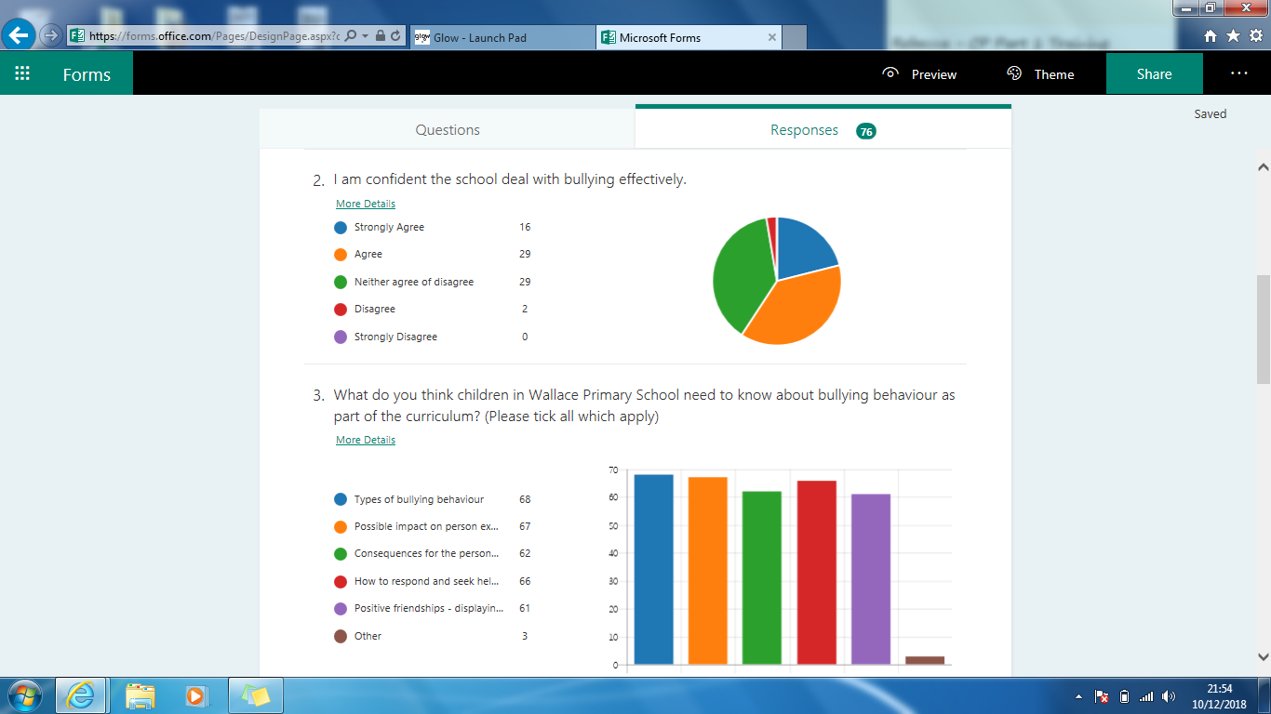Results from the multiple choice questions within the parental online survey. Other questions required answers in prose and are represented throughout the policy.

